Mathews Seafood Festival 2022
Hosted by:
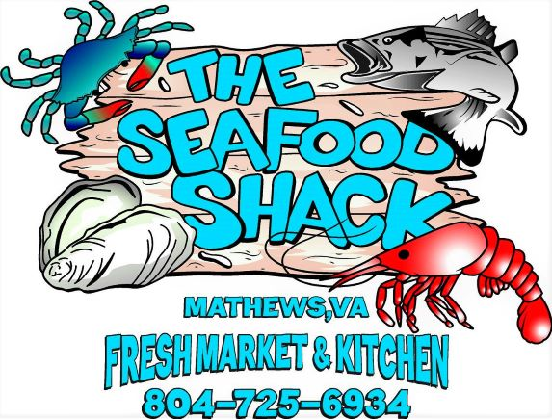
Vendor Information/Application Form
The Mathews Seafood Festival 2022 will be held at William’s Wharf Landing, Mathews. The event is from 3pm-8pm, September 24, 2022, rain or shine, all sales are final, no refunds. Vendors are to set up from 12pm-2pm, NO vehicles allowed in event area after 2pm, gates open at 2:15pm. We are anticipating 1000-1200 guests this year.
Vendor spaces are 12’X12’. Vendor tents, tables, chairs, etc. must be secured to prevent blowing around. You are liable for damages, and/or injuries.
Cost for a vendor space is $100. This includes one vendor space, and one operator. Addition personnel must purchase an event ticket.
Vendor application and payment must be received by 9/15/2022.
Fill out information below, and submit with payment to: theseafoodshack2019@gmail.com
Submit in person to: The Seafood Shack 10744 Buckley Hall Rd. Mathews, VA 23109
Or mail to: The Seafood Shack, 28 Irvinville Ln. Mathews, VA 23109

Contact Name:
Booth/Business name:
Email Address:
Phone # Cell #
Type of Vendor (craft, food, service, informational):
Payment: Check/Money Order Credit Card Cash
Credit Card # Exp CCV

