**Step 1.**

Click Register on top left of page which will bring up the menu on the right (below pic)

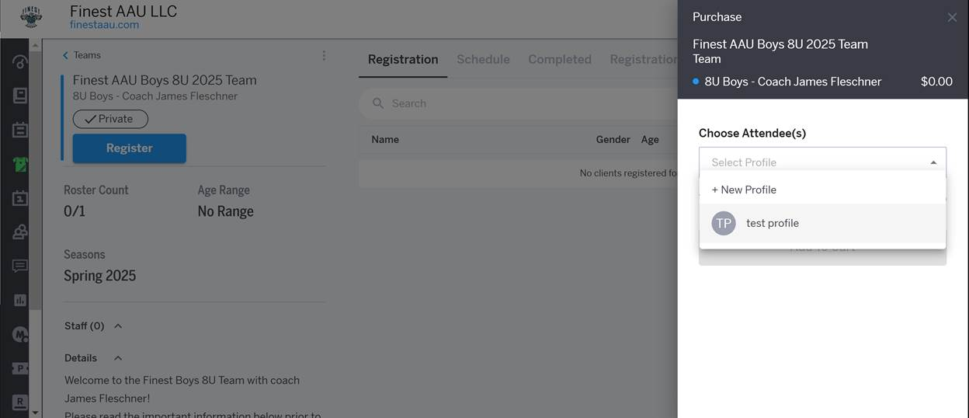

**Step 2.**   
Choose your child’s name in the drop down labeled “choose Attendee(s)”

After selecting your child’s name, click “Add To Cart”

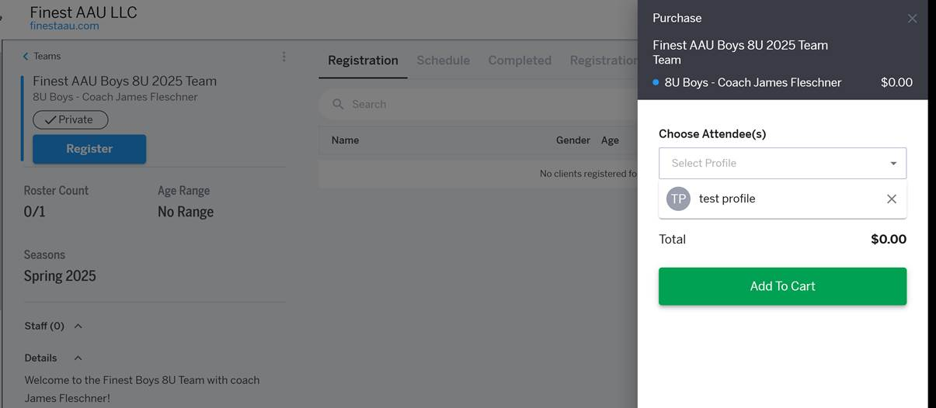

**Step 3.**   
Next step is clicking the BLUE hyperlink labeled “Fill Out Event Form”

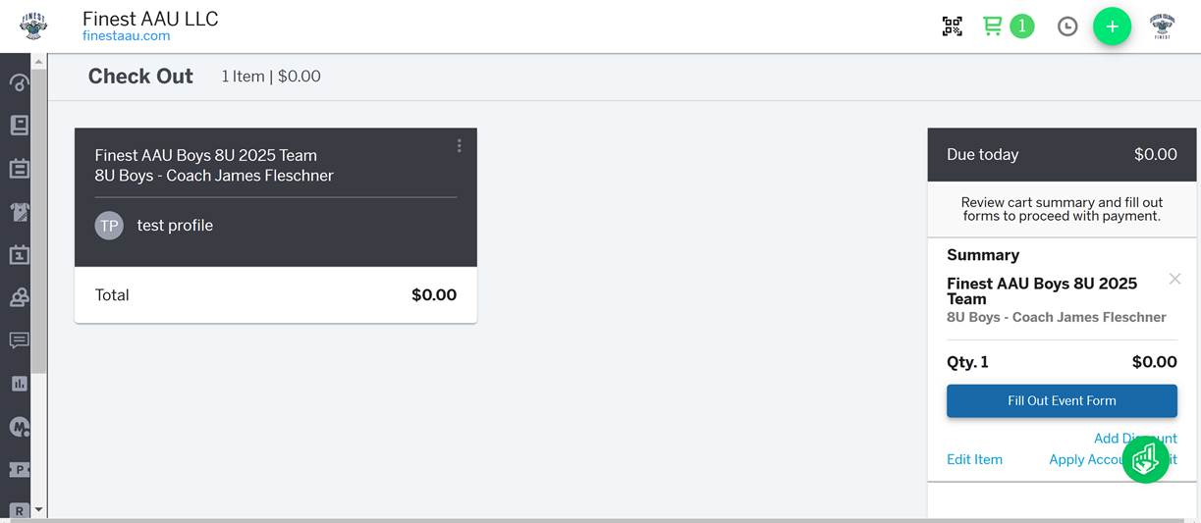

**Step 4.**

This will bring up the menu on the left side of the page (below).   
Please complete the information requested and click “Submit”.

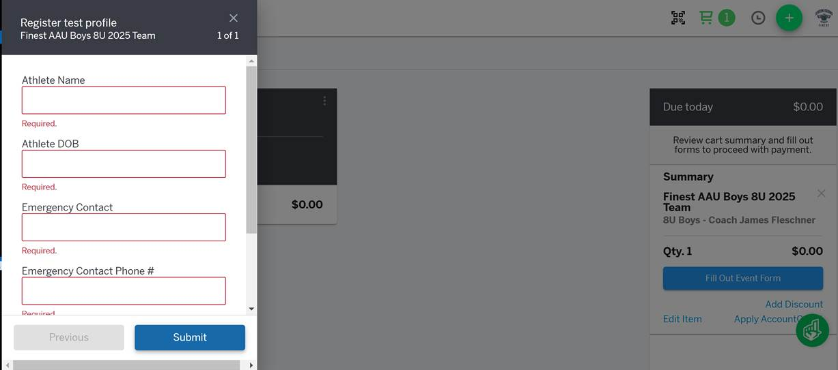

**Step 5.**

After submitting the information (above) you will need to click the blue link on the right of page “Continue to Payment” (even though there is no payment/amount being requested)

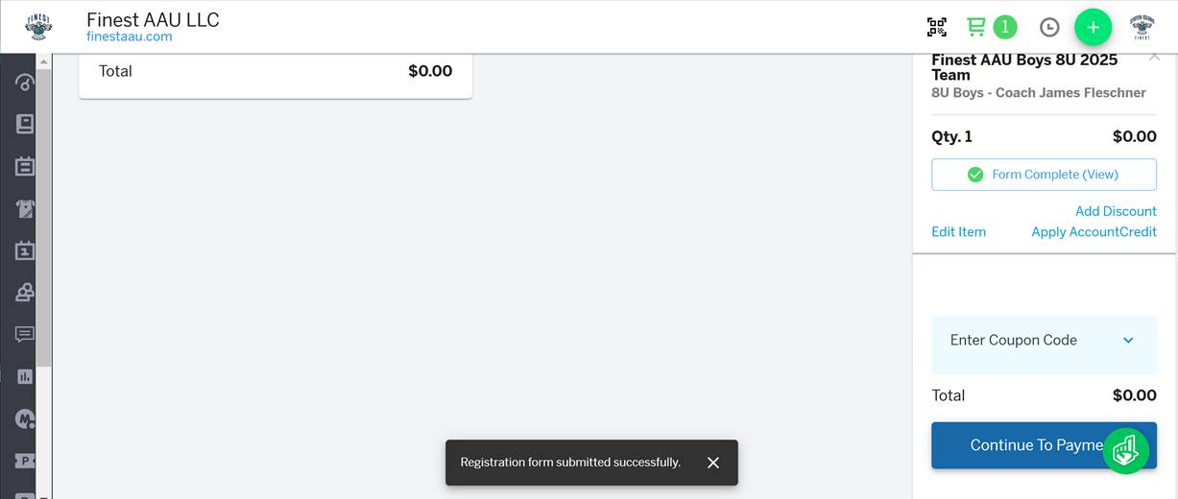

**Final Step.**

YOU MUST CLICK THE GREEN LINK “PURCHASE” TO COMPLETE YOUR REGISTRATION

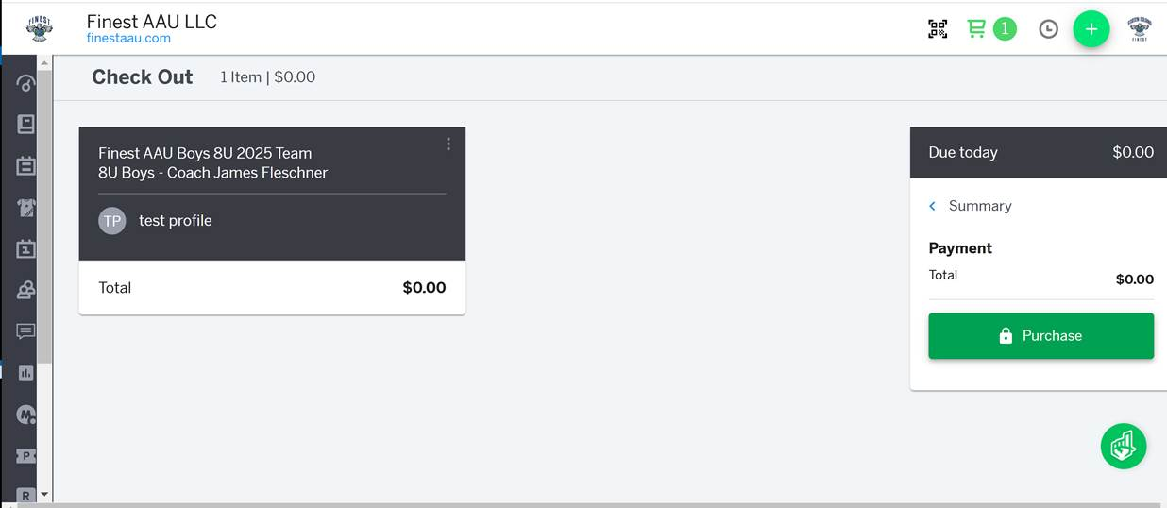

**THIS PAGE** (below) CONFIRMS YOUR HAVE COMPLETED YOUR REGISTRATION

