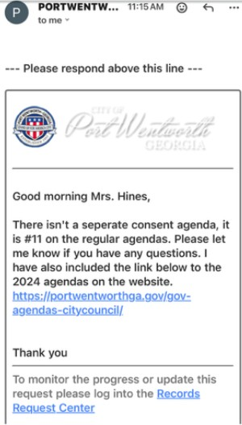
WHAT THE HECK IS A CONSENT AGENDA? #11 ON THE REGULAR AGENDA APPARENTLY
When I was a town clerk in rural Wisconsin, I had many duties. Those duties included, but were not limited to, correspondence with agencies, filing forms with the state, writing legal documents for our town lawyer, selling dog licenses and graves, registering voters, writing grants for road construction and parks, answering questions regarding taxes, settling squabbles over township ordinances, training our election workers, paying the towns bills, and of course preparing for the monthly Town Supervisors’ meeting. Those meetings, similar to our city council meetings, required that I develop an agenda, identify items that needed separate votes, create a fiscal report, advertise the meeting according to Open Meetings laws (1 week in advance in three physical places as well as on the website and in the newspaper), and make sure every supervisor received the packet of information we would cover at least a week in advance. Included in that packet was a “consent agenda”.
According to Roberts Rules of Order, a consent agenda is a list of items for discussion that are grouped together for approval to save time during the meeting. Typically, these items include everyday management of the municipality, expenditures, incoming revenue, communications regarding governance, and any pending items for the coming month. Key word here is LIST. A council member may move to take something off the list and separate it out to be further discussed. The City Council in Port Wentworth votes on a consent agenda at each meeting. It always passes unanimously. However, we never have access prior to or at the meetings to see the “list” they are voting on. So I decided to use the Freedom of Information Act (Open Records Law) to request a copy of the last 20 months of Consent Agendas for the PW City Council. I was curious what was being approved by Council under that heading. I got a response, and it was telling.
If there isn’t a list, a consent agenda, do they know what they are voting on? How does a regular taxpayer get that information? Or is it carte blanche for the current administration?

