Imagine what could be:
Port Wentworth must be more responsive to the residents. Period.
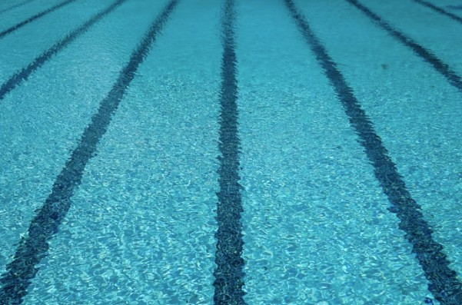

You’re sitting in the stands watching as your middle schooler is about to take off in lane 5. She’s very good at free-style swimming, in fact, she’s the one to beat in this heat. You dream of a scholarship for her.
You’re the proud Dad of a son whose job is to protect and serve from the lifeguard tower of a local beach or pool. During his morning hours he teaches swimming to six-year-olds in the community.
It’s another day of 101-degree weather in the coastal empire. Thank goodness you have access to a public pool that is run and maintained by the City of Port Wentworth. Wait, the City of Port Wentworth does not have a public pool. Nowhere for kids to learn to swim, for folks to cool off, to swim where there is little risk of critters and disease. Nowhere for our youngsters to improve their skills in competitive swimming and diving. Nowhere for our seniors to swim laps to improve their health.
But soon we’ll have a practice ice rink for a semi-pro hockey team. A practice facility that will never host a pro game. A facility that will occasionally be available to the public to use, if you have the equipment.
The city is providing the land, infrastructure, and financing the construction of a building that will be owned by a PRIVATE company. Right in the middle of public property, in the park we are currently paying to construct. There minimal jobs or revenue for the community. Benefits? Kids can be on teams they say. Hockey gear costs are excessive. I did the math; it will cost between $252 and $2100 to outfit your kid for hockey. You want them to play goalie? It will cost you $2100-$4300. There are the added costs of lessons, ice time, and travel team fees. And then there is Miscellaneous: Skate sharpening, stick tape, stick wax, Kevlar socks, skate guards and more. The continued costs of gear maintenance add up.
Google “cost of hockey gear” and you’ll find: Helmets range from $50-$430, Face Shield Range: $20-$90, Mouthguards Range: $15-$40, Neck Guards Range: $11-$35,Shoulder Pads Range: $25-$220, Elbow Pads Range: $15-$160, Gloves Range: $24-$230,Hockey Pants Range: $15-$230, Protective Cup Range: $12-$95,Shin Pads Range: $20-$200, Shin Pads Range: $20-$200, Sticks Range: $45-$370,Goalie Pads Range: $170-$2,000. (FloHockey.tv)

