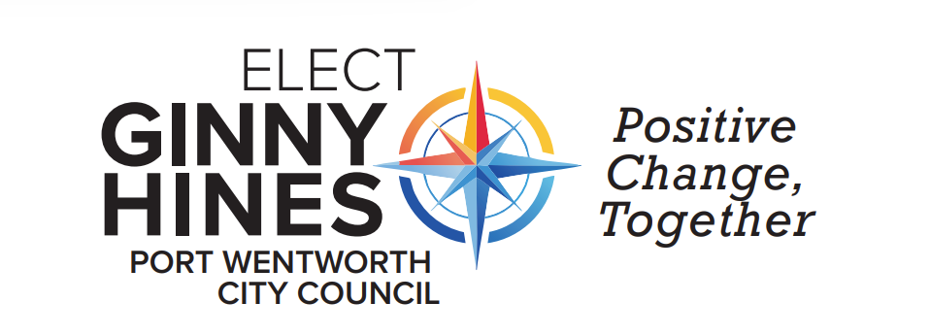

FOR IMMEDIATE RELEASE
Date: August 1, 2025
Contact: Ginny Hines
Phone: 715-587-5523
Email: vhines3445@gmail.com
Website: www.electginnyhines.com
Ginny Hines Announces Candidacy for Port Wentworth City Council Member At-Large
Port Wentworth, GA – Ginny Hines, a dedicated community advocate and lifelong supporter of civic engagement, is proud to officially announce candidacy for City Council Member At-Large in the upcoming municipal election for the City of Port Wentworth, Georgia.
With a deep commitment to inclusive leadership and community-first values, Hines enters the race on a platform built on shared governance, transparency, fiscal responsibility, community responsiveness, and balanced growth and development.
"Port Wentworth is a city full of potential, but realizing that potential requires leadership that listens, collaborates, and plans with both the present and future in mind," said Hines. "I’m running to ensure every resident has a voice at the table—and that the table is open, accessible, and accountable to all."
If elected, Hines pledges to:
- Promote Shared Governance: Encourage greater civic participation and collaboration between city officials and residents to shape public policy.
- Ensure Transparency: Strengthen access to information and decision-making processes to rebuild trust in local government.
- Uphold Fiscal Responsibility: Prioritize careful budgeting and responsible stewardship of public funds to meet current needs and prepare for long-term sustainability.
- Enhance Community Responsiveness: Focus on listening and responding to residents' concerns with urgency and empathy.
- Guide Smart Growth & Development: Support thoughtful, equitable development that preserves the character of Port Wentworth while encouraging innovation and opportunity.
Hines' experience in higher education teaching and leadership, local government, and community service has prepared her to meet the challenges and opportunities facing Port Wentworth today.
"This campaign is not about one voice—it’s about our voice as a community. Together, we can build a Port Wentworth that works for everyone."
The election for City Council Member At-Large will take place on November 4, 2025. Residents are encouraged to engage with the campaign and learn more by visiting www.electginnyhines.com, or Facebook “Elect Ginny Hines PW City Council”, and Instagram “elect_ginny_hines”.

About Ginny Hines
Graduate of USMC Quantico Dependents’ High School, Grand Valley State University, Salem International University, West Virginia University, and Ferris State University. Public school teacher in WV, retired teacher educator, retired municipal clerk, elections inspector, former owner/operator of Phloxology Vineyards. Founding member of Rice Hope Neighborhood Watch and graduate from Port Wentworth Citizens’ Police Academy.

Media Contact:
Virginia Hines
715-587-5523
vhines3445@gmail.com
www.electginnyhines.com

