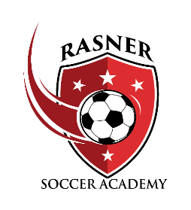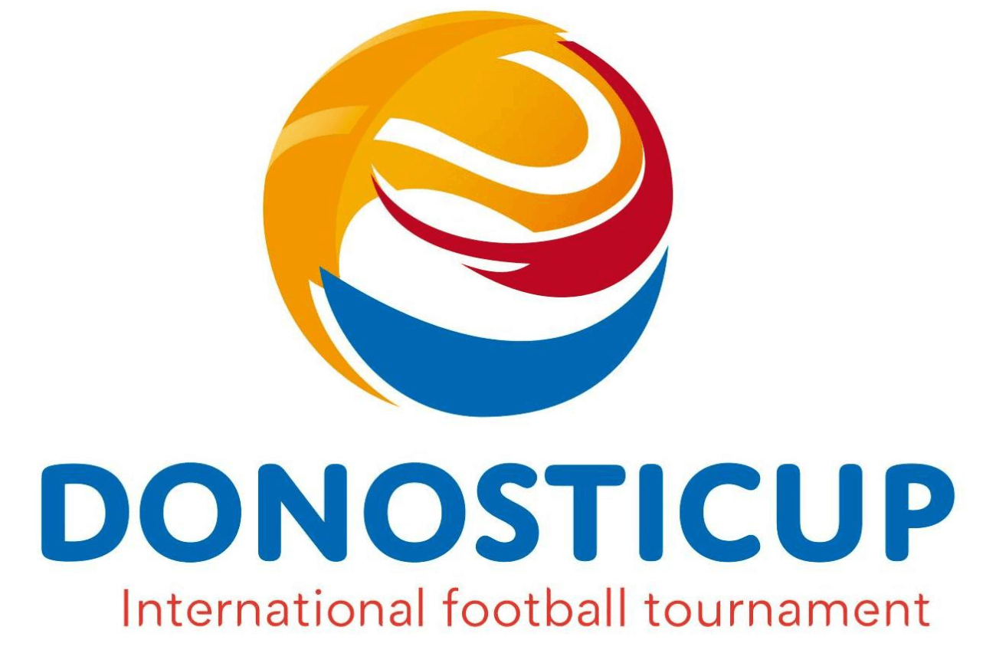

**Rasner Soccer Academy – Spain Trip**

**Donosti Cup**

The Donosti Cup is the largest international soccer tournament in southern Europe. Only a short distance to the France border, this tournament is settled in the northern part of Spain known as Basque Country. Rasner Soccer Academy is excited to offer this unforgettable opportunity!

​

Spain leads the ranking of participating teams with 198, followed by the USA with 74 and France with 22. The other countries represented are Italy, Portugal, United Kingdom, Sweden, Norway, Jordan, Lebanon, Japan, Chile, Guatemala, Peru, and Republic of Congo.

* 12+ soccer complexes in and around San Sebastian.
* Good artificial turf and natural grass fields.
* Biggest international tournament in southern Europe
* Impressive opening ceremony at Anoeta Stadium, home of Spanish pro club Real Sociedad
* Lots of social events during the tournament
* Beautiful beaches

**Donosti Cup Itinerary (Exact dates are TBD):**

Fri June 27th – Depart US for Barcelona

Sat June 28th – Arrive Barcelona, Training session, Site-seeing

Sun June 29th – Training session, Tour Camp Nou, Day of leisure

Mon June 30th – Depart Barcelona (am), Arrive and team check-in Donosti Cup, Check in to accommodations

Tue July 1 – 1st round matches, Team pictures, Opening Ceremony

Wed July 2 – 1st round matches, Live music at Fan Zone, Site-seeing

Thurs – July 3 – 1st round matches, Live music at Fan Zone, Site-seeing

Fri – July 4th – Final round matches, Live music at Fan Zone, Site-seeing

Sat – July 5th – Final round matches, Europe and Champions Finals, Donosti Cup Party and Closing Gala

Sun – Jul 6th – Europe and Champions Finals – Return to Barcelona

Mon – Jul 7th – Return to US

RSA will typically start the process of solidifying the roster spots for these trips a minimum of a year in advance of the trip. This will allow families to make decisions of who will be going on the trip and time to budget for the trip. We will be looking to take 14 – 16 players per team. Any and all family members are encouraged to accompany the player on the trip, but it is not a necessity. Players traveling without family members will be well supervised and “adopted” by other families on the trip.

Each player trip package will include the following:

* Player Kit – Backpack, three uniform tops (White, Red, Red w/black), two pair of shorts (Black, Red), two pair of socks (white, black), and a pennant.
* Roundtrip flight (prices may vary from year to year and from the departure airport)
* Room accommodations (these will vary depending on individual choice)
* Food (all meals will be included with the exception of meals outside of the café and 2-3 meals)

Each parent trip package will include the following:

* Roundtrip flight (prices may vary from year to year and from the departure airport)
* Room accommodations (these will vary depending on individual choice)
* Food (prices will depend on individual choice)
* 2 night stay in Montreat (Black Mountain, NC) for training sessions and fundraising videos

All teams will meet at Montreat College for a weekend in August for soccer training sessions and to get team video for fundraising purposes. This trip is included in the trip package and is a great opportunity for families to get to know each other and the players to play together to prepare for the Europe trip.

The base price of the Spain trip will be approximately $2900 per person. Trip prices will fluctuate due to airline costs and hotel costs. Individual choices may also cause a change in price.

A variety of fundraising programs will be used to aid in reducing the cost of the trip. We will be using the Montreat weekend to get fundraising ideas, video footage, and launch some fundraising campaigns. Player/family participation in the fundraising efforts can significantly reduce the cost of the trip per player/family.

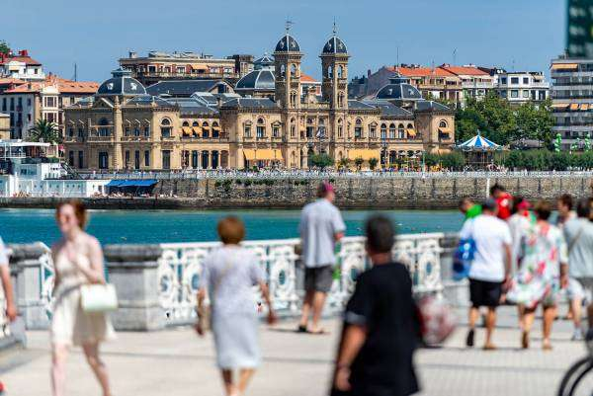 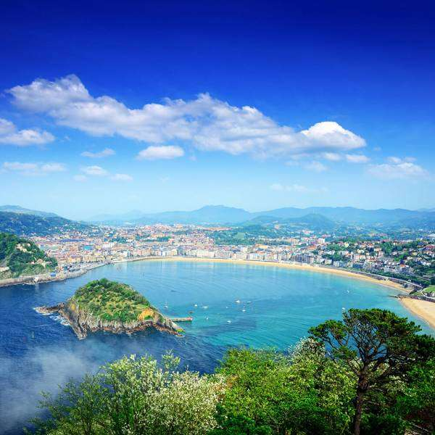 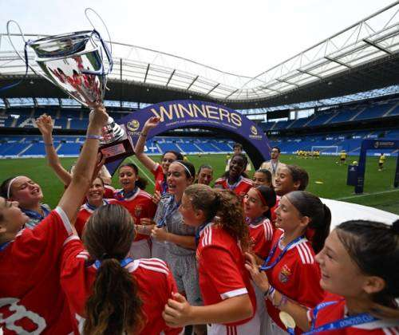

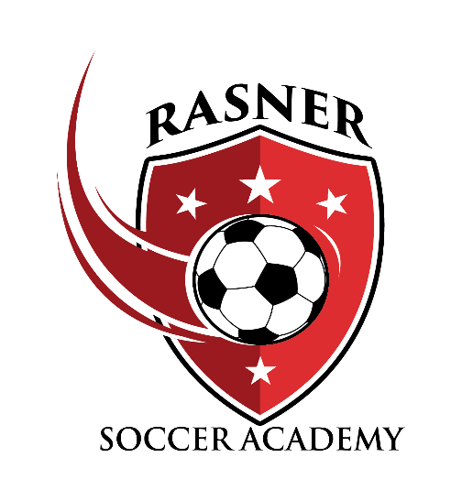

**(931) 308-8258**