Article
Mindfulness-Based Interventions & Binge Eating Disorder Treatment: The Good, The Bad, The Ugly
Brenna Bray,¹⁻⁴* Amanda J. Shallcross,⁵ David A. Wiss,⁶ Adam Sadowski,⁷ Barbara Kalu,^{1,8} Katherine Bray,^{1,9} Chris Bray,^{1,10} Heather Zwickey^{1,11}
1 NourishED Research Foundation (NRFi), Boulder, CO, 80305, USA
2 Building Research Across Interdisciplinary Gaps (BRIDG) Program, National Centers for Complementary and Integrative Health (NCCIH), National Institute of Health (NIH), Bethesda, MD, 20892, USA
3 Helfgott Research Institute, National University of Natural Medicine, Portland, OR, 97201, USA
4 Graduate School, Clinical Research MS Program, National University of Natural Medicine, Portland, OR
5 Department of Wellness and Preventative Medicine, Cleveland Clinic, Cleveland, OH, USA
6 Department of Community Health Sciences, Fielding School of Public Health, University of California Los Angeles, Los Angeles, CA, USA
7 Community Health Centers, Burlington, VT, USA
8 School of Education, Clinical Mental Health Counseling MS Program, Johns Hopkins University. Baltimore, MD, USA
9 School of Nursing, Duke University, Durham, NC, 27710, USA.
10 Amherst H. Wilder Foundation, Saint Paul, MN, 55104, USA
11 Nutrition Department, National University of Natural Medicine, Portland, OR, USA; hzwickey@nunm.edu

* Correspondence: brenna@nourishedrfi.org; Tel.: +1 206-819-9647
Abstract: Binge Eating Disorder (BED) has high lifetime prevalence rates (4.5–31%) and low treatment success rates (38.3–43.6%). Moreover, ~95% of individuals who meet DSM criteria for binge eating disorder never receive a formal diagnosis, 67% do not perceive the need for treatment, and ~55–85% never receive or pursue standard treatment. This mixed-methods cross-sectional study collected information from 14 expert binge eating disorder researchers and clinicians about barriers to accessing binge eating disorder treatment. Experts were identified based on federal funding, PubMed-indexed publications, practice in the field, leadership in professional societies, and/or popular press distinction. Semi-structured interviews were anonymously recorded and analyzed by ≥2 investigators using reflexive thematic analysis and quantification. Nine participants (64%) spontaneously described 11 treatment barriers, including (1) stigmatization (from healthcare providers as well as internalized and systemic/sociocultural stigmatization); (2) healthcare inequity, avoidance, and under-use; (3) treatment costs and insurance coverage; (4) lack of education and awareness about binge eating disorder (a) prevalence, (b) risk, and severity, (c) sociodemographic representation and who can have binge eating disorder, (d) diagnostic criteria and (e) validity that impact individuals with binge eating disorder, interpersonal relationships, healthcare providers/systems (e.g., binge eating disorder stigma, screening, diagnosis, and referrals), and sociocultural environments; (5) insufficient provider screenings; (6) prioritizing physical complications over underlying psychopathology; (7) insufficient resources for finding/coordinating care, including time and transportation; (8) ED provider and treatment center scarcity and waitlists; (9) treatment time; (10) facing and enduring discomfort and hardships associated with treatment; and (11) fear of letting go of the coping/eating behaviors. Secondary reflexive thematic analysis yielded a conceptual 3x3 model that categorizes barriers across two dimensions: (1) source of the barrier and (2) stage in the treatment-access-process the barrier impedes. Barrier sources were found to exist at: (i) the individual/patient-level; (ii) the interpersonal/healthcare-provider/system-level; and (iii) the sociocultural environment/systemic/systems-level. The three discrete yet dependent stages that barriers can impede are: (i) detection and identification; (ii) treatment-seeking and planning; and (iii) treatment access and engagement. This model can be used to identify individual, interpersonal, and systemic program-, process-, and policy needs while also illuminating how these needs interact with one another. The model can also be used as a tool for conceptualizing possible solutions that individuals, healthcare providers/systems, and policy-makers can use to improve binge eating disorder identification and treatment engagement. Addressing binge eating disorder treatment barriers will require a collective effort from healthcare providers, policymakers, researchers, and social media influencers. This should include education and awareness campaigns on binge eating disorder prevalence, demographics, stigmatization, scalable treatment options and benefits that target individuals who experience binge eating disorder, social and healthcare providers who serve them, and the environments binge eating disorder occurs in. Free, one-stop online resource platforms can streamline treatment-seeking and access, overcoming many barriers. Research funding is also needed to identify and test new treatment options that are: (a) free or low-cost; (b) community-based or accessible virtually; and (c-d) socio-culturally and socio-demographically sensitive, inclusive, and responsive.
Citation: Bray, B.; Shallcross, A; Wiss, D; …Zwickey, H. Treatment Access Barriers in Binge Eating Disorder Int J. Environ. Res. Public Health 2025, xx, x. https://doi.org/10.3390/xxxxx
Academic Editor: ***
Received: ***
Accepted: date
Published: date
Publisher’s Note: MDPI stays neutral with regard to jurisdictional claims in published maps and institutional affiliations.

Copyright: © 2025 by the authors. Submitted for possible open access publication under the terms and conditions of the Creative Commons Attribution (CC BY) license (https://creativecommons.org/licenses/by/4.0/).
Keywords: Binge eating; binge eating disorder; eating disorder; eating disorder treatment; treatment barriers; treatment costs; stigmatization; health equity; screening and diagnosis; public policy

- Binge Eating Disorder is a National, Global, and Public Health Crisis
Binge eating disorder (BED) is an autonomous DSM-5 and DSM-5-TR mental health diagnosis characterized by episodes of rapidly consuming objectively large amounts of food due to loss of control while associated with distress, guilt, and shame, and occurring at least once per week for at least three months (Figure 1A).^{1,2} The disorder is associated with high lifetime prevalence rates, with National and global surveys estimating that 5–31% of U.S and global populations will experience binge eating disorder at some point in their lifetime.^{3,4} A secondary analysis of the Global Burden of Diseases 2019 epidemiological databases estimated 17.3 million individuals experienced binge eating disorder in 2019, equivalent to 22.34% of the global population and accounting for 0.8 million disability-adjusted life-years (DALYs)(9,800 DALYs per 100,000 people, or 0.98 DALY per person) (Figure 1B).[27] Studies also find that 93.4–96.8% of individuals who meet DSM criteria for BED never receive a formal diagnosis,[16, 17] ~95% don’t know themselves that they have an eating disorder,[13, 16, 18] and behavioral and psychological symptoms are often minimize and under-reported (at subthreshold levels),[19-26] suggesting the current lifetime prevalence rate estimates may be grossly underestimated.[9-12]

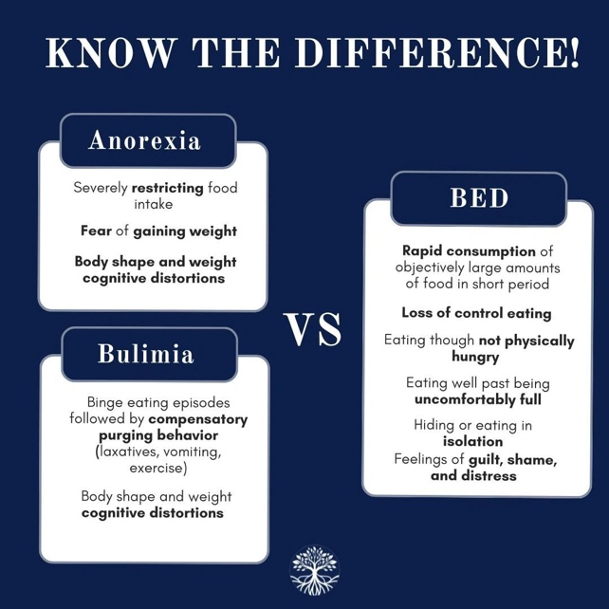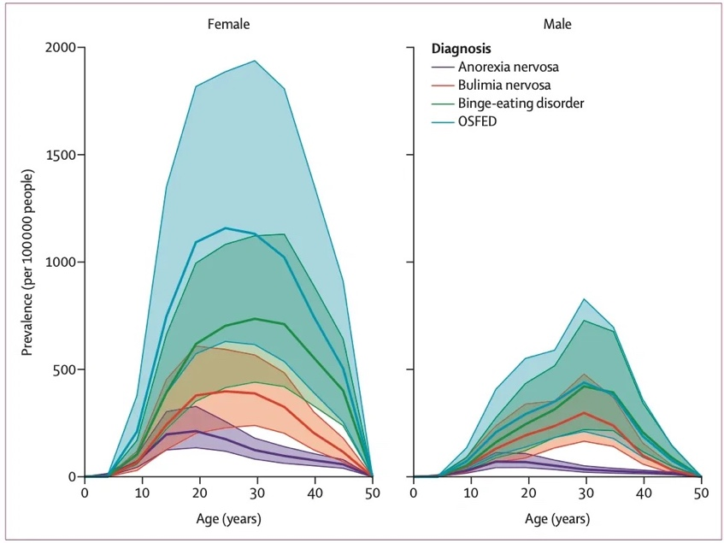
Figure 1 (Left) Binge eating disorder (BED) is an autonomous DSM-5 and DSM-5-TR mental health diagnosis characterized by episodes of rapidly consuming objectively large amounts of food due to loss of control while associated with distress, guilt, and shame, and occurring at least once per week for at least three months (APA, 2020). (Right) 2019 Lifetime prevalence rate estimates for BED and other eating disorders. A secondary analysis of the Global Burden of Diseases 2019 epidemiological databases estimated 17.3 million individuals experienced a binge eating disorder diagnosis in 2019, equivalent to 22.34% of the global population and accounting for 0.8 million disability-adjusted life-years (DALYs)(9,800 DALYs per 100,000 people, or 0.98 DALY per per-son)(Santomauro et al., 2021). BED, Binge eating disorder; OSFED, Other Specified Feeding or Eating Disorder.
Binge eating disorder is the most common eating disorder (Figure 1B) and its lifetime prevalence rates (~22.3–31%) are similar to those estimated for substance related and addictive disorders (SRADs, 22–30%, which includes alcohol use disorder (AUD) and other substance-related conditions); anxiety disorder (20%–30%, which includes generalized anxiety disorder (GAD) and panic disorder), and major depressive disorder (MDD, 16–27%).{CDC, 2024 #12834}{NIHCM, 2025 #12835} Despite the similar prevalence rates, 2025 data from NIH RePORTer shows that at the time of this publication, the NIH actively allocates $7.4 billion USD to substance related and addictive disorders (including AUD) across 11,964 active projects(); $2.7 billion USD to depression research across 4,743 active projects (), $1.5 billion to anxiety research across 2,686 active studies funding (), and yet only $0.58 billion to eating disorder research broadly (including anorexia nervosa, bulimia nervosa, BED, and otherwise specified feeding and eating disorder, OSFED across 1,071 active studies), and $0.039 billion USD to BED research across 89 active studies ().

Table 1 Mental Health Comorbidities Associated with Binge Eating Disorder in National and Global Surveys (2001–2013)*⁵
Mental Health Disorder  (as assessed via the DSM-IV or CIDI) | Pooled Lifetime Prevalence Rate*  (n=39,274 adults with BED included in studies conducted 2001–2013) |  |  | U.S. NESARC-III (Udo & Grilo, 2019)  (n = 35,709 adults with BED) |  |  | WHO-WMH Study (Kessler et al., 2013)  (n = 1,929 adults with BED) |  |  | SNEDQRPR Study (Welch et al., 2016)  (n = 850 individuals with BED) |  |  | SQCDS (Ulfvebrand et al., 2015)  (n = 526 individuals with BED) |  |  | WHO-NCR (Hudson et al., 2007)  (n = 260 adults with BED)
 | % | n | N | % | n | N | % | n | N | % | n | N | % | n | N | % | n | N
Any psychiatric disorder/DSM Dx | 89% | 34173 | 38424 | 94% | 33495 | 35709 | 4%¹ | 83 | 1929 | N/A | N/A | N/A | 74% | 390 | 526 | 79% | 205 | 260
Any Axis-I Mood Disorder | 66% | 25419 | 38424 | 70% | 24961 | 35709 | 5%¹ | 100 | 1929 | N/A | N/A | N/A | 45% | 237 | 526 | 46% | 121 | 260
Any Axis-I SRAD/SUD | 63% | 24370 | 38424 | 68% | 24175 | 35709 | 5%¹ | 87 | 1929 | N/A | N/A | N/A | 9% | 48 | 526 | 23% | 61 | 260
Depression/MDD | 61% | 23945 | 39274 | 66% | 23389 | 35709 | 5%$ | 98 | 1929 | 24% | 203 | 850 | 32% | 170 | 526 | 32% | 84 | 260
Any Axis-I Anxiety Disorder | 55% | 21772 | 39274 | 59% | 21068 | 35709 | 5%¹ | 96 | 1929 | 17%⁷ | 146 | 850 | 56% | 292 | 526 | 65%⁴ | 169 | 260
Anxiety/GAD | 31% | 12071 | 38424 | 33% | 11784 | 35709 | 6% | 118 | 1929 | N/A | N/A | N/A | 26% | 139 | 526 | 12% | 31 | 260
OCD** | 2% | 39 | 1636 | N/A | N/A | N/A | N/A | N/A | N/A | 1% | 10 | 850 | 2% | 8 | 526 | 8%⁵ | 21 | 260
Post-traumatic stress disorder (PTSD) | 31% | 11432 | 36819 | 32% | 11284 | 35709 | N/A | N/A | N/A | 9% | 80 | 850 | N/A | N/A | N/A | 26% | 68 | 260
ADD/ADHD | 8% | 245 | 3039 | N/A | N/A | N/A | 9%² | 179 | 1929 | 2% | 14 | 850 | N/A | N/A | N/A | 20%⁶ | 51 | 260
Schizophrenia or Schizoaffective Dx | 0.2% | 2 | 850 | N/A | N/A | N/A | N/A | N/A | N/A | 0.2% | 2 | 850 | N/A | N/A | N/A | N/A | N/A | N/A
Autism Spectrum Disorder | 0.2% | 2 | 850 | N/A | N/A | N/A | N/A | N/A | N/A | 0.2% | 2 | 850 | N/A | N/A | N/A | N/A | N/A | N/A
Table Legend: Mental Health Comorbidities Associated with Binge Eating Disorder in National and Global Surveys (2001–2013) in Bray et al., 2022b* *”Pooled Lifetime Prevalence Rates are pooled from the most comprehensive information available on BED mental health comorbidities, which come from five national and global prevalence studies, including: (1) the World Health Organization (WHO) World Mental Health (WHO-WMH) Survey Initiative conducted in 2001–2003 in 24,124 respondents (1,929 adults with BED) in 30 countries (Kessler et al., 2013); (2) the WHO National Comorbidity Replication survey (WHO-NCR) conducted 2001–2003 through face-to-face interviews administered to a sample of 9,282 adults in the U.S (260 with binge eating disorder)(Hudson et al., 2007); (3) a nationally representative study of 35,709 adults with binge eating disorder conducted in the U.S. between 2012–2013 (conducted as part of the national epidemiologic survey on alcohol and related conditions III, NESARC-III); (Udo & Grilo, 2019); (4) a National study conducted in Sweden that assessed psychiatric comorbidities through medical records of 526 adults presenting to specialist clinics for binge eating disorder between 2008–2012 (the Stepwise quality control database study, SQCDS) (Ulfvebrand et al., 2015); and (5) a Swedish study that linked extensive longitudinal data from the Swedish national eating disorders quality registers and patient registers (SNEDQRPR) to assess psychiatric comorbidity in 850 adults with binge eating disorder, with data extracted in 2009 (the SNEDQRPR study, SNEDQRPRS; Welch et al., 2016). For each study, the most prevalent comorbidity is indicated in bold. The standard errors and confidence intervals for these data are in the original manuscripts. **At the time of the WHO WMH survey initiative, OCD was classified as an anxiety disorder, but was reclassified as no longer being an anxiety disorder in the DSM-5, used at the time this study was conducted. $Describes statistics for major depressive episode/dysthymia (an Axis-I DSM diagnosis). ¹Disorders were coded as absent: (1) for countries that did not assess for these disorders, or (2) among respondents who were not assessed for these disorders (n=24,124) (Kessler et al. ,2013). ²Excluded New Zealand since it was not assessed for this disorder. Except for Brazil, Romania, and Northern Ireland, all other countries only assessed those who are ≦44 years old for this disorder (n=12,413) (Kessler et al. ,2013). ³Excluded Belgium, France, Germany, Italy, Netherlands, Portugal, and Spain, since these countries were not assessed for this disorder (n=19,476) (Kessler et al. ,2013). ⁴OCD was coded as absent among respondents who were not assessed for this disorder (Hudson et al., 2007). ⁵Restricted to a random sub-sample of respondents (n=1,139) (Hudson et al., 2007). ⁶Restricted to respondents in the age range 18-44 (n=1,672) (Hudson et al., 2007). ⁷Any anxiety disorder does not include OCD or PTSD (Welch et al., 2016). Abbreviations: ADD/ADHD, attention deficit disorder/attention deficit hyperactive disorder; APA, American Psychiatric Association; BED, binge eating disorder; CIDI, The WHO’s Composite International Diagnostic Interview, used to assess mental health in National surveys; DSM-IV, the APA’s Diagnostic and Statistical Manual of Mental Disorders, Fourth Edition (updated to the Fifth Edition, DSM-V, in 2013); Dx, diagnosis or disorder; GAD, generalized anxiety disorder MDD, major depressive disorder; OCD, obsessive compulsive disorder; PTSD, post-traumatic stress disorder; SD, schizoaffective disorder; SRADs, substance-related and addictive disorders; SUD, substance use disorder; WHO, World Health Organization, WMH, World Mental Health surveys.

- Binge Eating Disorder is a Private Health Crisis
BED is associated with a complicated health sequelae that includes high rates of co-occurrence with psychiatric and Axis-I mood disorders (89%, 66%)⁵ including substance related and addictive disorders (SRADs, 63%), depression (61%), anxiety (55%), post-traumatic stress disorder (PTSD, 31%), and attention deficit disorder and attention deficit hyperactive disorder (ADD/ADHD; 8%)⁵ that are thought to go undiagnosed often and contribute to the development and maintenance of BED,^{5,10,11} in part as a means of masking or coping untreated symptoms (Table 1).^{5,10,11}

The impacts of BED extend beyond behavioral psychology; it is also associated with a complicated high rates of adverse childhood and lifetime experiences (ACEs and ALEs), interoceptive neurodivergence, as well as overweight and obesity, cardiovascular disease, hypertension, hyperlipidemia, hypercholesterolemia, diabetes, cardiometabolic disorder, and low self-esteem that significantly impair quality of life.^{5,10,11}

- Risk Factors Associated with Binge Eating Disorder
Behavioral genetic data consistently support the contributions of genetic, epigenetic, and environmental influences to binge eating disorders and symptoms, with environmental factors thought to hold slightly more weight than genetics.¹²⁻¹⁶ For example, case-control family and twin-based studies conducted in 2004 - 2010 estimate BED heritability to be between 39%–57%¹²⁻¹⁵ and attribute 65%–72% of variance to environmental factors, with 42%–59% attributed to unique environmental factors (not shared by co-twins)^{13,16} and 13% attributed to common environmental factors.¹³

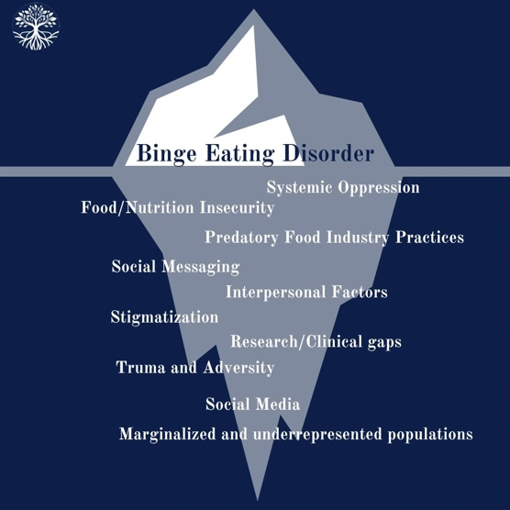
Figure 2 Environment factors experts associate with binge eating disorder largely center around social justice issues (Bray et al., 2020a).
Several models of environmental factors for binge eating disorder have been proposed.^{11,17} Environmental factors most robustly associated with BED by experts and in the literature include: (1) gaps in clinical research are care; (2) systematic issues and systems of oppression; (3) invalidation; (4) marginalization (including lack of access to resources and under-representation); (5) economic precarity; (6) stigmatization and discrimination (including internally, socioculturally, and in healthcare systems and from healthcare providers); (7) trauma and adversity; (8) food insecurity; (9) interpersonal factors; (10) social messaging and social media; (11) nutrition scarcity; and (12) predatory food industry practices and environments (Figure 2).¹¹
- Binge Eating Disorder Treatments: Evidence-Based Practice and Practice-Based Evidence
Standard of care interventions for BED include eating disorder-focused cognitive behavioral therapy and interpersonal therapy in either individual or group formats (recommended as the frontline intervention by the American Psychiatric Association (APA)),^{18,19} medications (the APA recommends antidepressants (e.g., [es]citalopram, sertraline, and fluoxetine) or the amphetamine stimulant lisdexamfetamine (developed for the treatment of ADD/ADH and approved for BED) for adults with BED who prefer medications or have not responded to psychotherapy alone),^{18,19} and behavioral weight loss.^{18,19} Anticonvulsant medications like topiramate and psychodynamic therapies like family-based therapy (FBT) also have some guideline support in the context of BED.¹⁸⁻²⁰

A variety of evidence-based practices are also increasingly use in the context of BED without formal guideline support, including glucagon-like peptide-1 (GLP-1) receptor agonists like Ozempic and Wygovi,²¹⁻²⁶ client-centered humanistic therapy,²⁰ and third-generation behavioral therapies like mindfulness-based interventions (MBIs),²⁷⁻³¹ dialectical behavioral therapy (DBT, which includes elements of mindfulness and are often categorized as MBIs),³¹ and DBT guided self-help.^{32,33}

Treatment options for BED have advanced considerably in the past decade and are gaining traction not just in the literature but also in clinical and nonclinical use.³⁴ For example, a 2024 growth analysis report valued the BED market at $0.81 billion USD in 2024, "driven by increasing awareness, advancements in treatment options, and the rising prevalence of the disorder across the 8 major markets," (Figure 3)³⁴ Moreover, the market is forecasted to grow at a compound annual growth rate (CAGR) of 6.00% between 2025 to 2034, reaching an estimated market value of $1.45 Billion USD by 2034.³⁴
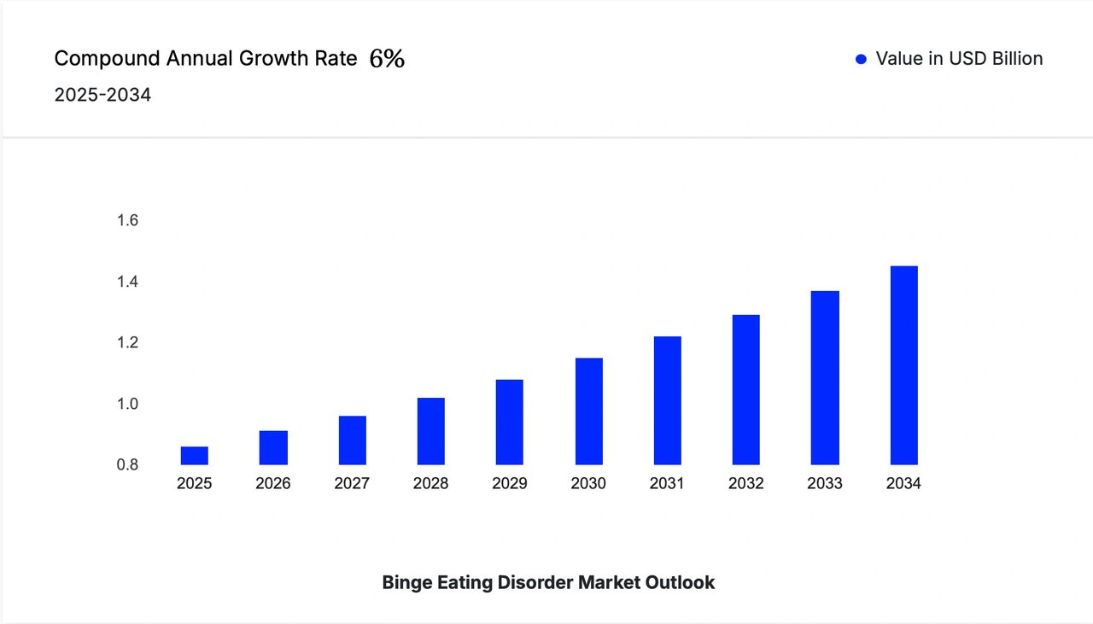
Figure 3 The binge eating disorder market was valued at $0.81 Billion USD in 2024 driven by "increasing awareness, advancements in treatment options, and the rising prevalence of the disorder across the 8 major markets," (Express Market Research, 2024). It is expected to grow at a compound annual growth rate (CAGR) of 6.00% between 2025 to 2034 and attain a market value of $1.45 Billion USD by 2034 (EMR, 2024), making the need for accessible and effective binge eating disorder treatments more critical than ever (Bray et al., 2023, 2024, 2025 (in prep).
- Treatment Gaps in Binge Eating Disorder
While treatment options for BED continue to evolve, treatment success rates currently cap at <50% (38.3–43.6%),^{3,6} with high recurrence rates (49–64%),^{3,35} high rates of treatment dissatisfaction,³⁶ and early discontinuation of care.³⁶ Moreover, studies find that 93.4–96.8%^{37,38} of individuals who meet DSM criteria for BED never receive a formal diagnosis, 67.3% do not perceive the need for formal treatment³⁷, and 56.4–86.8% never receive or pursue standard treatment,^{3,37} and 85% lack access to healthcare.³⁹ Despite the high market value, treatment access remains a critical issue in the field.^{40,41}

Treatment access barriers identified by experts in the field and empirical support include (1) stigmatization (socioculturally, internal, and within healthcare systems and among healthcare providers that are thought to drive healthcare avoidance and contribute to the deficits in detection, screening, and diagnosis); (2) healthcare inequity, avoidance, and underuse (related to stigmatization and discrimination socioculturally and in healthcare systems and providers); (3) treatment costs and insurance coverage; (4) lack of education and awareness about BED (specifically related to BED (a) prevalence, (b) risk, (c) severity, (d) sociodemographic representation and who can have BED, (e) diagnostic criteria and (f) validity that impact (i) individuals with BED, (ii) interpersonal relationships, (iii) healthcare providers/systems (e.g., BED stigma, screening, diagnosis, and referrals), and (iv) sociocultural environments; (5) insufficient provider screenings (related to stigmatization, stereotyping, and lack of training and education on BED); (6) prioritizing physical complications over underlying psychopathology; (7) insufficient resources for finding/coordinating care, including time and transportation; (8) ED provider and treatment center scarcity and waitlists; (9) treatment time burden; (10) facing and enduring discomfort and hardships associated with treatment (often including undiagnosed and untreated adverse childhood and lifetime experiences, trauma, and PTSD); and (11) fear of letting go of the coping/eating behaviors.^{40,41} Overall, these findings unanimously underscore the urgent need for research that can identify and test new treatment options for BED that are: (a) free or low-cost; (b) community-based or accessible virtually; and (c-d) socio-culturally and socio-demographically sensitive, inclusive, and responsive^{5,10,11,31,40-42}

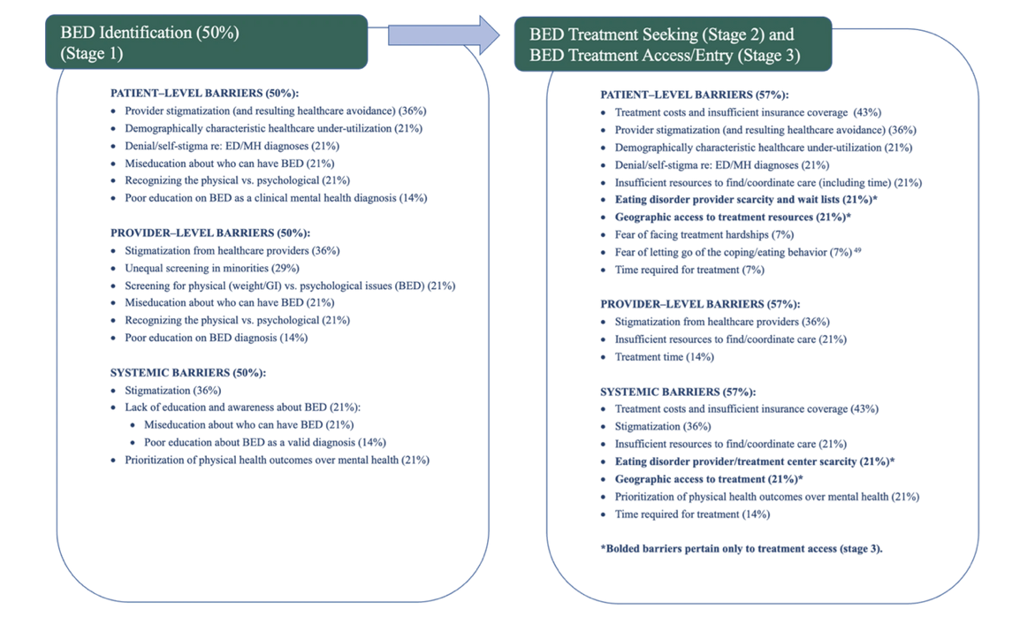
Figure 4 Theoretical model of patient-, provider-, and systems-level barriers that can impede binge eating disorder (BED) identification (Stage 1), treatment-seeking (Stage 2), and treatment engagement (Stage 3), as spontaneously identified by binge eating disorder experts in a cross-sectional mixed-methods study (Bray et al., 2025 (in prep)).
- Mindfulness-Based Interventions Have Strong Empirical Support in Binge Eating Disorder
Mindfulness-Based Interventions (MBIs) have gained increasing traction in clinical mental health counseling over the past two decades.^{29,43-46} These practices were largely introduced to allostatic Western Healthcare by Jon Cabat Zinn^{43,47-58} and center around mindfulness practices originally found in Buddhist traditions and teachings such as the dhamma (the written teachings of the Buddha)^{50,51} as a state that can offer freedom from internal conflict between the ego and the basic truth of human suffering.⁵⁹ MBIs have a large and growing base of empirical support in the context of Western mental health, clinical counseling, feeding and eating disorders, and binge eating disorder specifically.[12, 39-42, 49] MBIs are incorporated into second-wave CBT [12, 50-54] (the standard of care for eating disorder and BED treatment).¹⁸⁻²⁰ MBIs – including mindfulness-based stress reduction (MBSR), acceptance and commitment therapy (ACT), and compassion training/compassion-focused therapy (CFT) – are considered independent third-wave behavior therapies²³¹ and are also incorporated into other third-wave behavioral therapies like dialectic behavior therapy (DBT)),[12, 50-55] with improved treatment responses that are well-supported in the literature.[12, 39-42, 46, 49, 55-63]

A 2019 meta-analysis of the effects of third-wave behavioral interventions on disordered eating and body image concerns found that the aspect of mindfulness was responsible for the strong, positive, and improved outcomes observed in third-wave behavioral approaches (including CBT, DBT, MBIs, and others (Linardon et al., 2019). A 2020 systematic review and meta-analysis of mindfulness and eating disorder psychopathology identified 74 independent samples in 70 papers, including three samples consisting solely of individuals with current or past binge eating disorder with longitudinal effect sizes observed over a 180-day follow-up period in all studies [49]. The meta-analysis found inverse associations between mindfulness and eating disorder psychopathology (r = -.25, p < .001), both concurrently (r = -.25, p < .001) and prospectively (rs = -.22 to -.24, ps < .001), with strongest associations observed in binge eating (r = -.28, p < .001), emotional/external eating (r = -.29, p < .001), body dissatisfaction (r = -.29, p <0.001), acting with awareness, and nonjudging facets.

More recently, Grohmann and Laws’ 2021 comprehensive systematic review and meta-analysis of two decades of mindfulness-based interventions (MBIs) for binge eating identified 21 samples in 20 papers, including 11 RCTs meta-analyzed to reveal that MBIs significantly reduced binge eating severity score (g=-0.39, 95% CI: -0.68, -0.11; n= 335 MBIs, 283 controls) at the end of the trial; however, the reductions were not maintained at follow-up in the five studies that reported follow-up outcomes (g=-0.06, 95% CI, -0.31, 0.20, k = 5)[39]. MBIs also significantly reduced depression and improved emotion regulation and mindfulness ability [39]. Overall, the authors concluded that further research is needed on the efficacy of mindfulness-based interventions in BED and future studies should focus on including minority populations [39].

- Strengths Associated with Mindfulness-Based Interventions in Binge Eating Disorder Treatment
7.1 Utility and Efficacy
MBIs -- including mindfulness, meditation, mindful movement (yoga), and mindful eating -- are the most commonly endorsed and used complementary and integrative health (CIH) interventions among binge eating disorder experts, with 71% endorsement and >50% reported use [12].
Experts and literature endorse mindfulness in the context of reducing binge eating, overeating, and loss of control eating, and behavior change [12, 39, 46, 64]. Literature additionally supports mindfulness in the context of managing mood/depression; emotion regulation; and improving global eating disorder psychopathology (e.g., Binge Eating Scale score)[12, 39, 46, 64].
Importantly, experts also described mindfulness as being useful (in the context of binge eating disorder) for (1) helping patients tolerate treatment and cope with symptoms; (2) addressing and healing (i) trauma, (ii) the relationship with the body, (iii) body image, and (iv) movement and exercise; and (3) reducing anxiety [12]. These outcomes have not been empirically investigated or validated among clinical samples at the time of this publication and thus warrant empirical investigation [12].

7.2 Feasibility and Accessibility
Experts and literature also support the feasibility, acceptability, and accessability of mindfulness based interventions, highlighting empirical support (1) in the context of binge eating disorder [12, 39, 46, 64], (2) in remote/virtual formats [60, 61] and (3) free or low-cost options [43, 45, 65-67] that (4) overcome a variety of access barriers (e.g., cost, insurance coverage, provider scarcity, and geographic proximity)[12] (5) without compromising efficacy and (6) independent of the user's feelings about using MBIs [12].

- Limitations and Risks of Mindfulness-Based Interventions in the Context of Binge Eating Disorder
8.1 Limitations to Access & Feasibility: Time and Resource Intensive
On the other hand, a commonly noted limitation of standardized mindfulness-based intervention (MBI) protocols is precisely that they are not feasible/acceptable (due to lengthy time commitments) or scalable (due to the scarcity of skilled instructors, especially in smaller non-urban areas)[68, 69]. Also, remote delivery in the context of rigorous trials has not been tested (with few exceptions [60, 61]); thus, most evidence in the literature comes from in-person protocols[70-74]. This latter limitation is frequently cited as a limitation of all meditation studies (regardless of whether delivery is remote or in-person)[70-74]. These limitations highlight the clinical difficulty in establishing the evidence base for some of these more widely accessible options, as dosing often is not measured and the quality of intervention often varies [68, 69].

8.2 Limitations to Feasibility: Barrier to Uptake & Low Satisfaction Ratings
Binge Eating Disorder experts also identify several limitations associated with MBIs that are not otherwise yet explored elsewhere in the literature and warrant continued investigation and innovation [12]. For example, experts note that MBIs can have a potential barrier in client uptake [12] but relay that meditation and mindfulness can be effective, regardless of one’s feelings towards these practices [12]. Sharing this information with clients (e.g., that they don’t have to like mindfulness or meditation for the intervention(s) to be effective) may help minimize the particular uptake barrier of discomfort.
“I talk a lot [with my patients] about the data around mindfulness. I tell them how much I hate mindfulness and meditation, but how much it helps. …The fMRI data [is] astonishing –the most recent data [suggests that] even a small meditation practice changes threat sensitivity. I mean, I don't even know what to say except Marsha Linehan was right! You put it in DBT early on, and most of our patients hate it [but] …we used to think you had to get to a calm state [for meditation or mindfulness to be effective]; it turns out if you hate it the entire time, and you're thinking about your target [hate] list and you refocus your thoughts, that's like weightlifting for your brain. So obviously, I have a lot of enthusiasm about it.” (P72 as quoted in Bray et al., 2024 [12]). [This quote was already quoted above]

8.3 Risk for Trauma Activation, Self-Harm, & Suicidal Ideation
Second, experts report an emerging recognition of the very real risk that mindfulness and meditation interventions can prompt some individuals to be present with very challenging experiences, sometimes ones they have been avoiding for quite a while (and sometimes for the first time)[12]. Adversity and trauma underpin many clinical mental health conditions, including binge eating disorder[9-12, 14, 34, 37]. For example, binge eating disorder has high co-occurrence with increased, suprathreshold adverse childhood and lifetime experiences and binge eating behaviors are often reported as being used to cope with the discomfort of trauma and adversity [9-12, 14, 34, 37]. The discomfort of being present (mindful) to these experiences may then exist at the root of the binge eating behavior in some cases. In such cases, the ability to be present with those experiences may present a path to moving forward and healing. At the sime time, the ability to be present with those experiences may cause great discomfort that can (a) deter use of MBIs, (b) exacerbate other symptoms associated with trauma and stress related disorders (e.g., distress, anguish, dissociation, guilt, shame, depression, anxiety, rumination, and suicidal ideation), and (c) exacerbate other behaviors associated with trauma and stress-related disorders (e.g., increased use, misuse, and/or abuse of nicotine, alcohol, other substances, sex, gambling; dissociative behaviors; self-harming behaviors; and suicidal behaviors). The very real risks for evoking self-destructive behaviors (e.g., cutting, self-harm, alcohol or substance use, engagement in other risky behaviors, and suicidal ideation, planning, and attempts) underscore the importance that mindfulness-based interventions be trauma-informed.

8.4 Importance for Manualized Protocol Development and Correct Implementation
Last, 57% of binge eating disorder experts cautioned on the importance of accurate and appropriate [and mindful] implementation of complementary and integrative health interventions broadly, with 21-35% of experts addressing mindfulness practices (mindful movement (yoga) and/or meditation) specifically.

- Westernization of Mindfulness-Based Interventions in Binge Eating Disorder: A Recognized Limitation with Room for Innovation!
As addressed in section *** above, current MBIs are highly Westernized, which may limit their full potential impact. Folks who use these interventions often do not practice mindfulness or meditation in a way that aligns with original Buddhist tradition and thus lack the interpersonal elements that are at the heart of Buddhist-Informed Contemplative Counseling approaches. The fact that these Westernized mindfulness-based interventions STILL have effects in binge eating disorder is hopeful. We think we can do better. :)
However, tend to focus more on mindfulness and leave out other very important aspects of contemplative Buddhist practices. (1-3 sentences is fine). ϑ See if you can find any publications supporting this. If you can find any on PubMed that’s best. GoogleScholar is second best. If you can’t find any; that’s fine too.:)

- SILA SAMADHI PRAJNA INFO HERE.
Belinda Siew Luan Khong’s 2021 review on the alignment of Westernized mindfulness and meditation practices with their Buddhist roots states “the focus on making mindfulness ‘the first among equals’ at the expense of cultivating other aspects of the Eightfold Path, dana, sila and bhavana, is a disconcerting and worrisome trend,” (Khong, 2021). Here, we focus on the triad of Sila, samadhi, and Panna/Prajna equally, as an offering of re-centering Contemplative Buddhist informed psychotherapy and psychology practices and teachings.[MOU1]
[MOU1]Hieu: Feel free to use this and to what’s there, or scrap it entirely. :)

- CONCLUSION.

- The NourishED Research Foundation’s Buddhist- and Trauma-Informed Mindfulness Skills Course (Sila-Samadhi-Prajna)
The NourishED Research Foundation (NRFi) is a 501c3 organization that aims to improve awareness, prevention, treatment access, and clinical and lived experiences for eating disorders and other social justice issues (www.nourishedrfi.org). NourishED has a formal partnership with Project HEAL (a 501c3 organization that helps coordinate care for individuals with eating disorders), as well as with several eating disorder treatment programs that provide complementary and integrative approaches to eating disorder care (Galen Hope and COR Retreat). NourishED also has a formal partnership with the National University of Natural Medicine (NUNM), where NRFi's Founder and Director, Brenna Bray, PhD, completed her postdoctoral training in the Building Research Across Interdisciplinary Gaps (BRIDG) R90 fellowship program and is now an Associate Professor in the Clinical Research MS Program. NourishED also has a formal partnership with Naropa University, a Buddhist-oriented University in Boulder, CO, where Dr. Bray is an Adjunct Professor in the Psychology Dept. and in the Buddhist-Informed Contemplative Counseling (BICC) Cohort within the Clinical Mental Health Counseling MA Program).

NourishED has developed a 12-week Buddhist-Informed and Trauma-Focused Mindfulness Skills Course that is offered in online asynchronous, online live, and group live formats (https://nourishedrfi.org/skills-courses). The course was developed by Mỹ-Hiếu-Lê, MA, a Vietnamese Buddhist nun with a MA in Clinical Mental Health Counseling from Naropa University focusing on Buddhist-Informed Contemplative Counseling (https://nourishedrfi.org/mỹ-hiếu-lê) and Brenna Bray, PhD, an established researcher on Binge Eating Disorder with a focus on trauma and adversity, treatment access, and complementary and integrative health intervention use (Bray et al., 2020, 2022a, 2023, 2024, 2025(in prep)) and Founder and Director of the NourishED Research Foundation.

Aim 1: Evaluate the Safety & Feasibility of a 12-Week Buddhist- and Trauma-Informed Mindfulness Skills Course in Clinical & Non-Clinical Samples.
Aim 1: Evaluate the safety and feasibility of a weekly, 12-session Buddhist-Informed Mindfulness Skills Course in (a) online asynchronous, (b) online live group, and (c) in-person group formats (n = 5 –20/group) among individuals who self-elect to enroll in the study. Safety will be defined as <15% reported AEs and <10% SAEs. Feasibility will be defined as >74% completion of the entire Mindfulness Skills course among individual participants and >74% of participants attending >8/12 sessions (>74%)). Participants will be asked to report on whether they (i-ii) have a binge eating disorder diagnosis or access to healthcare, (iii-iv) receive- or plan to receive (e.g., waitlist) standardized treatment, and/or (v-vi) elect to avoid or delay standardized treatment for any reason (aim 3). Exploratory sub-analyses will be conducted between those six groups to inform which arms to include in a fully-powered randomized controlled trial. Future work will include waitlist controls and 12-session Twelve Step Facilitation comparator groups. Safety will be evaluated through weekly REDCap surveys. Between-group differences in safety and feasibility outcomes will be assessed with ANOVAs. Regression analyses will be used to assess whether intervention format predicts safety or feasibility outcomes. Findings will inform future study design.

Aim 1 will test safety and feasibility. Research Question: Are an (a) online asynchronous, (b) online live, and/or (c) in-person 12-week Buddhist-Informed Mindfulness Skills Course (https://nourishedrfi.org/skills-courses) or (d) a 12-week Twelve-Step Facilitation Program safe (<15% reported AEs) and feasible (>/= 75% completion rate and >/=75% of participants attending >/= 9/12 sessions (75%))? We hypothesize yes to all. The greatest risk as that mindfulness can activate trauma or adversity (a common co-morbidity and often underlying factor in BED). If unsupported, this can be serious. This risk is greatest in the online asynchronous course. We will mitigate this risk through weekly safety assessments administered through REDCap or in -person.

Aim 2: Assess Short- and Long-Term Efficacy of a 12-Week Buddhist- and Trauma-Informed Mindfulness Skills Course (Asynchronous, Virtual, & Live Formats) in Clinical and Non-Clinical or Sub-Clinical Samples.

Aim 2: Assess short- and long-term efficacy of the asynchronous, virtual, and residential formats of the Buddhist-Informed Mindfulness Skills Course in the four sub-populations identified in Aim 1 at 0-6 and 12 months after program commencement. The following outcomes will be assessed through REDCap surveys: (i) subjective and objective binge eating frequency (# of binge episodes per day and week), (ii) Eating Disorder Examination questionnaire (EDE-Q), binge eating scale (BES), and eating beliefs questionnaire (EBQ), (iii) Yale Food Addiction Scale 2.0 Scores, (iv) subjective craving (Likert Scale), (v) NIH Toolbox Item Bank v3.0 - Perceived Stress (Ages 18+) scores, (vi) emotional resilience (find most empirically validated and used scale), (v) self-efficacy (modified PROMIS self-efficacy scale), (vi) overall contentment and quality of life (***).

Aim 2: Are an (a) online asynchronous, (b) online live, or (c) in-person 12-week Buddhist-Informed Mindfulness Skills Course (https://nourishedrfi.org/skills-courses) or (d) a 12-week Twelve-Step Facilitation Program effective in (a) reducing subjective and objective binge eating frequency, severity of eating disorder psychopathology, perceived stress sensitivity, and emotional resilience when used as a complementary and integrative intervention for "treatment as usual" for folks who (a) lack access to healthcare, (b) lack a formal eating disorder diagnosis, (c) are waitlisted for formal treatment, (d) are receiving standard treatment, and/or (e) have elected to avoid or delay standard treatment.

Aim 1: Assess Demographic and Risk Factors of Adults with Binge Eating Disorder (Objective and Subjective With- and Without Diagnoses).
Aim 3: Assess basic demographic information of adults with binge eating disorder (subjective or objective and diagnosed or undiagnosed). Adults who (a) enroll in one of the 12-week Buddhist-Informed Mindfulness Skills Courses or (b) participate in social media groups that support eating or weight concerns/issues. Data will be collected via REDCap survey and will include age, sex/gender identity/status, race, ethnicity, employment status, number of household dependents, salary bracket, government assistance use, food and nutrition access, and basic biometric data for those who choose to provide it (weight, height, BMI, and past medical, family, social, surgical, and prescription history). Additional data will include (a) presence/absence, (b) time from onset, and (c) duration of (i) self-identification, (ii) formal diagnosis, or (iii) diagnostic criteria for (1) binge eating disorder, (2) “food addiction” (see aim 2) (3) conventional and expanded adverse childhood or lifetime experiences (ACEs, ALEs), (4) frequency of substance-related and addictive-like behaviors (alcohol, tobacco, other substances, exercise, sex or pornography, gambling, other food or eating-related behaviors, or other self-identified behaviors), and (5) outcome measures assessed in Aim 3: (i) subjective and objective binge eating frequency (# of binge episodes per day and week), (ii) eating disorder severity scale (EDSS) scores, (iii) Yale Food Addiction Scale 2.0 Scores, (iv) subjective craving (Likert Scale), (v) perceived stress sensitivity scale scores, (vi) emotional resilience (find most empirically validated and used scale), (vii) self-efficacy (modified PROMIS self-efficacy scale), (viii) mindfulness, maitri, and compassion, and (ix) overall contentment and quality of life (***). Participants will also be asked to report on the type and number of different treatment interventions have they considered or tried, and what has their attitudes or experiences with these interventions been.

Aim 3: What percentage of adults who (a) participate in social media groups that support eating or weight concerns/issues or (b) enroll in one of the four resource options above [an (a) online asynchronous, (b) online live, and/or (c) in-person 12-week Buddhist-Informed Mindfulness Skills Course (https://nourishedrfi.org/skills-courses) or (d) a 12-week Twelve-Step Facilitation Program] (1) meet diagnostic criteria for an eating disorder or "Food Addiction" (as assessed using the Yale Food Addiction Scale, 2.0, a highly validated scale that uses the DSM-V-TR diagnostic criteria for Substance Related Addictive Disorders but substitutes the word "substance" for "food" or "eating" (https://sites.lsa.umich.edu/fastlab/yale-food-addiction-scale/; https://pubmed.ncbi.nlm.nih.gov/?term=Yale+Food+Addiction&size=200)); (2) identify as having an eating disorder; (3) have a formal eating disorder diagnosis? What sociodemographic variables to these individuals report? What level of exposure to adverse childhood or lifetime experiences (ACEs, ALEs) and expanded ACEs/ALEs do these individuals report? What treatment interventions have they tried, and what has their experience with these interventions been?

REFERENCES:
1. APA. Diagnostic and Statistical Manual of Mental Disorders: Diagnostic and Statistical Manual of Mental Disorders, Fifth Edition. Arlington, VA: American Psychiatric Association; 2013.
2. APA APA. Binge-Eating Disorder (F50.81). In Section II: Diagnostic Criteria and Codes: Feeding and Eating Disorders. In: Diagnostic and Statistical Manual of Mental Disorders, Fifth Edition Text Revision (DSM-5-TR). 5-TR ed. Washington, DC; London, England; https://ia801602.us.archive.org/24/items/dsm-5-tr/DSM-5-TR.pdf: American Psychiatric Association; 2022:393-396.
3. Hudson JI, Hiripi E, Pope HG, Jr., Kessler RC. The prevalence and correlates of eating disorders in the National Comorbidity Survey Replication. Biol Psychiatry. 2007;61(3):348-358.
4. Termorshuizen JD, Watson HJ, Thornton LM, et al. Early Impact of COVID-19 on Individuals with Eating Disorders: A survey of ~1000 Individuals in the United States and the Netherlands. medRxiv. 2020.
5. Bray B, Bray C, Bradley R, Zwickey H. Mental health aspects of binge eating disorder: A cross-sectional mixed-methods study of binge eating disorder experts' perspectives. Front Psychiatry. 2022;13:953203.
6. Kessler RC, Berglund PA, Chiu WT, et al. The prevalence and correlates of binge eating disorder in the World Health Organization World Mental Health Surveys. Biol Psychiatry. 2013;73(9):904-914.
7. Udo T, Grilo CM. Psychiatric and medical correlates of DSM-5 eating disorders in a nationally representative sample of adults in the United States. Int J Eat Disord. 2019;52(1):42-50.
8. Ulfvebrand S, Birgegård A, Norring C, Högdahl L, von Hausswolff-Juhlin Y. Psychiatric comorbidity in women and men with eating disorders results from a large clinical database. Psychiatry Res. 2015;230(2):294-299.
9. Welch E, Jangmo A, Thornton LM, et al. Treatment-seeking patients with binge-eating disorder in the Swedish national registers: clinical course and psychiatric comorbidity. BMC Psychiatry. 2016;16:163.
10. Bray B, Sadowski A, Bray C, Bradley R, Zwickey H. Clinical aspects of binge eating disorder: A cross-sectional mixed-methods study of binge eating disorder experts' perspectives. Front Psychiatry. 2022;13:1087165.
11. Bray B, Bray C, Bradley R, Zwickey H. Binge Eating Disorder Is a Social Justice Issue: A Cross-Sectional Mixed-Methods Study of Binge Eating Disorder Experts' Opinions. Int J Environ Res Public Health. 2022;19(10).
12. Javaras KN, Laird NM, Reichborn-Kjennerud T, Bulik CM, Pope HG, Jr., Hudson JI. Familiality and heritability of binge eating disorder: results of a case-control family study and a twin study. Int J Eat Disord. 2008;41(2):174-179.
13. Mitchell KS, Neale MC, Bulik CM, Aggen SH, Kendler KS, Mazzeo SE. Binge eating disorder: a symptom-level investigation of genetic and environmental influences on liability. Psychol Med. 2010;40(11):1899-1906.
14. Hudson JI, Lalonde JK, Berry JM, et al. Binge-eating disorder as a distinct familial phenotype in obese individuals. Arch Gen Psychiatry. 2006;63(3):313-319.
15. Reichborn-Kjennerud T, Bulik CM, Tambs K, Harris JR. Genetic and environmental influences on binge eating in the absence of compensatory behaviors: a population-based twin study. The International journal of eating disorders. 2004;36(3):307-314.
16. Reichborn-Kjennerud T, Bulik CM, Kendler KS, et al. Gender differences in binge-eating: a population-based twin study. Acta Psychiatr Scand. 2003;108(3):196-202.
17. Culbert KM, Racine SE, Klump KL. Research Review: What we have learned about the causes of eating disorders - a synthesis of sociocultural, psychological, and biological research. J Child Psychol Psychiatry. 2015;56(11):1141-1164.
18. APA APA. Guideline Statements and Implementation: Binge-Eating Disorder. In: The American Psychiatric Association Practice Guideline for the Treatment of Patients with Eating Disorderss, Fourth Edition. 4 ed. Washington, DC; https://psychiatryonline.org/doi/epdf/10.1176/appi.books.9780890424865: American Psychiatric Association; 2023:47-50.
19. Hilbert A, Hoek HW, Schmidt R. Evidence-based clinical guidelines for eating disorders: international comparison. Current opinion in psychiatry. 2017;30(6):423-437.
20. Hilbert A, Petroff D, Herpertz S, et al. Meta-analysis of the efficacy of psychological and medical treatments for binge-eating disorder. Journal of consulting and clinical psychology. 2019;87(1):91-105.
21. Radkhah H, Rahimipour Anaraki S, Parhizkar Roudsari P, et al. The impact of glucagon-like peptide-1 (GLP-1) agonists in the treatment of eating disorders: a systematic review and meta-analysis. Eat Weight Disord. 2025;30(1):10.
22. Aoun L, Almardini S, Saliba F, et al. GLP-1 receptor agonists: A novel pharmacotherapy for binge eating (Binge eating disorder and bulimia nervosa)? A systematic review. J Clin Transl Endocrinol. 2024;35:100333.
23. Hay P, de Moraes CEF, Appolinario JC. Can we effectively manage binge eating disorder with pharmacotherapy? Expert Opin Pharmacother. 2024;25(17):2235-2241.
24. Chen W, Cai P, Zou W, Fu Z. Psychiatric adverse events associated with GLP-1 receptor agonists: a real-world pharmacovigilance study based on the FDA Adverse Event Reporting System database. Front Endocrinol (Lausanne). 2024;15:1330936.
25. Bartel S, McElroy SL, Levangie D, Keshen A. Use of glucagon-like peptide-1 receptor agonists in eating disorder populations. Int J Eat Disord. 2024;57(2):286-293.
26. Balantekin KN, Kretz MJ, Mietlicki-Baase EG. The emerging role of glucagon-like peptide 1 in binge eating. J Endocrinol. 2024;262(1).
27. Liu J, Tynan M, Mouangue A, Martin C, Manasse S, Godfrey K. Mindfulness-based interventions for binge eating: an updated systematic review and meta-analysis. J Behav Med. 2025;48(1):57-89.
28. Cheung LG, Thomas PC, Brvar E, Rowe S. User Experiences of and Preferences for Self-Guided Digital Interventions for the Treatment of Mild to Moderate Eating Disorders: Systematic Review and Metasynthesis. JMIR Ment Health. 2025;12:e57795.
29. Grohmann D, Laws KR. Two decades of mindfulness-based interventions for binge eating: A systematic review and meta-analysis. J Psychosom Res. 2021;149:110592.
30. Daniela M, Robinson L, Gordon G, Werthmann J, Campbell IC, Schmidt U. The outcomes of mindfulness-based interventions for Obesity and Binge Eating Disorder: A meta-analysis of randomised controlled trials. Appetite. 2021;166:105464.
31. Bray B, Shallcross AJ, Sadowski A, et al. Complementary and Integrative Health Use in Binge Eating Disorder: A Cross-Sectional Mixed-Methods Study of Binge Eating Disorder Experts' Perspectives. Int J Nurs Health Care Res. 2024;7(5).
32. Kenny TE, Carter JC, Safer DL. Dialectical behavior therapy guided self-help for binge-eating disorder. Eating disorders. 2020;28(2):202-211.
33. Carter JC, Kenny TE, Singleton C, Van Wijk M, Heath O. Dialectical behavior therapy self-help for binge-eating disorder: A randomized controlled study. The International journal of eating disorders. 2020;53(3):451-460.
34. EMR-Claight. Binge Eating Disorder Market Size and Share Outlook - Forecast Trends and Growth Analysis Report (2025-2034). https://www.expertmarketresearch.com/reports/binge-eating-disorder-market: Express Market Research (EMR) CLAIGHT;2024.
35. Grilo CM, Masheb RM, Wilson GT, Gueorguieva R, White MA. Cognitive-behavioral therapy, behavioral weight loss, and sequential treatment for obese patients with binge-eating disorder: a randomized controlled trial. J Consult Clin Psychol. 2011;79(5):675-685.
36. Kazdin AE, Fitzsimmons-Craft EE, Wilfley DE. Addressing critical gaps in the treatment of eating disorders. International Journal of Eating Disorders. 2017;50(3):170-189.
37. Sonneville KR, Lipson SK. Disparities in eating disorder diagnosis and treatment according to weight status, race/ethnicity, socioeconomic background, and sex among college students. Int J Eat Disord. 2018;51(6):518-526.
38. Cossrow N, Pawaskar M, Witt EA, et al. Estimating the Prevalence of Binge Eating Disorder in a Community Sample From the United States: Comparing DSM-IV-TR and DSM-5 Criteria. J Clin Psychiatry. 2016;77(8):e968-974.
39. Keski-Rahkonen A. Epidemiology of binge eating disorder: prevalence, course, comorbidity, and risk factors. Current opinion in psychiatry. 2021;34(6):525-531.
40. Bray B, Kalu B, Shallcross A, et al. Treatment Access Barriers in Binge Eating Disoder: A Narrative Review. TBD. Submitting July, 2025;Submitting April 2025.
41. Bray B, Kalu B, Shallcross A, et al. Treatment Access Barriers in Binge Eating Disoder: A cross-sectional mixed-methods study of binge eating disorder experts' perspectives. International Journal of Environmental Health Research (planned). Submitting July, 2025;Submitting July 2025.
42. Bray B, Rodríguez-Martín BC, Wiss DA, Bray CE, Zwickey H. Overeaters Anonymous: An Overlooked Intervention for Binge Eating Disorder. Int J Environ Res Public Health. 2021;18(14):7303 - 7319.
43. Bray B, Shallcross A, Sadowski A, et al. Complementary and Integrative Health Use in Binge Eating Disoder: A cross-sectional mixed-methods study of binge eating disorder experts' perspectives. Int J Nurs Health Care Res. 2024;7(1549).
44. Melnyk BM, Kelly SA, Stephens J, et al. Interventions to Improve Mental Health, Well-Being, Physical Health, and Lifestyle Behaviors in Physicians and Nurses: A Systematic Review. Am J Health Promot. 2020;34(8):929-941.
45. Goldberg SB, Tucker RP, Greene PA, et al. Mindfulness-based interventions for psychiatric disorders: A systematic review and meta-analysis. Clin Psychol Rev. 2018;59:52-60.
46. Hofmann SG, Gómez AF. Mindfulness-Based Interventions for Anxiety and Depression. Psychiatr Clin North Am. 2017;40(4):739-749.
47. Kabat-Zinn J. An outpatient program in behavioral medicine for chronic pain patients based on the practice of mindfulness meditation: Theoretical considerations and preliminary results. General Hospital Psychiatry. 1982;4(1):33-47.
48. Kabat-Zinn J. Full catastrophe living: The program of the stress reduction clinic at the University of Massachusetts Medical Center. 1990.
49. Kabat-Zinn J, Hanh TN. Full catastrophe living: Using the wisdom of your body and mind to face stress, pain, and illness. Delta; 2009.
50. Khong BSL. Walking with Buddha: Are we there yet? The Humanistic Psychologist. 2021;49(1):19-39.
51. Crane RS, Brewer J, Feldman C, et al. What defines mindfulness-based programs? The warp and the weft. Psychol Med. 2017;47(6):990-999.
52. Paulson S, Davidson R, Jha A, Kabat-Zinn J. Becoming conscious: the science of mindfulness. Ann N Y Acad Sci. 2013;1303:87-104.
53. Ludwig DS, Kabat-Zinn J. Mindfulness in medicine. Jama. 2008;300(11):1350-1352.
54. Kabat-Zinn J. Bringing mindfulness to medicine: an interview with Jon Kabat-Zinn, PhD. Interview by Karolyn Gazella. Adv Mind Body Med. 2005;21(2):22-27.
55. Kabat-Zinn J. Jon Kabat-Zinn, PhD. Bringing mindfulness to medicine. Interview by Karolyn A. Gazella. Altern Ther Health Med. 2005;11(3):56-64.
56. Kabat-Zinn J. Participatory medicine. J Eur Acad Dermatol Venereol. 2000;14(4):239-240.
57. Kabat-Zinn J, Massion AO, Kristeller J, et al. Effectiveness of a meditation-based stress reduction program in the treatment of anxiety disorders. Am J Psychiatry. 1992;149(7):936-943.
58. Kabat-Zinn J, Lipworth L, Burney R. The clinical use of mindfulness meditation for the self-regulation of chronic pain. J Behav Med. 1985;8(2):163-190.
59. Nhất Hạnh T. The miracle of mindfulness : a manual on meditation. Revised edition. Boston : Beacon Press, [1987] ©1987; 1987.

Anti-obesity medications like orlistat have a history of guideline support though are no longer approved by the U.S. Food and Drug Administration (the FDA).
Authors’ note: Whereas Eastern traditions tend to describe mindfulness as “presence” (conjuring an image of “showing up, as a friend” to the present moment, and to ourselves in the present moment and in each experience,” this fundamental element of acceptance of the present moment, with nonjudgement and a sense of surrender or humility, choosing not to fight it, nor seek to control it, meeting it as much as we can with our ego set aside and left out of it - to it, conceding we cannot change it any more than we could change rain, nonjudgement of the present moment - is often misinterpreted in the West at many different levels. First, acceptance the present se
Cognitive behavioral therapy (CBT), the standard of care for eating disorder and binge eating disorder treatment, developed in three waves: 1) First-wave CBT came out of the tradition of behavioral therapies and relies heavily on principles of operant learning and classical conditioning to change overt behavior. It gained popularity and use in the 1940s as a short-term behavior therapy treatment for cases of depression, severe anxiety, and PTSD that were endemic in World War II veterans. 2) Second-wave CBT evolved in the 1970s from Aaron Beck’s cognitive therapy and focuses on the principle that automatic thoughts and thought patterns about negative events are more impactful on mental health than the events themselves and that learning to identify and evaluate cognitive distortions and automatic/reflexive thought processes can help an individual effect change in reflexive thinking and mental health in turn. 3) Third-wave behavioral therapies developed in 2004 and tend to have a greater emphasis on mental processes and mindfulness practices. These include Acceptance and Commitment Therapy (ACT), Dialectical Behavior Therapy (DBT), Mindfulness-Based Cognitive Therapy (MBCT), and Schema Therapy (see citations after footnote in text).
The review also identified four samples of individuals with current or past mixed eating disorders and two samples of individuals with current or past anorexia nervosa.
Training in mindfulness can be accessed for free or low cost through website platforms, mobile applications, and books/workbooks/audiobooks/ebooks (see citations in main text).
The Yale Food Addiction Scale 2.0 (YFAS 2.0) is a highly validated scale that uses the DSM-V-TR diagnostic criteria for Substance Related Addictive Disorders but substitutes the words "substance" and “substance use” for "food" and "eating," (https://sites.lsa.umich.edu/fastlab/yale-food-addiction-scale/, https://pubmed.ncbi.nlm.nih.gov/?term=Yale+Food+Addiction&size=200).

