Gosfield Parish Council

Gosfield Neighbourhood Plan 2023-2033

Pre-Submission (Regulation 14) Consultation Version
September 2024

Contents

1 introduction 2
What is neighbourhood planning? 2
Purpose of the plan 2
Policy context 3
Monitoring the Plan 4
Reviewing the Plan 4
2 local context 5
History of Gosfield 5
Profile of the community today 8
SWOT analysis 9
3 vision and objectives 11
Vision for Gosfield 11
Neighbourhood Plan Objectives 11
4 climate and environment 12
Wildlife-friendly design 12
Sustainable design 13
Local Green Spaces 14
Verges 17
5 design and heritage 19
Design and character 19
Heritage 20
6 getting around 23
Countryside access 23
Other issues with getting around 24
7 policies mapS 28

introduction

What is neighbourhood planning?
- The 2011 Localism Act gives local communities powers to produce neighbourhood plans which can be used to guide and shape future development in an area. Once made, a neighbourhood plan forms part of the development plan for the area. It will be used alongside the Braintree District Local Plan to determine planning applications.
- Neighbourhood plans must be subject to public consultation, examination, and local referendum prior to adoption. Policies contained within a neighbourhood plan should be supported by documented evidence and assessment of their sustainability as necessary. Neighbourhood plans must have regard to national policy, contained in the National Planning Policy Framework (NPPF), particularly in relation to supporting and promoting sustainable development.
- Where a neighbourhood plan is aligned with the strategic needs and priorities of the wider local area in Braintree district, neighbourhood planning can provide a powerful set of tools for local people to ensure that they get the right types of future development for their community.
- Any Neighbourhood Plan must meet the basic conditions set out below:
- the Neighbourhood Plan has regard to national policies and advice contained in guidance issued by the Secretary of State;
- the making of the Neighbourhood Plan contributes to the achievement of sustainable development;
- the making of the Neighbourhood Plan is in general conformity with the strategic policies contained in the development plan for the area;
- the making of the Neighbourhood Plan does not breach and is otherwise compatible with EU obligations;
- prescribed conditions are met in relation to the Neighbourhood Plan and prescribed matters have been complied with in connection to proposals within the Neighbourhood Plan.

Purpose of the plan
- This document represents the Neighbourhood Plan for Gosfield for the period 2023 to 2033. The Plan contains a vision for the future of Gosfield and sets out clear planning policies to realise this vision.
- The principal purpose of the Neighbourhood Plan is to guide development within Gosfield parish. It also provides guidance to anyone wishing to submit a planning application for development within the parish. The process of producing a plan has sought to involve the community as widely as possible. The different topic areas are reflective of matters that are of considerable importance to Gosfield, their residents, businesses and community groups.
- Some of the Neighbourhood Plan policies are general and apply throughout the Plan area, whilst others are site or area-specific and apply only to the appropriate areas illustrated on the relevant map. Nevertheless, in considering proposals for development, Braintree District Council will apply all relevant policies of the Plan. It is therefore assumed that the Plan will be read as a whole, although some cross-referencing between Plan policies has been provided.
- The process of producing the Neighbourhood Plan has identified a number of actions which have not been included in the policies’ sections. This is because these are not specifically related to land use matters and therefore sit outside the jurisdiction of a Neighbourhood Plan. These actions will be addressed by Gosfield Parish Council outside of the Neighbourhood Plan process.

Policy context
- The Neighbourhood Plan represents one part of the development plan for the neighbourhood area over the period 2023-2033, the other part being the Braintree Local Plan. It is a requirement that the Neighbourhood Plan is in general conformity with the strategic policies of the Local Plan.
- Braintree District Council, as the local planning authority, designated the Gosfield Neighbourhood Area in March 2021 to enable Gosfield Parish Council to prepare the Neighbourhood Plan. The Plan has been prepared by the community through the Gosfield Neighbourhood Plan Group.
- The Neighbourhood Plan has been prepared in accordance with the Town & Country Planning Act 1990, the Planning & Compulsory Purchase Act 2004, the Localism Act 2011 and the Neighbourhood Planning Regulations 2012 (as amended). The Neighbourhood Plan Group has prepared the plan to establish a vision for the future of Gosfield parish and to set out how that vision will be realised through planning and controlling land use and development change over the plan period.
- The map in Figure 1.1 below shows the boundary of the Neighbourhood Plan area, which is the same as the administrative boundary of Gosfield parish.
Figure 1.1: Gosfield neighbourhood plan area
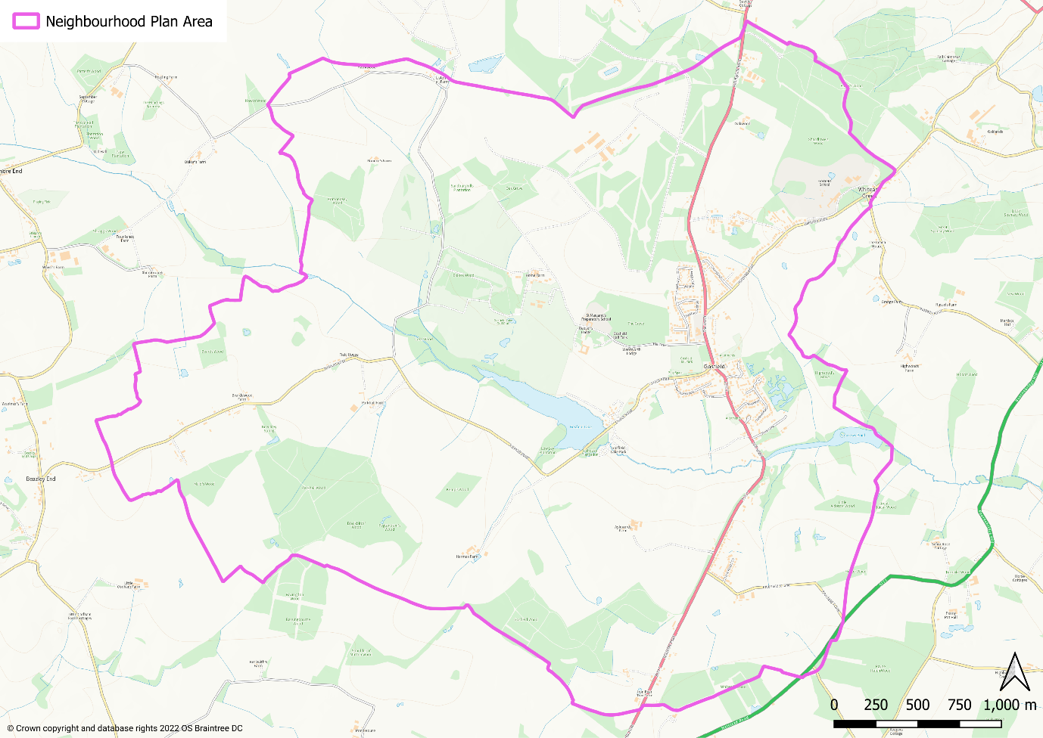

Monitoring the Plan
- Gosfield Parish Council, as the responsible body, will be responsible for maintaining and periodically revisiting the Plan to ensure relevance and to monitor delivery.

Reviewing the Plan
- In order to provide a consistent framework for policies that make up the development plan, the period of the Neighbourhood Plan has been aligned with that of the Braintree Local Plan. As such, its end date is 2033. It is acknowledged that this means the plan period is relatively short, at 10 years. As such, it will be necessary to undertake an early review of the Neighbourhood Plan. This should be commenced once a review of the Braintree Local Plan has been commenced and there is sufficient clarity relating to important strategic issues, in particular housing requirements. This is likely to be once a Submission Version (Regulation 19) version of the draft Plan has been published.
- The Braintree Local Development Scheme was published in November 2023. This establishes the intention to commence the review of the Local Plan in 2024, with a view to completing it in 2027. No date is given for when a Regulation 19 Submission Version of the emerging Local Plan will be published but this is likely to be around early 2026. Therefore it is expected that the Neighbourhood Plan review may be required to commence at a similar time.

local context

History of Gosfield
- Gosfield has a long and significant history. The original church that formed the heart of the community was built in 1190 – it was then replaced in 1435 with a new church built by Sir Thomas and Lady Rolfe, elements of which are incorporated in the current church, St Catherine’s. The organ was built in 1877 and is still in regular use. It was recorded that in 1400 Gosfield was ‘a great town with 240 people’ (communicants).
St Catherine’s Church
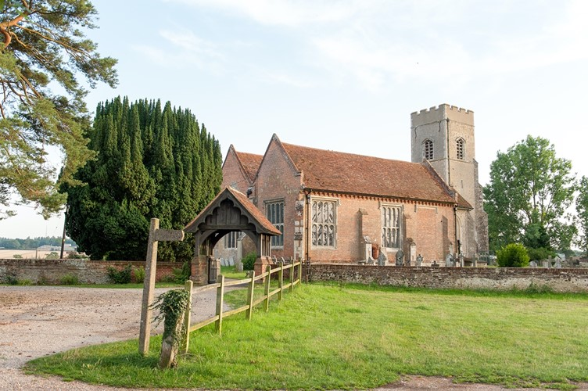

- Gosfield in 1890 was a quiet rural village whose inhabitants worked mainly in agriculture and was dominated by the two great estates of Gosfield Hall and Gosfield Place.
Gosfield Hall
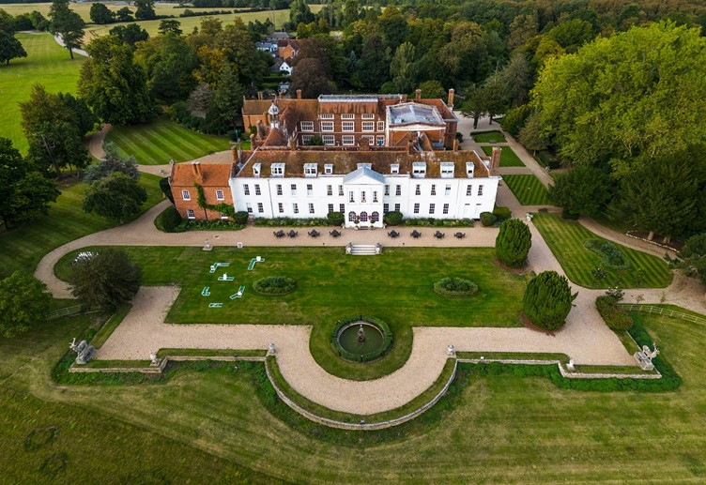

- Samuel Courtauld who had purchased Gosfield Hall in 1854 used his great wealth derived from his silk, crepe and textile business to provide housing for his workers. These new houses are now known as Park Cottages. He also built the Primary School and the coffee and reading rooms. The Sparrow family, owners of Gosfield Place also built a new school (now the front part of the Rowson Hall).
- World War One led to a decline in agriculture and many people were forced to look for alternative employment. Many working at Courtaulds or Crittall. The arrival of bus services was another factor.
- Electricity arrived in the 1930s but water supply and sewerage were still primitive.
- World War Two brought great changes. House building and repairs stopped, Gosfield Hall fell into disrepair. In 1941 the Americans arrived to build Gosfield Aerodrome. Soldiers were sometimes billeted on the village playing field and the young men of the village volunteered to serve their country.
- In 1950 the Parish Council bought part of the Gosfield Estate as a playing field for the village. Gosfield Hall was rescued from its poor state and became a nursing home, retirement home and eventually a wedding venue.
Gosfield Playing Field
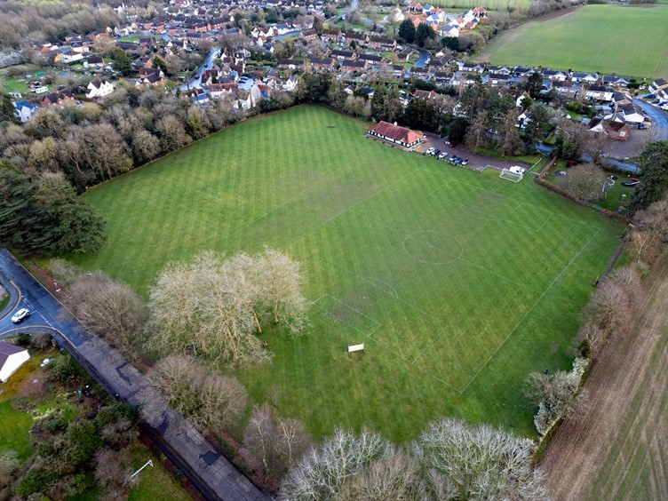

- The end of the World War Two saw a chronic housing shortage, returning armed forces wishing to set up home and start a family alongside the boom in birth rate during the war years, and Gosfield was no exception. Council housing was built, starting with The Limes in the late 1940s then followed by The Cedars in the early 1950s.
- The 1960s also saw major changes with the building of new housing estates, Nuns Meadow, Highlands, Greenfields and the School Park Estate (Meadway). These brought people from other parts of the UK and doubled the population of the village.
- The rapidly expanding population has largely stayed in Gosfield, resulting in the parish having the highest percentage of over-60s in the whole of Braintree district.
- In 1983 the Maurice Rowson Hall was opened.
Maurice Rowson Hall
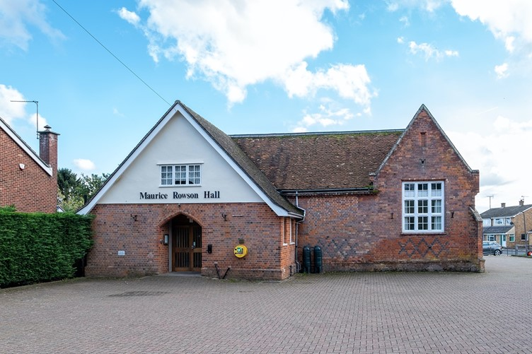

- In the 1980s Gosfield Parish Council acquired the sand and gravel workings as a Nature Reserve. In 2003 a new Pavilion was built on the Playing Field. In 2019 a new War memorial was built and in 2022 a new Village Community Shop was built as an extension to the Pavilion. All of these have been funded by the community and grants from other organisations.
War memorial
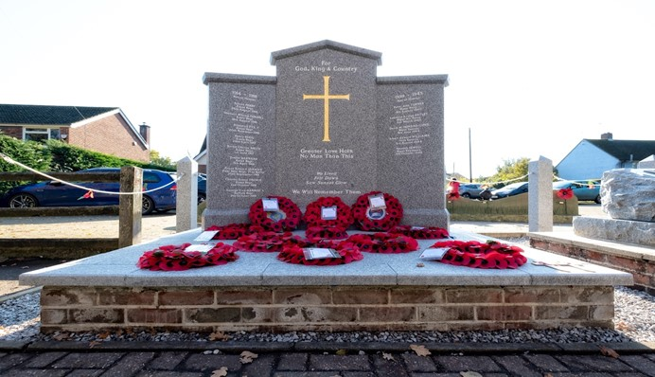

- The heritage of the village is recognised by the designation in 1988 of the Conservation Area. This incorporates a large part of the village, Gosfield Hall and the land inbetween. Indeed a substantial area of land incorporating Gosfield Hall is designated as a Historic Park and Garden.

Profile of the community today

The people
- In 2021, Gosfield parish had 1,451 residents. This represented an increase of 89 residents since 2011. The profile of the population in 2021 is striking. 34% of the population is aged 65 or over, compared with just 20% across Braintree district as a whole. By contrast, just 12% of the population fits the profile of young adults (aged 30 to 44) whereas in Braintree district the figure is 19%.
- The biggest change in the population between 2011 and 2021 was in those aged 75 or over, accounting for 83% of the growth in the population of the parish.
- This profile is backed up by the household composition in 2021. 20% of households were one-person households aged 66 or over (in Braintree district the proportion was 13%).
- Similarly, economic activity in Gosfield is very low, at 51% (Braintree district is 61%). Of those that are economically inactive, over 80% are retired. This feeds through to a low proportion of workers, with just 27% of residents aged 16 or over in full-time employment, compared with a figure of 36% for Braintree district.

The place
- Dwellings in Gosfield are predominantly large, with 32% having at least 4 bedrooms (across Braintree district the figure is 25%). There are however an above-average proportion of 2-bed properties – 32% compared with 27% across the district. Many of the larger properties are under-occupied, i.e. they have spare bedrooms compared with the number of people living in the household. A total of 86% of properties have at least one spare bedroom with 45% having at least two spare bedrooms.
- 57% of these properties are owned outright, which is well above the district figure of 34%. By contrast renting is very low with just 13% of households renting their homes (31% do so across Braintree district). Moreover, just 8% of these households live in social rented properties, which is half the district average.
- Today Gosfield is a thriving community with three schools (two of which are private), a public house, social club (the old Courtauld reading rooms), community shop, hairdressers, family restaurant and golf course. In total there are currently 34 Gosfield-based clubs and organisations.
Community shop
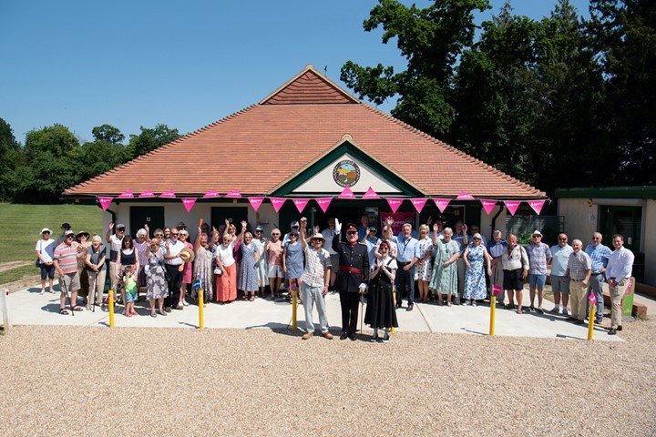

- Gosfield is situated 2.8 miles from Halstead and 6 miles from Braintree. This proximity gives it good access to a range of services and facilities, including Braintree Shopping Village, business parks and a water ski/resort venue.
- Gosfield village straddles the A1017 road which connects Braintree and Haverhill. It is served by a half-hourly bus service to and from Braintree and Halstead. It is also approximately one hour by train from London.

SWOT analysis

Strengths
1. Strong community spirit with a large number of thriving community organisations.
2. A number of community assets, including the village shop, Maurice Rowson Hall, children’s play area and playing fields
3. High quality rural environment, with the Nature Reserve being a significant asset
4. Proximity to larger centres of Braintree and Halstead.

Weaknesses
1. Limited public car parking
2. No provision for public electric vehicle charging
3. Limited shopping facilities in the village

Opportunities
1. Improve accessibility to countryside for leisure
2. Make better use of the Nature Reserve as a way of the community having access to nature
3. Make stronger local links with schools (particularly as a means of attracting young families into the village), Golf Club and Lake Resort.

Threats
- Limited availability of housing for local people in need and for young families.
- Insufficient provision of housing and other facilities that cater for the needs of an ageing population.
3. Road safety, due to speeding traffic and limited safe provision for pedestrians.

vision and objectives

Vision for Gosfield
- The vision for Gosfield over the plan period to 2033 is as follows:
The Gosfield Neighbourhood Plan will preserve the countryside, quality, village feel and thriving engaged community. It recognises that changes will be necessary to respond to environmental and climatic needs.

Neighbourhood Plan Objectives
- The objectives of the Neighbourhood Plan as identified through engagement with the community are as follows:
Climate and environment
- Encourage new development to maximise the protection and enhancement of biodiversity.
- Encourage new development to incorporate minimum energy use provided by renewable resources.

Design, heritage and green spaces
- Encourage development to incorporate high quality design that reflects the character of Gosfield.
- Protect existing village historical assets and open spaces.

Getting around
- Ensure the potential for residents to have safe and easy access to village assets and amenities.

Business and employment
- Continue to support local businesses.

Housing
- Ensure new development contributes to addressing the housing needs of Gosfield.

climate and environment

Wildlife-friendly design
- The design of individual buildings and of neighbourhood scale green and open spaces, including private gardens, will help to ensure that existing habitats present in Gosfield can thrive and a range of new habitats can be created. This is in line with the requirement of the Environment Act 2021 for all new development (excluding small householder proposals) to achieve net biodiversity gain of at least 10%.
- Planting is an important aspect of development and habitat creation. Not only does a well-considered planting scheme provide high quality landscaping, it is a fundamental aspect of enhancing biodiversity that otherwise would be lost. Planting schemes should ensure that tree species should be carefully selected to be responsive to landscape and historic character and to suit the planting location . Planting should not simply consist of trees but a range of shrubs and grasses too and should seek to include native species.
- Protecting species present in the area is also important. Examples of the simple solutions that well-thought out design can easily incorporate are:
- Integral bird and bat boxes under the eaves of the new houses, or artificial nests sited in places away from windows and doors, can create vital new roosting sites to support populations of birds and bats.
- Boundaries between dwellings can be made hedgehog friendly by including pre-cut holes for hedgehogs to more effectively move across neighbourhoods to forage.
- New planting schemes can support bees and other pollinators by including nectar-rich plants.
Bricks that allow birds to nest | Hedgehog-friendly fencing
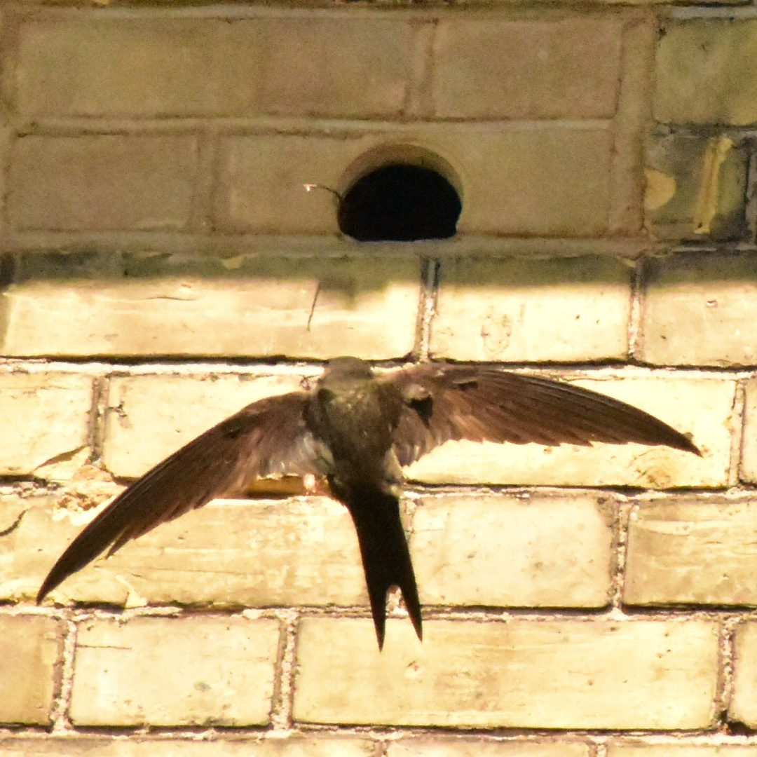 | 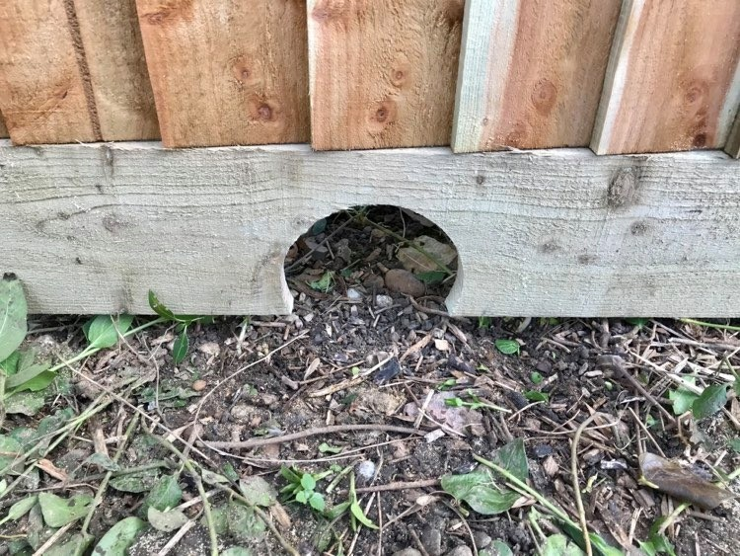
Credit: https://www.wienerberger.co.uk | Credit: Nature Recovery Network
- Development is encouraged to be informed by the full list of considerations in Natural England’s ‘Green Infrastructure Framework 2023’.

POLICY GOS1: WILDLIFE-FRIENDLY DEVELOPMENT
- All development proposals should deliver net biodiversity gains in addition to protecting existing habitats and species. Proposals to create or enhance existing green wildlife corridors are strongly encouraged.

- In particular, the incorporation of design features into new development that encourages local wildlife to thrive, is strongly encouraged.

- As part of its requirements to demonstrate net biodiversity gain, development should be designed to retain trees, shrubs and hedgerows of arboricultural, habitat and amenity value on-site and to conserve and enhance connectivity to the wider green infrastructure networks. Where this is accompanied by new planting, this should consist of native species of trees, shrubs and grasses acting as stepping stones for wildlife.

Sustainable design
- The Climate Change Act 2008 committed the UK to an 80% reduction in CO₂ emissions by 2050. In June 2019, an announcement was made by Government to reduce this further to almost 100% by 2050. This will be a major task that will require everyone to be engaged, from households and communities, to businesses and local and national government.
- In 2016, the residential sector alone accounted for over 16% of the UK’s annual greenhouse gas emissions (source: Department for Business, Energy and Industrial Strategy). The total emissions from all building types will therefore be much greater. Standards for ecologically sustainable homes and developments are established through Building Regulations and Braintree Local Plan Section 2 policies. Specifically Policy LPP72 (Resource efficiency, energy generation and energy efficiency) requires new residential dwellings to include renewable and low carbon energy technology to provide at least a 19% improvement in energy performance over the requirements of the 2013 Building Regulations. However, in order for built development to make a meaningful contribution towards achieving net zero by 2050, development needs to go further. New development is therefore encouraged to exceed the requirements of Local Plan Section 2 Policy LPP72 or, at very least, to ensure that new properties are designed so that they are ready to receive the technologies that are crucial to minimising their energy use, e.g. underfloor heating to increase the effectiveness of heat pumps, orientated south to maximise the potential from solar panels if installed, etc.

POLICY GOS2: LOW ENERGY AND ENERGY EFFICIENT DESIGN
- Proposals for new development, including the construction of new buildings and the redevelopment and refurbishment of existing building stock, should demonstrate how the design of buildings and site layouts minimise consumption of energy, water, minerals, materials and other natural resources in order to provide resilience to the effects of climate change.

- All developments should demonstrate how they have been designed to incorporate measures to adapt to climate change. The following measures should be incorporated into development:
- Wherever possible, new buildings should be orientated to maximise the opportunities for both natural heating and ventilation and reducing exposure to wind and other elements;
- Proposals involving both new and existing buildings should demonstrate how they have been designed to maximise resistance and resilience to climate change for example by including measures such as solar shading, thermal mass, heating and ventilation of the building and appropriately coloured materials in areas exposed to direct sunlight, green and brown roofs, green walls, etc;
- Use of trees and other planting, where appropriate as part of a landscape scheme, to provide shading of amenity areas, buildings and streets and to help to connect habitat, designed with native plants that are carefully selected, managed and adaptable to meet the predicted changed climatic conditions; and
- All development should minimise surface water runoff to prevent off-site flooding through the design of a suitable SuDS-based drainage system, and where possible incorporate mitigation and resilience measures for any increases in flood risk that may occur due to climate change.

Local Green Spaces
- Under the NPPF, Neighbourhood Plans have the opportunity to designate Local Green Spaces which are of particular importance to them. This will afford protection from development other than in very special circumstances. Paragraph 106 of the NPPF says that the Local Green Space designation should only be used where the green space is:
- in reasonably close proximity to the community it serves;
- demonstrably special to a local community and holds a particular local significance, for example because of its beauty, historic significance, recreational value (including as a playing field), tranquillity or richness of its wildlife; and
- local in character and is not an extensive tract of land.
- There are two spaces considered to meet the criteria (see Figure 4.1 for their location).
Figure 4.1: Local Green Spaces
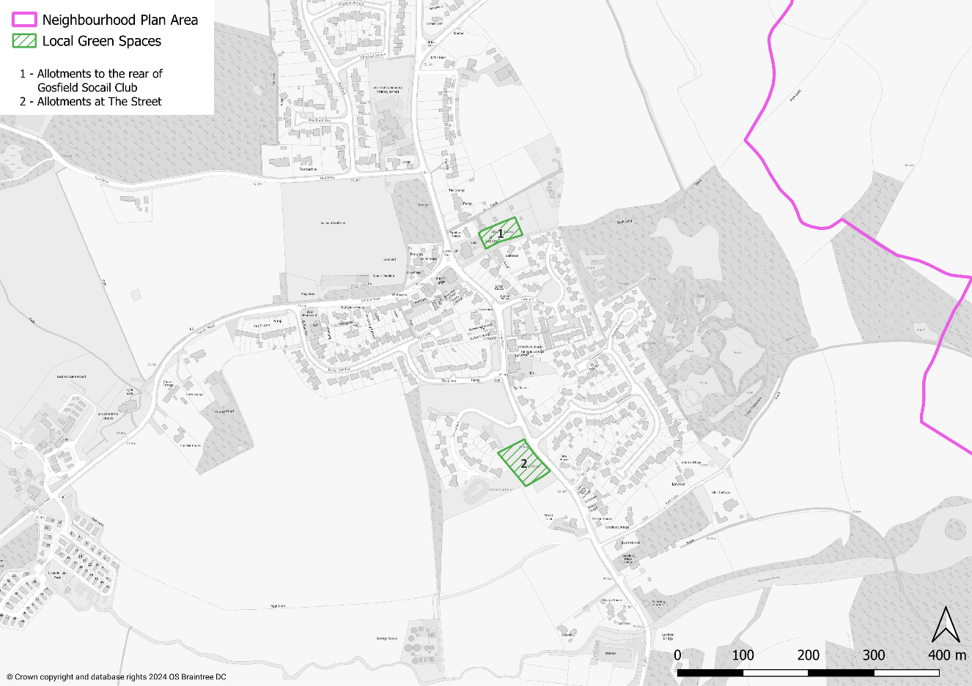

Allotments to the rear of Gosfield Social Club
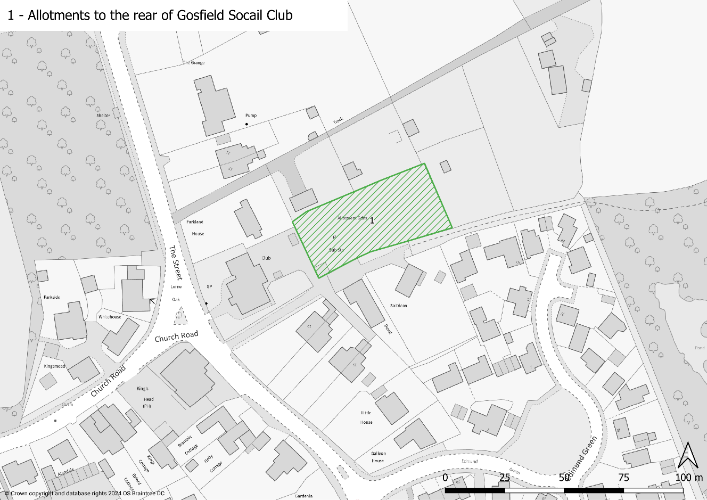
Allotments at The Street
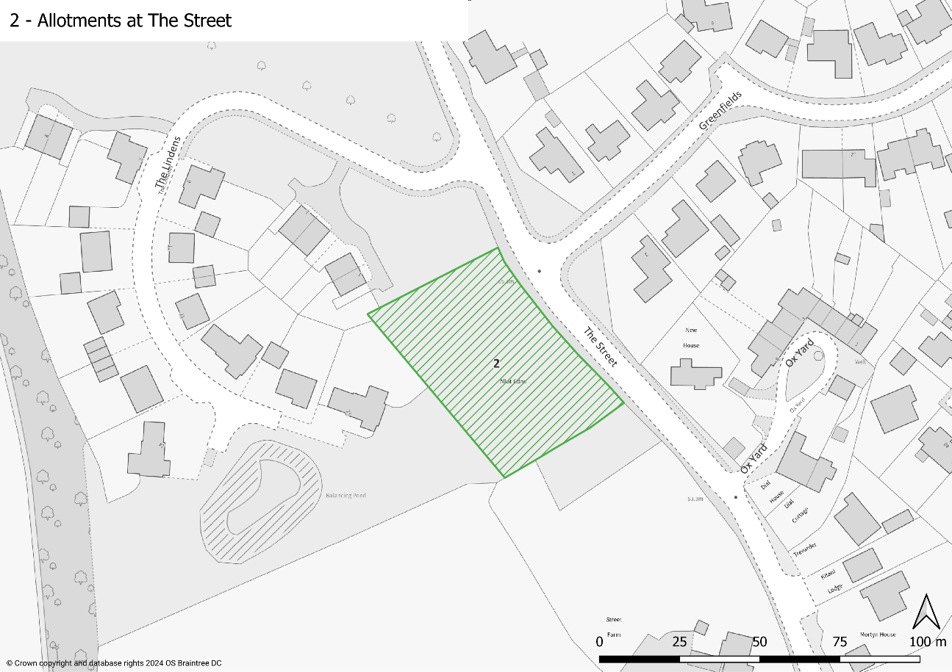

- Gosfield has a thriving Horticultural Society and has three shows throughout the year. Most of the produce shown is produced on the allotments at the Street and to the rear of Gosfield Social Club.
- The allotments are popular with all age groups, providing exercise, produce and social interaction.
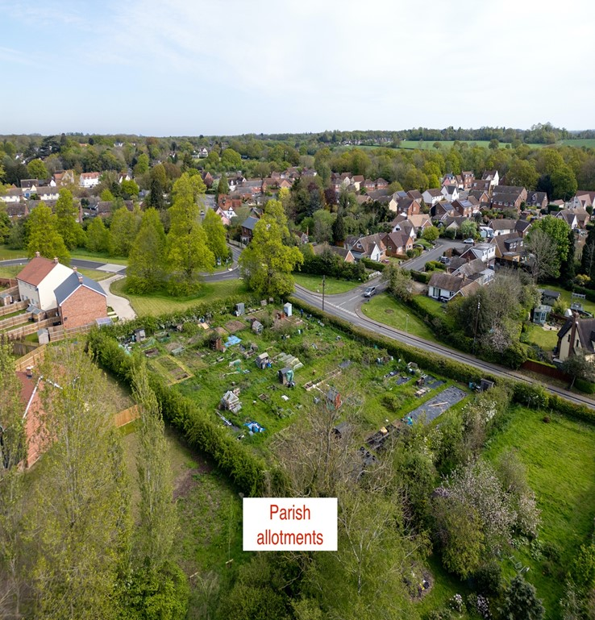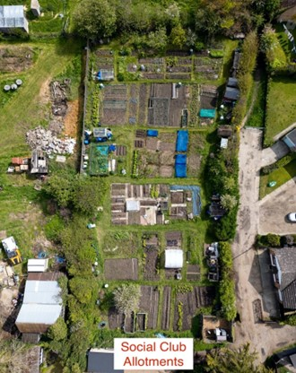

POLICY GOS3: LOCAL GREEN SPACES
- The following areas shown on the Policies Map and in Figure 4.1 are designated as Local Green Spaces:
  - Allotments at The Street
  - Allotments to the rear of Gosfield Social Club
- Proposals for built development on these Local Green Spaces should not be permitted unless the proposal is for an ancillary feature, and it can be clearly demonstrated that it is required to support or enhance the role and function of the identified Local Green Space.

- The Local Nature Reserve to the east of the village is also an important and much valued part of Gosfield. This is not included as a Local Green Space because it is already protected by Braintree Local Plan Policy LPP64 (Protected Sites).

Verges
- Generous grass verges are a key characteristic of Gosfield village. These are prominent at many of the junctions where The Street (A1017) meets side roads. They are important because they contribute towards the village’s distinctiveness. They also perform a biodiversity function, being a place where various species thrive.
A Gosfield verge
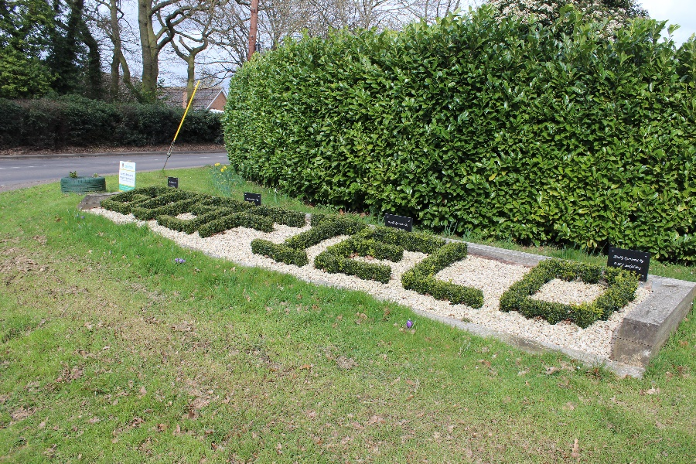

- New development in Gosfield village should also look to create similar opportunities along this main route, thereby maximising biodiversity and visual appeal as much as possible. In addition to the biodiversity gains the wide grass verges are pleasing to residents and visitors moving in and around the village.

POLICY GOS4: VERGES
- Existing green verges along roadways should be retained and should only be removed if it is clearly demonstrated to be part of necessary highway improvements, including for walking and cycling. Any such improvements should incorporate opportunities for planting around the existing verges wherever practicable.
- The design of roadways and verges to maximise biodiversity value will be supported.

design and heritage

Design and character
- The community of Gosfield has been very clear that the character of the village and surrounding area is one of the strongest assets of the parish. People value the village feel that development has provided in Gosfield and want new development to fit in with this.
- To support the development of the Neighbourhood Plan, a Design Assessment was undertaken. This took what is considered to be a representative sample of the residential streets or groupings of streets and provided a commentary on their features, both positive and negative.

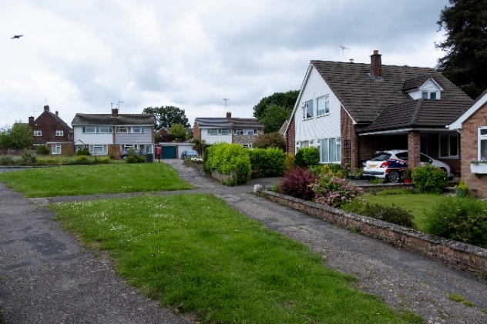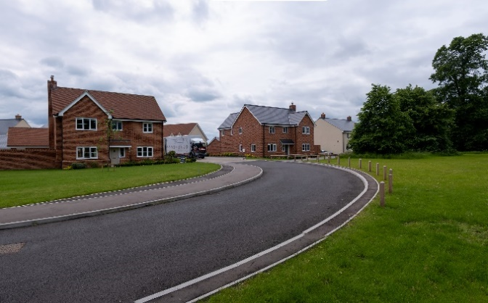

- A key feature is the fact that Gosfield has developed over a number of years, particularly since the post-World War II period, and each development period has shown slight different features. Therefore Gosfield is not a village where all development looks the same. Despite this, it is noticeable how the materials and styles of housing have shown a degree of consistency. Good design has taken these cues and applied them to the stye of day.

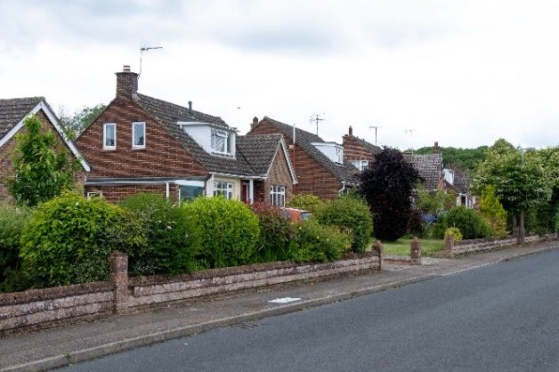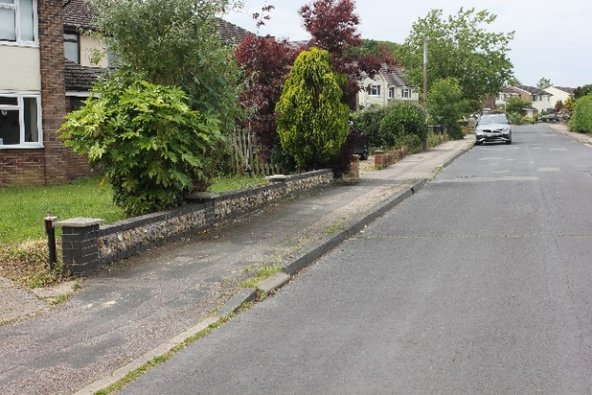

- One particular aspect of Gosfield’s character is the open feel of its residential areas. Densities of development are low, often supported by large front gardens and off-road parking, resulting in a less cluttered feel to the roadway. This has sometimes been enhanced by the provision of small public green spaces. The best frontages to properties are those with low boundaries that have been planted to create a natural feel.
- Some of the matters related to design and character are further addressed in other policies in the Neighbourhood Plan. However, in respect of ensuring high quality design, it is important that development proposals – and particularly major developments (as defined by the NPPF) – actively demonstrate how they have been informed by these principles. Their purpose is not to expect all development to be designed and laid out the same, irrespective of the circumstances; rather it is to inform development so that what is built represents high quality development in the context of Gosfield.

POLICY GOS5: DESIGN AND CHARACTER
- Development should demonstrate high quality design and layout which respects the local character of Gosfield. This includes the development of public buildings.

- In delivering high quality design, development proposals must demonstrate the appropriate use of design, layout, materials and features. The following principles should be considered as part of design proposals:
- Development should integrate with and enhance the form of its existing surroundings. In particular, the open aspect of the frontages to residential properties should be retained.
- Openness is a fundamental part of the character of Gosfield. Where appropriate a range of densities, house types and plot layouts along with public green spaces should be used to maintain this.
- Building heights and rooflines should provide diversity of frontage, scale and form, with building heights that reflect the prevailing height of surrounding buildings unless it can be demonstrated that a taller building could complement or enhance the local character.
- All connections, including road patterns, should ensure permeability for pedestrians and cyclists.
- Parking to support residential uses should be provided within the development. Where on-street parking provision is to be made, this should be in accordance with Essex County Council parking standards and should demonstrate, through the parking and/or road layout how this minimises the impact on the safety of pedestrians.

Heritage
- Gosfield is a parish rich in history. In total it has 53 nationally listed buildings, one scheduled monument (the Well House and donkey wheel at Gosfield Hall) and Gosfield Hall Historic Park and Garden. Of the listed buildings, two Grade I listed (Gosfeld Hall and St Catherine’s Church), one is Grade II* listed and the remainder (51) are Grade II.
- There is one structure in the parish which is considered to have local heritage interest, this being the Ha Ha wall.
Ha Ha wall
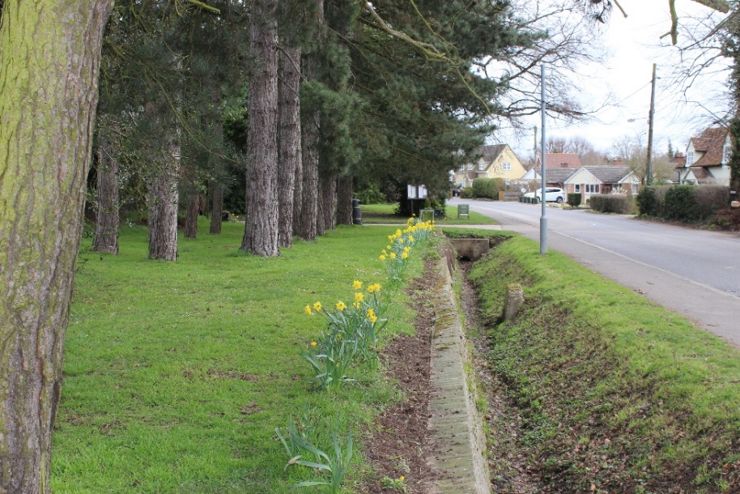

Figure 5.1: Location of Ha-Ha wall
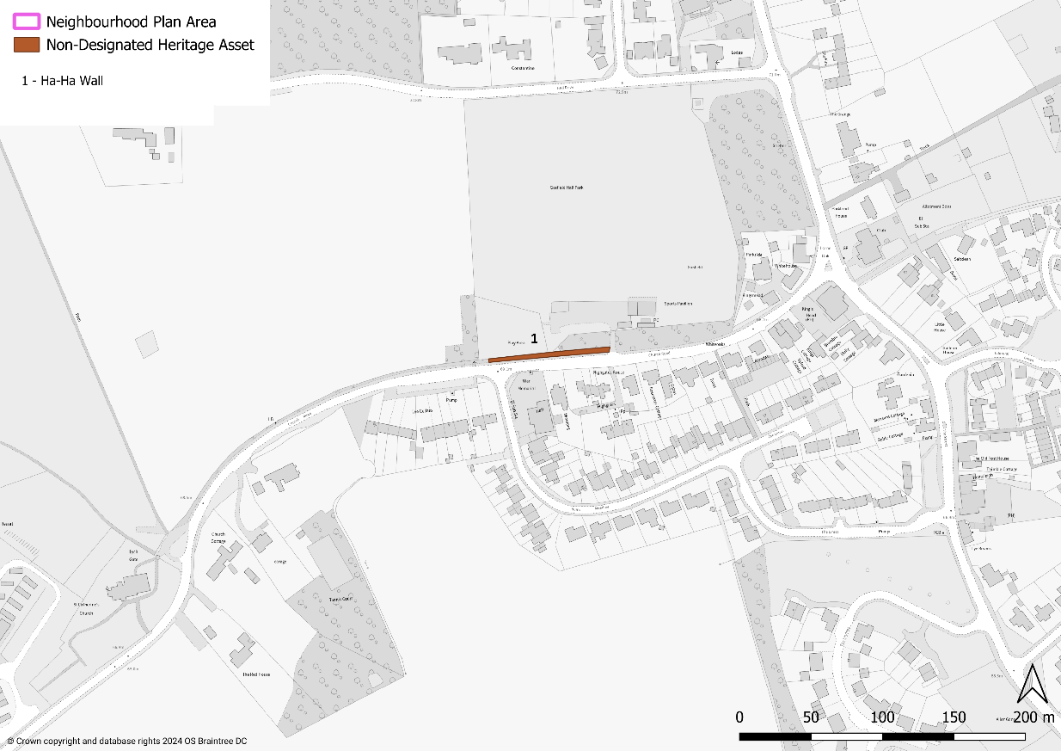

- The Ha Ha wall is in Church Road in Gosfield village and stretches from the Playing Field entrance to St Catherine’s Church. It marks part of the eastern boundary of the Gosfield Hall Estate. There is another Ha Ha wall in front of Gosfield Hall which is a listed feature.
- A Ha Ha prevented grazing animals on large estates from gaining access to the lawns and gardens adjoining the house, giving a continuous vista to create the illusion that the garden and landscape were one and undivided. Examples can be seen at five National Trust properties but few exist alongside public roads.
- The Ha Ha wall is therefore identified as non-designated heritage asset (which is different from national listing, i.e. Grade I, II and II*).

POLICY GOS6: NON-DESIGNATED HERITAGE ASSETS

- The Ha Ha wall, as shown on Figure 5.1, is identified as a non-designated heritage asset.

- In considering proposals which involve the loss or alteration of the non-designated heritage asset, consideration will be given to:
- whether the asset is structurally unsound and beyond feasible and viable repair (for reasons other than deliberate damage or neglect); or
- the extent to which measures to sustain the existing use, or find an alternative use/user, have been investigated.
- Where a development proposal would result in the loss of, or harm to a non-designated heritage asset, a balanced judgement will be made as to the acceptability of the proposal having regard to the scale of any harm or loss and the significance of the heritage asset.

getting around

Countryside access
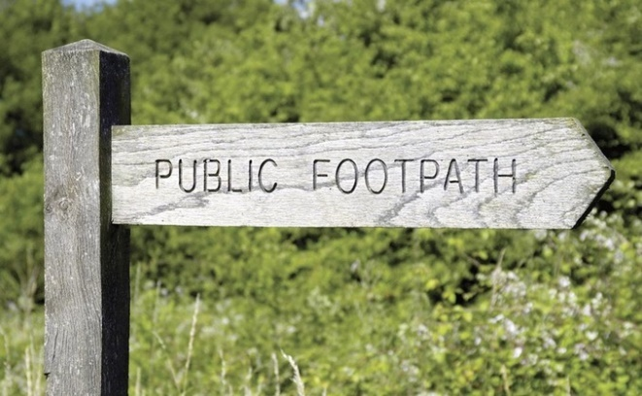
- In a rural communities such as Gosfield parish, where the availability of large scale informal public green spaces, access into the countryside is particularly important. The need for access as a means of exercise, to walk dogs and for general wellbeing is vital. Without this, the community becomes reliant on use of the private car to access leisure opportunities elsewhere, which creates lots of short distance car trips that do not contribute positively to sustainability.
- The NPPF states that ‘planning policies should protect and enhance public rights of way and access, including taking opportunities to provide better facilities for users, for example by adding links to existing rights of way networks’ (paragraph 104).
- Gosfield parish is currently relatively well served with Public Rights of Way (PROWs), as shown in Figure 6.1. Further improvements to the network of PROWs and bridleways are encouraged, along with the continued maintenance and upkeep of the existing network. Improved signage would also encourage more people to use the PROW network.
Figure 6.1: Public rights of way
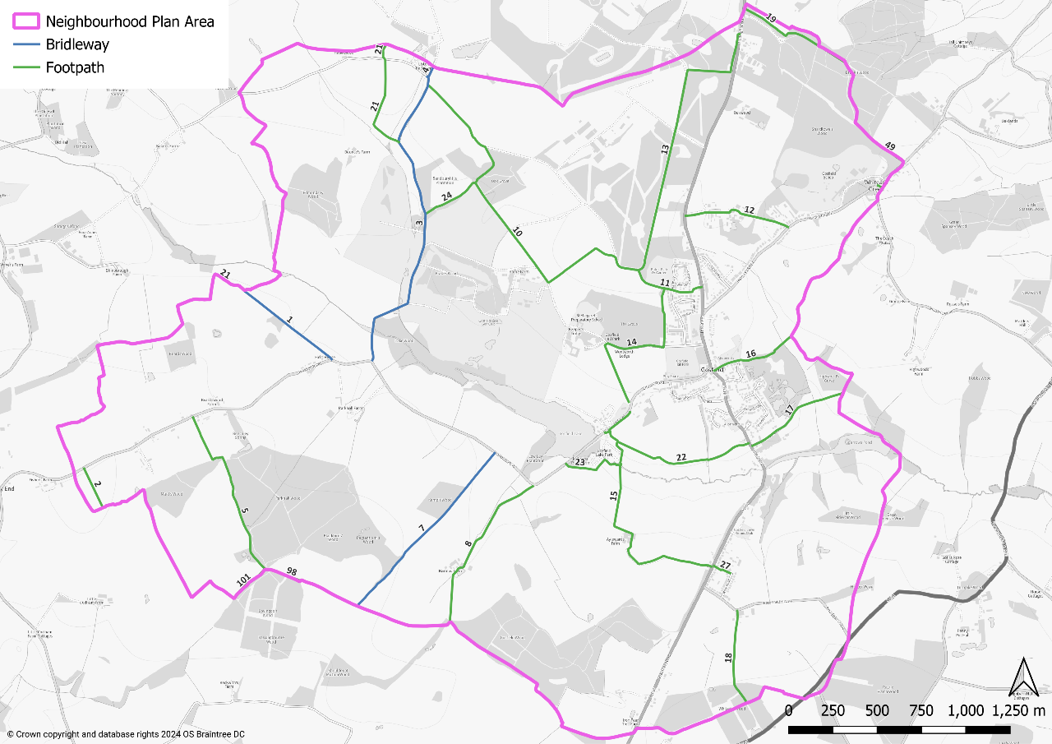

POLICY GOS7: ACCESS FOR WALKING, CYCLING AND HORSE RIDING
- Access to the countryside should be promoted through protection and maintenance of the existing Public Rights of Way (PROW) network, its enhancement where possible, provision of bridleways and the safety of users of rural roads and lanes.

- Any developments which leads to the loss or degradation of any PROW should not be permitted in other than very special circumstances. Proposals to divert PROWs or cycleways should provide clear and demonstrable benefits for the wider community. Where possible, development should enhance PROWs by improving existing routes and improving connectivity through the creation of new routes. In all cases it should seek to ensure that routes are suitable for those with disabilities.

- Proposals to develop a safe off-road cycle route between Gosfield and Halstead will be supported.

Other issues with getting around
- A number of matters were identified by the local community regarding getting around in Gosfield. None of these matters are directly planning policy matters, however they are of concern to the community and therefore it is important that they are identified and, where possible, action is taken to address them.

Pedestrian safety
- The A1017 road, also known as The Street, passes through Gosfield village and is the main through route between Braintree and Haverhill. As a result, it often experiences high volumes of traffic and speeding. The last road survey conducted in The Street recorded, in a seven-day period, 64,000 traffic movements with an average speed of 29mph traveling north and 32mph traveling south (in a 30mph limit). The two points where measurements were taken were in front of the Spinney and in front of the old Post Office.
- The road effectively splits the village in half so for pedestrians there is often a need to cross The Street to access services and facilities. The primary school is located to the north of the junction with Hall Drive. There is a second school, St Margaret’s, located in Hall Drive. They both generate vehicle and pedestrian traffic. There is considered to be a strong need for one or more pedestrian crossings.
Possible location of pedestrian crossing of A1017
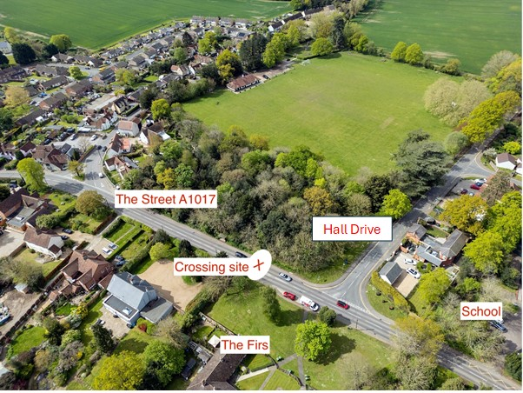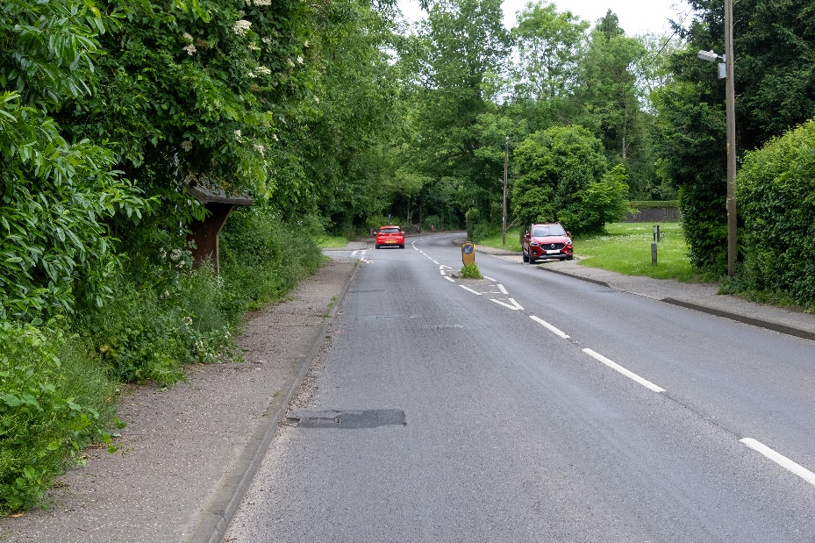

- The only location with suitable visibility is as shown on image above. There is currently a ‘refuge’ which is too small to provide protection to pedestrians and is frequently knocked down by passing vehicles. There is currently a layby for the Firs properties owned by Eastlight Housing Association. The proposed crossing would remove the layby and provide a small private car park to serve the properties located closer to them. It would also help to assist traffic flow to and from Hall Drive at peak times.
- Gosfield Parish Council will lobby Essex County Council, as highways authority, to install this pedestrian crossing.

Speeding
- More generally the village experiences speeding vehicles and dangerous driving. This is exacerbated by the worsening in the quality of local road surfaces. The need to better monitor speed limits and road condition is paramount.
- Braintree Road (the A1017) has a 60mph limit. Records show that there were 14 accidents between 2014 and 2024 including a triple fatality. There are parts along this route where there is no pavement or street lighting and children need to cross to get to bus stops which are located on grass verges with no standing area. The matter has been discussed many times at the Parish Council. However, no proposals – such as the road being redesignated as having a 40mph limit – have been made. The issue therefore remains and the Neighbourhood Plan, based on the views of the community, encourages that it be considered again.
- Church Road has a 30mph limit which changes to 60mph before St Catherine’s Church. There is a double bend and the road narrows. It is not possible for heavy goods vehicles to pass cars through the double bend.
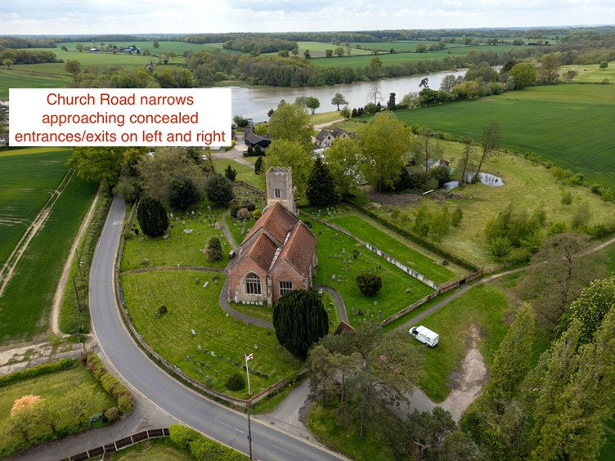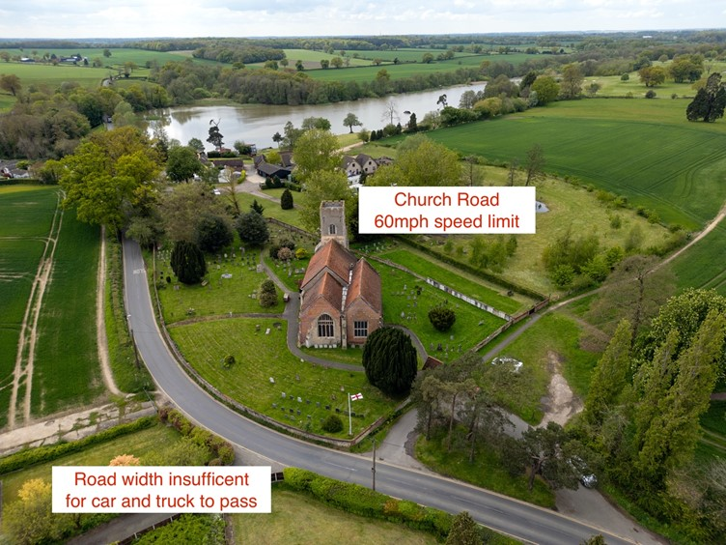

- The road then continues downhill between roadside banking. There are then concealed entrances and exits on both side of the road. The left entrance/exit is to Gosfield Lake Park, a development of 80 retirement park homes. The right entrance/exit is to Gosfield Lake Resort, a water ski and camping location. It is also used by patrons of the Appletree Restaurant.
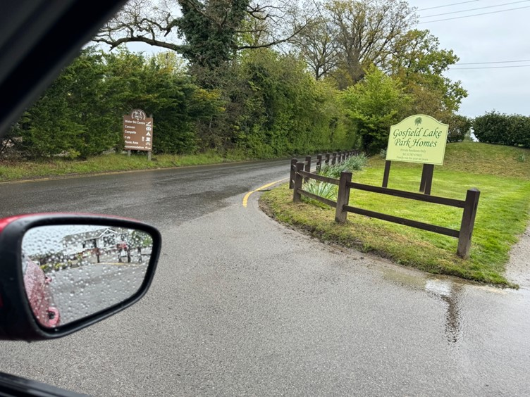
Poor visibility to right onto 60mph speed limit road.
80 properties use this sole exit .from Gosfield Lake.

- The road continues past the lake with a drop of 2 metres on the right and 10 metres on the left. Both sides are protected by basic wooden fencing. The road then reaches a single width bridge with restricted view of oncoming traffic. Given these numerous hazards and the concerns raised by the community through the development of the Neighbourhood Plan, Gosfield Parish Council will seek the redesignation of the road as a 30mph limit.

Accessibility of pavements
- Whilst a rural village such as Gosfield has relatively few pavements, those that it does have are vital for safe pedestrian access. Many of the pavements in Gosfield have access restricted because of the encroachment of hedges and undergrowth. This means pedestrians have to step into the roadway to pass these obstructions which can be dangerous, particularly where the view of drivers is restricted. Gosfield Parish Council will lobby property and landowners to keep hedges and undergrowth cut back appropriately.
Examples of pavements restricted by hedges and undergrowth
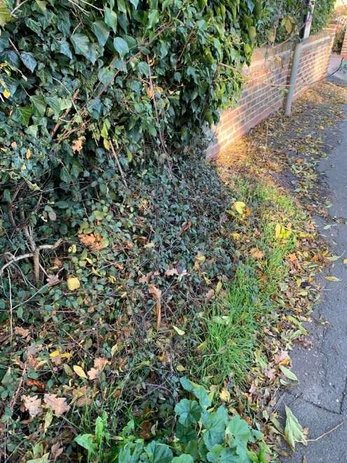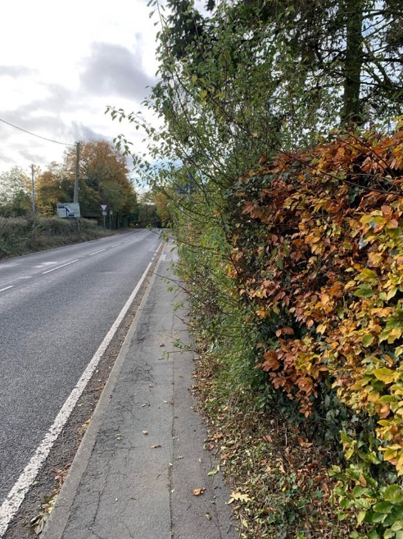

policies mapS
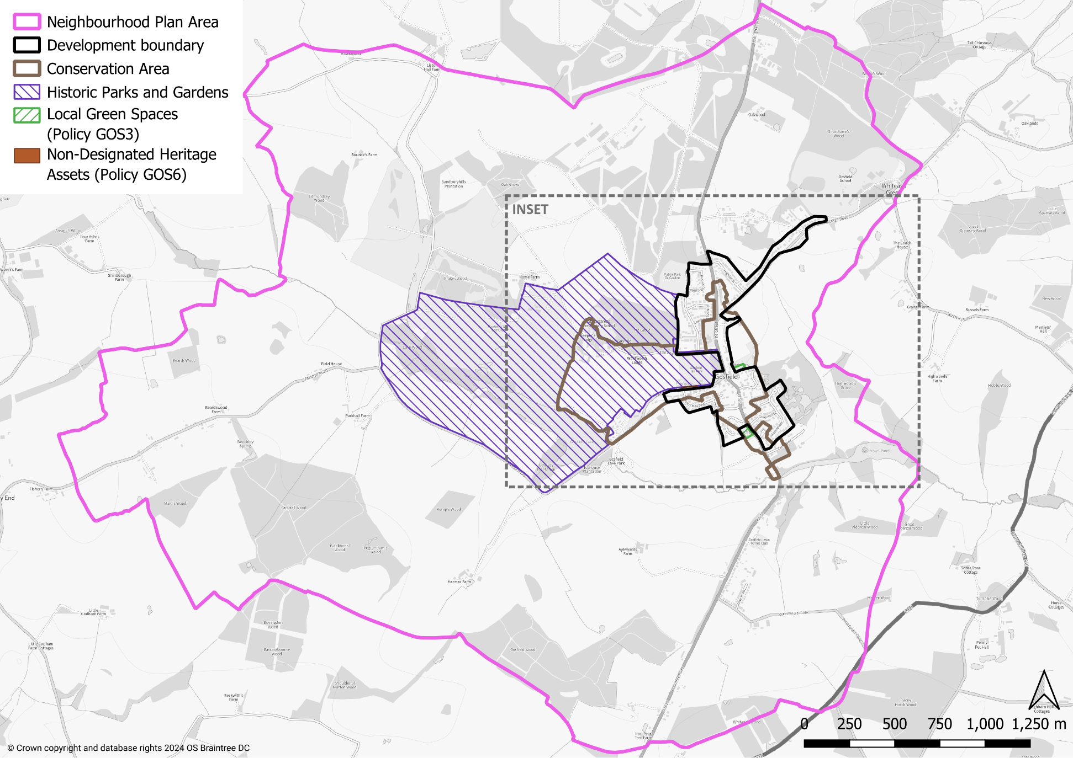
INSET MAP
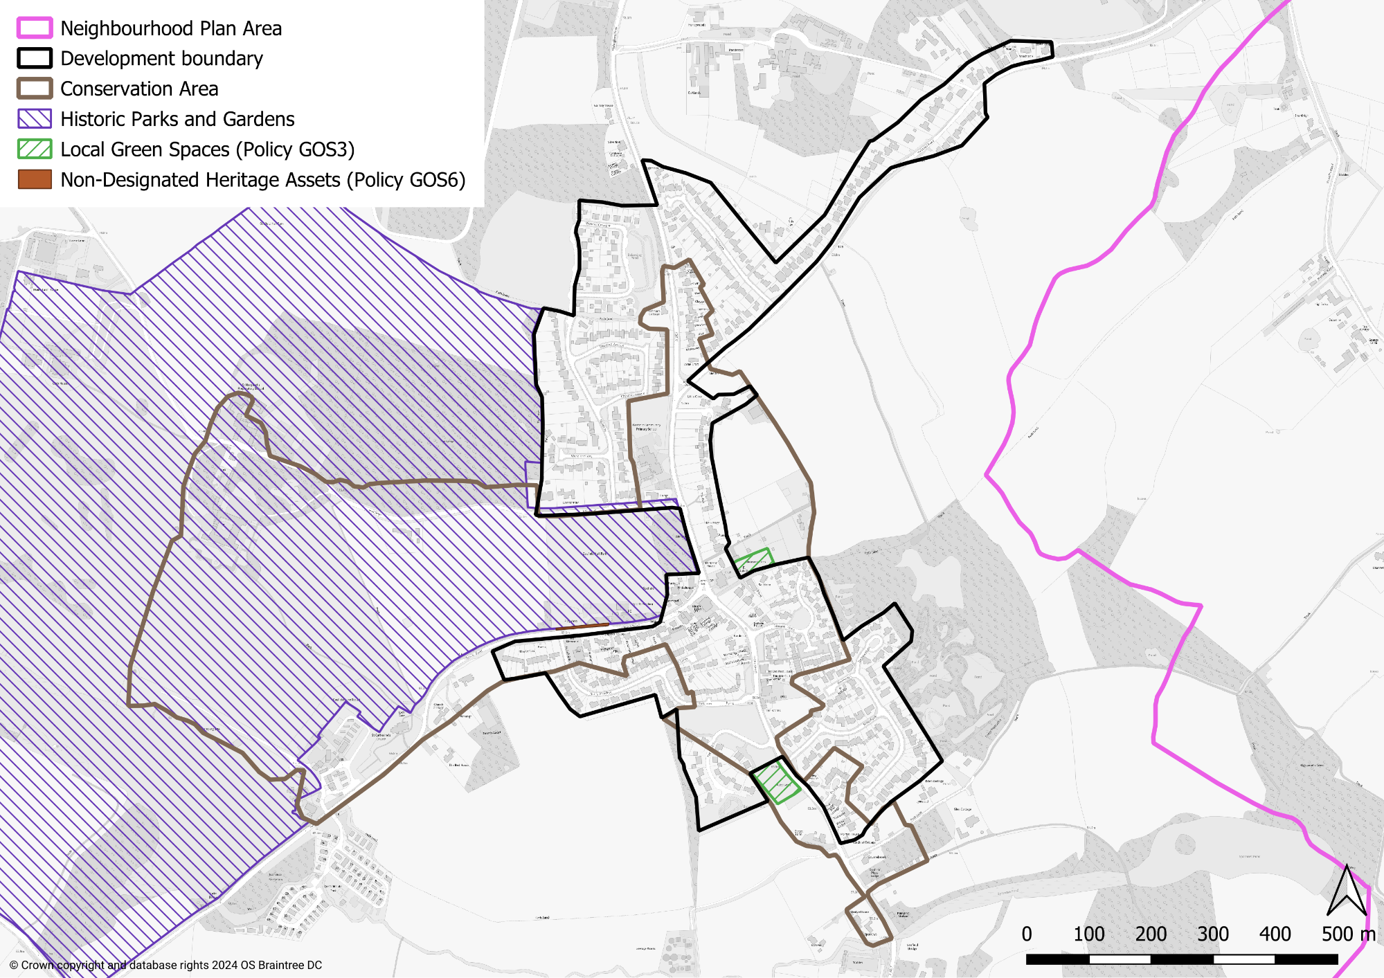

THIS PAGE IS INTENTIONALLY BLANK

https://designatedsites.naturalengland.org.uk/GreenInfrastructure/Home.aspx

