Gosfield Parish Council

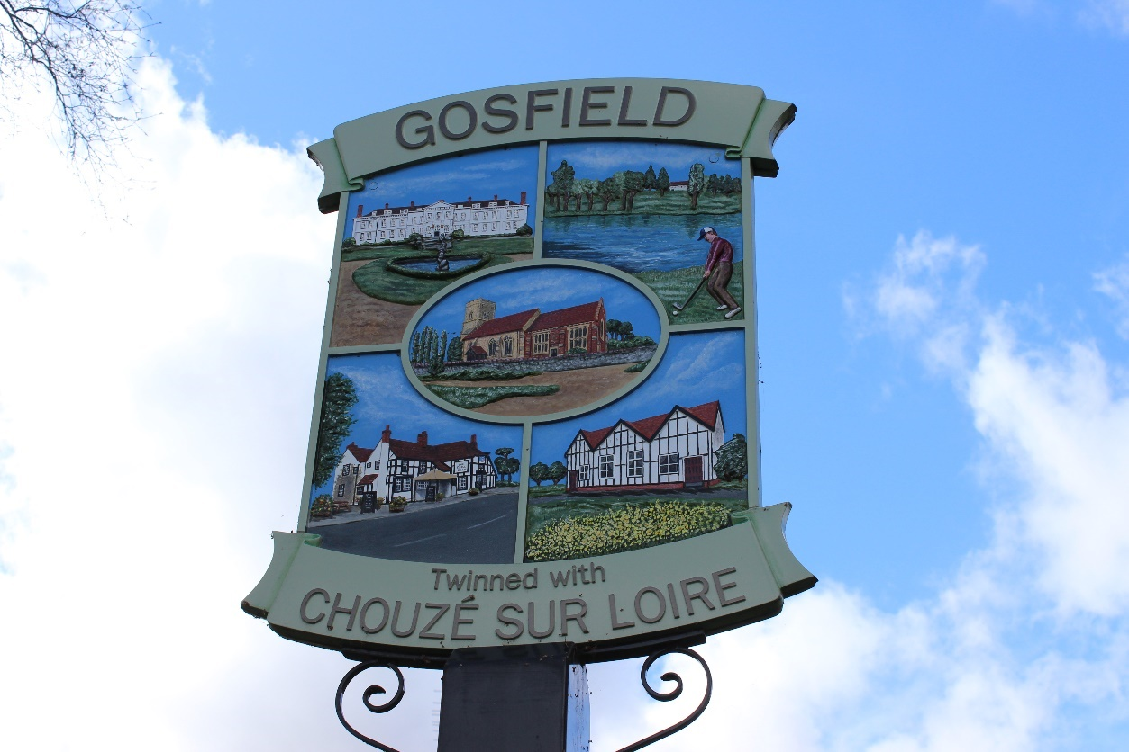
Gosfield Neighbourhood Plan 2023-2033

R14 Version submitted to BDC
April 2025

Contents

1 introduction 2
What is neighbourhood planning? 2
Purpose of the plan 2
Policy context 3
Monitoring the Plan 5
Reviewing the Plan 5
2 local context 6
History of Gosfield 6
Profile of the community today 9
SWOT analysis 10
3 vision and objectives 12
Vision for Gosfield 12
Neighbourhood Plan Objectives 12
4 climate and environment 13
Wildlife-friendly design 13
Sustainable design 15
Local Green Spaces 18
Verges 20
5 design and heritage 22
Design and character 22
Heritage 24
6 getting around 26
Countryside access 26
Other issues with getting around 28
7 policies mapS 31

introduction

What is neighbourhood planning?
- The 2011 Localism Act gives local communities powers to produce neighbourhood plans which can be used to guide and shape future development in an area. Once made, a neighbourhood plan forms part of the development plan for the area. It will be used alongside the Braintree District Local Plan (Section 1 and 2), the adopted Essex Minerals Local Plan (2014) (MLP) and the adopted Essex and Southend-on-Sea Waste Local Plan (2017) (WLP) to determine planning applications.
- Neighbourhood plans must be subject to public consultation, examination, and local referendum prior to adoption. Policies contained within a neighbourhood plan should be supported by documented evidence and assessment of their sustainability as necessary. Neighbourhood plans must have regard to national policy, contained in the National Planning Policy Framework (NPPF), particularly in relation to supporting and promoting sustainable development.
- Where a neighbourhood plan is aligned with the strategic needs and priorities of the wider local area in Braintree district, neighbourhood planning can provide a powerful set of tools for local people to ensure that they get the right types of future development for their community.
- Any Neighbourhood Plan must meet the basic conditions set out below:
- the Neighbourhood Plan has regard to national policies and advice contained in guidance issued by the Secretary of State;
- the making of the Neighbourhood Plan contributes to the achievement of sustainable development;
- the making of the Neighbourhood Plan is in general conformity with the strategic policies contained in the development plan for the area;
- the making of the Neighbourhood Plan does not breach and is otherwise compatible with EU obligations;
- prescribed conditions are met in relation to the Neighbourhood Plan and prescribed matters have been complied with in connection to proposals within the Neighbourhood Plan.

Purpose of the plan
- This document represents the Neighbourhood Plan for Gosfield for the period 2023 to 2033. The Plan contains a vision for the future of Gosfield and sets out clear planning policies to realise this vision.
- The principal purpose of the Neighbourhood Plan is to guide development within Gosfield parish. It also provides guidance to anyone wishing to submit a planning application for development within the parish. The process of producing a plan has sought to involve the community as widely as possible. The different topic areas are reflective of matters that are of considerable importance to Gosfield, their residents, businesses and community groups.
- Some of the Neighbourhood Plan policies are general and apply throughout the Plan area, whilst others are site or area-specific and apply only to the appropriate areas illustrated on the relevant map. Nevertheless, in considering proposals for development, Braintree District Council will apply all relevant policies of the Plan. It is therefore assumed that the Plan will be read as a whole, although some cross-referencing between Plan policies has been provided.
- The process of producing the Neighbourhood Plan has identified a number of actions which have not been included in the policies’ sections. This is because these are not specifically related to land use matters and therefore sit outside the jurisdiction of a Neighbourhood Plan. These actions will be addressed by Gosfield Parish Council outside of the Neighbourhood Plan process.

Policy context
- Once ‘made’, the Neighbourhood Plan will form part of the development plan for the neighbourhood area alongside the Braintree Development Plan (Section 1 and 2), Essex Minerals Local Plan (2014) and the Essex and Southend-on-Sea Waste Local Plan (2017). Policies within these Plans and the Neighbourhood Plan should therefore be considered collectively in the determination of development proposals in the area. It is a requirement that the Neighbourhood Plan is in general conformity with the strategic policies of the Local Plan.
- Braintree District Council, as the local planning authority, designated the Gosfield Neighbourhood Area in March 2021 to enable Gosfield Parish Council to prepare the Neighbourhood Plan. The Plan has been prepared by the community through the Gosfield Neighbourhood Plan Group.
- The Neighbourhood Plan has been prepared in accordance with the Town & Country Planning Act 1990, the Planning & Compulsory Purchase Act 2004, the Localism Act 2011 and the Neighbourhood Planning Regulations 2012 (as amended). The Neighbourhood Plan Group has prepared the plan to establish a vision for the future of Gosfield parish and to set out how that vision will be realised through planning and controlling land use and development change over the plan period.
- The map in Figure 1.1 below shows the boundary of the Neighbourhood Plan area, which is the same as the administrative boundary of Gosfield parish.
Figure 1.1: Gosfield neighbourhood plan area
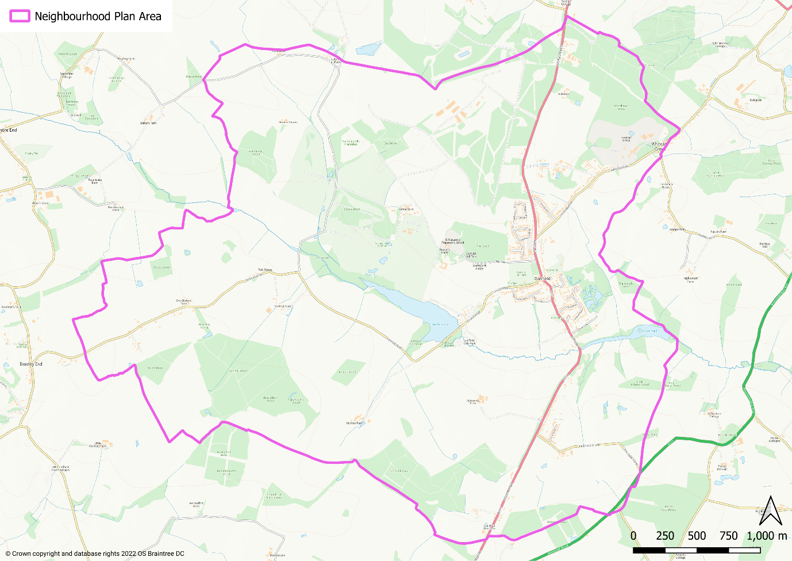

- Essex County Council is the Minerals and Waste Authority for the Plan area and is responsible for the production of mineral and waste local plans. These plans set out the policy framework within which minerals and waste planning applications are assessed. They also contain policies which safeguard known mineral bearing land from sterilisation, and existing, permitted and allocated mineral and waste infrastructure from proximal development which may compromise their operation.
- The Plan area includes land within a Mineral Safeguarding Area (MSA) due to the presence of sand and gravel deposits beneath the ground. This area is subject to a mineral safeguarding policy (see Policy S8 of the MLP), which seeks to prevent deposits being unnecessarily sterilised by non-mineral development. Proposals for non-mineral development coming forward in land designated as a MSA must demonstrate compliance with Policy S8 of the MLP. A Mineral Resource Assessment (MRA) would be required as part of a planning application for sites of 5ha where the application site falls within the MSA for sand and gravel, 3 ha for chalk and greater than 1 dwelling for brickearth or brick clay to establish the practicality and environmental feasibility of the prior extraction of mineral such that the resource is not sterilised. ECC, as the MWPA, must be consulted on all applications for non-mineral and non-waste development proposed within these areas that meet the tests set out in Policy S8.
- Policy 2 of the WLP establishes Waste Consultation Areas (WCAs) at a distance of 250m (400m in the case of Water Recycling Centres) around permitted, allocated and existing waste infrastructure. ECC must be consulted on all applications for non-minerals and non-waste development proposed within these areas.

Monitoring the Plan
- Gosfield Parish Council, as the responsible body, will be responsible for maintaining and periodically revisiting the Plan to ensure relevance and to monitor delivery.

Reviewing the Plan
- In order to provide a consistent framework for policies that make up the development plan, the period of the Neighbourhood Plan has been aligned with that of the Braintree Local Plan. As such, its end date is 2033. It is acknowledged that this means the plan period is relatively short, at 10 years. As such, it will be necessary to undertake an early review of the Neighbourhood Plan. This should be commenced once a review of the Braintree Local Plan has been commenced and there is sufficient clarity relating to important strategic issues, in particular housing requirements. This is likely to be once a Submission Version (Regulation 19) version of the draft Plan has been published.
- In March 2024 Braintree District Council established an intention to review its Local Plan, with the new plan having an end date of 2041. In September 2024, following amendments to the NPPF, a timetable was established for the preparation of the Local Plan Review. The intention was to adopt the new plan in December 2026, with a Regulation 19 Submission Version of the emerging Local Plan to be consulted on in Spring 2026. Therefore it is expected that the Neighbourhood Plan review may be required to commence at a similar time.

local context

History of Gosfield
- Gosfield has a long and significant history. The original church that formed the heart of the community was built in 1190 – it was then replaced in 1435 with a new church built by Sir Thomas and Lady Rolfe, elements of which are incorporated in the current church, St Catherine’s. The organ was built in 1877 and is still in regular use. It was recorded that in 1400 Gosfield was ‘a great town with 240 people’ (communicants).
St Catherine’s Church
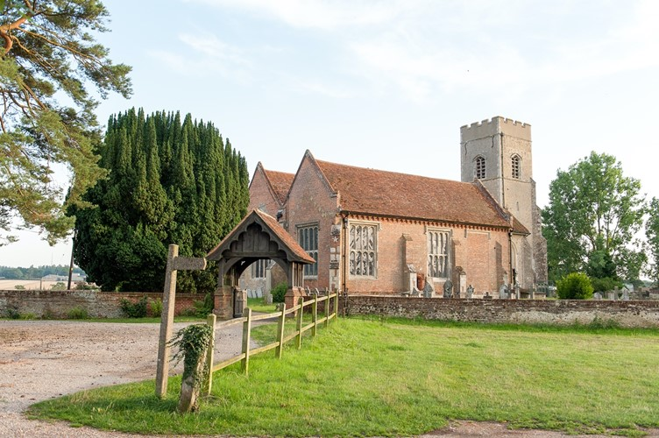

- Gosfield in 1890 was a quiet rural village whose inhabitants worked mainly in agriculture and was dominated by the two great estates of Gosfield Hall and Gosfield Place.
Gosfield Hall
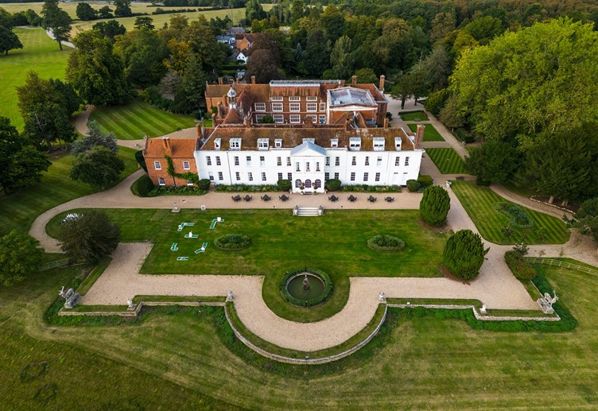

- Samuel Courtauld who had purchased Gosfield Hall in 1854 used his great wealth derived from his silk, crepe and textile business to provide housing for his workers. These new houses are now known as Park Cottages. He also built the Primary School and the coffee and reading rooms. The Sparrow family, owners of Gosfield Place also built a new school (now the front part of the Rowson Hall).
- World War One led to a decline in agriculture and many people were forced to look for alternative employment. Many people took jobs working at Courtaulds or Crittalls. The arrival of bus services helped people to access jobs further afield.
- Electricity arrived in the 1930s but water supply and sewerage were still primitive.
- World War Two brought great changes. House building and repairs stopped, Gosfield Hall fell into disrepair. In 1941 the Americans arrived to build Gosfield Aerodrome. Soldiers were sometimes billeted on the village playing field and the young men of the village volunteered to serve their country.
- In 1950 the Parish Council bought part of the Gosfield Estate as a playing field for the village. Gosfield Hall was rescued from its poor state and became a nursing home, retirement home and eventually a wedding venue.
Gosfield Playing Field
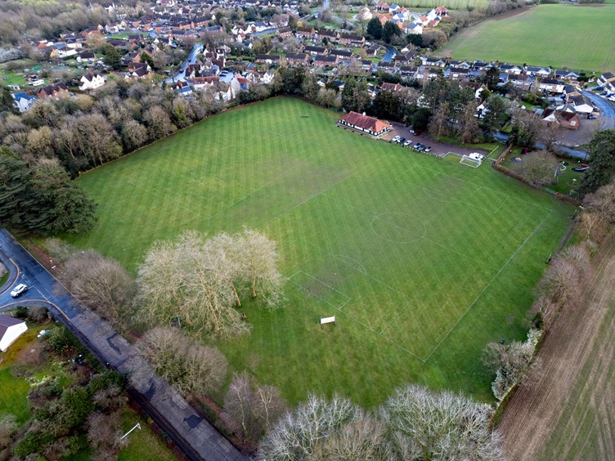

- The end of the World War Two saw a chronic housing shortage, returning armed forces wishing to set up home and start a family alongside the boom in birth rate during the war years, and Gosfield was no exception. Council housing was built, starting with The Limes in the late 1940s then followed by The Cedars in the early 1950s.
- The 1960s also saw major changes with the building of new housing estates, Nuns Meadow, Highlands, Greenfields and the School Park Estate (Meadway). These brought people from other parts of the UK and doubled the population of the village.
- The rapidly expanding population has largely stayed in Gosfield, resulting in the parish having the highest percentage of over-60s in the whole of Braintree district.
- In 1983 the Maurice Rowson Hall was opened.
Maurice Rowson Hall
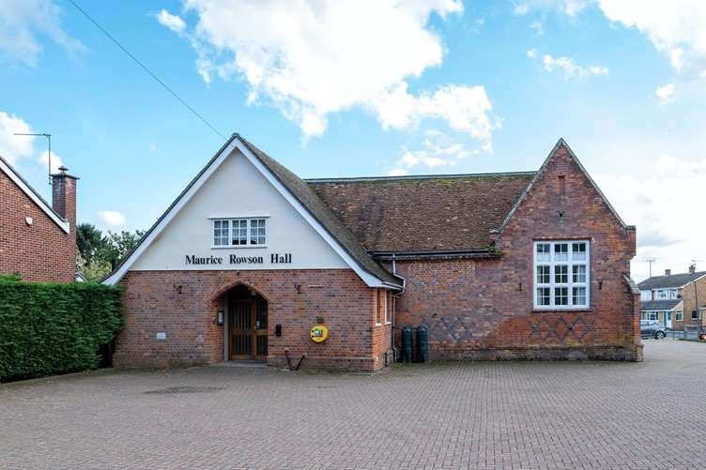

- In the 1980s Gosfield Parish Council acquired the sand and gravel workings as a Nature Reserve. In 2003 a new Pavilion was built on the Playing Field. In 2019 a new War memorial was built and in 2022 a new Village Community Shop was built as an extension to the Pavilion. All of these have been funded by the community and grants from other organisations.
War memorial
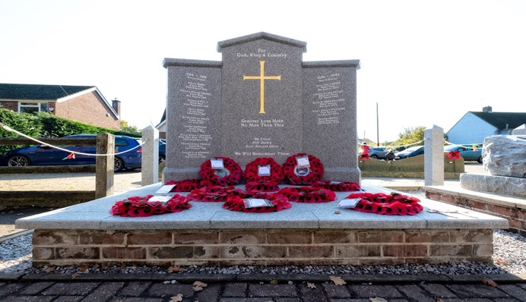

- The heritage of the village is recognised by the designation in 1988 of the Conservation Area. This incorporates a large part of the village, Gosfield Hall and the land in between. Indeed a substantial area of land incorporating Gosfield Hall is designated as a Historic Park and Garden.

Profile of the community today

The people
- In 2021, Gosfield parish had 1,451 residents. This represented an increase of 89 residents since 2011. The profile of the population in 2021 is striking. 34% of the population is aged 65 or over, compared with just 20% across Braintree district as a whole. By contrast, just 12% of the population fits the profile of young adults (aged 30 to 44) whereas in Braintree district the figure is 19%.
- The biggest change in the population between 2011 and 2021 was in those aged 75 or over, accounting for 83% of the growth in the population of the parish.
- This profile is backed up by the household composition in 2021. 20% of households were one-person households aged 66 or over (in Braintree district the proportion was 13%).
- Similarly, economic activity in Gosfield is very low, at 51% (Braintree district is 61%). Of those that are economically inactive, over 80% are retired. This feeds through to a low proportion of workers, with just 27% of residents aged 16 or over in full-time employment, compared with a figure of 36% for Braintree district.

The place
- Dwellings in Gosfield are predominantly large, with 32% having at least 4 bedrooms (across Braintree district the figure is 25%). There are however an above-average proportion of 2-bed properties – 32% compared with 27% across the district. Many of the larger properties are under-occupied, i.e. they have spare bedrooms compared with the number of people living in the household. A total of 86% of properties have at least one spare bedroom with 45% having at least two spare bedrooms.
- 57% of these properties are owned outright, which is well above the district figure of 34%. By contrast renting is very low with just 13% of households renting their homes (31% do so across Braintree district). Moreover, just 8% of these households live in social rented properties, which is half the district average.
- Today Gosfield is a thriving community with three schools (two of which are private), a public house, social club (the old Courtauld reading rooms), community shop, hairdressers, family restaurant and golf course. In total there are currently 34 Gosfield-based clubs and organisations.
Community shop
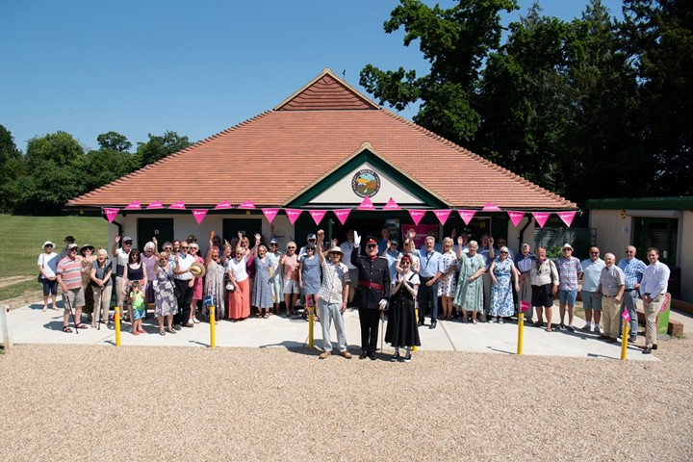

- Gosfield is situated 2.8 miles from Halstead and 6 miles from Braintree. This proximity gives it good access to a range of services and facilities, including Braintree Shopping Village, business parks and a water ski/resort venue.
- Gosfield village straddles the A1017 road which connects Braintree and Haverhill. It is served by a half-hourly bus service to and from Braintree and Halstead. It is also approximately one hour by train from London.
- Gosfield parish is surrounded by the parishes of Braintree and Bocking, Greenstead Green and Halstead Rural, Sible Hedingham, Stisted and Wethersfield.

SWOT analysis

Strengths
1. Strong community spirit with a large number of thriving community organisations.
2. A number of community assets, including the village shop, Maurice Rowson Hall, children’s play area and playing fields
3. High quality rural environment, with the Nature Reserve being a significant asset
4. Proximity to larger centres of Braintree and Halstead.
5. Relatively regular bus services.

Weaknesses
1. Limited public car parking
2. No provision for public electric vehicle charging
3. Limited shopping facilities in the village

Opportunities
1. Improve accessibility to countryside for leisure
2. Make better use of the Nature Reserve as a way of the community having access to nature
3. Make stronger local links with schools (particularly as a means of attracting young families into the village), Golf Club and Lake Resort.

Threats
- Limited availability of housing for local people in need and for young families.
- Insufficient provision of housing and other facilities that cater for the needs of an ageing population.
3. Road safety, due to speeding traffic and limited safe provision for pedestrians.

vision and objectives

Vision for Gosfield
- The vision for Gosfield over the plan period to 2033 is as follows:
The Gosfield Neighbourhood Plan will preserve the countryside, quality, village feel and thriving engaged community. It recognises that changes will be necessary to respond to environmental and climatic needs.

Neighbourhood Plan Objectives
- The objectives of the Neighbourhood Plan as identified through engagement with the community are as follows:
Climate and environment
- Maximise the protection and enhancement of biodiversity.
- Maximise the adoption of renewable technologies.

Design, heritage and green spaces
- Incorporate high quality design that reflects the character of Gosfield.
- Protect existing village historical assets and their setting and open spaces.

Getting around
- Ensure the potential for residents to have safe and convenient access to village assets and amenities.

Business and employment
- Continue to support local businesses.

Housing
- Contribute to addressing the housing needs of Gosfield.

climate and environment
- Gosfield parish is located within the Essex Climate Action Commission’s (ECAC) recommended Climate Focus Area (CFA), which is formed of the Blackwater and Colne River catchment areas. The CFA has been established to demonstrate best practice in sustainable land use management and help implement the recommendations in the ECAC’s 2021 report. The overall goal of the CFA is to achieve net zero carbon emissions through carbon reduction and carbon sequestration methods (e.g. afforestation, reforestation, improved forestry or agricultural practices, and revegetation). The secondary goal of the CFA is to become more climate change resilient by:
- improving soil health and access to natural green space and increasing biodiversity
- reducing air pollution,
- reducing flooding,
- reducing the urban heat island effect,
- improving the amenity and liveability of Essex communities.
- The Gosfield Neighbourhood Plan seeks to support these goals through targeted local policies.

Wildlife-friendly design
- The design of individual buildings and of neighbourhood scale green and open spaces, including private gardens, will help to ensure that existing habitats present in Gosfield can thrive and a range of new habitats can be created. This is in line with the requirement of the Environment Act 2021 for all new development (excluding small householder proposals) to achieve net biodiversity gain of at least 10%.
- Planting is an important aspect of development and habitat creation. Not only does a well-considered planting scheme provide high quality landscaping, it is a fundamental aspect of enhancing biodiversity that otherwise would be lost. Planting schemes should ensure that tree species should be carefully selected to be responsive to landscape and historic character and to suit the planting location . Planting should not simply consist of trees but a range of shrubs and grasses too and should seek to include native species.
- Protecting species present in the area is also important. Examples of the simple solutions that well-thought out design can easily incorporate are:
- Integral bird and bat boxes under the eaves of the new houses, or artificial nests sited in places away from windows and doors, can create vital new roosting sites to support populations of birds and bats.
- Boundaries between dwellings can be made hedgehog friendly by including pre-cut holes for hedgehogs to more effectively move across neighbourhoods to forage.
- New planting schemes can support bees and other pollinators by including nectar-rich plants.
Bricks that allow birds to nest | Hedgehog-friendly fencing
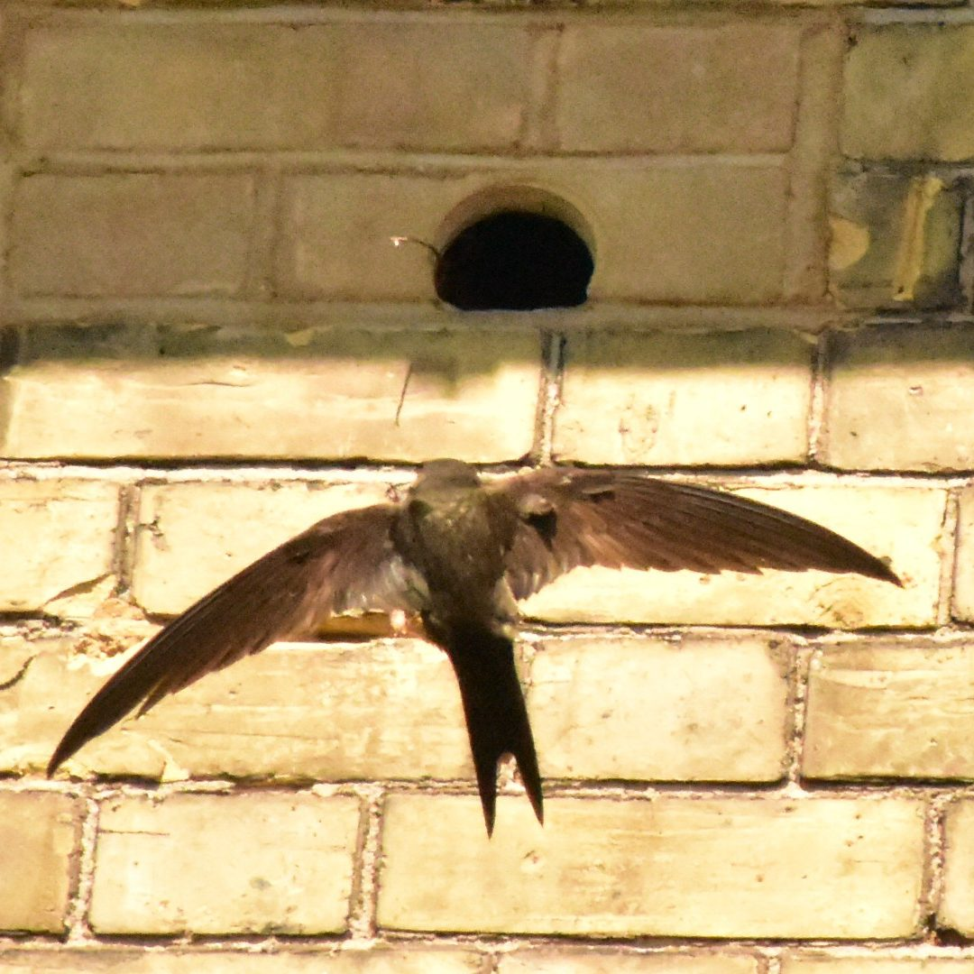 | 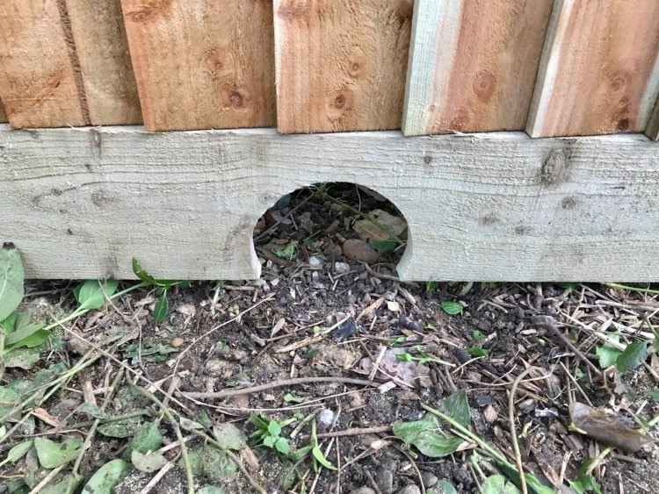
Credit: https://www.wienerberger.co.uk | Credit: Nature Recovery Network
- Green infrastructure and open space should be approached from a multifunctional perspective combining uses such as sustainable drainage, public open space, green corridors/ walking and cycling routes shading through street trees and biodiversity conservation to combine functional uses with amenity benefits. These features should be strategically located to provide green infrastructure and landscaping in prominent spaces to maximise the benefits and connectivity to site users and increase the usability of multifunctional space. Development is encouraged to be informed by the full list of considerations in Natural England’s ‘Green Infrastructure Framework 2023’. It should also be informed by Essex County Council’s requirements on applicants regarding green infrastructure, as follows:
- Essex Green Infrastructure Strategy (2020) - seeks to protect, create, and improve green infrastructure (GI) for biodiversity and people; improve connectivity and inclusivity, by supporting healthier, more active lifestyles; and contribute to economic growth.
- Essex Green Infrastructure Principles and Standards 2022 - the nine GI principles/ standards seek to demonstrate what ‘good likes like’ in designing and delivering GI and align with the national GI framework/standards.
- Essex Green StoryMap (2022) - is the evidence base to inform GI policies, strategies and projects and sets out a spatial analysis of GI provision across Essex.
- Flood Management/SuDs; Landscapes and Greenscapes and Building with Nature - sections of the Essex Design Guide also provide content on GI.

POLICY GOS1: WILDLIFE-FRIENDLY DEVELOPMENT
- All development proposals should deliver a minimum of 10% net biodiversity gain in addition to protecting and enhancing existing habitats and species. Proposals to create or enhance existing green wildlife corridors are strongly encouraged.

- In particular, the incorporation of design features into new development that encourages local wildlife to thrive, is strongly encouraged.

- Development should be designed to retain trees, shrubs and hedgerows of arboricultural, habitat and amenity value on-site and to conserve and enhance connectivity to the wider multifunctional green infrastructure networks. Where this is accompanied by new planting, this should consist of native species of trees, shrubs and grasses acting as stepping stones for wildlife.

Sustainable design
- The Climate Change Act 2008 committed the UK to an 80% reduction in CO₂ emissions by 2050. In June 2019, an announcement was made by Government to reduce this further to almost 100% by 2050. This will be a major task that will require everyone to be engaged, from households and communities, to businesses and local and national government.
- In 2022, the residential sector alone accounted for nearly 17% of the UK’s annual CO₂ emissions (source: Department for Energy Security and Net Zero). Whilst the total has decreased by 30% since 2012, it has increased as a proportion of the overall total (from 15% in 2022. Standards for ecologically sustainable homes and developments are established through Building Regulations and Braintree Local Plan Section 2 policies. Specifically Policy LPP72 (Resource efficiency, energy generation and energy efficiency) requires new residential dwellings to include renewable and low carbon energy technology to provide at least a 19% improvement in energy performance over the requirements of the 2013 Building Regulations. However, in order for built development to make a meaningful contribution towards achieving net zero by 2050, development needs to go further. New development is therefore encouraged to exceed the requirements of Local Plan Section 2 Policy LPP72 or, at very least, to ensure that new properties are designed so that they are ready to receive the technologies that are crucial to minimising their energy use, e.g. underfloor heating to increase the effectiveness of heat pumps, orientated south to maximise the potential from solar panels if installed, etc.
- The East of England is an area of high water stress. Measures to improve water efficiency in developments are therefore strongly encouraged. This can be achieved by a fixtures and fittings approach, including through rainwater/storm water, harvesting and reuse, and greywater recycling. Such measures to improve water efficiency standards and opportunities for water reuse and recycling also reduces the volume of wastewater needing to be treated at water recycling centres. This will help to reduce carbon emissions in the supply and recycling of water.
- Braintree Local Plan Strategic Policy SP6 (Infrastructure and Connectivity) and Policy LPP52 (Layout and Design of Development) require developers to demonstrate that there is sufficient water available to support the proposed development and that adequate mains foul water treatment and disposal already exists or can be provided in time to serve new development.
- Increasingly, residential properties are seeing more paved and decked areas in gardens at the expense of green areas. This means rainwater has nowhere to go, increasing the amount of water travelling into the sewer which can then cause flooding. The use of natural drainage and sustainable drainage systems (SuDS) to minimise surface water run-off from existing properties and new development as part of the solution to protect the sewer network is important. Such measures help to avoid surface water run-off from entering the foul drainage network, and connections to a surface water sewer will only be considered by the wastewater authority (Anglian Water) where all other options are demonstrated to be impracticable. Braintree Local Plan Policies LPP74 (Flooding Risk and Surface Water Drainage), LPP75 (Surface Water Management Plan) and LPP76 (Sustainable Urban Drainage Systems) provide direction on this.

POLICY GOS2: LOW ENERGY AND ENERGY EFFICIENT DESIGN
- Proposals for new development, including the construction of new buildings and the redevelopment and refurbishment of existing building stock, should demonstrate how the design of buildings and site layouts improves water efficiency and minimises consumption of energy, water, minerals, materials and other natural resources in order to provide resilience to the effects of climate change.

- The design and standard of any new development should aim to meet a high level of sustainable design and construction including measures which minimise waste reduction, re-use and recycle minerals, and use sustainable materials, including in relation to their procurement and be optimised for energy efficiency, targeting zero carbon emissions.

- All developments should demonstrate how they have been designed to incorporate measures to adapt to climate change. New development will be supported where it is designed and built to be Net Zero Carbon (in operation) having regard to Policy NZ1 set out in the Greater Essex Planning Policy Position for Net Zero Carbon Development. The following measures should be incorporated into development:
- Wherever possible, new buildings should be orientated to maximise the opportunities for both natural heating and ventilation and reducing exposure to wind and other elements;
- Proposals involving both new and existing buildings should demonstrate how they have been designed to maximise resistance and resilience to climate change for example by including measures such as solar shading, thermal mass, heating and ventilation of the building and appropriately coloured materials in areas exposed to direct sunlight, green and brown roofs, green walls, etc;
- The use of low embodied carbon materials, assessed through a Whole Life Cycle Carbon Assessment, should be prioritised. With regard to reducing upfront embodied carbon emissions from new development, reference should be made to the findings and recommended targets set out in the Essex Embodied Carbon Policy Study 2024 (or any successor document);
- New residential development should seek to meet a target standard of 100 litres per person per day (l/p/d);
- Use of trees and other planting, where appropriate as part of a landscape scheme, to provide shading of amenity areas, buildings and streets and to help to connect habitat, designed with native plants that are carefully selected, managed and adaptable to meet the predicted changed climatic conditions; and
- All development should minimise surface water runoff to prevent off-site flooding through the design of a multifunctional SuDS-based drainage system, and where possible incorporate mitigation and resilience measures for any increases in flood risk that may occur due to climate change.

- The sensitive retrofitting of energy efficiency (including glazing) and renewable energy generation measures that serve historic buildings will be encouraged having regard to the Essex Design Guide, including the retrofitting of listed buildings and buildings in Conservation Areas, provided it safeguards their historic character and setting.

Local Green Spaces
- Under the NPPF, Neighbourhood Plans have the opportunity to designate Local Green Spaces which are of particular importance to them. This will afford protection from development other than in very special circumstances. Paragraph 107 of the NPPF says that the Local Green Space designation should only be used where the green space is:
- in reasonably close proximity to the community it serves;
- demonstrably special to a local community and holds a particular local significance, for example because of its beauty, historic significance, recreational value (including as a playing field), tranquillity or richness of its wildlife; and
- local in character and is not an extensive tract of land.
- There is one important green space considered to meet the criteria, at Wendell Crescent (see Figure 4.1 for its location).
Figure 4.1: Wendell Crescent Local Green Space
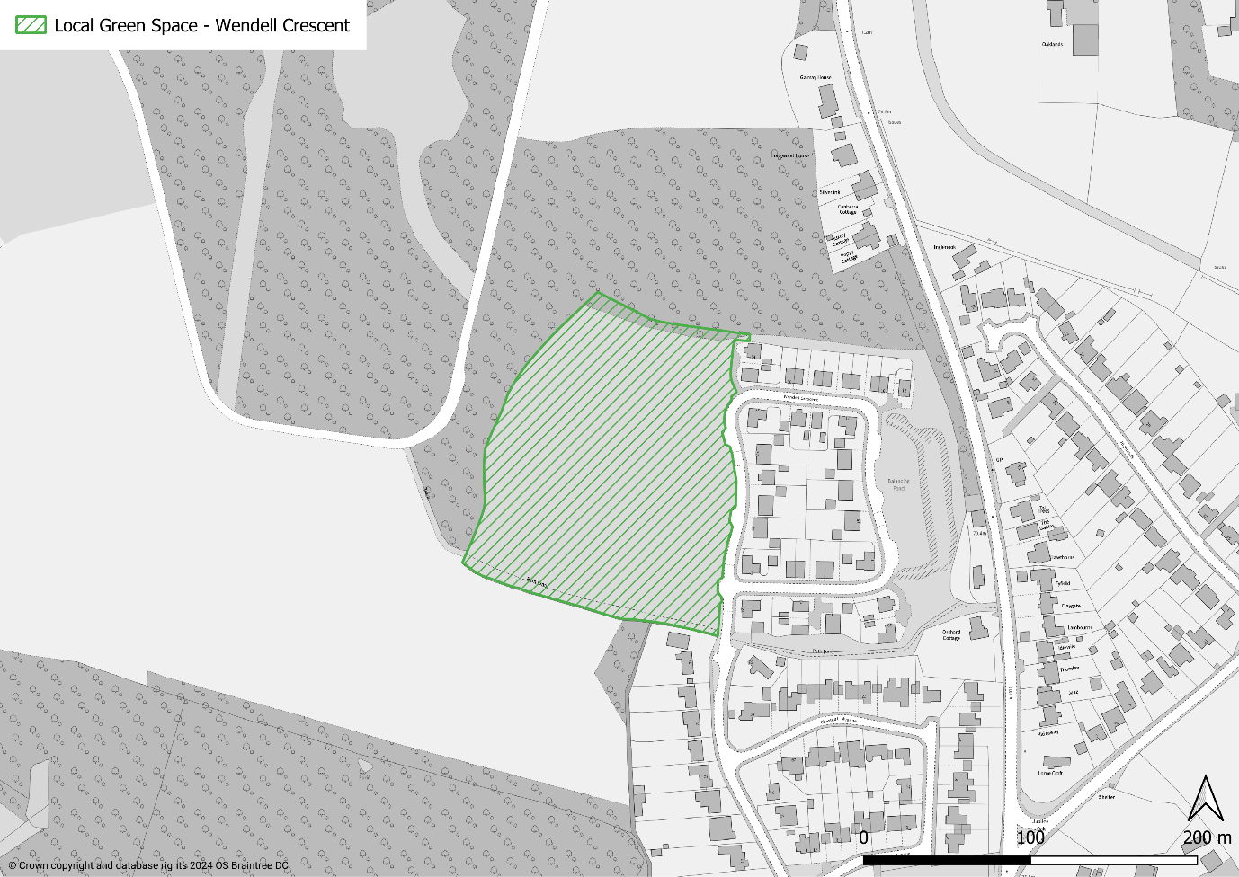

- The Wendell Crescent open space was created as part of the adjacent development. Whilst a new publicly accessible open space, it acts as a green corridor between the woodlands in Hall Drive and the open land beside the former RAF Gosfield Airfield. This is important as the area is roamed by red deer, fallow deer and muntjac. It is also bordered to the west by a public right of way which is a popular walking route from Hall Drive to the Airfield. The presence of the open space provides an attractive vista for walkers.
- The open space will be sown with wildflowers and have mown walkways that will allow residents to enjoy the flora and fauna, particularly during the summer months.
Wendell Crescent Local Green Space – view westwards
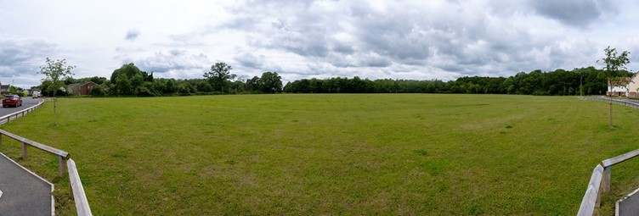
Wendell Crescent Local Green Space – view northwards
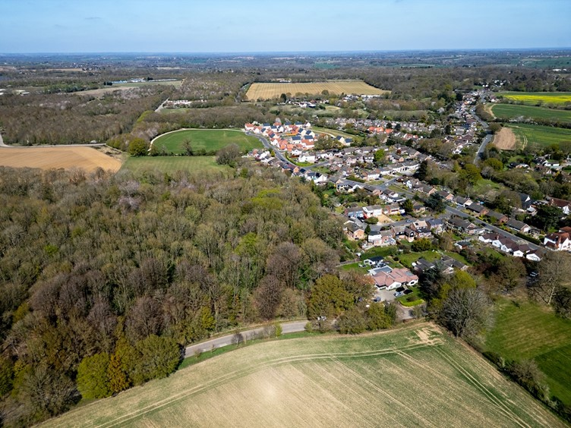
Local Green Space
POLICY GOS3: LOCAL GREEN SPACES
- The area adjacent to Wendell Crescent shown on the Policies Map and in Figure 4.1 is designated as a Local Green Space:
- Development proposals within the defined Local Green Space will only be supported in very special circumstances.

- The Local Nature Reserve to the east of the village – Gosfield Sandpits - is also an important and much valued part of Gosfield. This is not included as a Local Green Space because it is already protected by Braintree Local Plan Policy LPP64 (Protected Sites).

Verges
- Generous grass verges are a key characteristic of Gosfield village. These are prominent at many of the junctions where The Street (A1017) meets side roads. They are important because they contribute towards the village’s distinctiveness. They also perform a biodiversity function, being a place where various species thrive.
A Gosfield verge
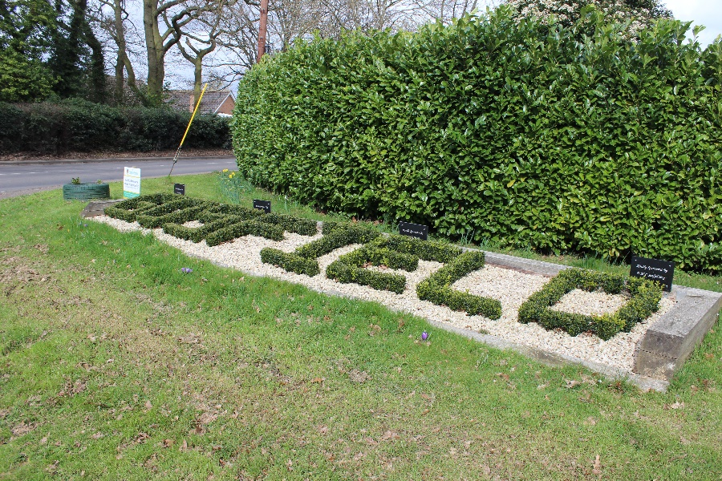

- New development in Gosfield village should also look to create similar opportunities along this main route, thereby maximising biodiversity and visual appeal as much as possible. In addition to the biodiversity gains the wide grass verges are pleasing to residents and visitors moving in and around the village.

POLICY GOS4: VERGES
- Existing green verges along the highway should be retained and should only be removed if it is clearly demonstrated to be part of necessary highway improvements, including for safe and convenient pedestrian and cycling routes. Any such improvements should incorporate opportunities for planting around the existing verges wherever practicable.
- The design of highways and verges to maximise biodiversity value will be supported.

design and heritage

Design and character
- The community of Gosfield has been very clear that the character of the village and surrounding area is one of the strongest assets of the parish. People value the village feel that development has provided in Gosfield and want new development to fit in with this.
- To support the development of the Neighbourhood Plan, a Design Assessment was undertaken. This took what is considered to be a representative sample of the residential streets or groupings of streets and provided a commentary on their features, both positive and negative.

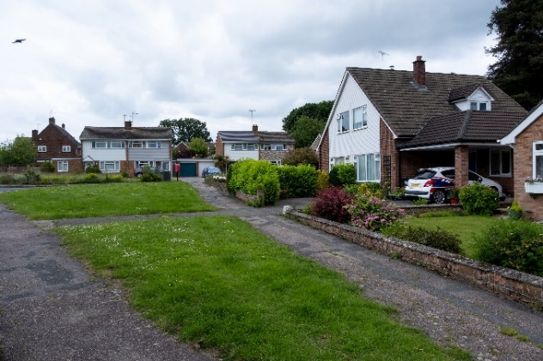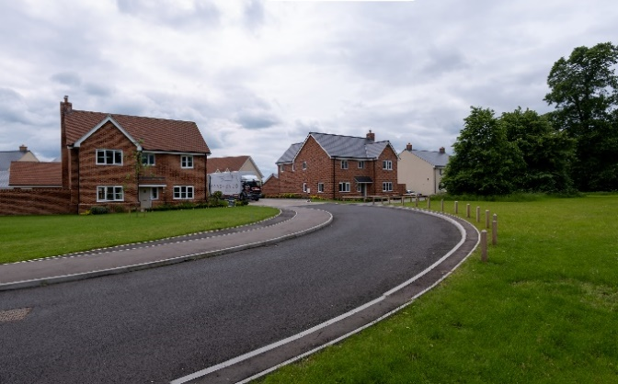

- A key feature is the fact that Gosfield has developed over a number of years, particularly since the post-World War II period, and each development period has shown slightly different features. Therefore Gosfield is not a village where all development looks the same. Despite this, it is noticeable how the materials and styles of housing have shown a degree of consistency. Good design has taken these cues and applied them to the stye of day.

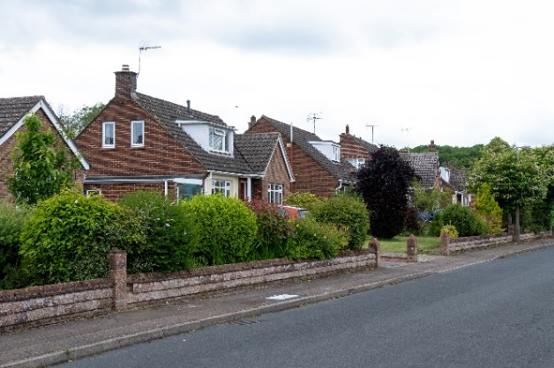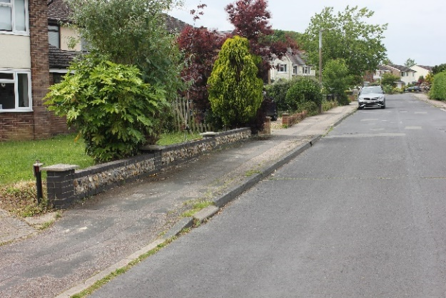

- One particular aspect of Gosfield’s character is the open feel of its residential areas. Densities of development are low, often supported by large front gardens and off-road parking, resulting in a less cluttered feel to the roadway. This has sometimes been enhanced by the provision of small public green spaces. The best frontages to properties are those with low boundaries that have been planted to create a natural feel.
- Some of the matters related to design and character are further addressed in other policies in the Neighbourhood Plan. However, in respect of ensuring high quality design, it is important that development proposals – and particularly major developments (as defined by the NPPF) – actively demonstrate how they have been informed by these principles. Their purpose is not to expect all development to be designed and laid out the same, irrespective of the circumstances; rather it is to inform developers so that what is built represents high quality development in the context of Gosfield.
- Parking guidance and standards are now provided in the following documents by the Essex Planning Officers Association (EPOA):
- Parking Guidance Part 1 (Parking Standards Design and Good Practice) covers most development applications across Essex.
- Parking Guidance Part 2 (Garden Communities and Large Scale Developments) will be less relevant to Gosfield because it mostly relates to large developments which are not expected to come forward in the parish.
- It will be up to the individual authorities (Braintree District Council and Essex County Council) to decide whether to formally adopt the standards. Until this happens, development should have regard to this guidance and standards.

POLICY GOS5: DESIGN AND CHARACTER
- Development should demonstrate high quality, safe design and layout which respects the local character of Gosfield. This includes the development of public buildings.

- In delivering high quality design, development proposals must demonstrate the appropriate use of design, layout, materials and features. The following principles should be considered as part of design proposals:
- Development should integrate with and enhance the form of its existing surroundings. In particular, the open aspect of the frontages to residential properties should be retained.
- Openness is a fundamental part of the character of Gosfield. Where appropriate a range of densities, house types and plot layouts along with public green spaces should be used to maintain this.
- Building heights and rooflines should provide diversity of frontage, scale and form, with building heights that reflect the prevailing height of surrounding buildings unless it can be demonstrated that a taller building could complement or enhance the local character.
- All connections should seek to be multifunctional in nature providing safe and convenient connectivity for pedestrians and cyclists within the development and to the surrounding countryside and key destinations.
- Parking to support residential uses should be provided within the development and should maximise use of permeable surfaces to ensure adequate drainage. Where on-street parking provision is to be made, this should have regard to the EPOA parking standards and should demonstrate, through the parking and/or road layout how this minimises the impact on the safety of pedestrians and other road users.

Heritage
- Gosfield is a parish rich in history. In total it has 53 nationally listed buildings, one scheduled monument (the Well House and donkey wheel at Gosfield Hall) and Gosfield Hall Historic Park and Garden. Of the listed buildings, two Grade I listed (Gosfeld Hall and St Catherine’s Church), one is Grade II* listed and the remainder (51) are Grade II.
- There is one structure in the parish which is considered to have local heritage interest, this being the Ha Ha wall.
Ha Ha wall
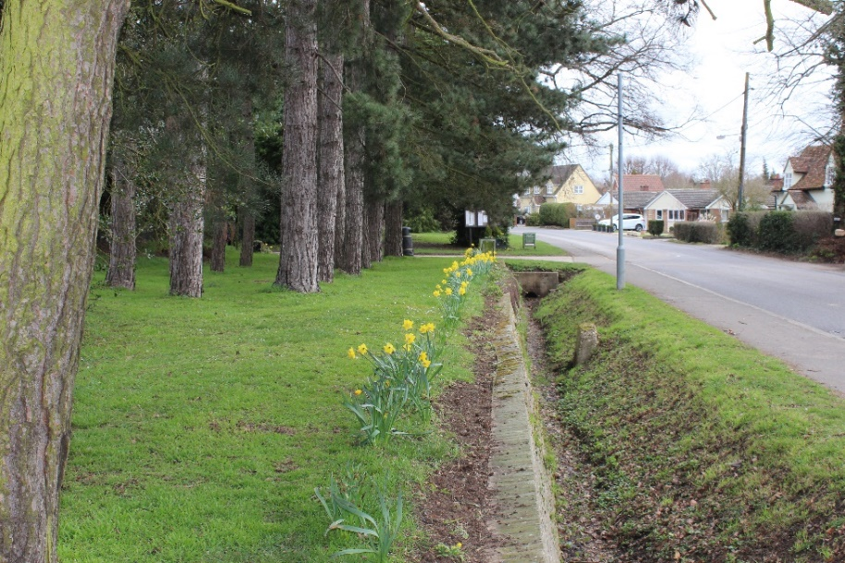

Figure 5.1: Location of Ha Ha wall
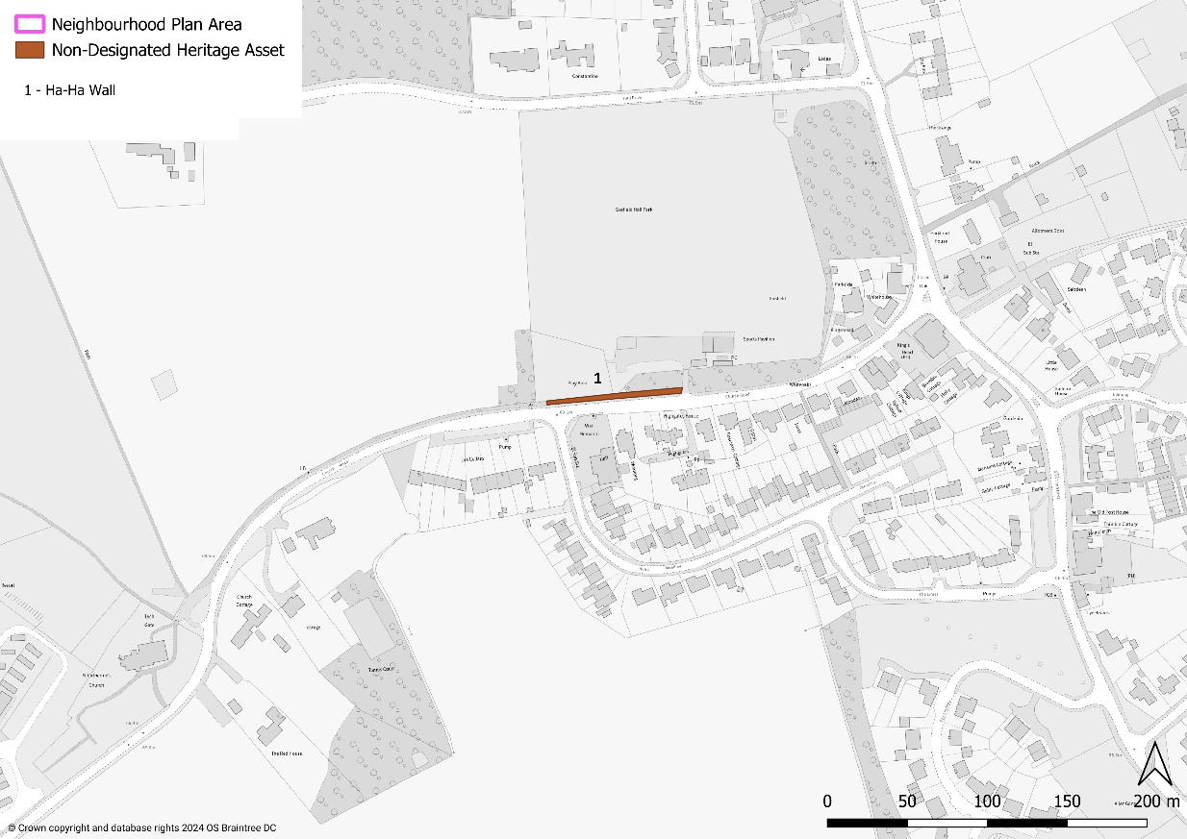

- The Ha Ha wall is in Church Road in Gosfield village and stretches from the Playing Field entrance to St Catherine’s Church. It marks part of the eastern boundary of the Gosfield Hall Estate. There is another Ha Ha wall in front of Gosfield Hall which is a listed feature.
- A Ha Ha wall prevented grazing animals on large estates from gaining access to the lawns and gardens adjoining the house, giving a continuous vista to create the illusion that the garden and landscape were one and undivided. Examples can be seen at five National Trust properties but few exist alongside public roads.
- The Ha Ha wall is therefore identified as a non-designated heritage asset (which is different from national listing, i.e. Grade I, II and II*).

POLICY GOS6: NON-DESIGNATED HERITAGE ASSETS

In considering proposals which involve the loss or alteration of a non-designated heritage asset, consideration will be given to:
- whether the asset is structurally unsound and beyond feasible and viable repair (for reasons other than deliberate damage or neglect); or
- the extent to which measures to sustain the existing use, or find an alternative use/user, have been investigated.
- Where a development proposal would result in the loss of, or harm to a non-designated heritage asset including its setting, a balanced judgement will be made as to the acceptability of the proposal having regard to the scale of any harm or loss and the significance of the heritage asset.

getting around

Countryside access
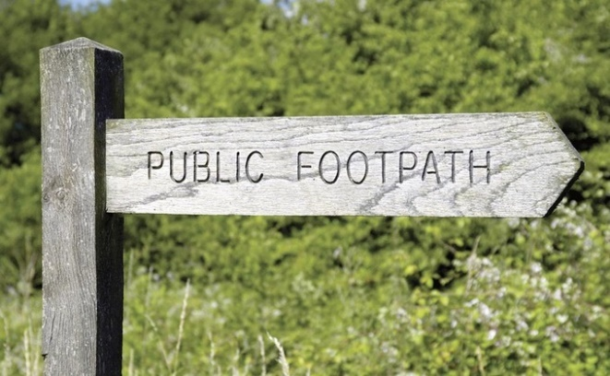
- In a rural communities such as Gosfield parish, where the availability of large scale informal public green spaces is limited, access into the countryside is particularly important. The need for access as a means of exercise, to walk dogs and for general wellbeing is vital. Without this, the community becomes reliant on use of the private car to access leisure opportunities elsewhere, which creates lots of short distance car trips that do not contribute positively to sustainability.
- The NPPF states that ‘planning policies should protect and enhance public rights of way and access, including taking opportunities to provide better facilities for users, for example by adding links to existing rights of way networks’ (paragraph 105).
- Gosfield parish is currently relatively well served with Public Rights of Way (PROWs), as shown in Figure 6.1. Further improvements to the network of PROWs and bridleways are encouraged, along with the continued maintenance and upkeep of the existing network. Improved signage would also encourage more people to use the PROW network.
Figure 6.1: Public rights of way
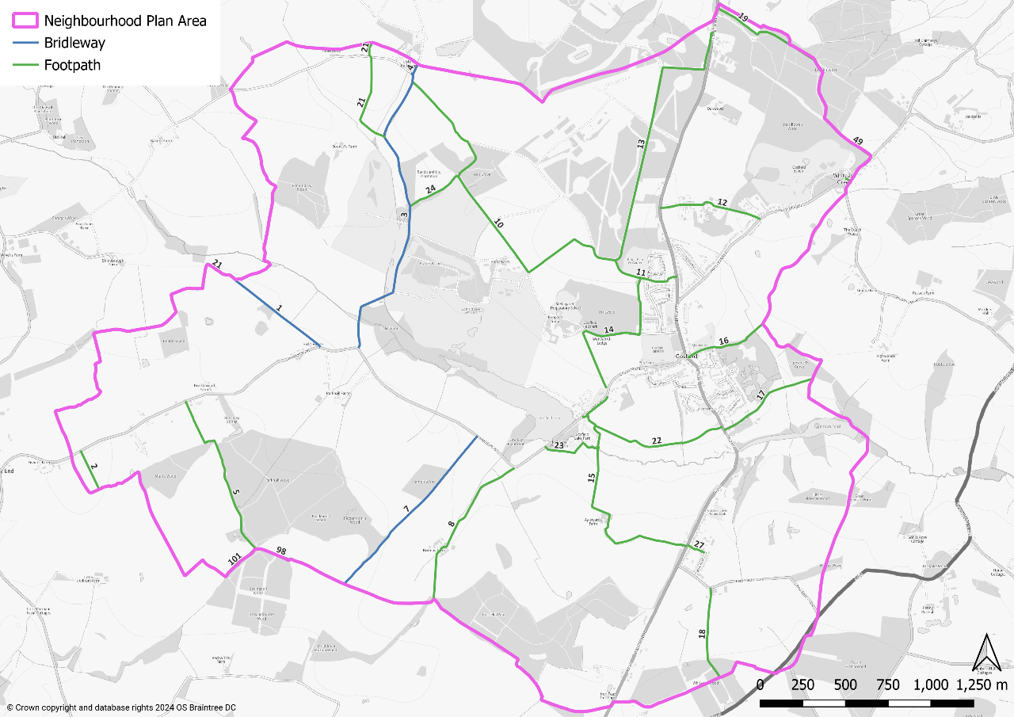

- The Essex Planning Officers Association (EPOA) has prepared a ‘Development and Public Rights of Way Advice’ note. This advice note informs and advises in situations where PROWs need to be considered and taken account of where development proposals impinge upon them. PROWs are recorded on the Definitive Map of Public Rights of Way, which is a legal document recording footpaths, bridleways and byways and restricted byways. Development should also have regard to the Essex County Council Development Management Policy DM11 (Public Rights of Way).
- Improving access can be achieved in simple ways. Better signage will enhance wayfinding which allows users to feel safer using designated walking and cycling routes. Incorporating lighting (being aware of ecological considerations) will improve routes and enhance the feeling of safety whilst improving surveillance.

POLICY GOS7: ACCESS FOR WALKING, CYCLING AND HORSE RIDING
- Access to the countryside will be promoted through the protection, maintenance and enhancement of the existing Public Rights of Way (PROW) network, as defined on the ‘Definitive Map of Public Rights of Way’, provision of bridleways and the safety of users of rural roads and lanes. Any proposals impacting upon a PROW should have regard to ECC Development Management Policy DM11 (Public Rights of Way) to ensure the safety of users of rural roads and lanes.

Any development which leads to the loss or degradation of any PROW should not be permitted in other than very special circumstances. Proposals to divert PROWs or cycleways should provide clear and demonstrable benefits for the wider community. Where possible, development should enhance PROWs by improving signage, existing routes and connectivity through the creation of new routes. In all cases it should seek to ensure that routes are suitable for those with disabilities.

- Improvements to cycling between Gosfield and its nearest main centre, Halstead, are considered likely to provide the greatest benefit for regular cyclists. Proposals to develop a safe off-road cycle route between Gosfield and Halstead will therefore be supported. At the present time no route has been identified.

Other issues with getting around
- A number of matters were identified by the local community regarding getting around in Gosfield. None of these matters are directly planning policy matters, however they are of concern to the community and therefore it is important that they are identified and, where possible, action is taken to address them.

Pedestrian safety
- The A1017 road, also known as The Street, passes through Gosfield village and is the main through route between Braintree and Haverhill. As a result, it often experiences high volumes of traffic and speeding. The last road survey conducted in The Street recorded, in a seven-day period, 64,000 traffic movements with an average speed of 29mph traveling north and 32mph traveling south (in a 30mph limit). The two points where measurements were taken were in front of the Spinney and in front of the old Post Office.
- The road effectively splits the village in half so for pedestrians there is often a need to cross The Street to access services and facilities. The primary school is located to the north of the junction with Hall Drive. There is a second school, St Margaret’s, located in Hall Drive. They both generate vehicle and pedestrian traffic. There is considered to be a strong need for one or more pedestrian crossings.
Possible location of pedestrian crossing of A1017
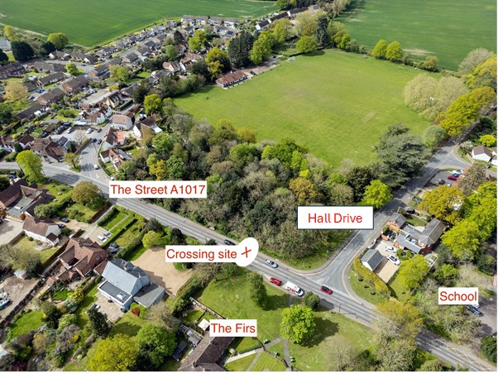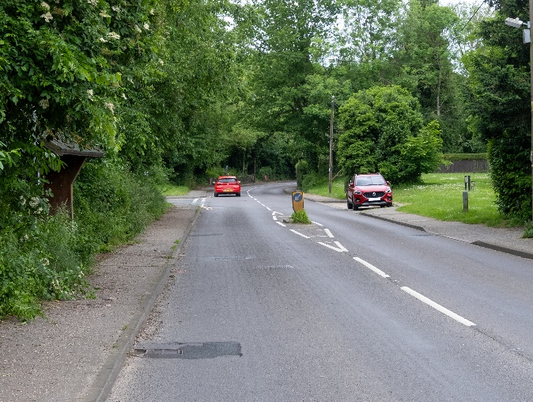

- The only location with suitable visibility is as shown on image above. There is currently a ‘refuge’ which is too small to provide protection to pedestrians and is frequently knocked down by passing vehicles. There is currently a layby for the Firs properties owned by Eastlight Housing Association. The proposed crossing would remove the layby and provide a small private car park to serve the properties located closer to them. It would also help to assist traffic flow to and from Hall Drive at peak times.
- Gosfield Parish Council will lobby Essex County Council, as highways authority, to install this pedestrian crossing.

Speeding
- More generally the village experiences speeding vehicles and dangerous driving. This is exacerbated by the worsening in the quality of local road surfaces. The need to better monitor speed limits and road condition is paramount. Two locations – Braintree Road and Church Road – have particular issues and are addressed below. Halstead Road is an also an important road where speeding is an issue.
- Braintree Road (the A1017) has a 60mph limit. Records show that there were 14 accidents between 2014 and 2024 including a triple fatality. There are parts along this route where there is no pavement or street lighting and children need to cross to get to bus stops which are located on grass verges with no standing area. The matter has been discussed many times at the Parish Council. However, no proposals – such as the road being redesignated as having a 40mph limit – have been made. The issue therefore remains and the Neighbourhood Plan, based on the views of the community, encourages that it be considered again.
- Church Road has a 30mph limit which changes to 60mph before St Catherine’s Church. There is a double bend and the road narrows. It is not possible for heavy goods vehicles to pass cars through the double bend.
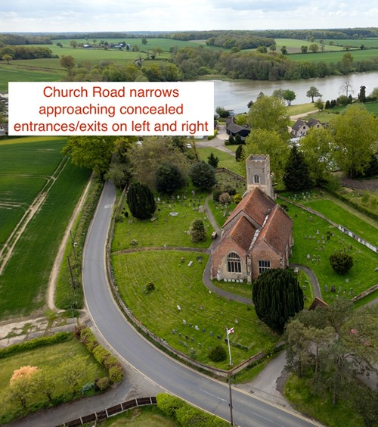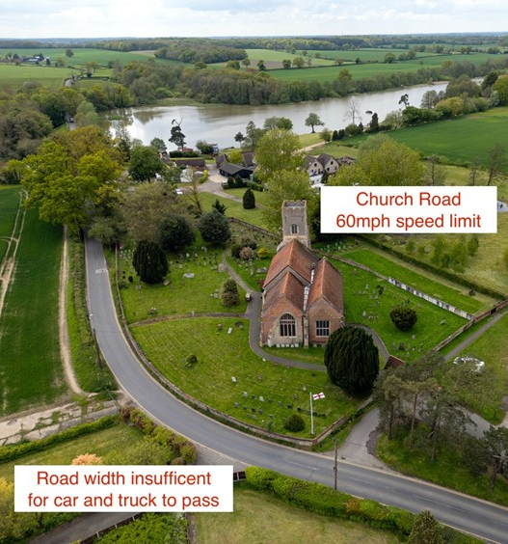

- The road then continues downhill between roadside banking. There are then concealed entrances and exits on both side of the road. The left entrance/exit is to Gosfield Lake Park, a development of 80 retirement park homes. The right entrance/exit is to Gosfield Lake Resort, a water ski and camping location. It is also used by patrons of the Appletree Restaurant.
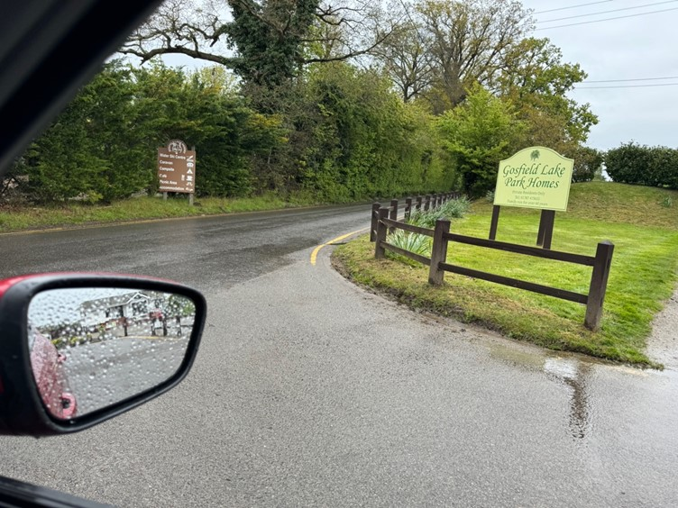
Poor visibility to right onto 60mph speed limit road.
80 properties use this sole exit .from Gosfield Lake.

- The road continues past the lake with a drop of 2 metres on the right and 10 metres on the left. Both sides are protected by basic wooden fencing. The road then reaches a single width bridge with restricted view of oncoming traffic. Given these numerous hazards and the concerns raised by the community through the development of the Neighbourhood Plan, Gosfield Parish Council will seek the redesignation of the road as a 30mph limit.

Accessibility of pavements
- Whilst a rural village such as Gosfield has relatively few pavements, those that it does have are vital for safe pedestrian access. Many of the pavements in Gosfield have access restricted because of the encroachment of hedges and undergrowth. This means pedestrians have to step into the roadway to pass these obstructions which can be dangerous, particularly where the view of drivers is restricted. Gosfield Parish Council will lobby property and landowners to keep hedges and undergrowth cut back appropriately.
Examples of pavements restricted by hedges and undergrowth
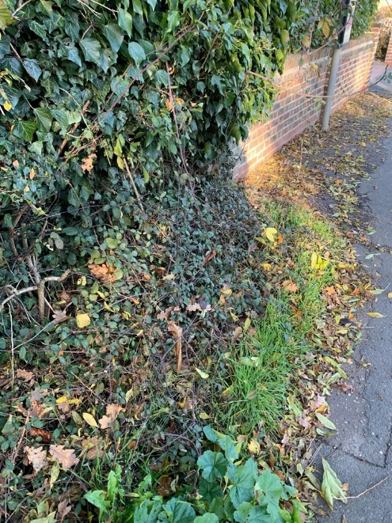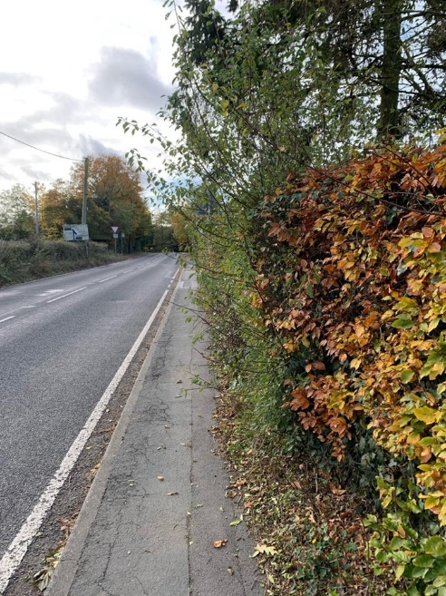

policies mapS
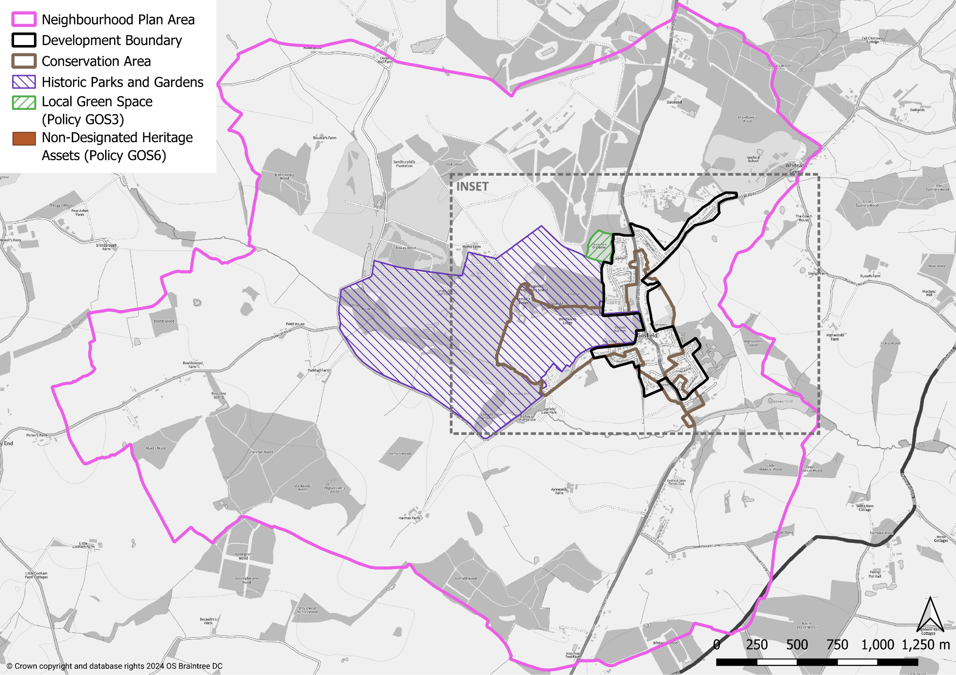
INSET MAP
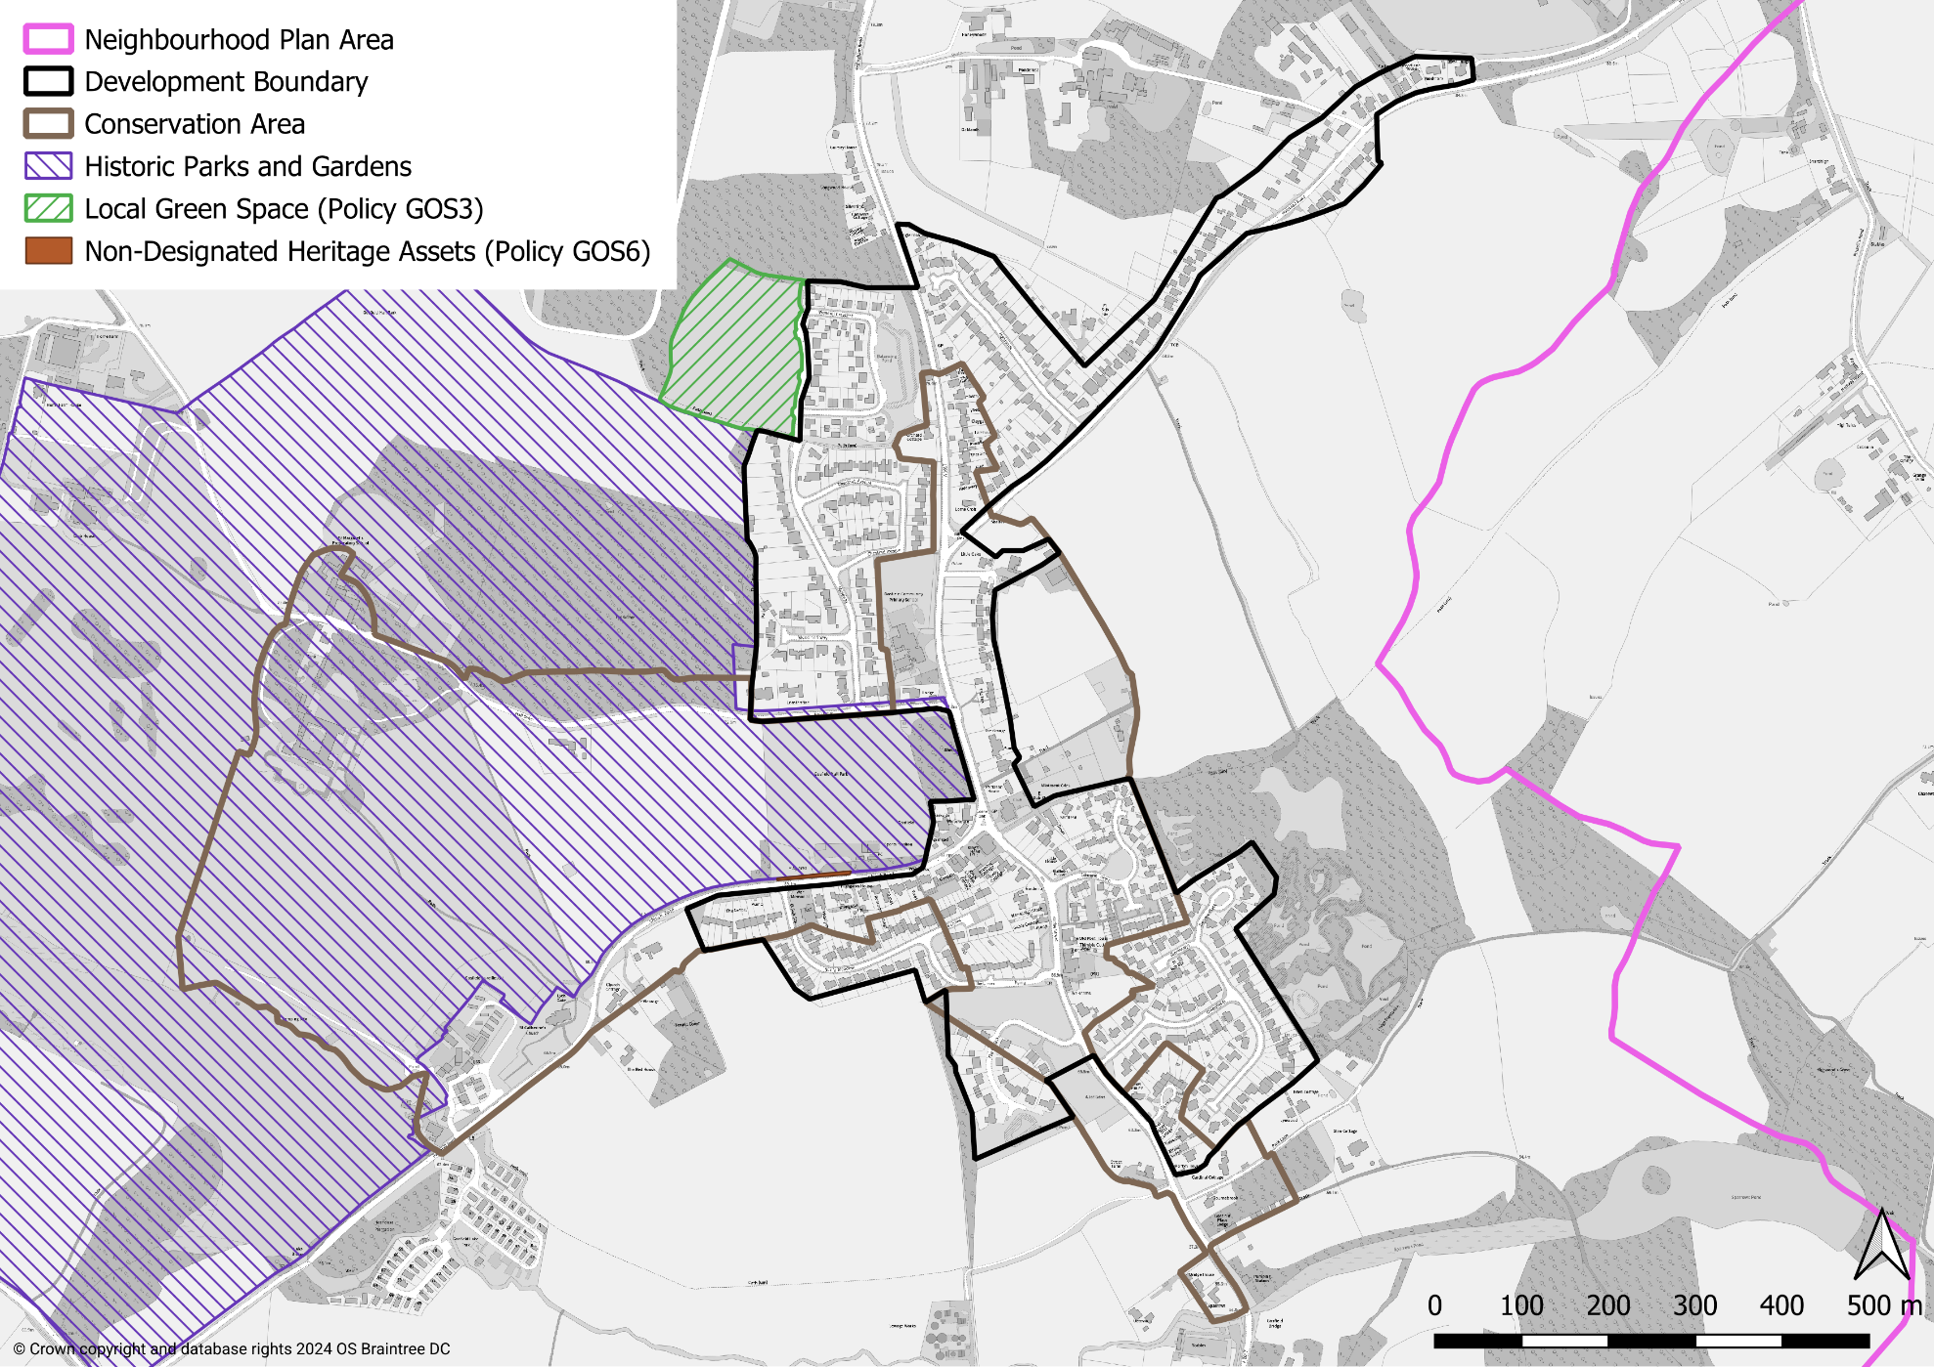

THIS PAGE IS INTENTIONALLY BLANK

ECAC (2021) Net-Zero: Making Essex Carbon Neutral (https://www.essex.gov.uk/sites/default/files/2023-07/Net%20Zero%20-%20Making%20Essex%20Carbon%20Neutral%20%282023%29.pdf)
https://designatedsites.naturalengland.org.uk/GreenInfrastructure/Home.aspx
https://www.essex.gov.uk/sites/default/files/2024-02/Essex%20Green%20Infrastructure%20Strategy%202020.pdf
https://www.essexdesignguide.co.uk/supplementary-guidance/essex-green-infrastructure-standards/
https://www.placeservices.co.uk/green-essex/
https://www.essexdesignguide.co.uk/design-details/landscape-and-greenspaces/
https://www.essexdesignguide.co.uk/media/2954/net-zero-carbon-planning-policy-for-greater-essex-november-2023.pdf
https://www.essexdesignguide.co.uk/media/2981/essex-embodied-carbon-policy-study-technical-evidence-june-2024.pdf
https://www.essexdesignguide.co.uk/media/3023/essex-parking-guidance-2024-part-1-design-and-good-practice.pdf
https://www.essexdesignguide.co.uk/media/3022/essex-parking-guidance-2004-part-2-garden-communities-and-large-scale-development.pdf
https://www.essex.gov.uk/sites/default/files/migration_data/files/assets.ctfassets.net/knkzaf64jx5x/71Tt0crmRtih5IsUiI0EyA/58b10a0398cc92793425f23666f584b8/development_management_policies-highways-transportation.pdf

