Minutes for RMSST Middle Grades Campus Founding Meeting #2
Tuesday, July 21, 2026
Attendance: Ms. Waddell- Director, Ms. Baskett (8th grade), Ms. Tate (6th grade), Mr. Bare (7th grade), Ms. Coleman (7th grade), Ms. Hall (4th grade), Mr. Mohammad (6th grade), Ms. Carlock (4th grade), Ms. Long (4th grade, 6th grade), Ms. Ricketts (4th grade), Mr. Phillip (5th grade), Ms. McLeod-Lalor (8th grade)
1.Called to order at 6:32pm by Amanda Baskett
2.Mrs. Baskett led a review of bylaws draft and the group made edits by consensus
- Mr. Bare motioned to approve the bylaws.
- Mr. Phillip seconded.
- All approved. Motion carried.
3. Interim Officer Discussion and then a slate was built through consensus
President: Mrs. Joma McLeod-Lalor
Vice-President: Mr. Charles Phillip
Co-treasurer: Ms. Nikea Tate
Co-treasurer: Ms. Katherine Carlock
Secretary: Mr. Stephen Bare
- Ms. Shuntay Hall motioned that the interim officers listed above have the full approval to start the organization to include filing for an EIN, opening a bank account, filing for 501c3 status, and filing with the Georgia Secretary of State.
- Dr. Pheobie Coleman seconded the motion.
- All approved. Motion carried.
4. Discussion about membership recruitment starting and dues
- Noted that there are 283 students
5.Ms. Waddell reviewed Roadmap
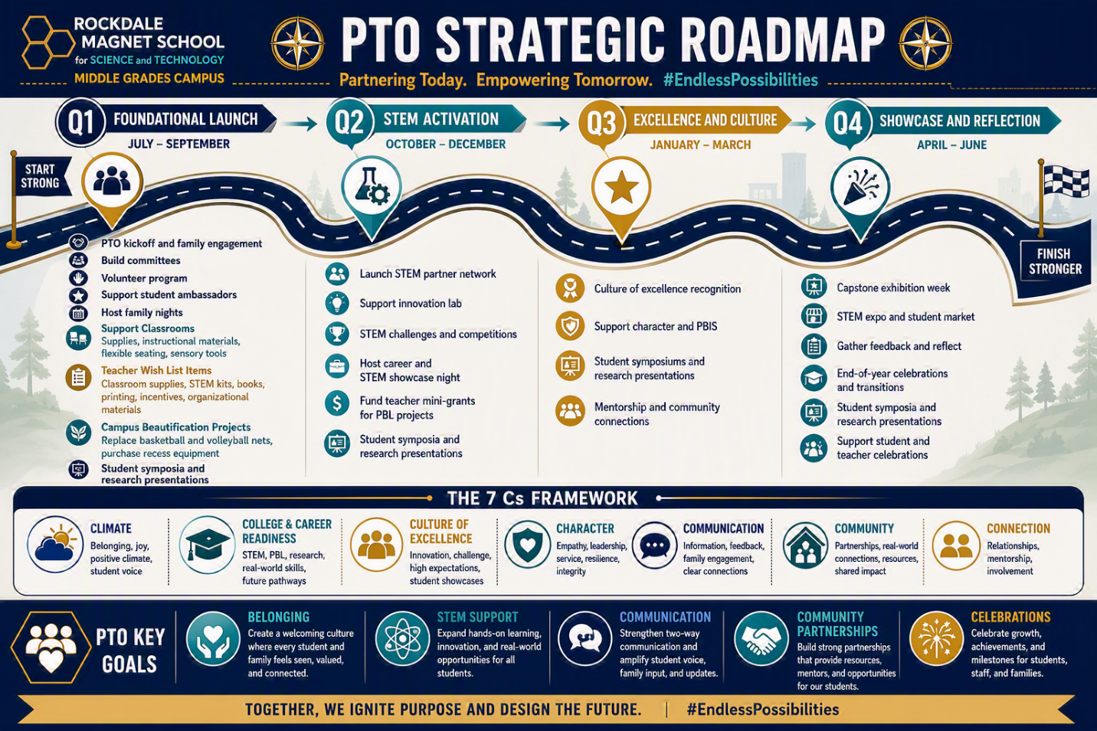

6. Designed PTO Membership Fee and opportunity for tiered membership
Membership Dues | Number of Students | Percentage Paying | Total in Dues
50 | 283 | 0.7 | 9905
Tiered System:
Scientist | 50
Researcher | 75
Innovator | 100+

7. Communication strategy discussion with two text threads started. One for administration of the PTO and one for volunteers.
8. Discussed next steps to establish PTO and officers agreed to communicate on tasks between now and Open House.
9. Established Volunteer Schedule for Open House:
7/28- Night before Open House: Shuntay, Carlock, Baskett
*5-7pm*
7/29- PTO Information, Volunteer Sign up & Membership Table at Open House:
3:30-4:30: Includes setup- Carlock, Coleman
4:30-5:30: Ashley Phillip, Ricketts
5:30-6:30: Bare, Long
6:30-7:30: Includes cleanup- McLeod-Lalor, Jazmine Williams (new volunteer)
10. Motion to adjourn by Mrs. McLeod-Lalor at 8:42pm; seconded
All approved; motion carried

