Authored By: Jayden S. Wisniewski

09/09/2024

Title: “Skateboarder Elf Rebellion”

Produced By: Jayden Wisniewski

Game Idea:

* Skateboarding elf
* Race to the goal
* The faster you are the higher your score multiples
* Grinding rails and defeating opponents increases score
* Defacing Signs Increases score
* One level, multiple paths, sonic like

Story:

Elves of the woodlands lived in peace with humans until the industrialised world claimed the elves' forest.after 100s of years and broken multiple broken promises the skateboard elf rebellion gains notoriety. Destroying propaganda and fighting back against the fascist human race that unjustly destroyed the once beautiful land. Take the fight to the man and join the S.E.R.

Concept art: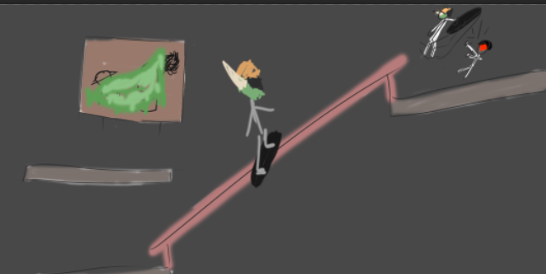

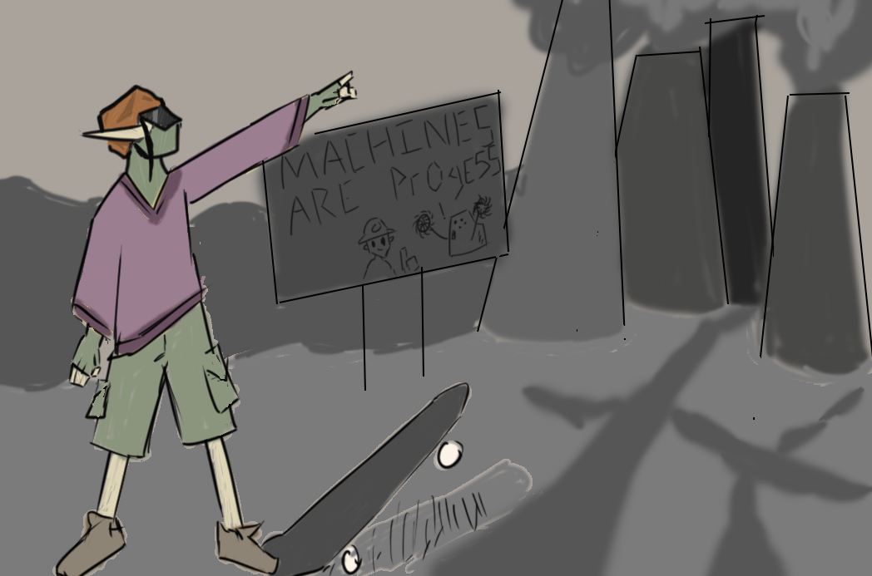

**Reflection:**

Godot frustrated the hell out of me. The single scripts per nodes and node based engine formatting really frustrated me. But as my game progressed I found things that would’ve taken me much longer in other engines were as simple as dragging a node and checking a box. I wish my game had more and I’m mildly disappointed. But between learning a language based of C++ (one I’ve never even seen before) and learning an entirely new format of engine work I was happy with and proud of what I accomplished, and godot has grown on me.

**Game Link**

<https://bigredpandaa.itch.io/skateboarderelfrebellion>