Authored By: Jayden S. Wisniewski

10/12/2024

Title: “I Still Love Her”

Itch.io: <https://bigredpandaa.itch.io/i-still-love-her>

I Still Love her…

*Game Plan Doc*

*Ideation*

**Idea’s:**

Horror, Phycological, Relationships, Monster, Dark Themes, Blood, Fighting Demons, Magic, Evil Church.

**BrainStorm Ideas:**

* Monster hunting shotgun Priest
* Demon Priest Possessed son and you have to save him
* **Monster wife tries to kill you**
* Vampire Dating Sim

**Visual Style:**

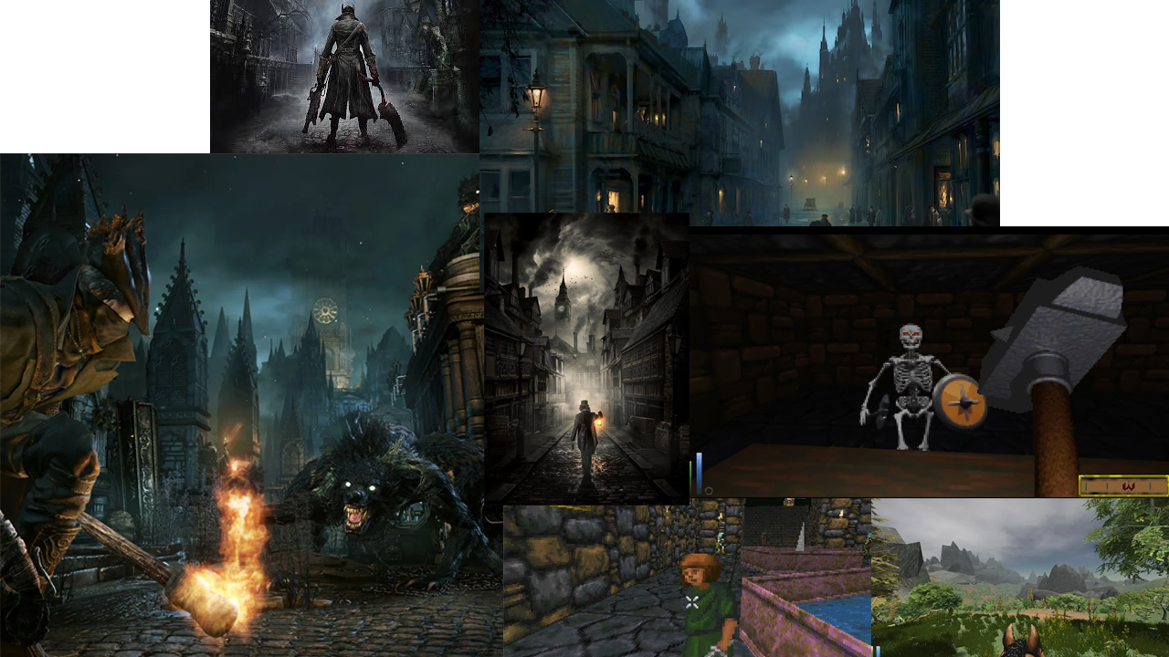

*Game Finalisation*

**Game Idea:**

The setting is a dark fantasy world. The playable area is confined to a house. Your wife has recently gotten sick and each night becomes a terrible beast, a werewolf! The priest comes by and tells you to lock her away for your safety, the priest asks you to administer her a cure every hour and give her nothing else. Your monstrous wife talks to you from behind the door asking you to help her, she asks for food and books and will eventually ask you to free her. It's your choice to listen to the priest, listen to your wife, or listen to neither.

**Major Systems:**

Cutscenes

Voice Lines

Sounds

3D/2D interactions

Music

Juice

Camera movment

**Mechanics**

* Picking up objects
  + Pick up objects that display on screen
* First person movement
  + Moving from a 3D First person POV
* Timer (Removed)
  + Timer for completing objectives
* Object interaction
  + Passing objects through a door

**7 P’s**

*Purpose:*

To tell a story that represents how BPD can affect a person and their relationships in a creative and respectful way

*Plot:*

your sweet wife is infected with an illness and is turning into a werewolf. You lock her behind a door and you’re tasked with her care. Your actions will affect the outcome of the game

*Proportions:*

The environment will be scaled to the average size of a male man

*Pose:*

The world will be framed in a rugged low poly look.

*Personality;*

Dark, serious, morality based

*Perspective*

The camera will be in the perspective of the protagonist first person view

*Presentation*

Dry and dark colours, night time foggy atmosphere.

*Development*

UI Mockup

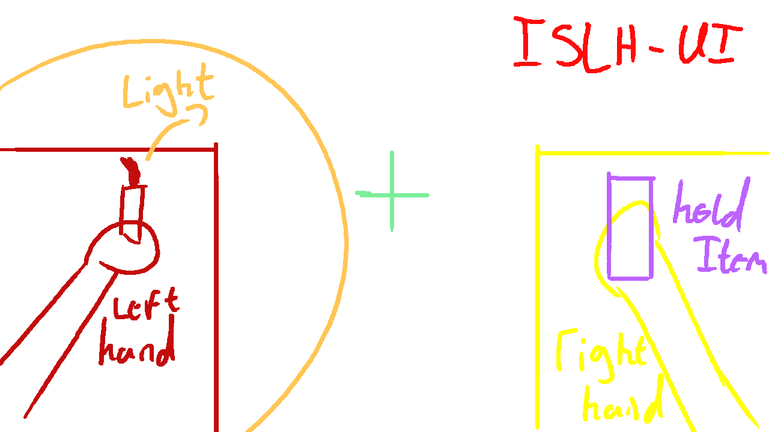

Final;

