Class #002

Jayden Wisnewski

The Design Of Pokémon Art



What makes every new Pokémon game so exciting? What are you hoping to see every time you pop in the game cartridge? You want to see the Pokémon and catch your favourites and build the most diverse and fun team for you to claim every badge. Within each element each Pokémon can essentially function the same, so what makes us want some more then others? The design of the Pokémon themselves, the sprites, the models, the evaluations. Some people may pick a pokemon that looks intimidating like an *Incineroar, Ghastly, or Houndoom*. Maybe they like cute pokemon: *Munchlax, Skitty. Or Cubchoo*. But what makes up these designs that make them so interesting?

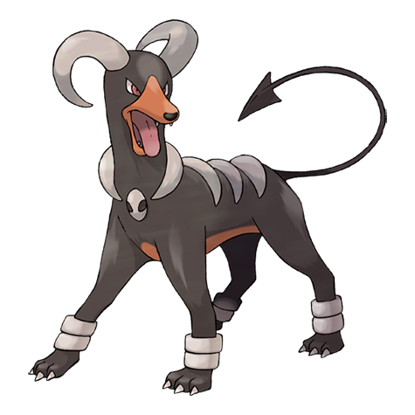

Pokémon, typically are designed with purpose. Typically seeing this weird creature on your screen or on your roster you could see their lifestyle without even reading the Pokédex. A great example of this is *Snorlax*. He is a happy and lazy, sleepy pokemon with the word “snore” baked into his name.he feels similar to the Pokémon equivalent to a panda, and that little bit of character we can see from Pokémon to Pokémon make up part of the reason we love each of them differently and tend to have favourites. Seeing a character in a pokemon allows you to apply a personality to them and build a connection, however small, to each and every Pokémon allowing us people to make connections to our favourite designs.

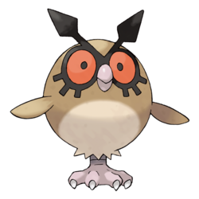

Some Pokémon also represent certain animals we may have connections to outside of the game world. Pokémon can be made to look similar to Mice, Dogs, Cats, Bears, Birds, Ect. Making these choices in design builds a further bond with the player. Personally I always liked owls as a kid and during my play through of *Pokémon: Heart Gold* I always kept a HootHoot in my team, why? Because I am a silly human with silly human connections, and even though HootHoot isn’t very special and is a very easy Pokémon to catch, it's alway nice to have one in my team.

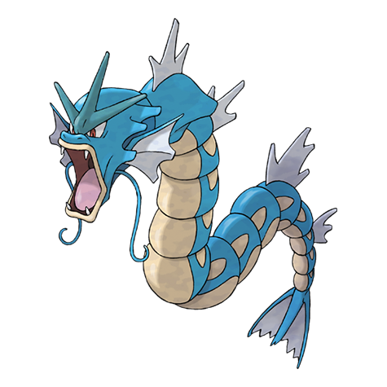

Lastly, Their evolutions, Some Pokémon start out (in my opinion) Useless and pretty uninteresting; Magikarp & Metapod immediately come to mind. But catching these Pokémon is an investment to some players because holding on to these less interesting Pokémon lead to awesome and extremely uniquely designed Pokémon like Gerados & Butterfree. So sometimes we catch Pokémon not because we want that specific one but because we want the much more powerful evolution and watch them grow from nothing to something truly fearsome. Once again, that observable growth via evolution, watching the sprite look bigger and stronger than the last, provides another point of connection between the players of Pokémon and the Pokémon in the game.