Authored By: Jayden S. Wisniewski
3/26/2024

Title: “Sail & Sword: The Oceans Revenge”
Produced By: Icarus Entertainment

Work In Progress

Sail & Sword: The Oceans Revenge

Design Document
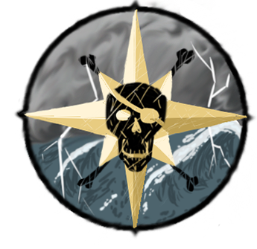

Contents:
The Crew 3
Gameplay 3
Introduction: 3
Major Mechanics 3
Tutorials 4
Tutorial Design 4
Gameplay Loop 5
Gameplay Mechanics 6
Weather 8
Boat Gameplay 9
On Land Gameplay 11
Boss Battles 13
Level Layouts 15
Enemy Types and Behaviour 19
Game Information 19
Game Feel 19
Characters 20
The Artstyle 21
Map 21
Major Locations 22
Asset List 22
Story 25
The Control Scheme 26
Controls Needed 26

The Crew
- Game Director
  - Jayden Wisniewski

- Art Lead
  - Brianne Hotte
- Art team
  - Aidan Cacoilo
  - Sergio Mouro

- Programming Lead
  - Kenechukwu Ozoemene
- Programming
  - Ashley Hacker
  - Ilya Soukoreff

- Sound & Music
  - Aidan Cacoilo
  - Brianne Hotte
  - Ilya Soukoreff

- Design Team
  - Jayden Wisniewski
  - Aidan Cacolio

Gameplay

Introduction:

Welcome and Thank you for reading, this document intends to outline all important information regarding Icarus Entertainments 2025 Release of the game “Sword & Sail” This is a student project of which we all have high hopes for. Enjoy your time reading about this sea surfing title.

Major Mechanics
- Sailing
- Ship-Ship Combat
- On land exploration
- On Land Combat
- Puzzle Items
- Hint System

Tutorials
No flow state breaking/Pausing. We will use simple Direction and Diagram sign posts. Easy to skip for returning players and informational to returning players.

Tutorial Design
You awake on a rowboat with Maris, She is rowing. As you come to she greets you and introduces herself. She offers you an opportunity to take revenge on those who had killed you. She does suggest getting a ship, and good for you, she knows where to find one! As dusk fades you and maris arrive on the far side of one of Captain Crows Crew’s fortified resupply checkpoints, you land near the training ground and are introduced to the sword and pistol, there will be a sign with diagrams and button prompts to show how the player can use their newfound tools. A dummy will be there for the player to hit and once the player is comfortable with their new tools. They can continue through a path in the trees (Highlighted by Maris standing near the entrance) towards the fort.

Once they reach the fort they can enter through the fort's backdoor. Once inside there will be 2 enemies to guard the hallway that leads further into the fort. Once dispatched the player will be led down a hallway into a stash of rum in barrels which is a healing point for the player. Maris will explain that rum cures all ailments and can heal the player to full health. After that there will be 2 more rooms of enemies for the player to further experiment with the sword and pistol. They emerge from the front of the fort onto the dock, another barrel of rum will be there to heal any damage the player might’ve taken. Once on the dock it is as simple as going over to the ship and pressing the prompted button to steal and take control of the vessel.

Once the ship is stolen alarm bells will ring and the ship tutorial will start. Maris will say she can see ships coming so the player should prepare, after a little bit of the player having control over their boat with no enemies to let them press a few buttons, Maris will say “ship spotted!” and the enemy ships will appear. The player will have to fight ships with the guidance of Maris who tells the player how to do certain actions. UI will be used to help detail what the player can do. After the fight the player sails off into the sunrise.

[Title Drop]

The player then arrives at Captains Cove where the player meets Kingston and Lola, who will explain how to upgrade the ship they just stole, and how to upgrade the player's gear, the player will purchase rudimentary gear to make sure they know what they're doing. Then they are shown where their boat is kept, Maris then tells the player to set sail.

Gameplay Loop

The gameplay loop begins after all basic tutorials are completed in the intro (Sailing, Land Combat, etc.). The game is an Open-World Explorer game with ports at which the player can choose to land at. The player may not leave the boundaries of the ship while not at port but can wander the ship while not at the helm. Ports have One Static docking area where the player may land and disembark from. The docking area will be fairly obvious and will be indicated by a dock, highlighted by lighter water surrounding it.
Story Ports:
The primary and most crucial type of port is the Story Port. The intention is to have four main story ports. The first 3 ports will be attached to islands that have a smaller plotline on it as well as a “dungeon” ; each dungeon will have enemies within, 2 items used to solve puzzles, as well as a boss fight at the end of the dungeon. Each boss is related to the smaller plotline for that island, as well as an underling for the final boss. Once the dungeon of each island is complete the plotline wraps up and the player is rewarded with lots of booty (treasure). These Islands will appear as Dioramas at sea. Interacting with the docks will transport the players to the scene.

In essence the gameplay loop will boil down to: Sail, Dock, Puzzle, Reward, Upgrade. Each step of this loop should feel rewarding in its own way and should gently guide the player into the next part of the loop at the player's discretion.

Gameplay Mechanics
These are tools the player will have at their disposal to progress through the game. This Encapsulates General Game Progress, Story Progress, and Side quest Progress.

The Boat
Sailing
Sailing begins on the ship. As you board your ship, you don’t immediately begin sailing. As you can explore the small area, your ship provides. Sailing is done from a wide perspective, slightly angled behind a top-down Point of view.

Rules of the boat's movement

- The Boat cannot move backward
- The Boat's movement speed is determined in three stages: slow, medium, fast. This speed is determined by the player and is like a gear shift. To go from slow to fast, you first need to go medium speed, then to fast and vice versa. With no sail raise, the boat will not stop, but instead will slowly drift to a stop.
- The player can only steer left and right, the forward movement is determined by the movement speed stage the boat is in and the lower the movement stage they are in the faster they turn the ship.
- Crashing into objects at sea will knock the boat back slightly. These objects can range from other ships, islands, or rocks. Hitting these items can and should damage the boat. The movement backwards is to prevent the player from unintentionally getting stuck onto these objects, as the boat can’t necessarily back up. The damage that the boat takes should also have a cooldown of a short duration (~1 second) to prevent the player from obliterating their health bar.
- If the boat has stopped the player can still rotate the boat. This allows for the player to escape from being stuck or to turn around in tight spaces.
- Docking the ship at a port will bring it to a scripted halt

Wind Riding
Wind Riding is one passive mechanic that will persist during gameplay and is up to the player to choose to interact with it. While sailing, the player has a chance to often find large gusts of wind on the sea. These gusts of wind can go in all directions and will be found randomly spawning, but should try to point out to the open sea and not into land masses. If the player sails into the wind, the ship will shake and rock side to side. If the player faces against the wind, the ship will drastically be slowed. The more sail the player has hanging down, the more their overall speed will be reduced (fast being the most affected and no sail being the least affected). If the player faces the wind, the player will begin “wind Riding” and will significantly speed the ship up and allow the player to quickly sail on.

Cannons
Cannons are a Crucial part of the ship as these will be the player's main form of damage. The cannons are mounted on both sides Left and Right. The side cannons are good damage dealers, Maris will man the cannons with a magic effect over the cannons. The player will shoot either the left or right cannons by pressing down on the left or right triggers. The player will aim these cannons with the ship's rotation. The camera should rest above the ship tilted slightly back instead of directly above.

The Captain
All of these abilities can be used when on foot as the captain.

Sword
A simple sword. The sword has two forms of attack: Light & Heavy. These will be using the Right bumpers on a controller. The heavy attacks will slowly recharge whereas light attacks can be used to harass opponents. The heavy attacks will have a large sweep being able to swipe across large crowds of enemies and deal mass amounts of damage, the light attack will have a smaller swipe radius targeting about 1.5 the size of an enemy, being able to hit two or more targets if precise enough.

Pistol
The Captain's ranged weapon. The captain can use this both as a tool and as a weapon. The Captain uses the gun in a sort of queue system, upon holding the button to signal shooting the gun an icon will appear in 3D space on the screen and as the player highlights enemies and shootable objects they will highlight and once released the captain will fire it in order. The limiting factor that keeps this gun down would be how much ammo the player has. Each subsequent upgrade the player gets will be an addition of one bullet added to the total of one. Starting with a minimum of 1 bullet and a maximum of 4 bullets. Each time the gun is fired by the player no matter how many bullets were used there is a set cooldown of 4 seconds.

Harty Rum
The Harty Rum is an item the captain will have to find in each level. The Harty rum will Bring the player from any amount of health to full health and can be used at any time, holding a max of 3 at a time. All empty bottles can be refilled at any barrel of rum, on the same button press as healing at them.

Story Port Items

Lantern (Captain CannonBall)
Can light up dark areas as well as certain objects on fire. Objects include fuses, explosive barrels, or other lights. When equipped into an item slot this will passively light up areas around the player.

Explosive Ammo (Captain CannonBall)
Explosive Ammo Will shorten the range of the Pistol drastically (Half or more). This ammo will be able to break metal objects and blockages. This Item can also be used to blast away metal covered enemies and decimate any other “squishy” enemObjects will be Shiny to make it clear they will shatter with explosions.

Harpoon (Captain Sploosh)
The Harpoon will be used to pull the player towards designated objects. The player can use this to cross large gaps without falling in. The harpoon can also be used to pull designated objects towards the player.

Scuba Boots (Captain Sploosh)
The Scuba Boots will allow The Captain to enter areas submerged beneath water marked as “Shallow water” this type of water will be lighter and faintly transparent with the deeper areas around looking like an oceanic drop off. The captain will not be able to use his gun underwater. The Captain can take off the scuba boots to float to the surface again. There is no limit to the duration of time The Captain can spend under the water.

Paraglider Kilt (Lady Luck)
The Paraglider will allow the captain to ride strong gusts of wind and glide across large open gaps where the spear gun isn’t applicable. The player will be rushed across the gaps below using visibly marked “Lucky Wind”.

Lucky Lockpick (Lady Luck)
The Lockpick seems to work like magic and allows the captain to access rooms with a lock, this is a simple timing puzzle where a player needs to press the interaction button right as the player's spinning icon matches with the static unlock icon in the circle.

Weather
The game will have small uses of what we will call “Weather”. This will include a simple day and night cycle and some visual changes and or ambience changes; with additions of wind dispersed amongst the open sea. The player will be able to sail at max speed for any duration for any amount of time. Wind does not globally affect the players traversally on water. Instead the player can find small pockets of wind that point towards a general direction. That can be used in both positive and negative contexts. If the player runs with the wind they will receive a 2x Speed boost while riding with the wind. If the player runs against it the speed of the boat will be halved. The speed boost should only affect the boat for a few seconds longer after leaving the speed boost whereas the player will be instantly set back to 100% speed after exiting a wind tunnel at the wrong end.

Weather will not be present inside of a building but should be present at the open sea and when on land (if applicable). The day and night cycle should be persistent across both areas as well as the weather. Matching open world sections to our individual levels is important in showing the elapsing of time for the story or the duration the player has taken between transitions. For the optimal game feel we want the player to feel as if the time between ship and land was mere moments. Failing to do this would break flowstate and could take a player out of the game.

Boat Gameplay

We’ve defined some rules for this type of gameplay already so before we continue lets reiterate the rules already given to the Ship you captain:
- The ship moves forward only
- The ship can get speed boosts from utilising the wind
- The boat can only fire from the sides
- The boat is steered left and right

So moving forward, the boat is the main source of movement between key moments on land, although this makes this aspect of the game no less important and in need of interest. The player will have enemy ships that they can fight against. The ships will come in variety of:

- Merchant Ships
  - Merchant ships are fast ships that run away from the player. On defeat they drop a lot of money, they should be the weakest of all ship types.
- Black Sails
  - These are your classic enemy, they are a weaker ship that roughly matches the players level of equipment, if not a little less. These ships take a few good shots to take down and will typically shoot the player.
- Metal Ships
  - These boats are stronger than average until a player cleans the metal covering the sides of each ship with explosive ammo. Once the metal is removed they will be able to be Damaged with normal cannon fire and can be sunk easily (1-2 normal cannonballs)
- Lucky Ship
  - These ships have wind on their side and the only way to get a shot in is to ride the wind behind them, these ships are fast but bigger than the oceans revenge and these ships can be caught if the captain rides the lucky winds of these ships and gets a shot in to sink them.
- Scuba Ship
  - These ships are marked by a telescope and flag which poke out from the water, the scuba boats will launch explosive barrels from under the water up at the player, The player can shoot the barrels to make them explode before contact, to make the scuba boat emerge from the water to damage it the player will need to hit the telescope from the top of the boat. The Boat will then emerge from the water to fight the captain one on one

The captain's ship “The Oceans Revenge” will fire cannonballs from the left or right side whenever the respective trigger or mouse button is pressed down. The shots will be fired in a straight line from the ship's side. The cannons will be aimed with the ship's rotation.

The Player will also be given different Ammo types for they’re ship, cycled through with the left and right bumpers, these should have limited quantities excluding the basic cannon ball. The variations of cannonball are

- Basic shot
- Chain Shot
- Explosive Shot

Each shot has its own type of interaction with each variety of enemy Ship as listed below

Weapon → Ship Interaction:

- Chain shot — -50% Movement—->Lucky Ship(Sails)
- Explosive Shot — Critical —>Lucky Ship(Hull)
- Explosive shot — Removes Armor —> Metal Ships (Hull)
- Chain Shot —- Removes Periscope —-> Scuba Ship (Sails) [Submerged]
- Explosive Shot — Critical —> Scuba Ship (Hull) [un-submerged]
- Explosive Shot — Critical —> Metal Ship (Hull) [un-armored]
- Explosive Shot — Critical —> Black Sails (Hull)
- Explosive Shot — Critical —> Merchant Ships (Hull)
- Chain shot — -75% Movement—-> Metal Ship(Sails)
- Chain shot — -75% Movement—-> Black Sails (Sails)
- Chain shot — -100% Movement—-> Merchant Ships (Sails)

A critical in the context of ship to ship battle is doubling of the damage generated by the player. The player can distribute criticals but cannot receive them to provide consistent expectation of outcome for receiving damage while providing a feeling of luck when dealing damage.

The Boat will work on a hidden set health. The health will be indicated by a jelly screen. Similar to call of duty’s health indicator. The screen should get darker with a creaking noise intensifying as the players ship takes more and more damage. Before the player is fully sunk display warning text to the player alerting them to the dire scenario they’re in.

On Land Gameplay

Movement
Player movement will work at a constant speed with eight directional movement. The player will have no sprint but instead move at a consistent speed across the map whilst on land. The speed should be adequate for brevity of travel but not so fast to allow the player to completely breeze past points of interest in the game. (I know that can sound confusing just make him a nice jaunt speed)

The On land sections of this game should feel like a classic dungeon crawling adventure, focusing on puzzle solving with simplistic and easy to learn combat.

Most simple enemies will take one to two hits to take down. The more advanced enemies that will be island specific will be a game of “rock, paper, scissors” between the enemy and player. By that I mean, if the enemy has a metal shield the player's basic sword attack won’t work until the player blows up the shield, so on ad infinitum.

The Captain has two basic attacks and many different tools. The two Basic attacks the captain will have will be a light and strong attack. These two attacks will change in timing and damage output.

Light Attack
The light attack will have a second or less on its output and deal small outputs of damage, enough to take a small beginner enemy but too weak to be significant as a single strike on a boss. The range of the light attack will be a small swipe in front of the captain roughly 1.5 times the size of an enemy hitbox.

Heavy Attack
The Heavy attack is an attack that will need to be charged up, the charged attack will deal a great amount of damage and wipe most enemies (Excluding bosses) down in one strike. The heavy attack will swipe out in front of the player able to hit 3 enemies in one strike.

The captain will also be provided a pistol and this pistol will have different ammo that can interact as both tools and weapons.

Basic Shot
The basic Shot is a small blast out in front of the player in a cone shape. This shot can splinter enemies with wooden shields in one shot and take out enemies with a size of 2.5 enemies. This ammo type is infinite.

Spread Shot
Spread Shot is similar to a basic shot but goes farther and spreads wider. The ammo type can do everything the basic shot can do but will cover more range and distance. This ammo type has a capacity of 50.

Explosive Shot
The explosive shot is only available after the battle with Captain Cannonball. The explosive shot is a special variety of shot that will destroy shiny metal objects: Blockades, shields, and Armour (in the case of Captain CannonBall). This ammo is a one shot to all varieties of enemy (excluding bosses) and should be extremely valuable as a tool and weapon This ammo Type has a Capacity of 15

With all the combat going on the captain will need a healing mechanic. This takes the form of Hearty Rum found around the levels you can explore.

Hearty Rum
The player will have 3 bottles of hearty rum on them to be used whenever need be. Once the rum is used it heals the player to full and turns into an empty bottle. The empty bottles can be refilled at rum barrels which will be placed around islands. On interaction, the player's health will fill and their bottles will refill turning back into Hearty Rum for the player to use later.

Boss Battles

Captain Sploosh
Captain Sploosh is a Scuba Diver and his battle takes place on his sunken ship under the water. The boss will start under the water and as the player hits the boss he will call upon his kraken that will reach its arms through the bottom of the ship. The player will need to remove there scuba boots that weigh them under the water until the kraken passes all while swimming around and dodging Sploosh’s timed explosive barrels, after the kraken passes, Sploosh will attempt to recall the beast and turn his back to the player allowing the player to use the Harpoon to yank the boss back into water and resubmerge to restart the combat with the boss. This loop will happen three times and each time will get faster and more intense with each cycle.

Lady Luck
Lady luck is a casino running pirate lord and is not only lucky but quick on feet. Lady luck does not have a specific boos room but will lead up above the casino room floor to the second floor. While overlooking the casino below the player will use the lucky paraglider and ride the winds that will lead to each room. The winds will be similar to a sliding puzzle and should lead to two separate rooms. Lady luck will be hiding in one of these rooms, indicated by her glittery trail. Following her will lead you to a room After beating her once she’ll flee to the other room removing that room's instance of her creating one in the next room. After using the same assortment of directional winds to reach the other side of the room the player will fight Lady luck once again. After the second fight she will drop her lucky lockpick. Re-entering the wind puzzle again you will need the lucky lockpick once more to (once reached) unlock the third and final door. Inside she will fight the player one last time, and upon her defeat the boss will be vanquished, she will throw her boomerang at you and you will have hit it back at you and then race to her position in the room to land a hit. .

Captain Cannonball
Captain Cannonball is home to an industrialised island fortress. Reaching Captain Cannonballs cannon Shooting range you will find him wearing small plate armour. He will be impervious to any non-explosive attacks. Once the player blows the metal plating off the boss using the explosive ammo the boss will be stunned and open to attack. Abusing this opening Captain Cannonball will jump up to the explosive cannonball production track. Grabbing the cannonballs off the track he will begin tossing them down at the player. At random he will throw down an explosive barrel. The player will need to use the lantern to relight the barrel and toss it back up at the boss to toss him back down. The boss will once more be stunned and wont put up much of a fight before being defeated.

Captain Crow

This boss is the culmination of all the other previous bosses. He will begin the fight by pulling out a shield; the player will blast the shield away with explosive ammo and abuse the boss whilst his guard is down.after a short back and forth with this system crow will move to the second phase. Lifting both him and the player onto platforms. Crows will call upon a great wind. As more platforms rise from the bottom the player will need to quickly jump from platform to platform using the wind and the glider to reach each platform. If the player takes too long the boss will aim and shoot them. After reaching him The platform crow is standing on the player will knock him down back into the arena. As a final move,Crow will flood the arena while staying dry on a platform. The water will rush against the player pulling the player toward the back of the arena where the player will fall to their death. The player will need to keep up against the rushing water and also dodge explosive barrels. Captain Crow will eventually turn around to twist a crank and reload his roster of explosive ammo. Upon turning around the player can yank the boss into the water causing him to fall off to his doom

Level Layouts
Turtle Isle Outskirts (tutorial)
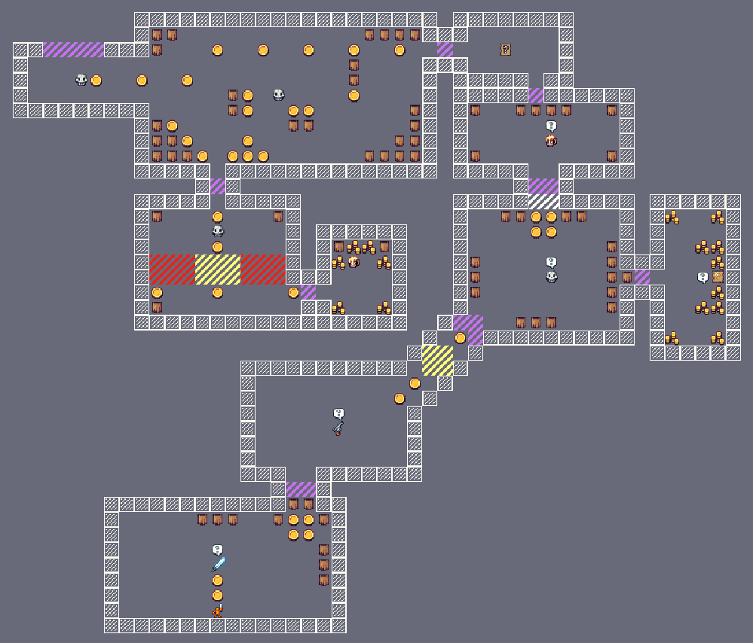
The Mermaid
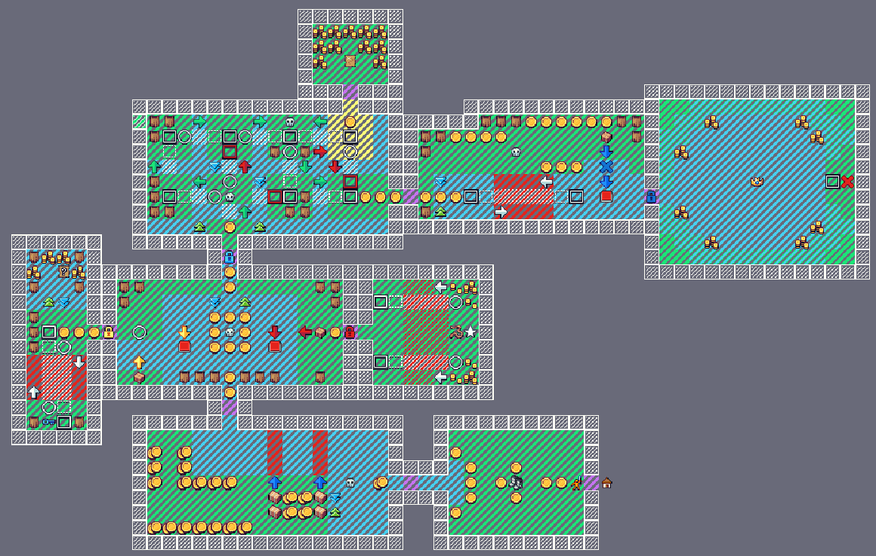
Bomb Bay
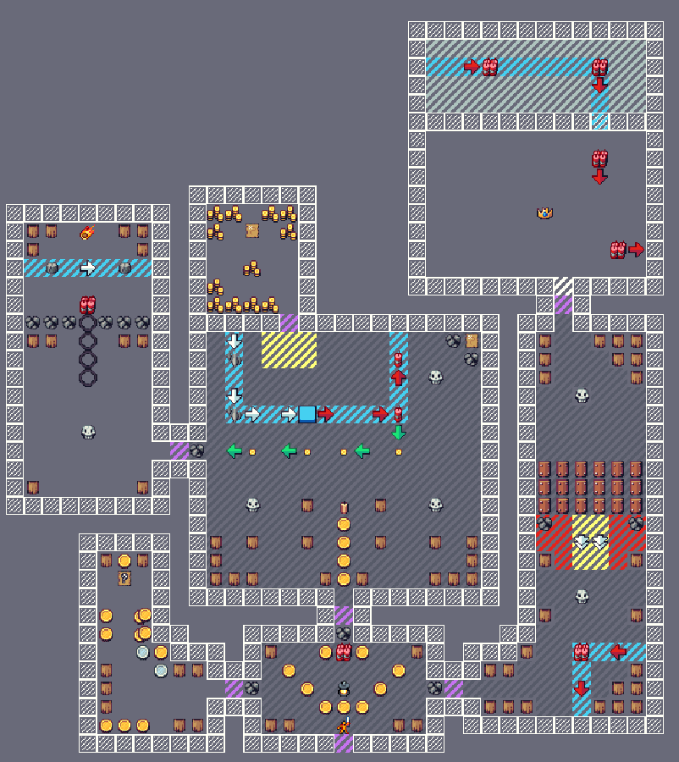
Lucky Landing
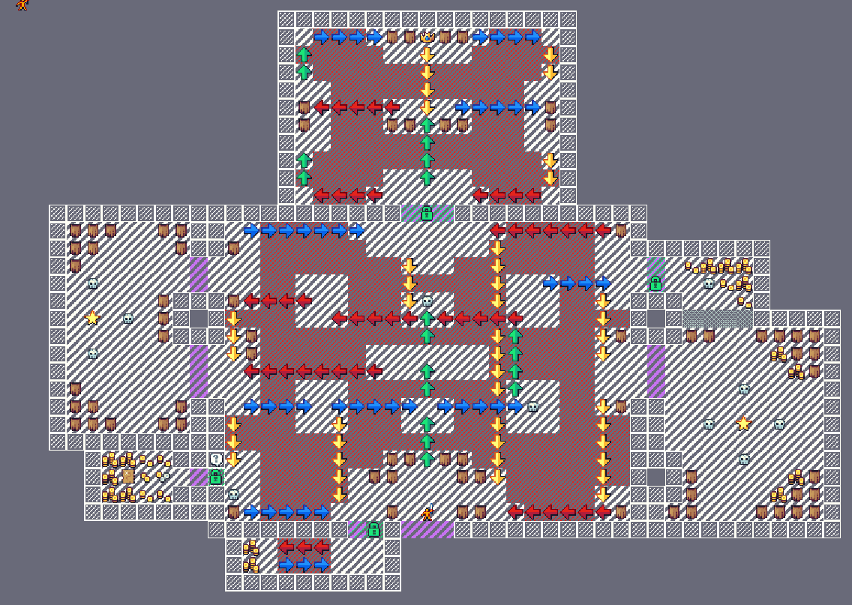
Crows Castle
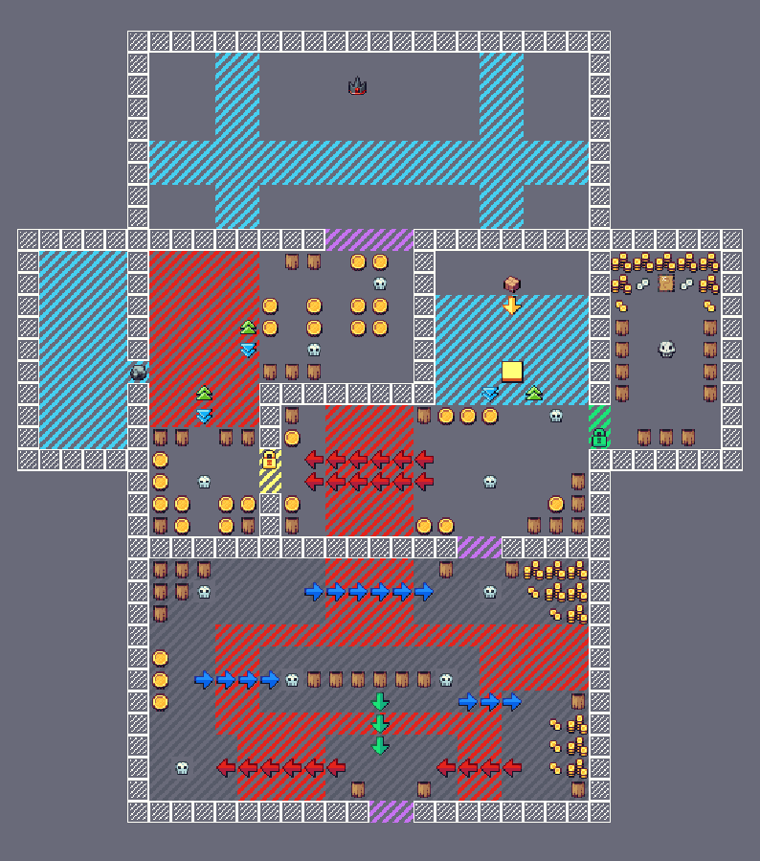

Currency Distribution and Uses
Currency or in our case, Doubloons will have three different Values:
 | Copper Doubloon | 10g
 | Silver Doubloon | 50g
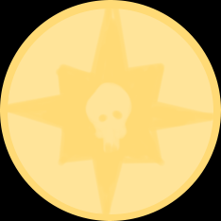 | Gold Doubloon | 100g

Enemies, Barrels and within the level layout is where coins will be found. These will be all locations where coins can be found. Coins can be used to upgrade your weapons and armour, the player will also be able to restock any rum or special ammos from on the sea vendors or at the Captains Cove.

Coins will be abundant and most will be copper coins. Upgrades will be fairly expensive, and should typically only be able to earn one if the player explores and finds the treasure rooms in each dungeon.

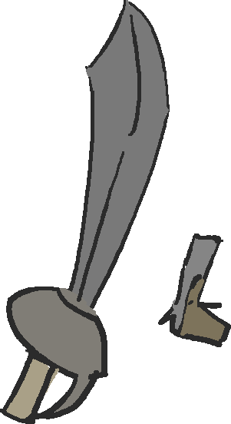 | Upgrade 0 | 150g
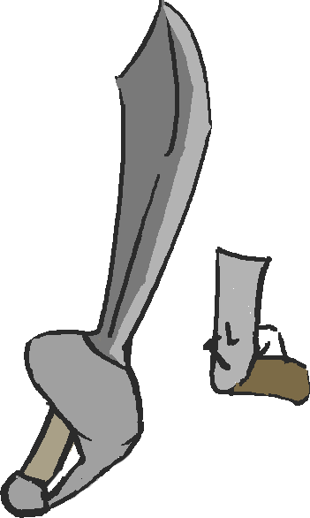 | Upgrade 1 | 2000g
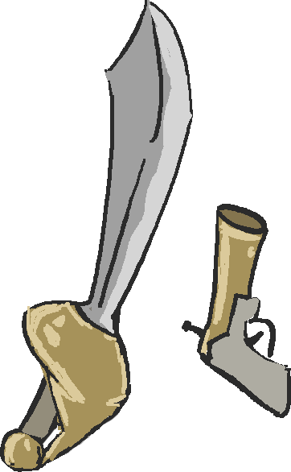 | Upgrade 2 | 2500g
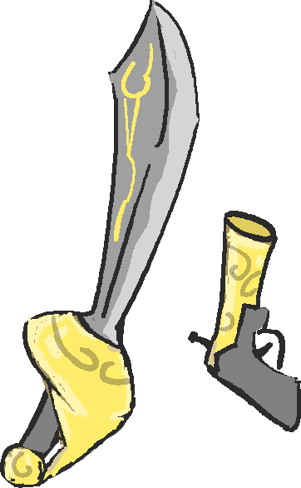 | Upgrade 3 | 3000g

Enemy Types and Behaviour
Seek and Destroy Enemy:
- Find the player
- Walk to the player
- Attack
- Pause action (do nothing for a second)
Ranged Enemy:
- Get within range of player
- Aim
- Pause action
- Fire
- Pause action
- Back up if the player is too close
Pac-Rat Enemy:
- Has a path
- Follows path
- Hits the player if he crosses the path

Game Information

Game Feel
This Game is a love letter to the LEGEND of ZELDA. This game's design and over game play loop will look and feel very familiar to the legend of zelda specifically Link's Awakening. On land, movement should feel snappy and deliberate. The player will have 8 directions, 4 cardinal and 4 diagonal when on foot to hopefully help the movement feel snappy and responsive.

Ship game play will feel less precise. The boat should feel big and take time to respond. This ship shouldn’t feel impossible to turn just hefty and as if you aren’t in charge of the boats every action but instead are guiding a large beast as it charges onward. As a reference for game feel within the ship look to Assassin's Creed IV: Black Flag

Characters
- The Captain
This is the protagonist and player character. He is the Undead pirate King, brought back to life to enact the Oceans Revenge. He has no Jaw and Can’t speak. Despite his lack of input he enacts the revenge of the ocean and brings swift justice to the men who had killed him
- Maris
Maris is The Captain's ally and magical guide. She is cloaked in mystery despite her bubbly and charismatic personality. Using her magic she is The Captains first mate, manning cannons and letting masts fly with the flick of the hand, as well as using a magic conch shell to contact the player while they are away from the ship. At the end of the story Maris is revealed to be the physical embodiment of the sea and has been using The Captain to Enact her will throughout the game.
- Captain Crow
Once The Captains look out, he was always jealous of The Captains success and grew resentful. Maris wanting to stop The Captains ironfisted rule over the once peaceful sea assisted Crow to hold a coup. Successful in the coup, Crow saw no more need for maris and stopped listening to her pleas for peace. His rule is ruthless, a terrible destruction of all that was peaceful and calm of the sea.
- Lady Luck
She is a successful Gambling Tycoon. She runs and owns a whole Island dedicated to earning her money. She is a Lucky girl and likes to get her way. Crow had promised her greater expansion of Gambling Empire if she helped him take out the Captain. Helping Crow granted her the island she has now, destroying the lives of innocents who waste all their money only to end up stuck on the island. A Terrible fate.
- Captain CannonBall
A man of Simple pleasure, he loves nothing more than explosions. He runs a Bomb Factory and produces the highest Quality Explosives. He is a hot head and hates nothing more than someone getting in the way of his success. Cannonball’s deal with Crow was free access to all the minerals and gunpowder he needed to make newer and more powerful explosives. He drains the world of its natural resources and he uses them to destroy his foes mercilessly.
- Captain Sploosh
Smart, Calculated and full of ingenuity, Captain Sploosh lives in his sunken ship and builds machines to manipulate the natural order of the ocean. He Dreams of pulling his ship from the ocean floor. As he works towards his ultimate goal he builds fish powered machines of war and submarines to obliterate the innocent without risking sinking. He manipulates the natural world to make progress in terrorising the innocent. Crow had promised to fund his ideas if he had helped him in toppling the captain and allowing crow to sit the throne
- The Mighty Shelldon
A crazy old man who seems to be everywhere. He can talk to the captain telling him about his past as the Great King of the Pirates despite unwittingly talking to the former King. Shelldons Claims are outlandish and comical and are a reprieve from the more serious elements of the story. He occasionally will ask the player to sail to islands and collect his relics from his past, usually being a nonsensical item with no clear purpose.
- Kingston
A smuggler. He is a captain in the distant foreign military but finds profits within the dangerous Turtle Isle. He makes port at Captains Cove and sells leftover military munitions to the captains, or anyone else who’ll pay good coin.
- Lola
The Novice Craftsman who was neglected in her home for being seen as an unfit Craftsman decided to stow-away aboard Kingston’s ship and landed at Captains Cove selling her talents in leather working and Blacksmithing to the Carefree and rebellious Pirates of the Turtle Isle.

The Artstyle
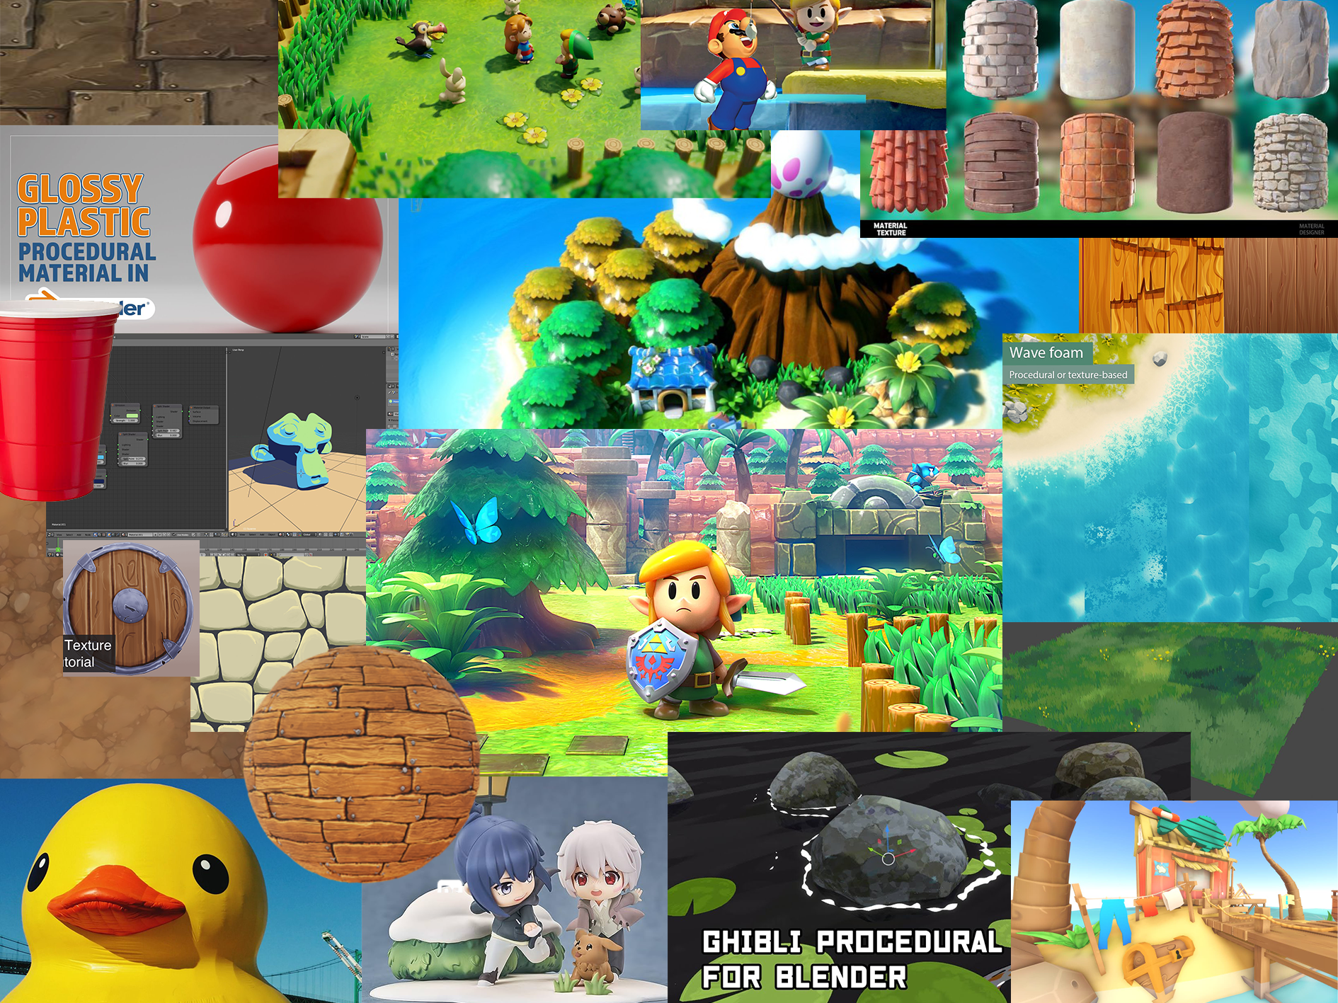
This Game will use a Simple, Friendly, and highly Saturated Style, Initially The game was talked about following in the Style of NINTENDO’s: Link’s Awakening. The Game will feel Tropical and as if it’s a fun and harmless adventure. Despite the more intense story having a more simple and toy-like artstyle could help lift the game out of being a dark and over serious game lacking the beauty of the tropics. The Style should not overshadow the story with how it’s made, but this game should look fun and appealing from the visual alone. Using the association of toy’s with the plastic and simple style should invoke that childlike feeling of playing with toys.
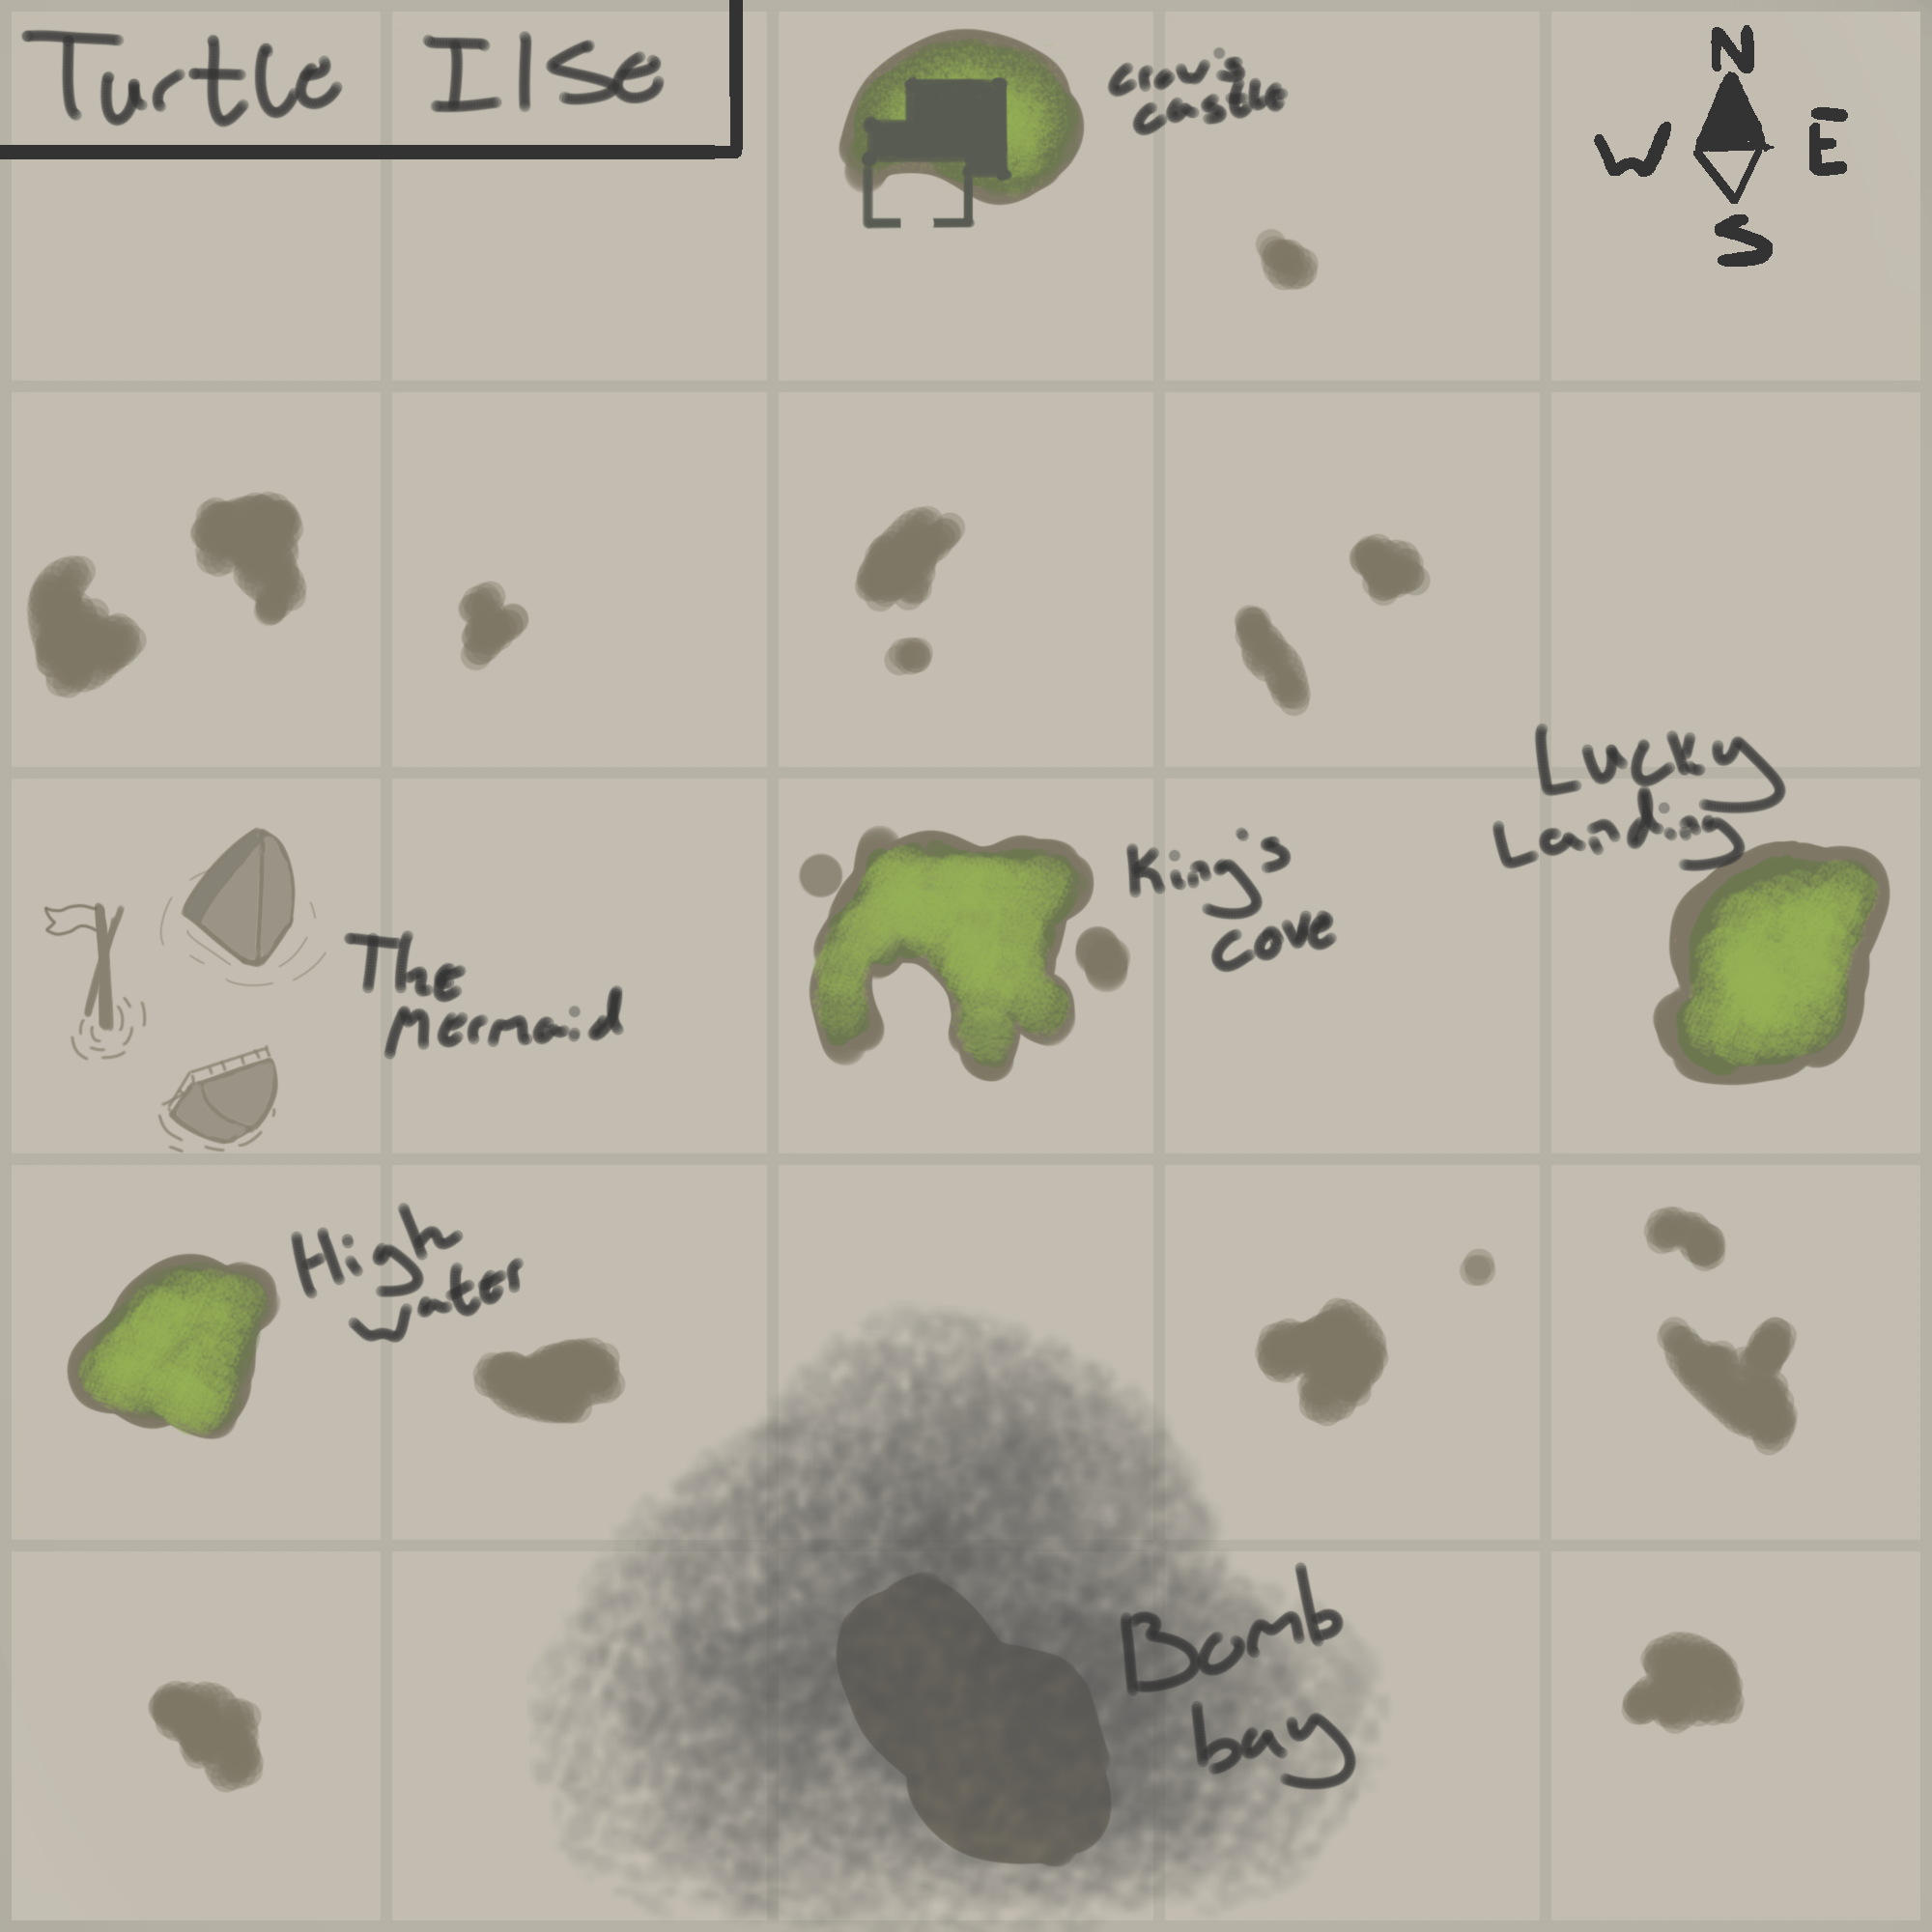

Map

Major Locations
- Captain’s Cove
A Friendly and peaceful island, inhabited by Drifters and people getting their start. It’s humble and kind with a few bungalows and mild vegetation like trees and berry bushes. This is where the captain comes to refuel, rest and Improve before the perilous quest is taken
- Crow’s Castle
A Stalwart Stone fortress implanted in the centre of the Turtle Isle. It is rumoured to be impenetrable and only a fool would go anywhere near it. Crow took the fort a little over a year ago and claimed the throne of the Pirate king and ruled the Turtle Isle With Ruthless Dictatorial power.
- Lucky Landing
An island exploding with lights and advertisements. It is one big Casino island and purely made to Earn Lady Luck and Captain Crow near infinite money off the backs of the gullible people who visit this island exploding with sound and lights.
- Bomb Bay
The Factory Island, The island is completely Polluted and is nearly devoid of all natural resources. The Island is a bomb factory and produces seemingly infinite bombs that fuel the armies of Captain Crow. It's the home of Captain CannonBall. He uses the local islanders to work his destructive factory and fuel the Explosive armies of Captain Crow.
- High Water
An Island of fishermen who are having trouble. There’s a rumour of the Sinking Of Captain Sploosh now more than three years ago. Life had been peaceful after the battle that sank his ship and fish used the debris on the ocean floor as natural habitats making the fish population dense on the coast of high water. But recently the vast fish population disappeared and rumour says the Captain Sploosh still lives at the bottom of the sea in his sunken ship and is using the fish to power his Mind boggling Machines

- The Mermaid
Captain Sploosh’s Sunken ship. Found after being given a map drawn by The Mighty Shelldon who claims to remember the battle. With the guidance of Maris you use a diving bell and go deep beneath the sea and board The Mermaid to take out Captain Sploosh and restore the ocean's Natural order and rejuvenate High Water’s Fish population.

Asset List

- General Tilling
  - Main Characters
    - Protagonists
      - Captain (Player Character)
      - Maris
    - Bosses
      - Captain Sploosh (Boss 1)
      - Lady Luck (Boss 2)
      - Captain CannonBall (Boss 3)
      - Captain Crow (Final Boss)
    - Friendly NPCs
      - Lola
      - Kingston
      - The Mighty Shelldon
      - Fishermen (3 Variations)
      - Islander (5 Variations)
      - Factory Islander (3 Variations)
  - Coins/Doubloons (Gold, Silver, Copper)
  - Palm trees
  - Houses
  - Fishing rods
  - Boat Dock
  - Barrel
  - Beach sand tile (w/ variations)
  - Grass tile variations
    - Foliage
    - Stones
    - Flowers
  - Stone tile
    - Stone to grass
  - Path
    - Dirt
    - Stone
    - Path end to stone
    - Path end to grass
  - Path end to sand
  - Chest (Opened/Closed)
- Ships
  - The Oceans Revenge
  - The Mermaid
  - Black Sails
  - Lucky Ships
  - Submarine
  - Metal Ships
- The Mermaid
  - Wood Plank Tiles
  - Stone Blocks
  - Water Tiles
  - Fish Fighters (in/out of water)
  - Kraken Tentacles
  - Iron Boots
  - Fishing Harpoon
- Bomb Bay
  - Metal Walls
  - Stone Floors
  - Conveyor belt
  - Explosive ammo pouch
  - Lantern
  - Explosive Barrel
  - Armoured Guard (2 Variations)
  - Metal Doors
  - Wood rubble
  - Ore Rubble
- Lucky Landing
  - Red Carpet floor with gold trim
  - Pillar
  - Slot Machine
  - Card game Table
  - Roulette Wheel
  - Lucky Pirate (3 Variations)
  - Wind Gusts
  - Paraglider
  - Lucky Lockpick
- Crows Castle
  - Cracked Tile floor
  - Stone Walls
  - Crow Banners
  - Pitfall
  - Pirate Throne
- High Water
  - Fishing Dock
  - Fishing net
  - Fish skeleton

Story

You are a Pirate lost at sea. A lost soul, you are Undead and without a name. Your skin is gone and any recognizable feature to bone. Awaking at sea, you remember your fate, The torment, and Pain of Cannon Fire. You remember Coin resting in a crown of bone: The Crown of The Pirate King. Along with the crown, you remember a face, it’s of a woman, a woman reaching a hand out towards you as the light fades. As you return to reality, you see the woman, she rests by the rudder of the small sailboat you alone captain.

The woman tells you of her name: “Maris” she also informs you of your fate as a soul tormented on earth. The only way to pass on peacefully is to rid the world of those who brought you to death. The Four Pirate Lords, those who wash away all in their way with the goal of gaining endless power. Your role is to bring peace to the Turtle Isle and rid them of the tyrants who rest at the top.

As you defeat the Pirate Lords, you slowly remember That you were the former Pirate king, and you were betrayed by the Lords who once served you. As you jump from Island to island, Maris talks of the sea and the strange woman seemingly has no clear origin. Before you face the King Himself: Captain Crow, She Explains who you are, you were the former King and she was the reason you were killed. She had cleaned your memory hoping you wouldn’t remember her and how she influenced Crow to rise up against your resistive hold over the once peaceful and free flowing sea.

Maris Tells you she is “The will of the Sea” and is, in essence, the sea itself. She regrets her actions, as Crow was not only restrictive but also destructive to her Sea. He refused to listen to her after taking the throne. So she returned you to life to restore the balance she had medaled in. After a short fight with her, the captain wins the fight. Maris sinks to the bottom of the sea. Unable to pilot the massive ship on his own, the captain is forced to take a defenceless sailboat. As he approaches the fort Crow calls on the kraken, formerly controlled by Sploosh, the captain is taken off guard and immediately obliterated by this monster (Give a long pause and remove the respawn button to emphasise maris’s absence) as darkness sets in the captain flashes back to life. Maris stands above The Captain, arm outstretched. They are on the ocean's revenge and The Captain’s” Iconic ship fires upon the beast. Maris apologises and reunites with the captain for the fight against the watery monster. After the defeat of the kraken the captain and maris now reunited go to take on the evil captain crow in their final showdown.

The Control Scheme

Controls Needed
- Player
  - Move
    - WASD
    - Left Stick
  - Light Attack
    - Space
    - RB
  - Heavy Attack
    - Hold space
    - RT
  - Shoot
    - Shift
    - LB
  - Interact/Speak
    - E
    - West Face Button
  - Map
    - ESC
    - Start
  - Inventory
    - TAB
    - Select
  - Hint
    - CTRL
    - North Face Button
- Ship
  - Fire Cannons
    - Right/Left Arrow
    - RT/LT
  - Raise Sails
    - Up Arrow
    - RB
  - Lower Sails
    - Down Arrow
    - LB
  - Turn Ship
    - A/D
    - Left Stick
  - Look Around
    - E/Q
    - Right Stick

