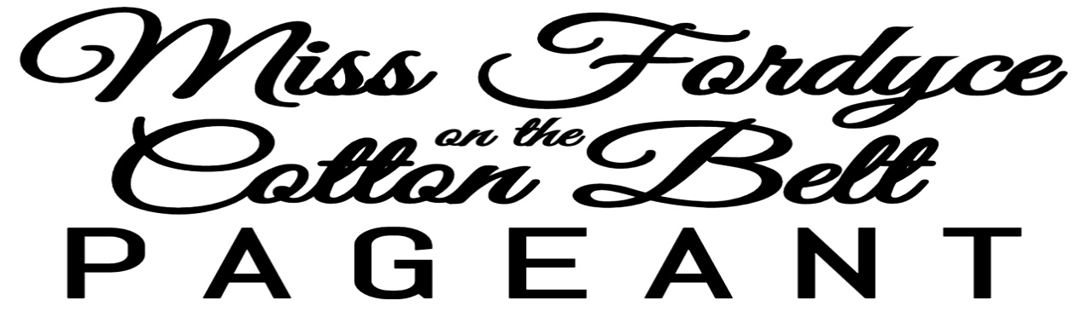

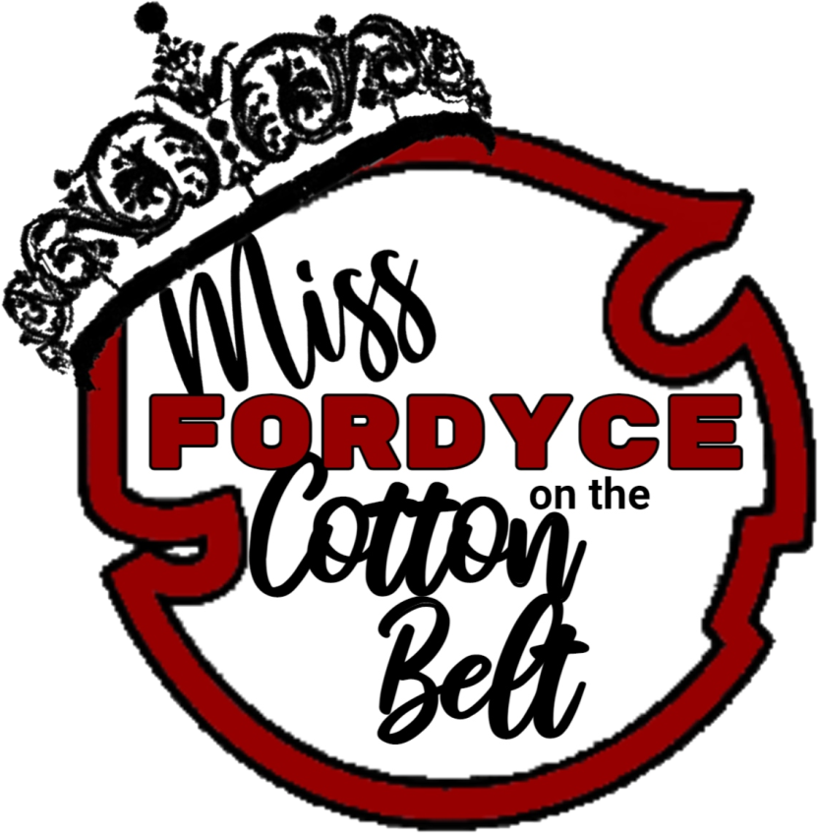

The Fordyce on the Miss Fordyce on the Cotton Belt pageant will be held on April 16th at FHS Little Theater at 2pm. **Deadline to turn in entry forms is Monday April 11, 2022.** Return entry form by email to [cottonbeltpageant@gmail.com](mailto:cottonbeltpageant@gmail.com), or turn in at the Fordyce Civic Center or the Dallas County Library. Title winners for all divisions are invited to ride in the festival parade April 23rd at 11:00am. Title winners for Teen and Miss, will be expected to be present at Fordyce on the Cotton Belt festival events, and may be asked to announce acts, contest, and special events throughout the festival. Teen and Miss winners will be ambassadors of the festival and will be assigned responsibilities and duties upon crowning. Registration for all divisions will be 12:00 to 1:00 on the day for the pageant. **Divisions:** *Please check*

**[ ] Baby Miss (0-12months) [ ] Tiny Miss (3yrs -4rs) [ ] Junior Miss (11yrs-13yrs)**

**[ ] Baby Miser (0-12 months) [ ] Little Miss (5yrs-7yrs) [ ] Teen Miss (14yrs-16yrs)**

**[ ] Toddler Miss (13months – 2yrs) [ ] Young Miss (8yrs- 10yrs) [ ] Miss (17yrs-21yrs)**

**[ ] Toddler Mister (13months – 2yrs) Total** *(division & photogenic)*$_________

**\* You MUST be registered by 1:00 pm the day of the pageant!**

**Entry fee for Baby – Junior Miss is $25.00 Entry fee for Teen and Miss is $40.00 these divisions will compete in sportswear, on stage question, and eveningwear.**

*Contestants will get one adult free, all other admission for the pageant is $3.00 per person,*

*Make Checks Payable to Fordyce on the Cotton Belt*

**Photogenic competition is optional for all divisions for an additional $10.00 photos must be 5x7 or larger no glamour shots. Photos must be turned in by 1:00 on the day of the pageant for judging. Contestants are also welcomed to participate in an optional people’s choice, contestants will be provided a bag with their name and be placed at the entrance, and the contestant with the most money donated in their bag will be crowned people’s choice winner in their division.**



Name: ____________________________________

Age: ____________Date of Birth: ______________

Parents: ___________________________________

Hometown: ________________________________

*Favorite Color: ____________________________

*Favorite Food: ____________________________

*Favorite Song: ____________________________

*Favorite Activity: __________________________

*Favorite Person: ___________________________

School: ______________________Grade: _______

Activities and Clubs: ____________________________________________________________________________________

Future Goals & Plans: _______________________

______________________________________________________________________________________________________________________________*\* for Baby – Young Miss only*

General Release: In consideration of Fordyce on the Cotton Belt, I am permitting my child to participate in this pageant. I understand that personal items lost or stolen during the pageant are my responsibility. I understand the elimination or combination of divisions is the pageant director’s discretion. I understand that the judges’ decisions are final, and score sheets will **not** be released. Entry fees are non-refundable. I understand to be eligible to compete in the Teen and Miss divisions contestants must be unwed and not a mother.

Parent or Guardian: __________________________________

Date: _____________________________________________

Suellen West, Fordyce on the Cotton Belt Pageant Director [cottonbeltpageant@gmail.com](mailto:cottonbeltpageant@gmail.com) 870-250-2565 *(text only) onlyonplease)*