## Template for IAPRI 2025 Papers

Name Surname 1 and Name Surname 2*

1 Department, University or Institute, Country

2 Department, University or Institute, Country

\**Corresponding author. Email:* [*i.name@institute.edu*](mailto:i.name@institute.edu)

**Abstract:** All papers submitted for IAPRI 2025 must use this template. All details regarding formatting are stated below. Included are examples of how to present equations, figures, tables, and references. The abstract must offer a concise summary of the paper and be between 200 and 300 words (no less than 200 words). Abstracts should be Calibri 10-point, single-spaced.

Keywords: keywords in lower case, separated by commas and finish with a full-stop.

### 1 Introduction

This template contains the styles and formatting required IAPRI 2025 papers. The paper must be letter-sized (8.5” x 11”) or A4 (210mm x 297mm), use single column format and have the following margins: 1 inch on all sides. All text, figures and tables are to be kept within the margins.

The font sizes and styles used in the paper are: 1) Title: Calibri 18-point size bold, sentence style, centered; 2) Headings: Calibri 12-point bold; 3) Sub-headings: Calibri 11-point bold; 4) Body text: Calibri 10-point, justified, double-spaced.

The Conference header must be shown on the first page only. Do not include page numbers, they will be added later.

### 2 Document structure

The paper must be arranged in the following order: title, authors, affiliation, corresponding author, abstract, keywords, introduction, body of the paper (subdivided using suitable headings and sub-headings as required), conclusions, acknowledgements and references. The authors' names are given as first name written in full followed by middle initial(s) and last name written in full. References must be numbered consecutively in the text with square brackets and Arabic superscript numerals. An example of the in-text referencing format is as follows: Work by Lee and Bennett [1] was supported by Jones [2] but later rejected by Harman *et al.* [4].

Use these section headings with suggested lengths.

* Introduction (approximately 1/2 page):
* Methodology (approximately 1 page):
* Results (approximately 1-2 pages):
* Discussion (approximately 1-2 pages):
* Conclusion (approximately 1/2 page):
* References:
* Acknowledgments (optional):

#### 2.1 Equations

Equations must be centred on the page and numbered consecutively as they appear in the text using Arabic numerals in parenthesis. Within the test equations must be referred to by their numbers only, e.g. an example equation is given in (1) below.

$f\left(x\right)=a_{0}+\sum_{n=1}^{∞}{\left(a_{n}\cos{\frac{nπx}{L}}+b_{n}\sin{\frac{nπx}{L}}\right)}$ (1)

#### 2.2 Figures

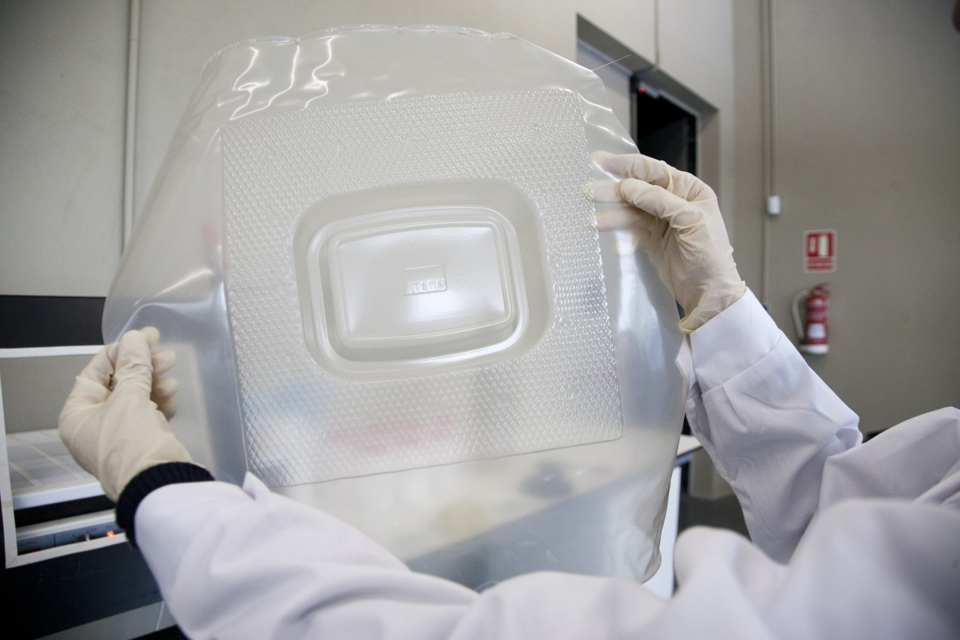Diagrams, graphs and photographs are all labelled as figures. The figures must be numbered consecutively with Arabic numerals in the order in they are mentioned in the text. The word ‘Figure’ must be spelt out in full in the text and must be capitalised, i.e. Figure 1, Figure 2, etc.. The figure, figure number and caption must be centred on the page with the caption written below the figure, as shown in Figure 1.

**Figure 1**: Thermoformed tray sample.

Each table must be located as close as possible to their first reference in the text. Tables must be consecutively numbered with Arabic numerals. The table, table number and caption must be centred and written below the table, as shown in Table 1.

|  |  |  |  |
| --- | --- | --- | --- |
| Sample type | Equivalent viscous damping ratio, ζ | Thickness x width [mm] | Initial length [mm] |
| Steel | 0.8% | 1 x 25 | 185 |
| Aluminium | 1.25% | 3 x 25 | 315 |
| Acrylic | 6.30% | 4.5 x 25 | 250 |
| Carbon fibre | 2.50% | 3 x 25 | 325 |

### Table 1: Properties of the material samples.

### 3 Conclusions

Particular care should be taken in this section the real value of a paper is reflected in the nature, soundness and clarity of the conclusions.

### Acknowledgements

If appropriate, include a short paragraph acknowledging any special support provided by a third party.

### References

Reference style. AMA – American Medical Association. All references should be numbered consecutively in order of appearance and should be as complete as possible. In text citations should cite references in consecutive order using Arabic superscript numerals. Use Calibri, 10-point font, single-spaced.

* Author Last Name First Initial Middle Initial. Title in sentence case. Abbreviated Journal Title in Title Case. Year; Volume (Issue#):PP-PP. doi: ##
* Book: Author last name Initials. Book Title: Subtitle. Publisher; Year.
* Journal: Author last name Initials. Article title. Journal Name. Year; Volume (Issue):Page range. doi or URL.
* Example 1: Piringer OG. Evaluation of plastics for food packaging. Food Additives and Contaminants 1994; 11(2), pp. 221-230.
* Example 2: Hofmann D, Ulbrich J, Fritsch D. Paul D. Molecular modeling simulation of gas transport in amorphous polymide and poly (amide imide) membrane materials. Polymer 1996; 37(21), pp. 4773-4785.