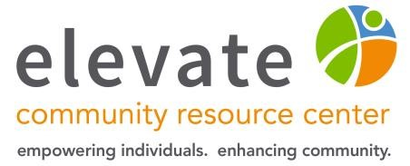
March 20th, 2023

To Whom This May Concern,

My name is Jessica Warden, and I am the Youth Services Program Manager at Elevate, a nonprofit focused on reducing substance use and increasing mental wellbeing in Washington, Waukesha, and Sheboygan County. One of the services that Elevate provides for youth is the Peers 4 Peers program, which empowers high school students to abstain from the use of alcohol and other drugs and encourages them to be positive role models in both their schools and communities.

Every school year, Elevate hosts three trainings where we provide the youth in our program with information and skills they need to provide support and leadership to their friends and classmates. For several of the training sessions, we ask guest speakers to present on topics that they have a strong personal or professional knowledge of, including local community resources, individuals who have lived experience with a substance use disorder, and family members who have lost a loved one to substance use.

In late February of 2023, Elevate had Erin Rachwal from the Love, Logan Foundation come and speak to the 10th-12th graders in our Waukesha County Peers 4 Peers groups. Throughout the session, Erin spoke passionately about working with the community to share her family’s story and educating youth about the dangers of substance use, especially Fentanyl. But Love, Logan’s presentation was not just educational, it was engaging and relevant to the students in our program, which was highly evident by the amount of questions and discussion that immediately followed during the Q&A portion of the training session.

Both the youth and school staff we work with were greatly moved by the Love, Logan presentation, and several student groups specifically brought up wanting to address the issue of Fentanyl within their schools and communities after hearing Erin speak. We greatly appreciate Love, Logan for taking the time to share their work and their message with the youth in our program, and we look forward to partnering with them again in the future.

If you have any questions, please do not hesitate to reach out to me.

Sincerely,
Jessica Warden, MPH, PS, CPPE
Youth Services Program Manager
N169 W21005 Meadow Lane | Jackson, WI 53037
P: 262-388-3132 | F: 262-677-2124 jwarden@elevateyou.org

