**First Word**

**First Christian Church Brownstown**

**January 2025**

**Upcoming Events**



The annual Youth-led Valentine’s Banquet will be coming up in February. Watch for sign-up information coming soon!



**Bond Christian Service Camp Fundraiser**

#### We Exist to:

#### * WORSHIP the Living God * WIN People to Jesus * TRAIN God’s People for Service

#### * SEND Them Out Into the World

#### 



**From the Minister**

As 2024 comes to a close, I am finishing up what I do every year at this time, next year’s sermon schedule. I make a schedule each year. I pray for God’s leading on what to preach. I think about what God has put on my heart. Then I slowly but surely get a full year’s sermon schedule planned out. Naturally, things change every yet, and I have to adapt. However, I always go into the year with a plan.

In 2025, God has led me to preach on Jesus. He is the foundation of our faith. Without Jesus we are lost. Without Jesus we have no hope. We really can’t focus on him enough. This why this coming year we will be focusing on Jesus. In fact, throughout the entire year I will be preaching about Jesus. We will be walking with Jesus through the Gospels. Notice I didn’t mention one specific Gospel. I plan to harmonize the Gospel accounts of Jesus. This means we will be combining all four Gospels into a cohesive account of the life of Jesus. In doing this, I hope we will be meeting Jesus anew, seeing him with fresh eyes.

I hope you will join me in this endeavor.



God bless,  
Nathan Brands

**Just for the Youth**



The youth will be attending Winter Jam on Saturday, January 18, 2025 in St Louis, MO. More details to come.

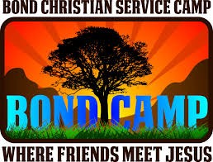

Bonding at Bond will be February 23rd from 5-7 pm. All 4th – 12th graders are invited to attend. More information coming soon!

## What’s Going On?

**Breakfast Fellowship:** If you would like to provide breakfast on a Sunday morning, there will be a sign-up sheet in the kitchen. Breakfast starts at 9:00 am.

**Leadership Team (Elder’s & Deacon’s) Meeting** is Tuesday, January 14th @ 7:00 pm.

**Youth Groups for 4th – 12th Grade** will be taking a break for the holidays.

**Ladies Secret Sister Reveal/Brunch** will be Saturday, January 25th at 10:00 am. All ladies are invited to attend. We will be drawing names for the 2025 Secret Sister program that morning.

VB

## 



## 5th Sunday

A 5th Sunday Offering will be taken up on Sunday, March 30th. The entire amount collected will be going to the Building Loan Principle. The goal is $22,000.

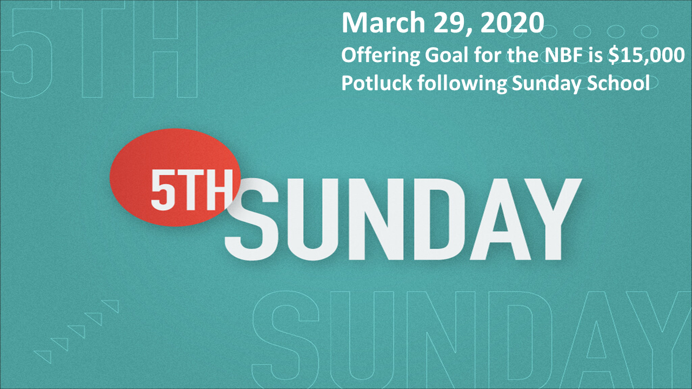

## For the Record

Date Attendance Offering Building Fund

12/1 57 $2,819.41 $1,230.00

12/8 54 $1,655.00 $30.00

12/15 69 $2,521.00 $60.00

12/22 61 $1,972.00 $885.00



First Christian Church

Brownstown

516 W. Cumberland Rd.

P.O. Box 296

Brownstown, IL 62418

618-427-3687

Website: [www.fccbrownstown.com](http://www.fccbrownstown.com) Email: [brownstownfcc@gmail.com](mailto:brownstownfcc@gmail.com)

Nathan Brands, Preaching Minister Jamie Smith, Administrative Assistant



*Frank Rook

*Jessa Adams

*Hudson Smith

*Ashton Smith

*Faye Schwarm

**Bruce/ Stephanie Miller

*David Hipsher

*Patrick Sattherthwaite

*Bruce Miller

*Tiffany Hipsher

*Birthday

**Anniversary