First Word

First Christian Church Brownstown
April 2026

Bond Camp Schedule
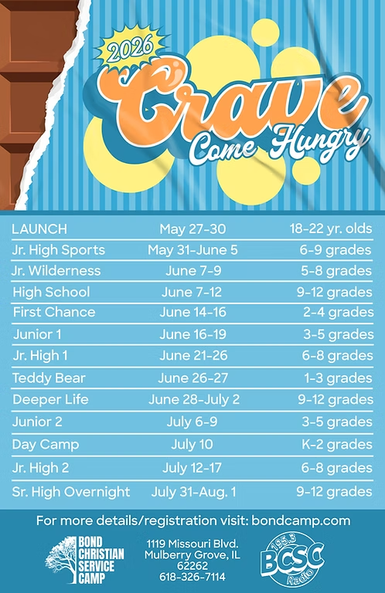
We are collecting dish soap for Bond Camp!
Place your items on the table in the back of the fellowship hall.
Camp registration has begun! Go to bondcamp.com to register. The church will pay for 1 week of camp per camper.

We Exist to:

* WORSHIP the Living God * WIN People to Jesus * TRAIN God’s People for Service

* SEND Them Out Into the World

From the Minister
Around this time of year, I often make an appeal to send kids to Bond camp. This year is no different. Camp is a great experience for children. It helps promote spiritual growth. It does this through solid Biblical teaching free from the distractions of today’s modern world. No phones, internet, TV, or other distractions getting in the way. Plus, the teaching focuses on the truth of Scripture, which is something much better to focus on. Their spiritual growth will also be aided by the relationships they form with other believers amongst their peers. The Bible says, “iron sharpens iron.” This is a great way to help strengthen the faith of our children.
If you don’t have a child to send to camp, you can still support the camp. Every year on Easter Sunday we collect a ’30 pieces of silver’ offering. This year will be no different. Over the past few years, we have sent this offering to Bond camp. We are doing the same this year. Please, help us support the camp with the offering on Easter.
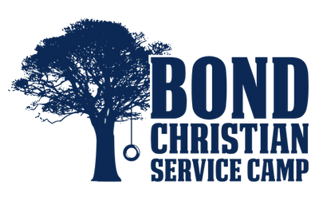

God bless,
Nathan Brands

Volunteers Needed
Looking for volunteers to mow the parsonage monthly for each month April-September.

Contact Don Lovett for more information.

Worship Center Construction Project Update
The drywall has been completed and the painting has begun. The woodwork (hang doors, hand rail, and trim) will be completed soon, followed by laying the flooring.

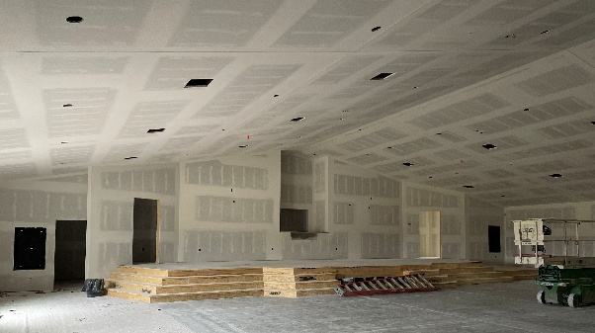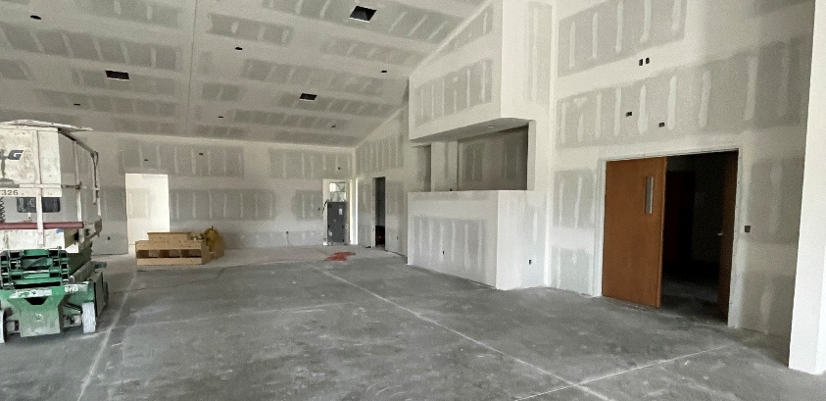

What’s Going On?
Breakfast Fellowship: If you would like to provide breakfast on a Sunday morning, there will be a sign-up sheet in the kitchen. Breakfast starts at 9:00 am.
Leadership Team (Elder’s & Deacon’s) Meeting is Tuesday, April 14th @ 7:00 pm.
Youth Groups meet on Sundays from 6:30 – 8:00 pm.
Easter Services: Sunday, April 5th 7:00 am – SONrise Service at Liberty Christian
9:30 am – Easter Worship Service
Memorial Service for those who passed away during 2025, will be Sunday, April 19th at 9:30 am.
Graduation Sunday will be Sunday, May 2nd during the morning worship service at 9:30 am.



Ladies Bible Study
The ladies Bible study group will meet on Wednesdays at 6:30 pm. We will be doing the study, Really Bad Girls of the Bible by Liz Curtis Higgs.


5th Sunday
A 5th Sunday Offering will be taken up on Sunday, May 31st. The entire amount collected will be going to the Building Fund.
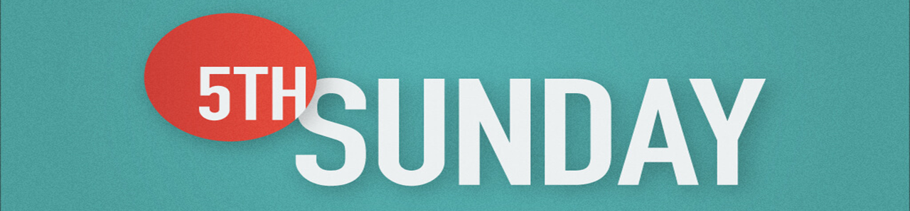

For the Record

Date Attendance Offering Building Fund
2/22 42 $1,647.41 $25.00
3/1 50 $3,203.00 $1,230.00
3/8 43 $1,389.00 $0.00
3/15 57 $2,655.00 $55.00
3/22 57 $1,401.00 $25.00



First Christian Church
Brownstown
516 W. Cumberland Rd.
P.O. Box 296
Brownstown, IL 62418
618-427-3687
Website: fcc-brownstown.com
Email: brownstownfcc@gmail.com

Nathan Brands, Preaching Minister Jamie Smith, Administrative Assistant



**Mitch/Rae Lynn Koehler
*Kent Durbin *Dona Adams
*Bonnie Shelton
*Sandy Gelsinger
*Laura Willms *Lauren Gould *Nathan Brands
*Stephanie Miller
*Karen Miller *Liz Oberlink
*Tresnee Adams
*Ella Satterthwaite
*Sherry Meador
*Randy Gelsinger
*Kent Woolsey
*Birthday
**Anniversary

