First Word

First Christian Church Brownstown
July 2026

Worship Center Construction Project Update
The audio & lighting equipment is being installed. The tile work around the baptistery is expected to be completed this month. The pew chairs have been placed in the Worship Center. The painters are doing some touch up throughout the room. The stained-glass windows should be installed this month. We are getting very close!! Thank you to the ones that helped and sacrificed your time for this project. It could not have been done without you.
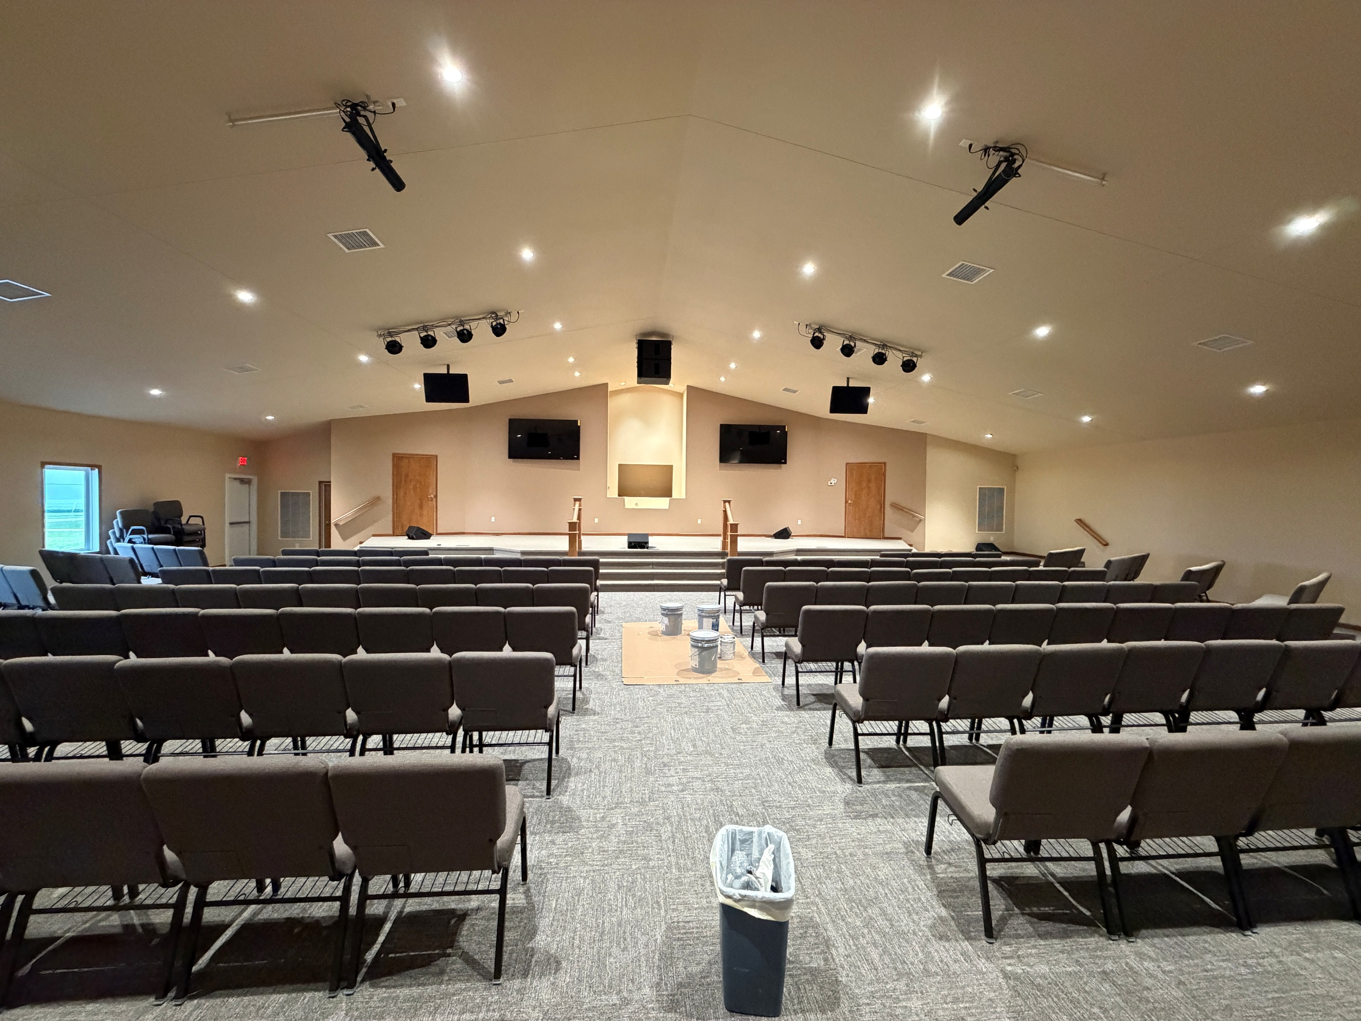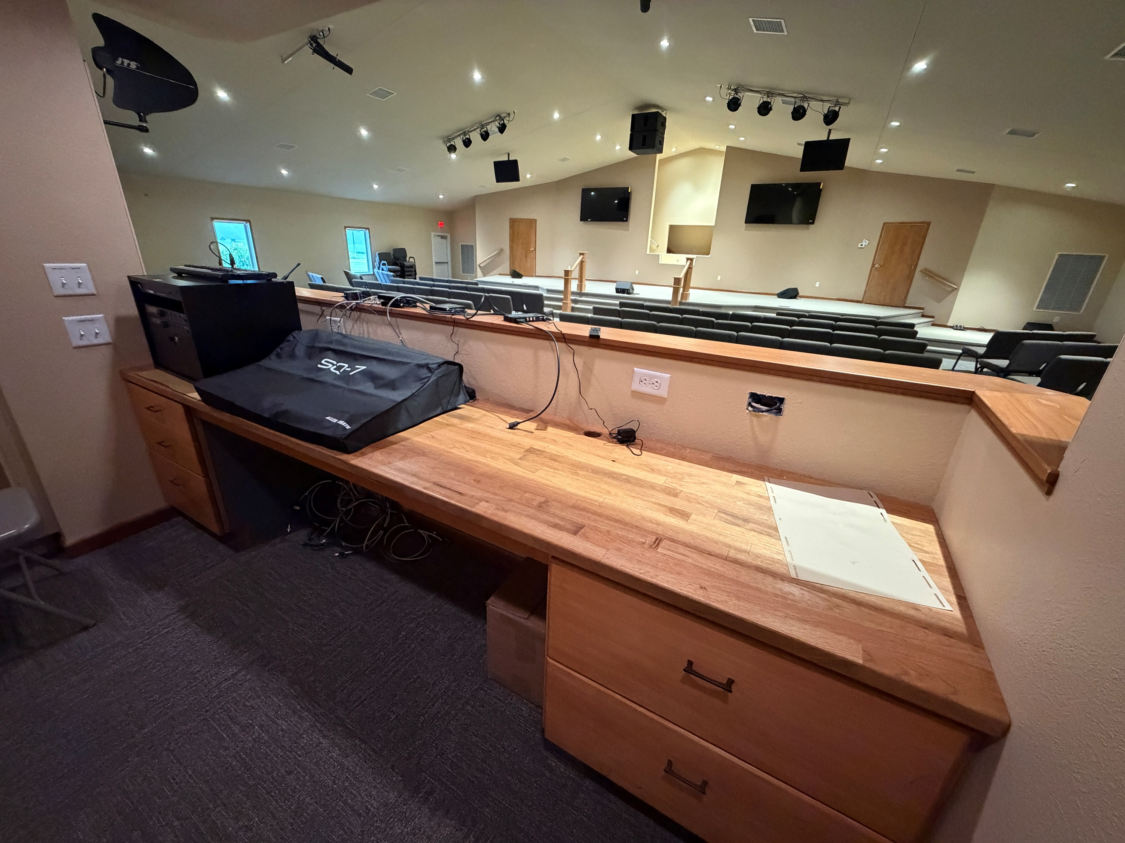
Stage Sound Booth

5th Sunday
A 5th Sunday Offering will be taken up on Sunday, August 30th. The entire amount collected will be going to the Building Fund. A potluck will follow Sunday School.
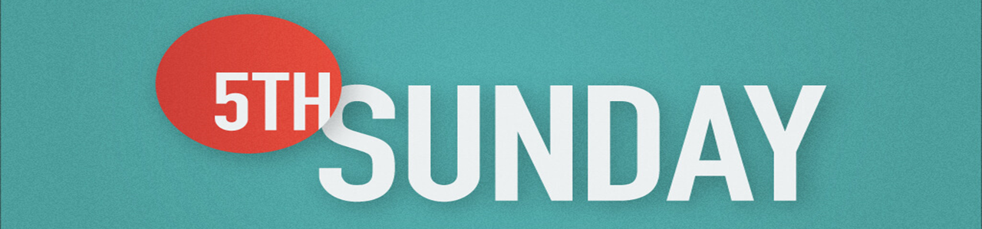

Volunteers Needed
Looking for volunteers to mow the parsonage monthly for each month July -September.

Contact Don Lovett for more information.

We Exist to:

* WORSHIP the Living God * WIN People to Jesus * TRAIN God’s People for Service

* SEND Them Out Into the World

From the Minister
Summer is often a time when we choose to go on vacations and take time off to get some much-needed rest. The problem is that the burdens and stress of life are waiting for us as soon as we return from vacation and sometimes even encroaches upon our vacation itself. While I acknowledge that we need vacations to rest and get away from the burdens and stress of life, what we truly need to acknowledge is that the ultimate rest we need is only found in God. Only God can take away the heaviness of our burdens. Only God can release us from the stress that afflicts us. Remember this summer as you take time off, spend time with God. Only He can give us the rest we need and are looking for.
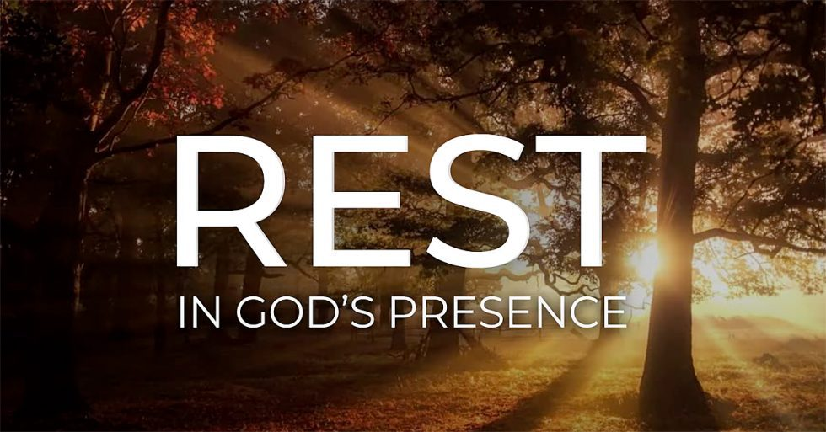

God bless,
Nathan Brands

Kidventure
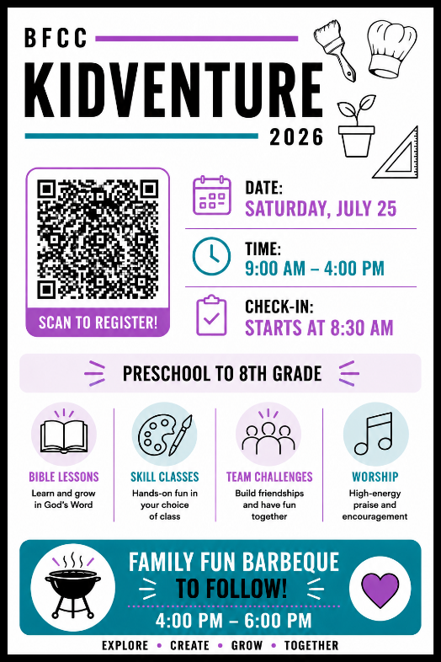

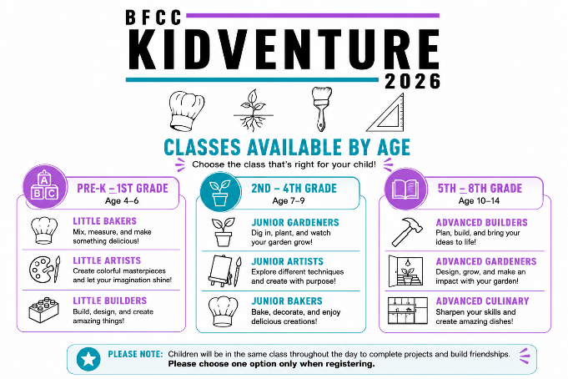

For more information or to volunteer to help, see Ashton Smith.

What’s Going On?
Breakfast Fellowship: If you would like to provide breakfast on a Sunday morning, there will be a sign-up sheet in the kitchen. Breakfast starts at 9:00 am.
Leadership Team (Elder’s & Deacon’s) Meeting is Tuesday, July 14th @ 7:00 pm.



Youth Events
Bond Christian Service Camp
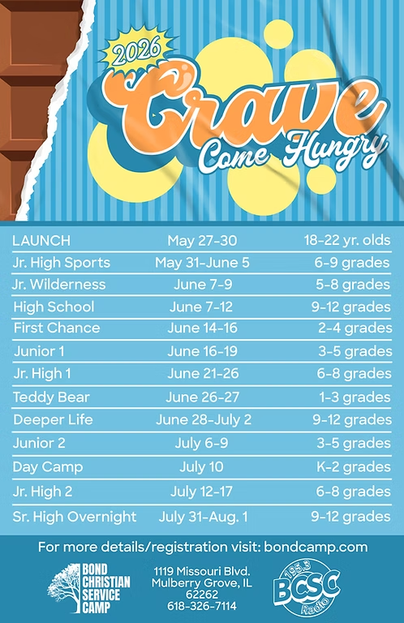
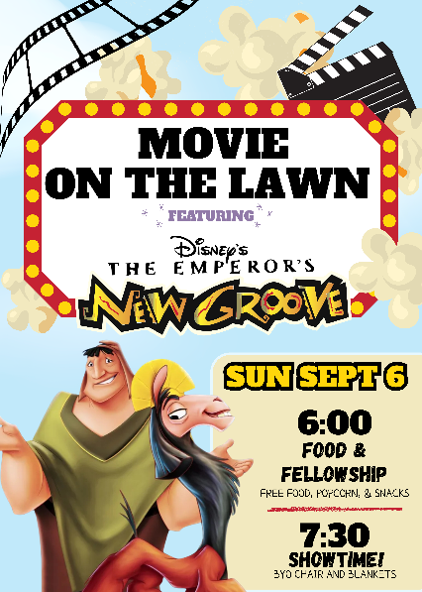

Go to bondcamp.com to register. The church will pay for 1 week of camp per camper.

For the Record

Date Attendance Offering Building Fund
5/31 66 5th Sunday $20,681.00
6/7 58 $2,368.00 $30.00
6/14 45 $2,053.25 $420.00
6/21 56 $2,446.00 $150.00



First Christian Church
Brownstown
516 W. Cumberland Rd.
P.O. Box 296
Brownstown, IL 62418
618-427-3687
Website: fcc-brownstown.com
Email: brownstownfcc@gmail.com

Nathan Brands, Preaching Minister Jamie Smith, Administrative Assistant

*Birthday
**Anniversary

*Jeremy Claycomb
*Brody Miller
*Charles Feltner Sr. **Chris/Sherry Meador
*Tena Gould
*Shannon Claycomb
*Brooke Meador
*Macy Claycomb
**Wayne/Sandra Lovett
*Ron Gould

