First Word

First Christian Church Brownstown
February 2026

Love Banquet/Trivia Night
The youth will be putting on a Trivia Night as part of our annual Love Banquet this year. The money collected will be going to the youth fund for an upcoming youth trip. The event will be held on Sunday, February 15th. More information will be coming soon!
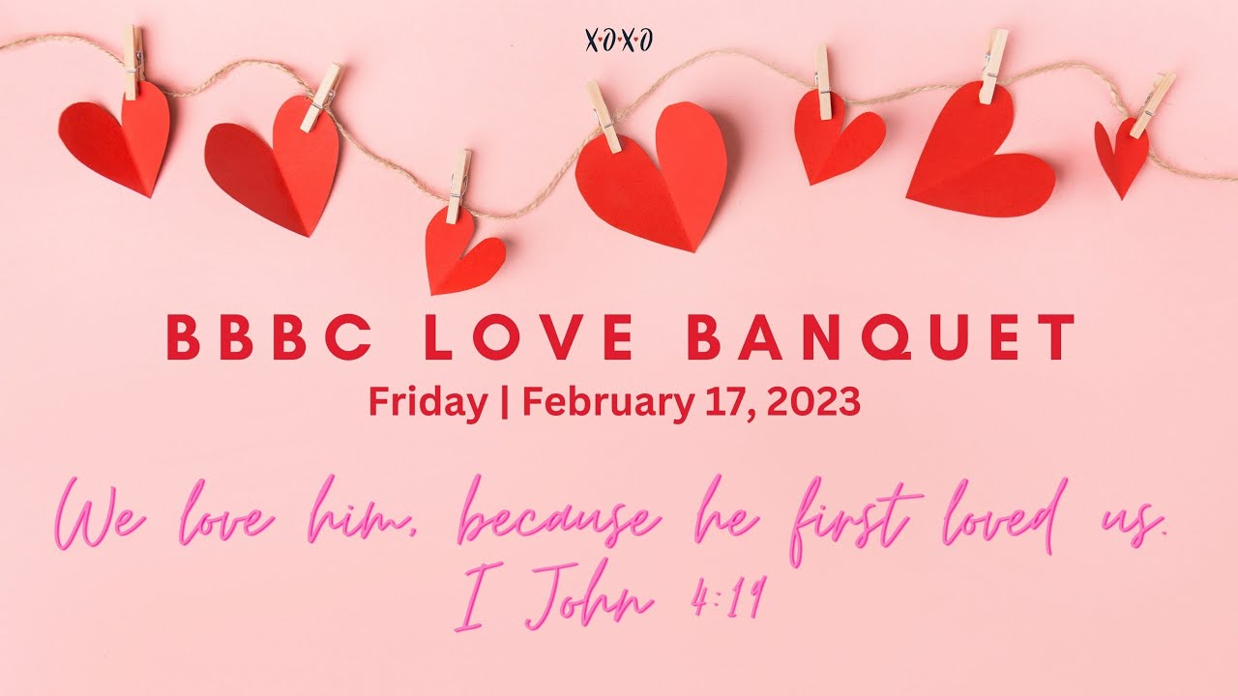

Worship Center Construction Project Update
The construction crew has been busy this week. The lighting is going up in the ceiling, sound equipment is being installed, and some drywall has been going up.
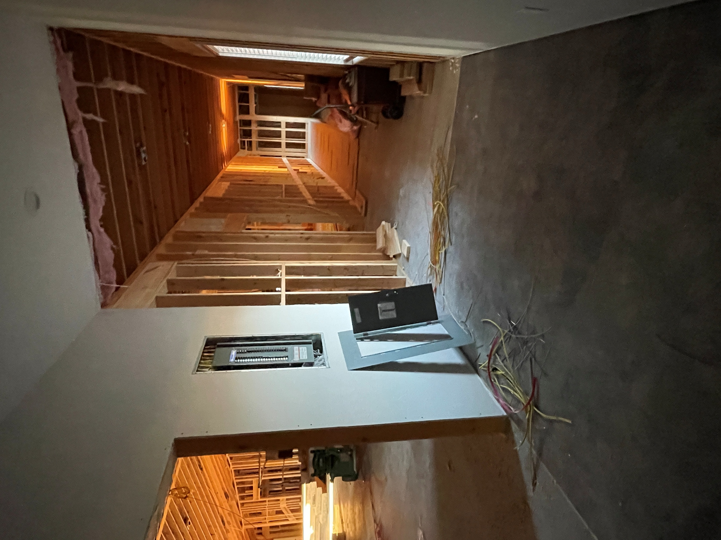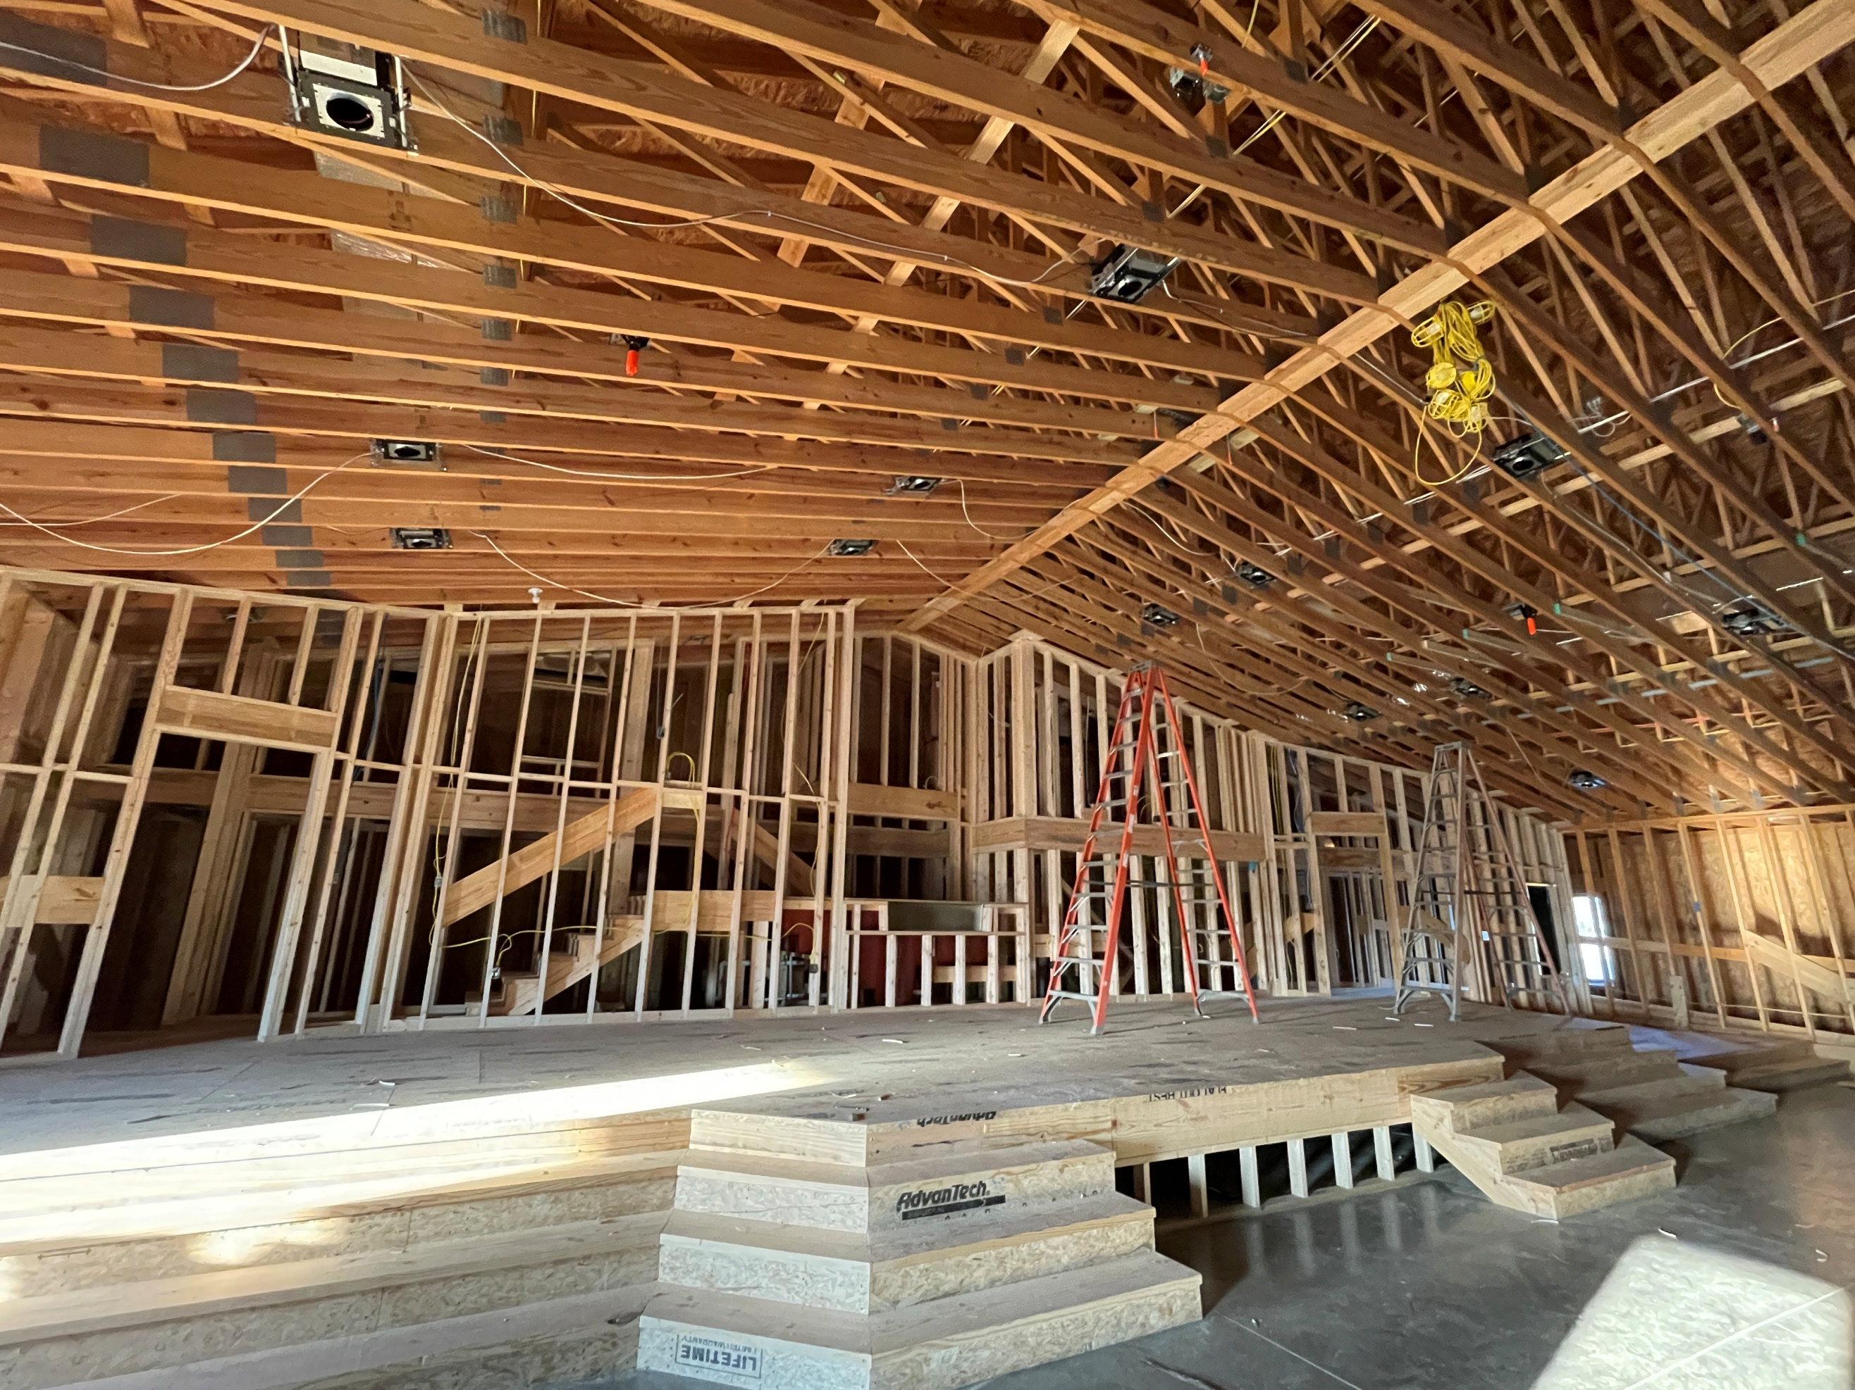
Hallway leading to back stage Stage

We Exist to:

* WORSHIP the Living God * WIN People to Jesus * TRAIN God’s People for Service

* SEND Them Out Into the World

From the Minister

“I believe that Jesus is the Christ, the Son of the Living God, and I accept Him as my Lord and Savior.”

This is the confession we make before we are baptized. However, what exactly are we confessing. Let’s break it down.

“…Jesus is the Christ…”
- This statement acknowledges that Jesus is the Messiah that was promised in the Old Testament prophecies. He is the one to save God’s people and establish an eternal kingdom.

“…Son of the Living God…”
- This affirms that Jesus is divine as the Son of God. He is not just a prophet or good moral teacher, or even an angelic being. He is the second person of the Trinity.

“…my Lord and Savior…”
- First the “my” means this is a personal relationship being established with Jesus. He is not a lord and savior, but your Lord and Savior. As your Lord, He is the ultimate authority in your life. This means you are to submit to Him in all things. As your Savior, He is the source of your salvation and thus reconciliation to God. This means we are no longer seen as guilty in God’s eyes and are now righteous. Our sins are forgiven.

It is important to remember why we do what we do and say what we say.

God bless,
Nathan Brands
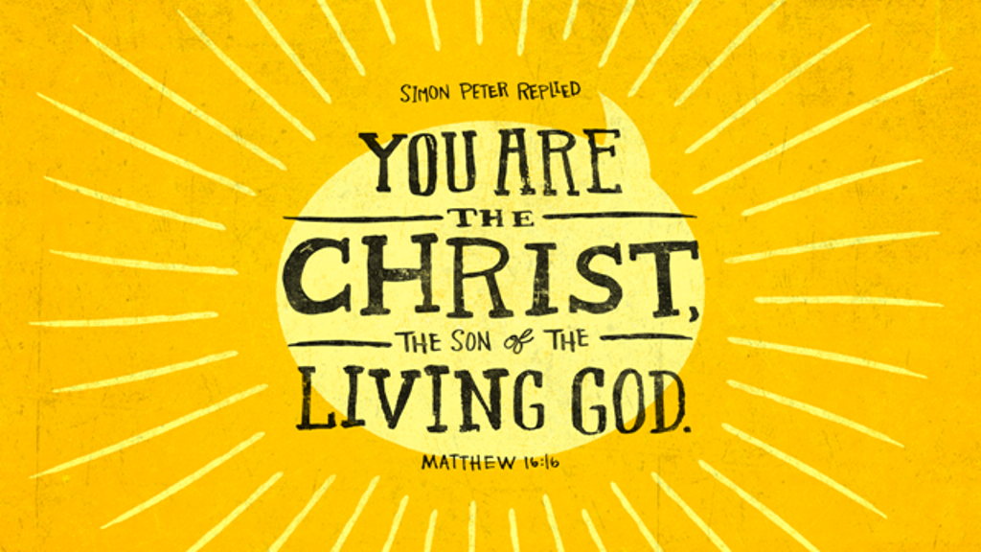

What’s Going On?
Breakfast Fellowship: If you would like to provide breakfast on a Sunday morning, there will be a sign-up sheet in the kitchen. Breakfast starts at 9:00 am.
Leadership Team (Elder’s & Deacon’s) Meeting is Tuesday, January 13th @ 7:00 pm.
Youth Groups will meet on Sundays from 6:30 – 8:00 pm. Youth Groups will resume in February. Watch for a start-up date coming soon!



5th Sunday
A 5th Sunday Offering will be taken up on Sunday, March 29th. The entire amount collected will be going to the Building Loan Principle. The goal is $22,000. There will also be a potluck following Sunday School.
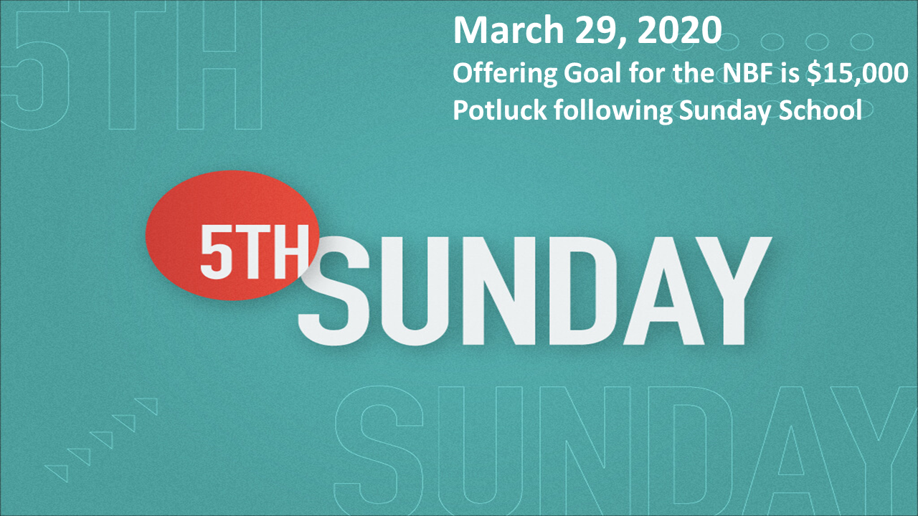

For the Record

Date Attendance Offering Building Fund
12/28 61 $1,925.00 $1,230.00
1/4 58 $3,071.00 $135.00
1/11 51 $1,557.00 $40.00
1/18 51 $2,343.00 $38.00
1/18 LPHS Love Offering $974.00



First Christian Church
Brownstown
516 W. Cumberland Rd.
P.O. Box 296
Brownstown, IL 62418
618-427-3687
Website: fcc-brownstown.com
Email: brownstownfcc@gmail.com

Nathan Brands, Preaching Minister Jamie Smith, Administrative Assistant


*Brody Gould
*Travis Gould
*Helen Holman
*Jordan Miller
*Tammy Woolsey
*Don Lovett
*Brad Sidwell
*Rae Lynn Koehler
*Birthday
**Anniversary

