**First Word**

**First Christian Church Brownstown**

**June 2025**

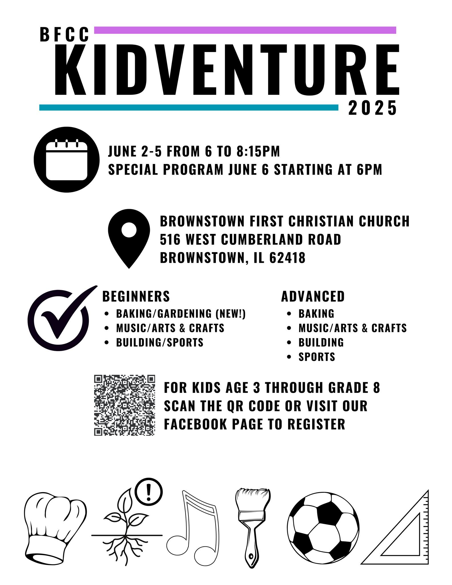

**Lighthouse Pregnancy & Health Services**

** **

Register at:

<http://brownstown-first-christian-church-471335.churchcenter.com/registrations/events/2923544> or scan the QR code with your phone’s camera.

#### We Exist to:

#### * WORSHIP the Living God * WIN People to Jesus * TRAIN God’s People for Service

#### * SEND Them Out Into the World

#### 



**From the Minister**

Father’s Day is on June 15th. I wanted to take a moment to show the importance of fathers in the home. This is not to say mothers aren’t important, but we are honoring fathers in June, so we are focusing on them.

Research shows that if fathers are present in a child’s life the children are 80% less likely to go to jail & 75% less likely to experience teen pregnancy. However, when a father isn’t in the home there is a negative impact. 71% of all high school dropouts, 90% of homeless & runaway children, and 63% of youth suicides come from fatherless homes. Here are some more items that show the importance of a father’s presence:

* Lower rates of infant mortality
* Lower risk of emotional & behavioral problems
* Lower risk of neglect & abuse
* Lower obesity rates
* Lower alcohol & substance abuse
* Better school performance
* More likely to go to college

All of this shows how important fathers are. I hope that you will take a moment on Father’s Day to express your gratitude for the fathers in your life.

**Camp Schedule**

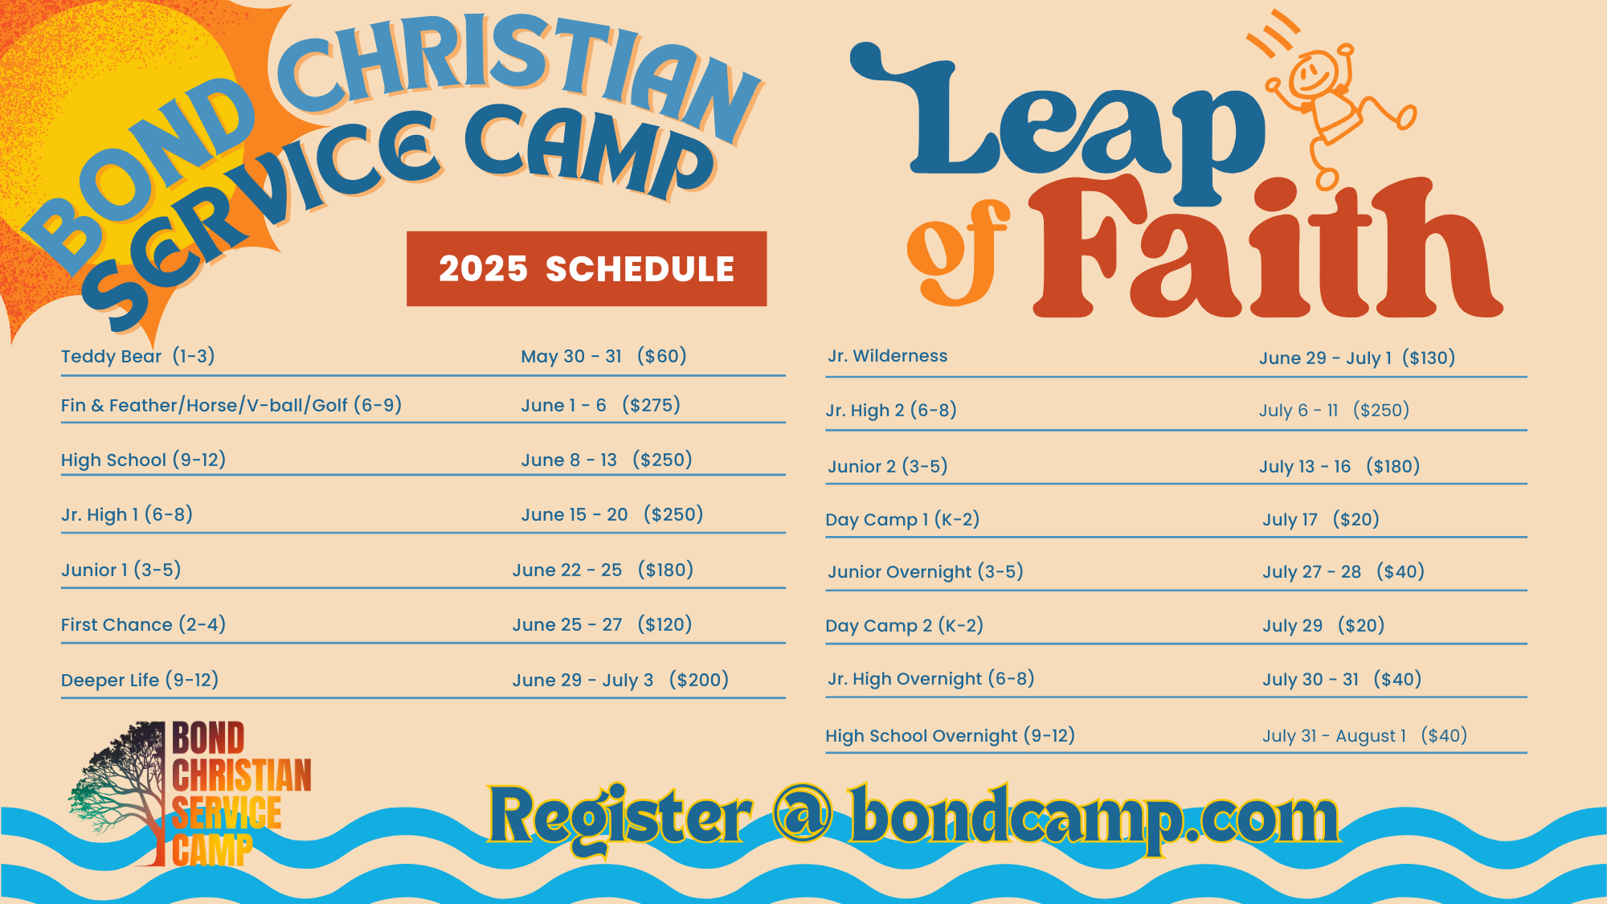

To register go to bondcamp.com.

The church will pay for one week of camp per camper for church members.

## What’s Going On?

**Breakfast Fellowship:** If you would like to provide breakfast on a Sunday morning, there will be a sign-up sheet in the kitchen. Breakfast starts at 9:00 am.

**Leadership Team (Elder’s & Deacon’s) Meeting** is Tuesday, June 10th @ 7:00 pm.

**Youth Groups** will be taking a break for the summer. They will resume in the fall.

**Ladies Bible Study** will be Wednesdays at 6:30 pm. It is a Beth Moore study, “To Live is Christ: The Life and Ministry of the Apostle Paul.” Get to know the man who said, “To live as Christ and die is gain.” Along the way you will get to know the “Apostle to the Gentiles” in a new way.

## 



## 5th Sunday

A 5th Sunday Offering will be taken up on Sunday, June 29th. The entire amount collected will be going to the Building Loan Principle. The goal is $22,000. There will also be a potluck following Sunday School.

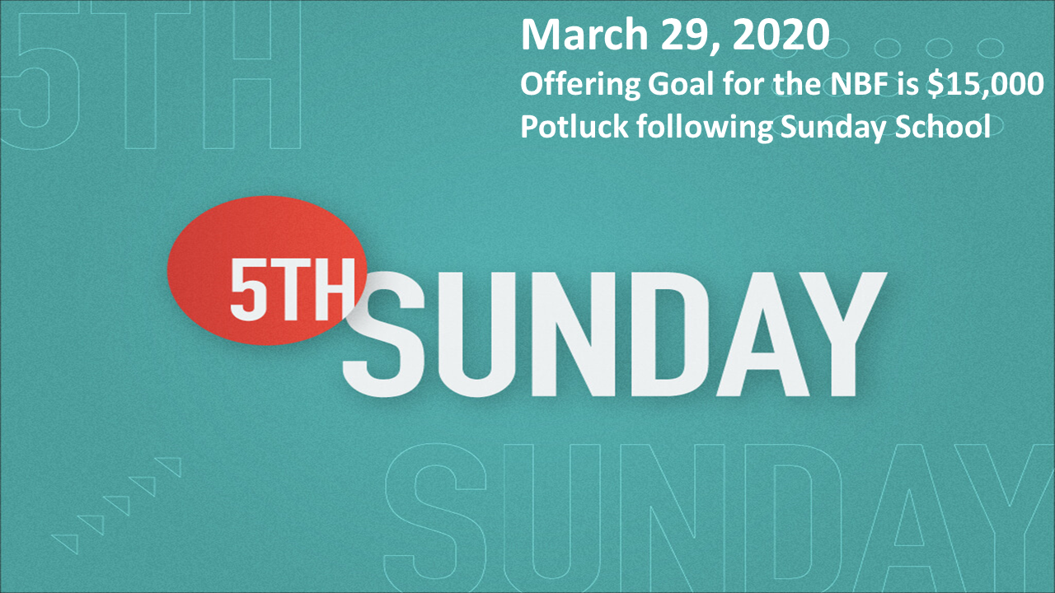

**Worship Center Construction Project Update** On May 4, the church approved a construction loan up to $260,000.00 from FNB Brownstown on a $400,000.00 Worship Center Construction project. Fulk Construction of Brownstown is the General Contractor. $54,000.00 was given upon signing the contract. 200 chairs have been ordered at a price of $16,000.00. The project is projected to begin mid-July.

## For the Record

Date Attendance Offering Building Fund

4/27 39 $2,150.00 $35.00

5/4 63 $2,215.00 $1,123.00

5/11 61 $2,516.00 $40.00

5/18 48 $3,331.00 $40.00



First Christian Church

Brownstown

516 W. Cumberland Rd.

P.O. Box 296

Brownstown, IL 62418

618-427-3687

Website: <fcc-brownstown.com>

Email: [brownstownfcc@gmail.com](mailto:brownstownfcc@gmail.com)

Nathan Brands, Preaching Minister Jamie Smith, Administrative Assistant



**Terry/Susan Smith

*Asa Satterthwaite

*Samuel Miller

*CambreeJachino

**Don/Robin Lovett

*Carter Smith

*Kyndal Adams

**Brad/Nikki Sidwell

**Bill/Cathy Smith

*Kaci Satterthwaite

*Terry Smith

*Judy Feltner

*Alivia Claycomb *Cathy Smith

*Birthday

**Anniversary