First Word

First Christian Church Brownstown
October 2025

Fall Fest

We Exist to:

* WORSHIP the Living God * WIN People to Jesus * TRAIN God’s People for Service

* SEND Them Out Into the World

From the Minister

September 25th was National Daughters Day, and September 28th was National Sons Day.
I am extremely glad to be a father. I believe my most important duty as a father is to raise my children to be Christians. Avie has already made this commitment, and I believe Jameson is on the path to doing the same. This requires me to do what I can to teach them how to follow Jesus. I would be lying if I said I was the only one learning though. I have learned from my children as well.
From Jameson, I am constantly reminded that God is the best. Jameson always says that am his second favorite father or the second-best dad, because God is the best. He also is quick to point out that God is the biggest and strongest and smartest and … whatever else may come up in conversation. The fact that this is so prevalent in his mind is quite inspiring.
From Avie, I have learned to always look for ways to help others. It is easy to overlook those in need. We get distracted or busy or more focused on other things. However, Avie is always on the lookout to help others. She wants to get people food that are hungry, give people money that are in need, and buy gifts for those that don’t have as much as she does. It is a good reminder to keep my eyes open to the needs of others.
I am encouraged by my children to follow Jesus to the best of my ability. I am sure we can all learn from those we teach. We can be learning from our children and the kids of today.
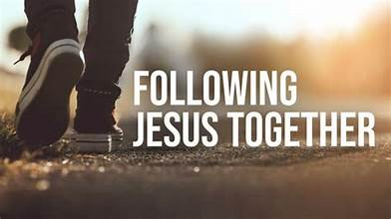
God bless,
Nathan Brands

Lighthouse Pregnancy & Health Services

Join us on Friday, October 24th at Centerpointe Church in Vandalia, IL for our annual trivia night. Doors open at 5:30 pm, trivia starts at 6:00 pm. Meal provided for free will donation. No outside food or drinks please. $15/person or $100 for a table of 8 (max number of 8 per team). Call the center at 618-283-8750 to register.
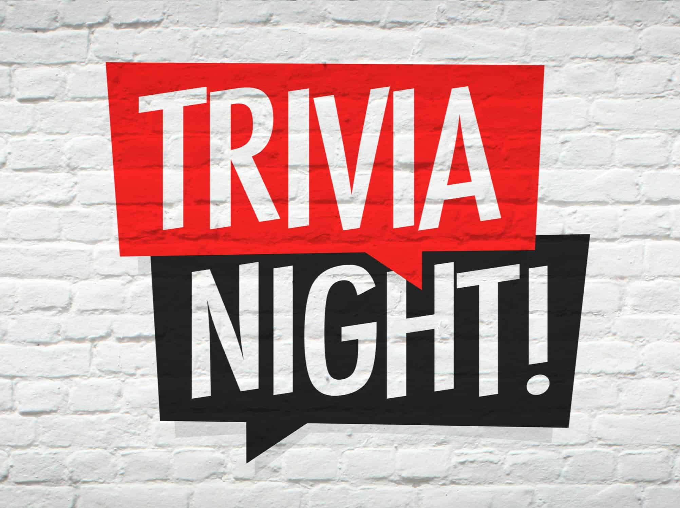

What’s Going On?
Breakfast Fellowship: If you would like to provide breakfast on a Sunday morning, there will be a sign-up sheet in the kitchen. Breakfast starts at 9:00 am.
Leadership Team (Elder’s & Deacon’s) Meeting is Tuesday, October 14th @ 7:00 pm.
Youth Groups will meet on Sundays from 6:30 – 8:00 pm.
Time Change will be Sunday, November 2nd.



5th Sunday
A 5th Sunday Offering will be taken up on Sunday, November 30th. The entire amount collected will be going to the Building Loan Principle. The goal is $22,000. There will also be a potluck following Sunday School.
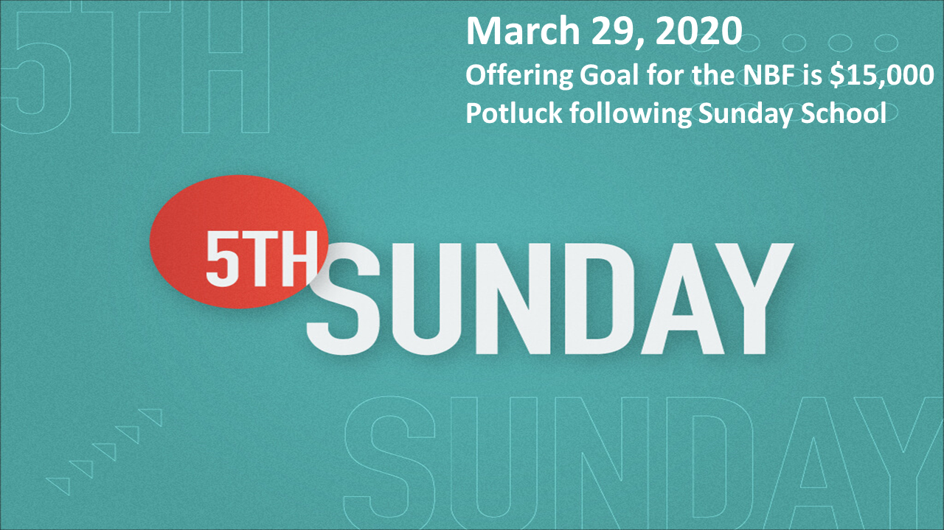

For the Record

Date Attendance Offering Building Fund
8/31 54 5th Sunday $18,201.00
9/7 55 $2,191.00 $0.00
9/14 55 $2,047.00 $240.00
9/21 72 $2,787.00 $1,200.00



First Christian Church
Brownstown
516 W. Cumberland Rd.
P.O. Box 296
Brownstown, IL 62418
618-427-3687
Website: fcc-brownstown.com
Email: brownstownfcc@gmail.com

Nathan Brands, Preaching Minister Jamie Smith, Administrative Assistant

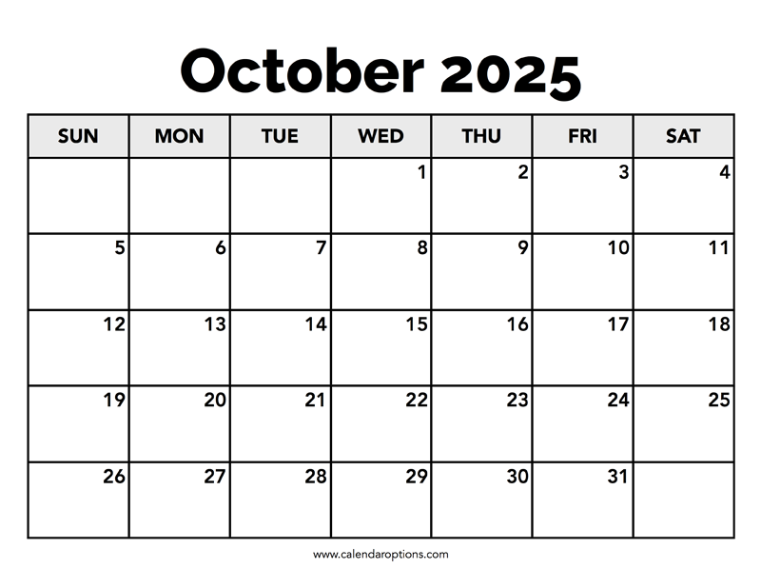
*Lyndsey Pruett
*Hazel Jachino
*Deanna Miller
**Frank/Shelly Rook
*Emalee Smith
*Cordelia Lytle
**Jody/Jamie Meador
*Jared Winters
**Patrick/Kaci Satterthwaite
**Travis/Lauren Gould
*Choya Morrison
*Jack Shelton
*Susan Smith
*Birthday
**Anniversary

