**First Word**

**First Christian Church Brownstown**

**July 2025**

**Camp Schedule**

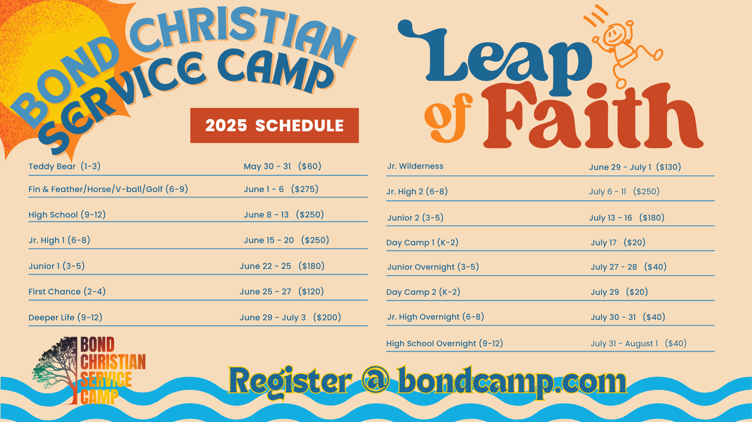

To register go to bondcamp.com.

The church will pay for one week of camp per camper for church members.

#### We Exist to:

#### * WORSHIP the Living God * WIN People to Jesus * TRAIN God’s People for Service

#### * SEND Them Out Into the World

#### 



**From the Minister**

Last Sunday (6/22/25), I spoke on preparing yourself to share the gospel from Luke 10:1-4. I wanted to take a moment to look at what Luke 10:5-11 says about how to share the gospel.

* Form Relationships (Luke 10:5-8): We need to take the time to get to know people. We need to live life with them and eat with them.
* Take Care of Needs (Luke 10:9a): It is hard for people to hear about their spiritual needs when they have physical needs that need to be met. Taking care of the sick, clothing and feeding the poor, and other ways to take care of needs are important.
* Share the Gospel (Luke 10:9b): People need to hear the message of Jesus. Part of this message is telling people about the coming of the kingdom of God.
* Be okay with Failing (Luke 10:10-11): Not everyone was willing to follow Jesus when he spoke about himself, and not everyone will be willing to follow Jesus when we speak about him. When people refuse to listen; share the gospel with others.

I hope that the combination of preparing to share and going to share the gospel seen in Luke 10:1-11 will benefit us in our goal of reaching people for Jesus.

God bless,  
Nathan Brands

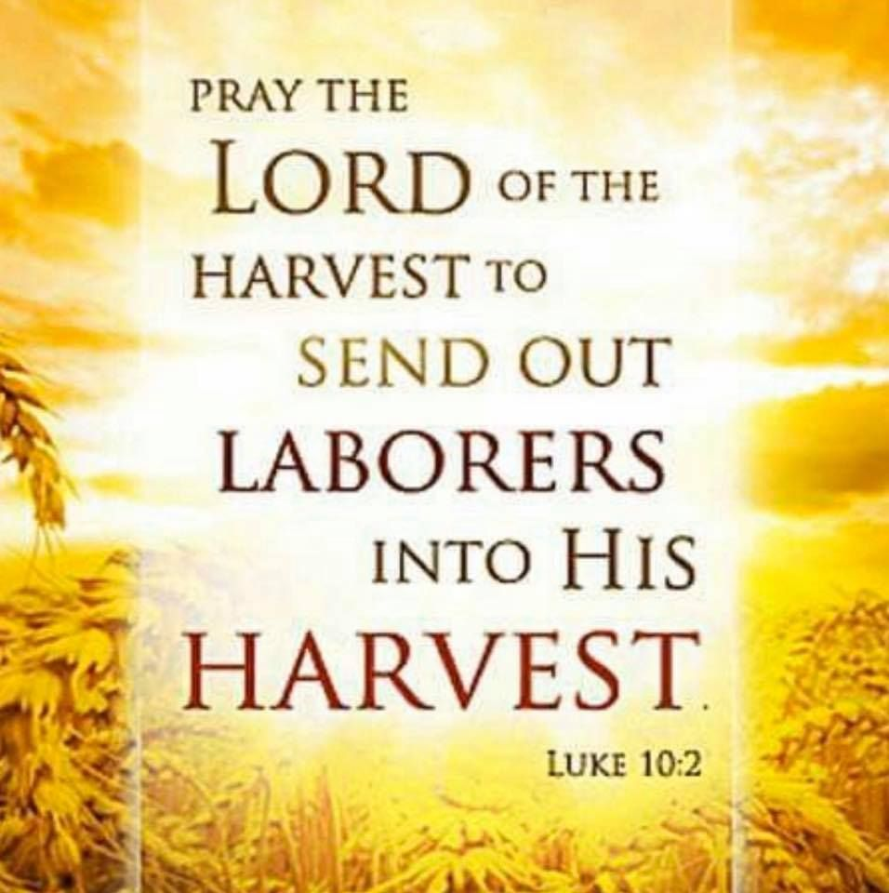

## What’s Going On?

**Breakfast Fellowship:** If you would like to provide breakfast on a Sunday morning, there will be a sign-up sheet in the kitchen. Breakfast starts at 9:00 am.

**Leadership Team (Elder’s & Deacon’s) Meeting** is Tuesday, July 8th @ 7:00 pm.

**Youth Groups** will be taking a break for the summer. They will resume in the fall.

## 



## 5th Sunday

A 5th Sunday Offering will be taken up on Sunday, August 31st. The entire amount collected will be going to the Building Loan Principle. The goal is $22,000. There will also be a potluck following Sunday School.



## For the Record

Date Attendance Offering Building Fund

5/25 55 $1,717.00 $135.00

6/1 59 $3,195.00 $1,200.00

6/8 95 $2,048.00 $65.00

6/15 58 $2,283.00 $40.00

6/22 65 $1,700.00 $0.00



First Christian Church

Brownstown

516 W. Cumberland Rd.

P.O. Box 296

Brownstown, IL 62418

618-427-3687

Website: fcc-brownstown.com

Email: [brownstownfcc@gmail.com](mailto:brownstownfcc@gmail.com)

Nathan Brands, Preaching Minister Jamie Smith, Administrative Assistant



*Jeremy Claycomb

*Brody Miller

*Charles Feltner Sr. **Chris/Sherry Meador

*Tena Gould

*Shannon Claycomb

*Brooke Meador

*Macy Claycomb

**Wayne/Sandra Lovett

*Ron Gould

*Birthday

**Anniversary