First Word

First Christian Church Brownstown
September 2026

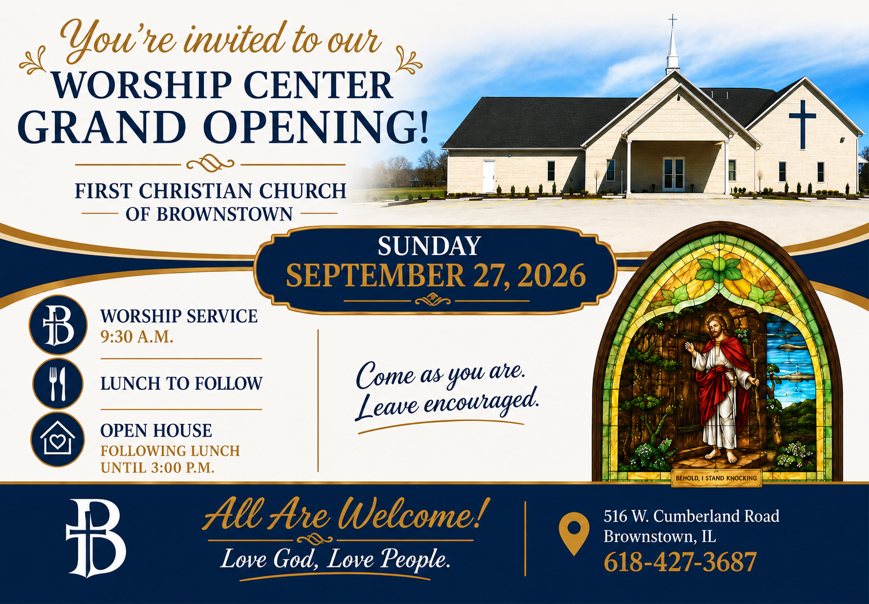

Open Doors, Open Hearts. Come See What’s Inside!
We are excited to announce the grand opening of our Worship Center at First Christian Church Brownstown, a space designed to honor God, gather His people, and serve the community. This is more than a building – it’s a place where worship meets mission, and where the Kingdom of God is made visible.
Whether you’ve been a part of our congregation for years or are new to our family, this worship center is designed to welcome you with open arms. Come see us, worship with us, tour the building, meet friendly faces, and enjoy a time of fellowship and good food.
Our church family has been working tirelessly on this building since we moved here on March, 24, 2018. I am full of gratitude for this amazing and giving congregation. Loving God and loving people is what you all do!
Our worship center will embody the calling of the church: to glorify God, make disciples, and live out His love in the world. Every detail – from the worship center to the fellowship hall – reflects our commitment to worship, community, and service.
Come as you are and leave feeling renewed in Christ!

We Exist to:

* WORSHIP the Living God * WIN People to Jesus * TRAIN God’s People for Service

* SEND Them Out Into the World

From the Minister
On Sunday, September 27th, we will be having our Grand Opening for our new worship center. Our service will at 9:30 am, as usual. However, after the service there will be a lunch at 11:30 am, and the church will be open until 3:00 pm for the open house.
I would like to encourage all of you to make this a great experience for any visitors. If you are able, please help us in some way during the Grand Opening. You could help welcome before or after the service or provide tours of the building for anyone that wants one. Also, I hope we can all have a welcoming spirit of hospitality. I’m sure this will be something most of you will excel at, since many of you seem to show this welcoming spirit already. Above all else pray for the Grand Opening and those in need of a church home.

God bless,
Nathan Brands

Upcoming Events
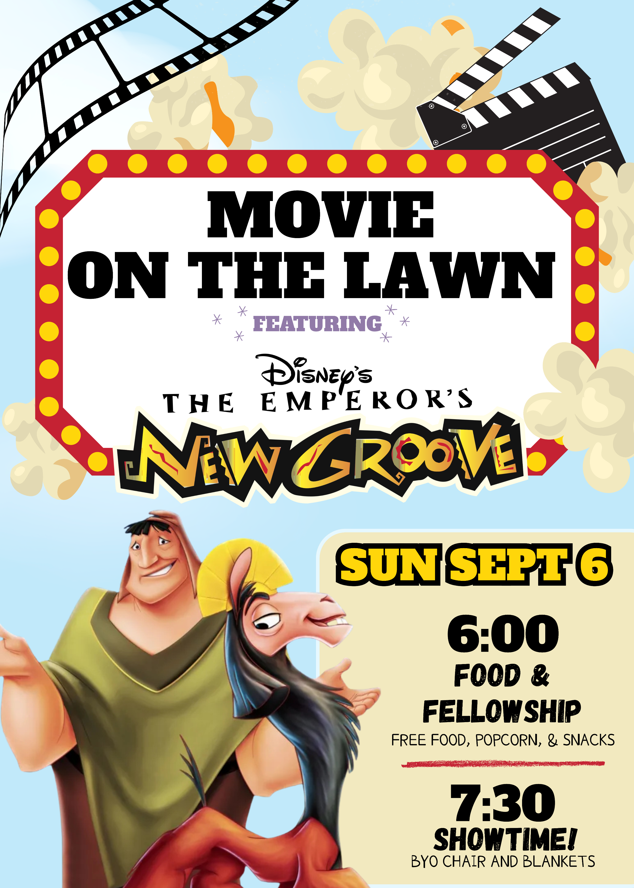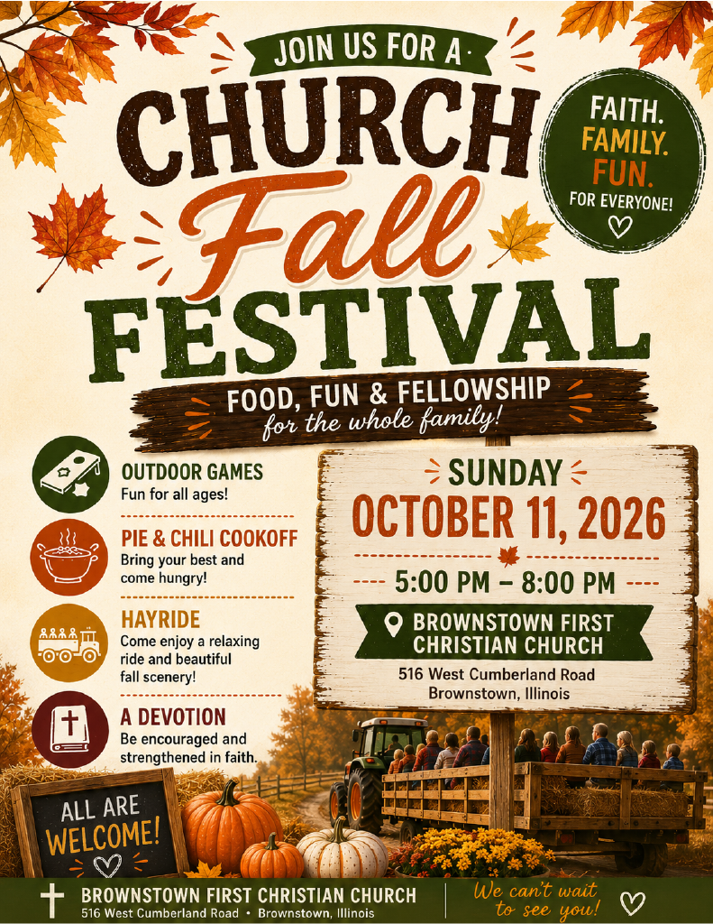

For more information, see Ashton Smith.

What’s Going On?
Breakfast Fellowship: If you would like to provide breakfast on a Sunday morning, there will be a sign-up sheet in the kitchen. Breakfast starts at 9:00 am.
Leadership Team (Elder’s & Deacon’s) Meeting is Tuesday, September 8th @ 7:00 pm.



5th Sunday
A 5th Sunday Offering will be taken up on Sunday, November 29th. The entire amount collected will be going to the Building Fund. A potluck will follow Sunday School.
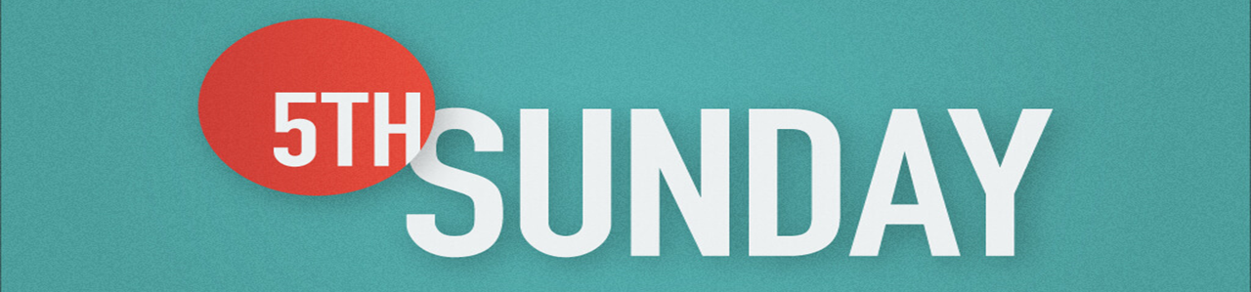

Volunteers Needed
Looking for volunteers to mow the parsonage monthly for each month September and October.

Contact Don Lovett for more information.

For the Record

Date Attendance Offering Building Fund
7/26 52 $1,052.00 $1,225.00
8/2 62 $3,352.75 $165.00
8/9 64 $2,016.00 $30.00
8/16 61 $2,365.00 $160.00
8/23 77 $2,666.00 $175.00

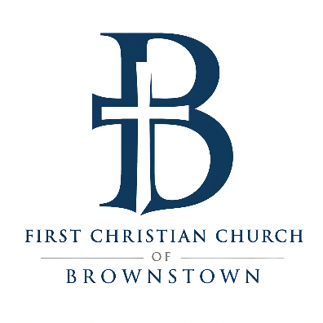

516 W. Cumberland Rd.
P.O. Box 296
Brownstown, IL 62418
618-427-3687
Website: fcc-brownstown.com
Email: brownstownfcc@gmail.com

Nathan Brands, Preaching Minister Jamie Smith, Administrative Assistant


*Zayne Koehler
*Mitch Koehler
*Jamie Meador
**Kent/Tammy Woolsey
*Jody Meador
*Bill Holman
*Birthday
**Anniversary

