First Word

First Christian Church Brownstown
February 2025

Upcoming Events

Bond Christian Service Camp Fundraiser
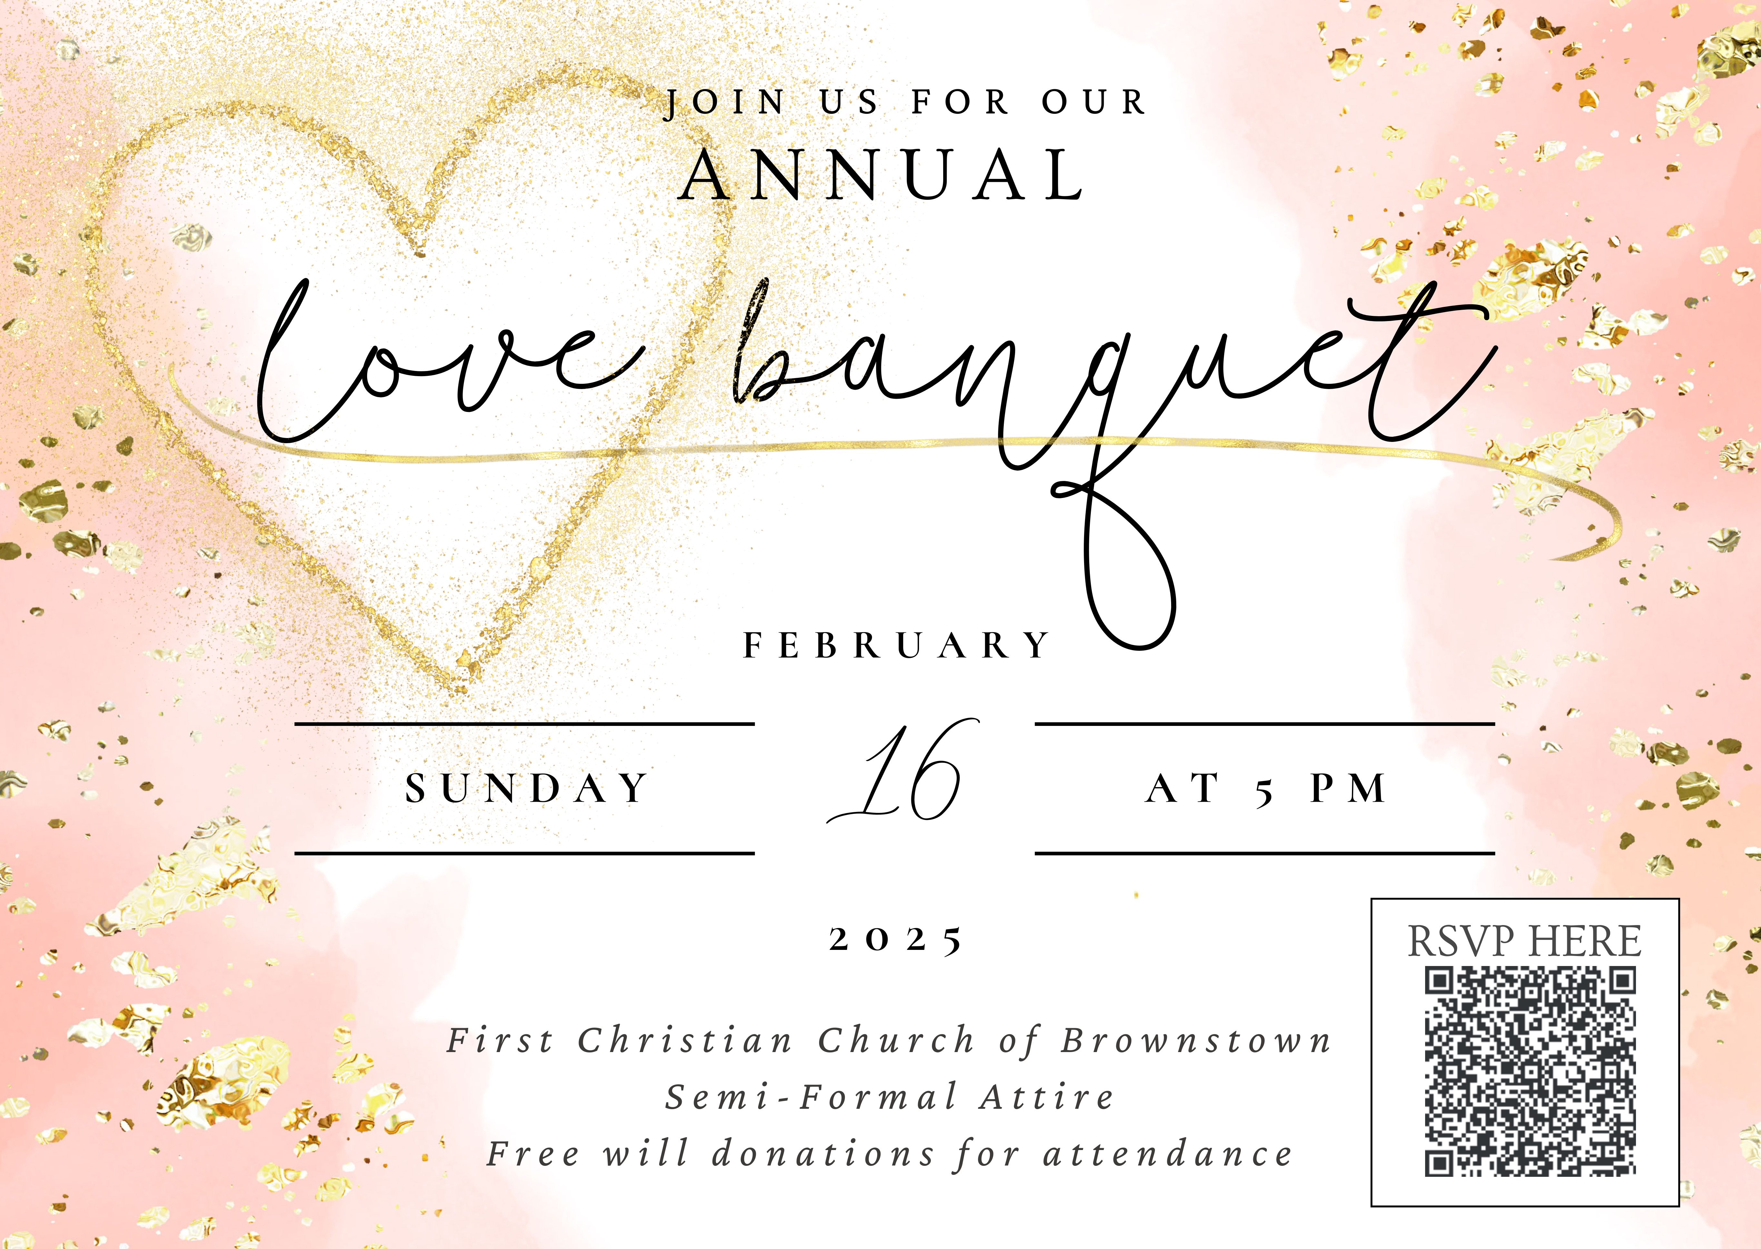

We Exist to:

* WORSHIP the Living God * WIN People to Jesus * TRAIN God’s People for Service

* SEND Them Out Into the World

From the Minister
February is a month of love. People celebrate love on Valentine’s Day every year on February 14th. In thinking about this, I’m reminded how many in our culture don’t really understand what love is. People often confuse love with one of two different words: romance and lust. Lust is a very strong sexual desire. Romance is a feeling of excitement and/or mystery associated with love. This is love that is either idealized or given to sentimentality.
There is a problem with thinking of love only through these two words; both make love more about yourself. Lust makes love all about your physical desire, and romance makes love about your mental desire. The problem is that both make love about you. This is not how the Bible talks about love.
In the Bible, love is commitment. This means it is not about desire and the emotions that often drive those desires.
In the Bible, love is selfless. Love is about others not yourself.
In the Bible, love is serving. Love is about giving not receiving.
Don’t get me wrong, desire for your spouse in a marriage is a good thing. I hope that married couples physically and mentally desire each other. However, to make love only about such things, is selling love short. It is cheapening the true nature of love.
Remember this month, as you celebrate love, to dedicate yourself to a Biblical understanding of love.


God bless,
Nathan Brands

Just for the Youth

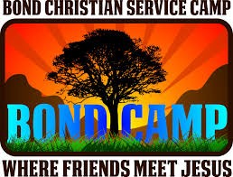

Bonding at Bond will be February 23rd from 5-7 pm. All 4th – 12th graders are invited to attend. More information coming soon!

What’s Going On?
Breakfast Fellowship: If you would like to provide breakfast on a Sunday morning, there will be a sign-up sheet in the kitchen. Breakfast starts at 9:00 am.
Leadership Team (Elder’s & Deacon’s) Meeting is Tuesday, February 11th @ 7:00 pm.
Youth Groups for 4th – 12th Grade will be taking a break for the holidays.
Guest Speaker: Jim Quick from Bond Christian Service Camp will be here on Sunday, February 9th to give an update on camp and some of the new additions.

VB



5th Sunday

A 5th Sunday Offering will be taken up on Sunday, March 30th. The entire amount collected will be going to the Building Loan Principle. The goal is $22,000.
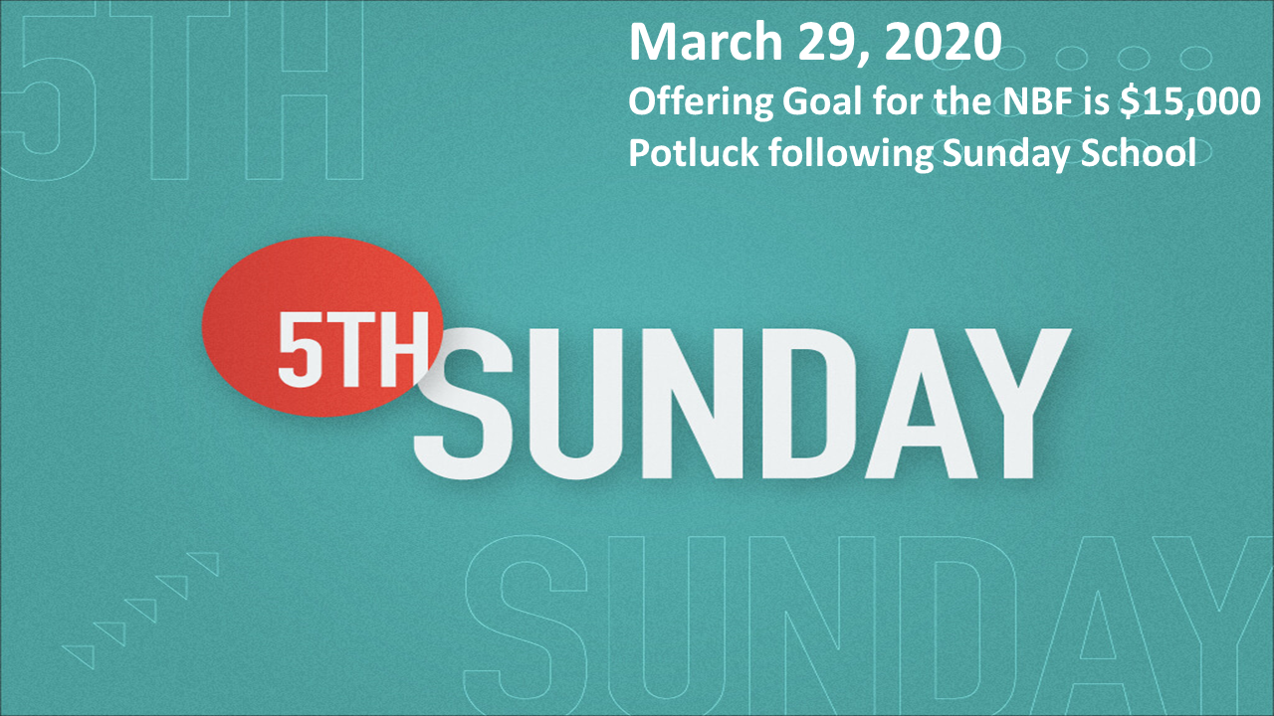

For the Record

Date Attendance Offering Building Fund
12/29 50 5th Sunday $17,562.06
1/4 30 $2,195.00 $530.00
1/12 48 $1,354.00 $40.00
1/19 62 $2,593.00 $30.00
1/19 Sanctity of Human Life Offering (LPHS) $832.00



First Christian Church
Brownstown
516 W. Cumberland Rd.
P.O. Box 296
Brownstown, IL 62418
618-427-3687
Website: www.fccbrownstown.com Email: brownstownfcc@gmail.com

Nathan Brands, Preaching Minister Jamie Smith, Administrative Assistant


*Brody Gould
*Travis Gould
*Rae Lynn Koehler
*Helen Holman
*Jordan Miller
*Tammy Woolsey
*Don Lovett
*Birthday
**Anniversary

