First Word

First Christian Church Brownstown
May 2026

Bond Camp Schedule
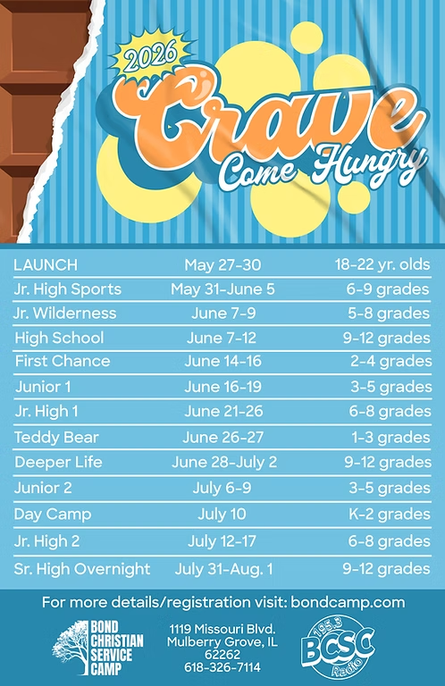
We are collecting dish soap for Bond Camp!
Place your items on the table in the back of the fellowship hall.
Camp registration has begun! Go to bondcamp.com to register. The church will pay for 1 week of camp per camper.

We Exist to:

* WORSHIP the Living God * WIN People to Jesus * TRAIN God’s People for Service

* SEND Them Out Into the World

From the Minister
I am reminded of your sincere faith, a faith that dwelt first in your grandmother Lois and your mother Eunice and now, I am sure, dwells in you as well.
2 Timothy 1:5
Here we see Paul commenting on the faith heritage of his disciple, Timothy. As Christians, we all have a faith heritage. We often have been impacted by our mothers, grandmothers, and other godly women in our lives.
As Mother’s Day approaches, we should take time to reflect.
- Reflect on the women who have helped nurture faith in your life. Remember to thank them for the part they played in your faith.
- Reflect on those that you can nurture in their faith, as the women in your life have done for you.


God bless,
Nathan Brands

Volunteers Needed
Looking for volunteers to mow the parsonage monthly for each month April-September.

Contact Don Lovett for more information.

Worship Center Construction Project Update
The painting is completed and the audio & lighting equipment is being installed. The woodwork (hang doors, hand rail, and trim) followed by laying flooring should be completed this month and then we will install the pew chairs.

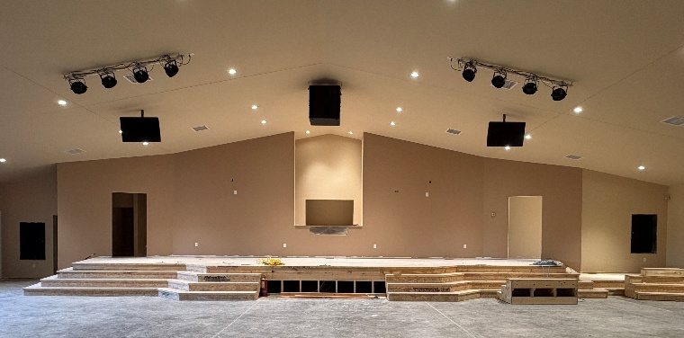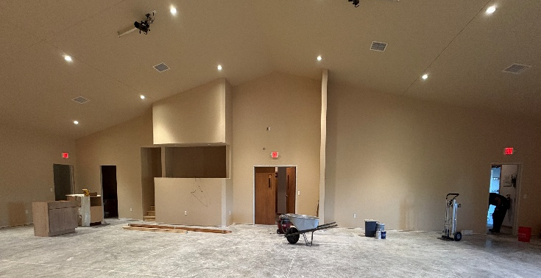

What’s Going On?
Breakfast Fellowship: If you would like to provide breakfast on a Sunday morning, there will be a sign-up sheet in the kitchen. Breakfast starts at 9:00 am.
Leadership Team (Elder’s & Deacon’s) Meeting is Tuesday, May 12th @ 7:00 pm.
Youth Groups meet on Sundays from 6:30 – 8:00 pm. The last youth group for this school year will be Sunday, May 3rd.
Graduation Sunday will be Sunday, May 2nd during the morning worship service at 9:30 am.
Baccalaureate will be Wednesday, May 6th at 6:00 pm at the Brownstown High School gym.
HS Graduation will be Saturday, May 9th at 3:00 pm.



Ladies Bible Study
The ladies Bible study group will meet on Wednesdays at 6:30 pm. We will be doing the study, Really Bad Girls of the Bible by Liz Curtis Higgs.


5th Sunday
A 5th Sunday Offering will be taken up on Sunday, May 31st. The entire amount collected will be going to the Building Fund.


For the Record

Date Attendance Offering Building Fund
3/29 56 5th Sunday $22,124.00
4/5 76 $3,406.00 $1,030.00
4/12 51 $1,458.60 $25.00
4/19 66 $2,323.00 $275.00



First Christian Church
Brownstown
516 W. Cumberland Rd.
P.O. Box 296
Brownstown, IL 62418
618-427-3687
Website: fcc-brownstown.com
Email: brownstownfcc@gmail.com

Nathan Brands, Preaching Minister Jamie Smith, Administrative Assistant


*Jameson Brands
*Vicki Hipsher
*Joann Strobel *Wayne Lovett
**Jack & Bonnie Shelton
*Karen Underwood
**Bill & Helen Holman
**David & Vicki Hipsher
*Bill Smith
*Birthday
**Anniversary

