First Word

First Christian Church Brownstown
October 2026

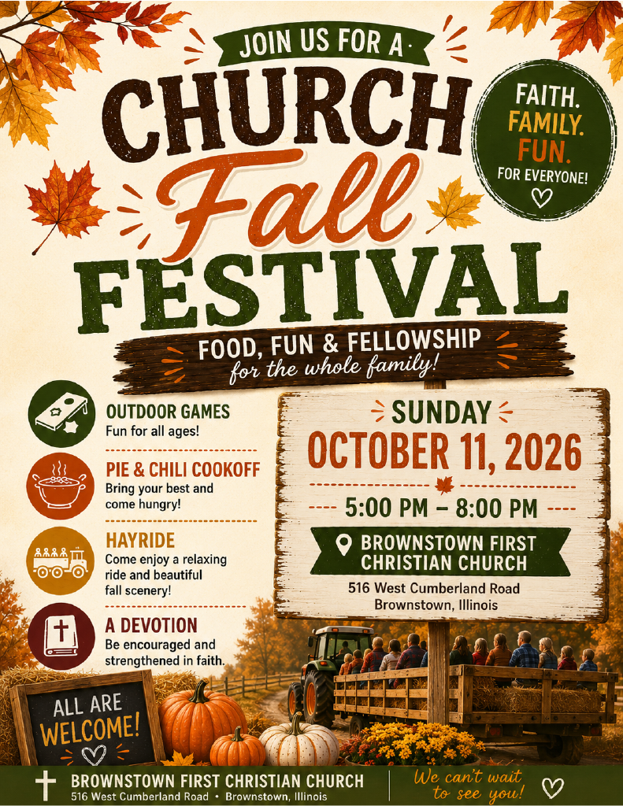

Life Chain
Since 1987, followers of Jesus have gathered in public witness on the first Sunday of October, in prayerful repentance over the sin of abortion in our cities and in the Church. Our local Life Chain will be held on Sunday, Oct. 4th from 2-3 pm on the corner of Kennedy & Gallatin in Vandalia. All participates are encouraged to take a stand (or seat) for Life. There will be signs available for you to hold while you are praying.
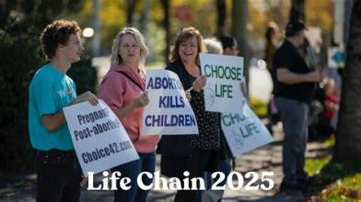

We Exist to:

* WORSHIP the Living God * WIN People to Jesus * TRAIN God’s People for Service

* SEND Them Out Into the World

From the Minister
Here at First Christian Church of Brownstown, we wish to follow God’s Word, the Bible. Words of man, whether it is in the form of creeds, mottos, or statements of faith, are not on the level of the words of God. This means the Bible is our sole authority in our faith and lives. We strive to follow this to the best of our ability.
This is seen in our church mission statement. LOVE GOD. LOVE PEOPLE. We have this as our mission statement because it is lifted straight out of the Bible. We invite all Christians and those interested in being a Christian to join us as we strive for this.

God bless,
Nathan Brands

Operation Christmas Child
The mission of Operation Christmas Child is to demonstrate God’s love in a tangible way to children in need around the world. Through this project, Samaritan’s Purse partners with the local church worldwide to share the Good News of Jesus Christ and make disciples of the nations.
“Let the children come to Me; do not hinder them, for to such belongs the kingdom of God.” Mark 10:14, ESV
Fill your box with gifts and attach the label. Shipping donation of $10 (made out the church) can be placed in the offering plate.
Please do not place shipping donation inside of the shoebox!
Return your box by Sunday, October 11th.
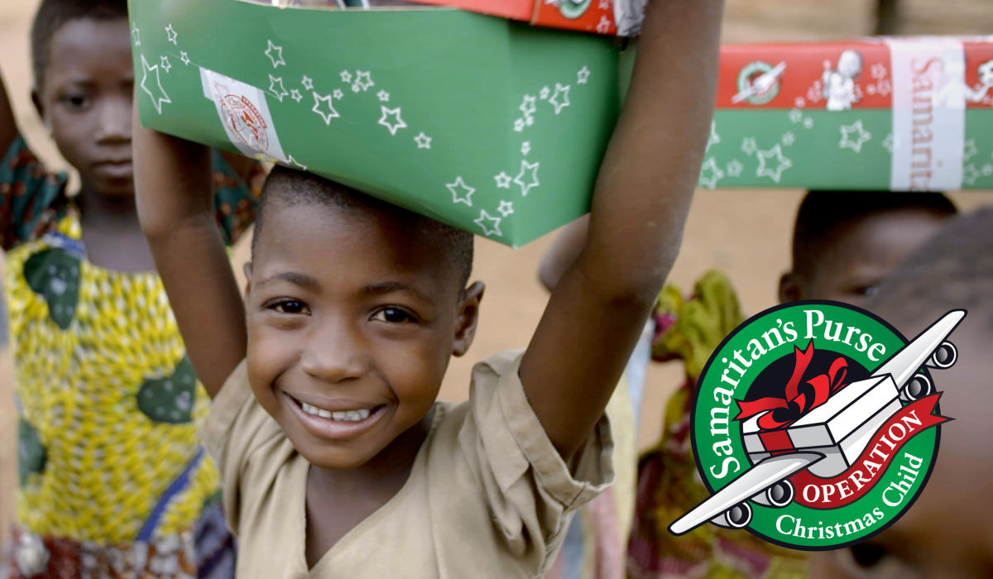

What’s Going On?
Breakfast Fellowship: If you would like to provide breakfast on a Sunday morning, there will be a sign-up sheet in the kitchen. Breakfast starts at 9:00 am.
Leadership Team (Elder’s & Deacon’s) Meeting is Tuesday, October 13th @ 7:00 pm.



5th Sunday
A 5th Sunday Offering will be taken up on Sunday, November 29th. The entire amount collected will be going to the Building Fund. Goal is $22,000. A potluck will follow Sunday School.
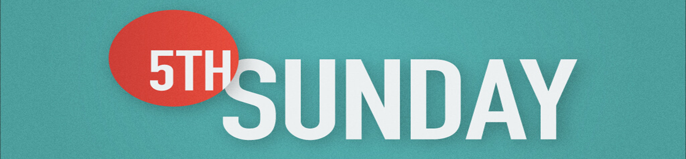

Volunteers Needed
Looking for volunteers to mow the parsonage for the month of October.

Contact Don Lovett for more information.

For the Record

Date Attendance Offering Building Fund
8/30 69 5th Sunday $20,023.00
9/6 63 $2,941.10 $40.00
9/13 68 $1,863.00 $30.00
9/20 68 $2,083.00 $161.00

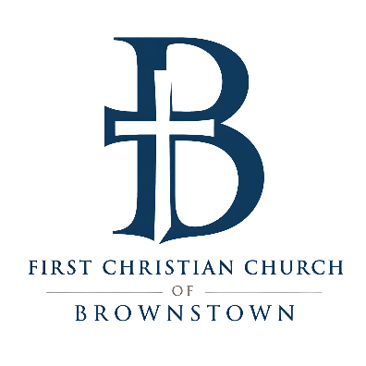

516 W. Cumberland Rd.
P.O. Box 296
Brownstown, IL 62418
618-427-3687
Website: fcc-brownstown.com
Email: brownstownfcc@gmail.com

Nathan Brands, Preaching Minister Jamie Smith, Administrative Assistant


*Hazel Jachino
*Deanna Miller
*Emalee Smith
*Cordelia Lytle
**Jody/Jamie Meador
**Patrick/Kaci Satterthwaite
**Travis/Lauren Gould
*Jack Shelton
*Susan Smith
*Birthday
**Anniversary

