**First Word**

**First Christian Church Brownstown**

**April 2023**

**Easter Services**



Sunday, April 9th

7:00 am

First Christian Church Brownstown

SONRISE SERVICE

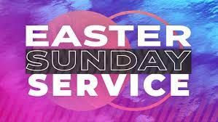

Join us this Easter Sunday for worship!

Sunday, April 9th at 9:30 am

We will be taking up a 30 pieces of silver offering with all collected going to Bond Christian Service Camp for their Chapel Bathroom Project.

#### We Exist to:

#### * WORSHIP the Living God * WIN People to Jesus * TRAIN God’s People for Service

#### * SEND Them Out Into the World

#### 



**FCCB Cookbook**

FCCB will be putting together another cookbook and we need your help with recipes. We are still a few recipes short on vegetables and potatoes. If you would like to submit and haven’t already done so, please let Jamie know this Sunday.



**Ladies Bible Study**

The ladies are doing a Beth Moore study, ‘Jesus, The One and Only,’ on Tuesdays, at 6:30 pm, here at the church. There is still time to join! See Joann Strobel for more information.



**Breakfast Fellowship**

If you would like to provide breakfast on a Sunday morning, there will be a sign-up sheet in the kitchen. Breakfast starts at 9:00 am.



## What’s Going On?

**Sunday Night Youth Group** for 5th – 12th grade will be Sundays from 5:00 – 6:30 pm. The last youth group until the fall will be April 2nd.

**Leadership Team (Elder’s & Deacon’s) Meeting** is Tuesday, April 11th @ 7:00 pm.



## 5th Sunday

The next 5th Sunday Offering is Sunday, April 30th. The entire amount collected will be going to the Building Loan Principle. The goal is $22,000. There will be a potluck following at noon.

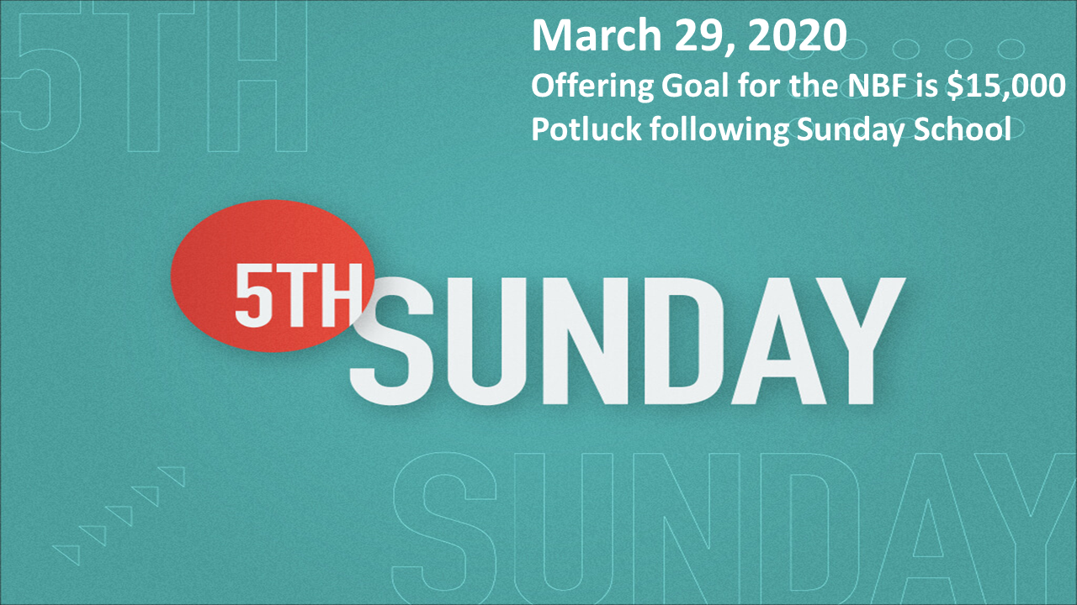

## For the Record

Date Attendance Offering Building Fund

2/26 71 $2,246.00 $2,845.00

3/5 77 $2,187.00 $1,070.00

3/12 62 $1,941.25 $0.00

3/19 54 $1,662.00 $0.00

Building Loan Balance - $130,741.02



First Christian Church

Brownstown

516 W. Cumberland Rd.

P.O. Box 296

Brownstown, IL 62418

618-427-3687

Website: [www.fccbrownstown.com](http://www.fccbrownstown.com) Email: [brownstownfcc@gmail.com](mailto:brownstownfcc@gmail.com)

Nathan Brands, Preaching Minister Jamie Smith, Administrative Assistant

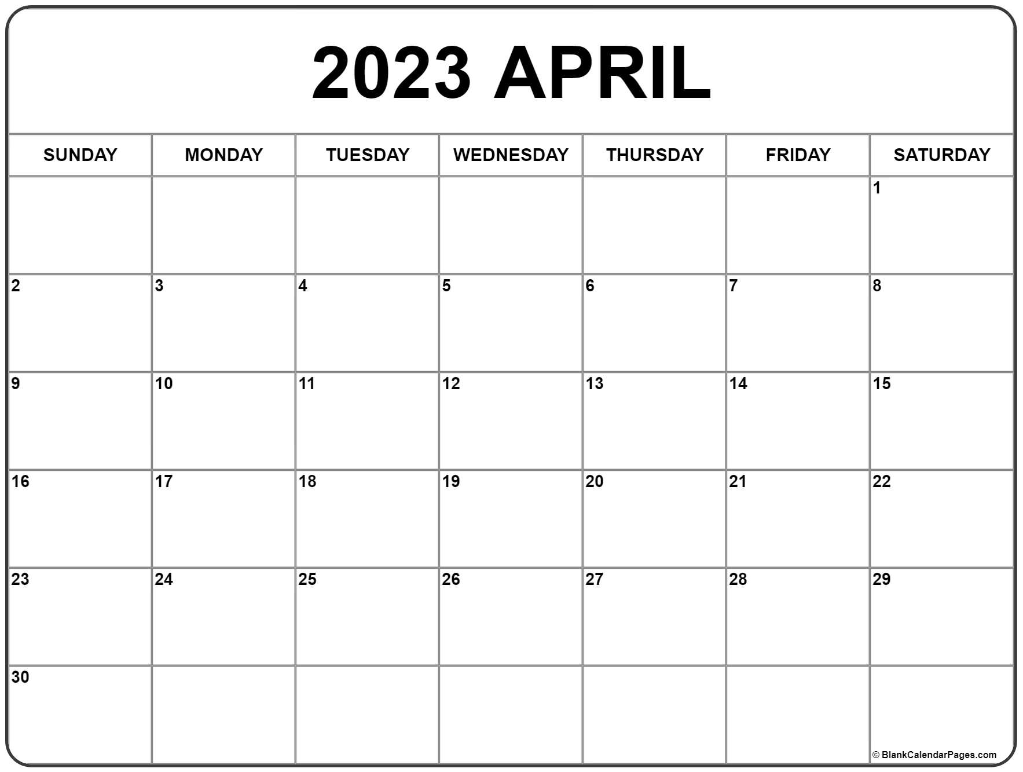

**Mitch/Rae Lynn Koehler

*Kent Durbin

*Josh Miller

*Bonnie Shelton

*Sandy Gelsinger

*Laura Willms *Lauren Gould *Nathan Brands

*Stephanie Miller

*Karen Miller *Liz Oberlink

**Mike/Lynn Boggs *Tresnee Adams

*Ella Satterthwaite

*Sherry Meador

*Randy Gelsinger

*Kent Woolsey

*Teresa Durbin

*Birthday

**Anniversary