**First Word**

**First Christian Church Brownstown**

**April 2024**

**Bond Christian Service Camp**



Camp registration has begun and the weeks are starting to fill up! To register go to bondcamp.com.

The church will pay for one week of camp per camper for church members.

**Ladies Bible Study**

The ladies are currently meeting each Wednesday evening at 6:30 pm for a Beth Moore Bible Study entitled ‘The Inheritance.’ It focuses on the many blessings we inherit as a child of God. The theme verse is Psalm 16:5-6, “The lines have fallen for me in pleasant places; indeed I have a beautiful inheritance.” All ladies are welcome.



#### We Exist to:

#### * WORSHIP the Living God * WIN People to Jesus * TRAIN God’s People for Service

#### * SEND Them Out Into the World

#### 



**From the Minister**

I was doing some reading on the state of Christianity in the US and found some interesting and troubling trends. Here is what I found.

* The fastest grow denominations/church groups in the US are theologically conservative. They hold to the traditional Christian beliefs on sexuality, gender, and life. This makes them counter-cultural in regards to this matter.
* Two of the fastest growing churches are Christian cults: Mormons and Jehovah Witnesses. They are theologically conservative but do not believe in the same Bible we do. However, their commitment to evangelizing the lost is obvious.
* Church switching is becoming a more popular form of church growth rather than conversion.
* Only 63% of Americans consider themselves Christians, as of 2021. This is down from 78% in 2011. The amount of people that Christianity lost was gained by those with no religion, which went from 16% to 29% over the same time frame. This group is often referred to as the religious “nones.” This group is made up of atheists, agnostics, and those that claim no religion.
* As of 2023, 4% of the US population are atheists. Of these atheists, 64% are men and 52% are adults under the age of 49.
* In a religious knowledge survey conducted in 2019, atheists scored just as high as Christians on questions regarding the Christian faith.

What is the takeaway from all of this?

* If we want to know why the church is not growing then the answer is two things: EVANGELISM & TEACHING.
* Churches grow when the people of the local churches tell people about their faith. This is why Mormons and Jehovah Witnesses have experienced the growth they have. Local churches could experience the same growth, but it will require the same commitment to tell others about our faith.
* Biblical truth, that is tradition, conservative theology is what people long for. People do not want a church that is just like the culture around us.
* Biblical teaching is vital. One of the results of many churches changing to be more like the culture we live in and many churches becoming very focused on being seeker-friendly is Christians are less educated about their faith. We need strong biblical teaching, during the sermon, during Sunday School or small groups, and especially at home.



God bless,  
Nathan Brands

## What’s Going On?

**Breakfast Fellowship:** If you would like to provide breakfast on a Sunday morning, there will be a sign-up sheet in the kitchen. Breakfast starts at 9:00 am.

**Youth Groups** will be starting back soon. Watch for a start date for the new year!

**Leadership Team (Elder’s & Deacon’s) Meeting** is Tuesday, April 9th @ 7:00 pm.

**FCCB Kidventure (VBS)** is June 17th – June 20th. More information coming soon!

VB



**Men’s Breakfast**

We will be gathering at FCCB for a time of prayer and fellowship at 7:00 am on the last Saturday of each month. This is open for all men! This months breakfast will be Saturday, April 27th.



## 5th Sunday

A 5th Sunday Offering will be taken up on Sunday, June 30th. The entire amount collected will be going to the Building Loan Principle. The goal is $22,000. There will be a potluck following at noon.

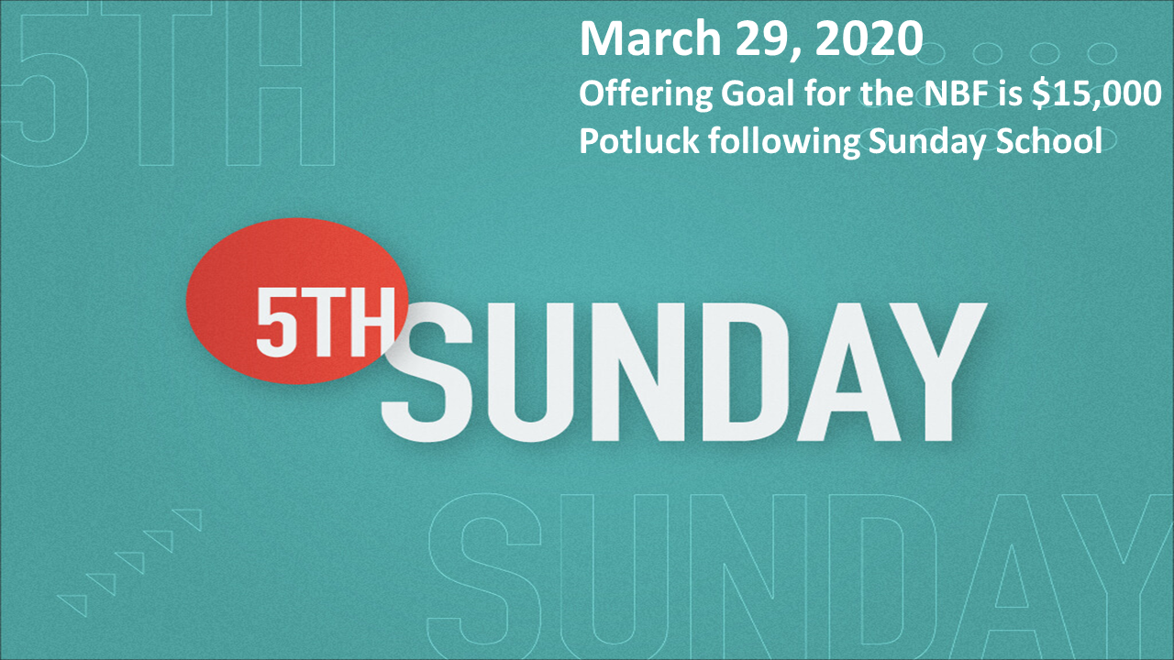

## For the Record

Date Attendance Offering Building Fund

2/25 65 $1,851.00 $100.00

3/3 56 $2,439.00 $6,310.00

3/10 48 $1,656.25 $30.00

3/17 61 $2,972.00 $40.00

3/24 66 $4,744.00 $0.00

3/31 94 5th Sunday $19,358.60

New Building Fund - $32,558.15

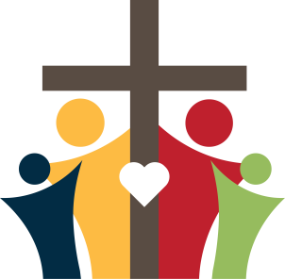

First Christian Church

Brownstown

516 W. Cumberland Rd.

P.O. Box 296

Brownstown, IL 62418

618-427-3687

Website: [www.fccbrownstown.com](http://www.fccbrownstown.com) Email: [brownstownfcc@gmail.com](mailto:brownstownfcc@gmail.com)

Nathan Brands, Preaching Minister Jamie Smith, Administrative Assistant

*Birthday

**Anniversary



*Teresa Durbin

*Kent Woolsey

*Randy Gelsinger

*Sherry Meador **Floyd & Dona Adams

*Ella Satterthwaite

*Tresnee Adams

*Karen Miller *Liz Oberlink

*Stephanie Miller

*Laura Willms *Lauren Gould *Nathan Brands

*Sandy Gelsinger

*Bonnie Shelton

*Kent Durbin *Dona Adams

**Mitch & Rae Lynn Koehler