**First Word**

**First Christian Church Brownstown**

**August 2023**

**Tools for School**

Backpack 2 School Event will be held on Wednesday, August 2nd from 4-6 pm at the First United Methodist Church in Vandalia. One free backpack to each student present.

Tools for School will be distributing school supplies to the community on August 2, 3, 4, & 5 at St. James Lutheran Church in Vandalia. Students must be present to receive supplies.

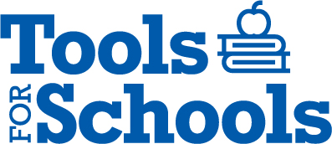

**Breakfast Fellowship**

If you would like to provide breakfast on a Sunday morning, there will be a sign-up sheet in the kitchen. Breakfast starts at 9:00 am.

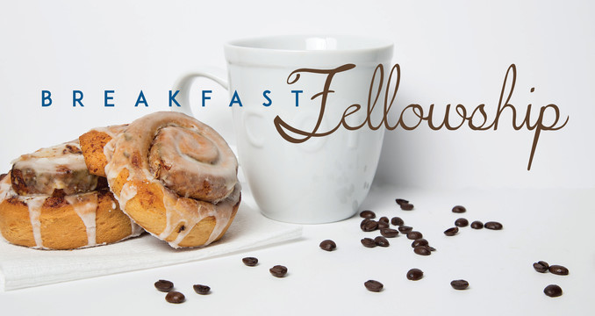

#### We Exist to:

#### * WORSHIP the Living God * WIN People to Jesus * TRAIN God’s People for Service

#### * SEND Them Out Into the World

#### 



**From the Minister**

Over the last few months, we have been looking into church history. Last month, we took a look at Martin Luther, and his contributions to the Reformation. This month we are looking at another person instrumental to the Reformation, John Calvin.

When we hear the name John Calvin, some of you might think of the theology that bears his name, Calvinism. Calvinism is not something that the Restoration Movement typically subscribes to. However, we clearly can trace our roots back to him.

There are two ways we trace back to John Calvin. The first is through the different Churches that find their roots in Calvin. Both Baptist denominations and Presbyterian denominations are roots in the teachings of Calvin. These denominations are the two that Alexander Campbell and Barton Stone left when they begin their own movement, which came to be known as the Restoration movement.

The second way we trace back to John Calvin is in his views on the sacraments. John Calvin only believed in two sacraments, baptism and communion. While Luther also only believed in only two sacraments, his view on communion did not differ much from the Catholic church. Calvin, however, had a more symbolic view of communion while he still held that the Holy Spirit had a role in communion that impacted the individual believers. Many other Reformations that held the more symbolic approach felt communion was purely symbolic, while Calvin felt that it was symbolic but not purely symbolic. This is the approach that I myself hold.



God bless,

Nathan Brands

## 5th Sunday

The next 5th Sunday Offering is Sunday, October 29th. The entire amount collected will be going to the Building Loan Principle. The goal is $22,000. There will be a potluck following at noon.

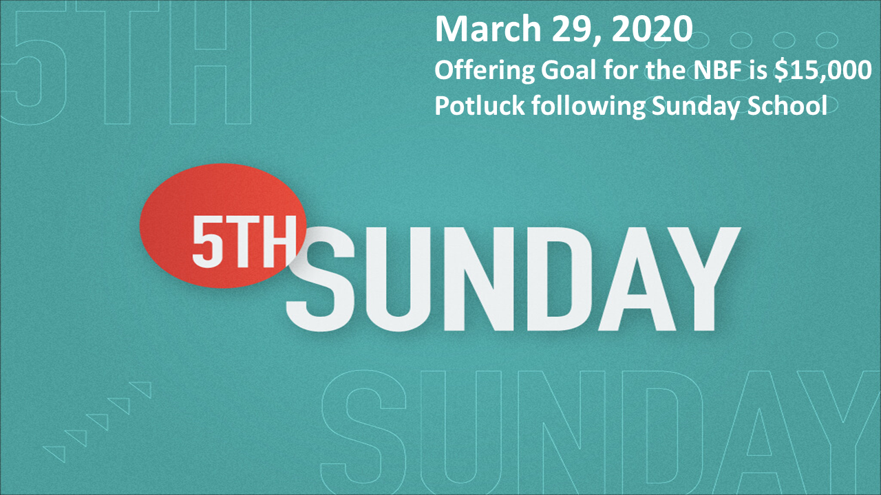

## What’s Going On?

**Leadership Team (Elder’s & Deacon’s) Meeting** is Tuesday, August 8th @ 7:00 pm.



## Youth Service Project

We will be meeting at the church on Sunday, August 20th from 5:00 – 7:00 pm for a Sidewalk Project.

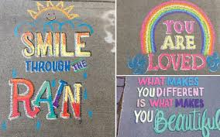

## For the Record

Date Attendance Offering Building Fund

6/25 66 $1,425.00 $3,390.00

7/2 65 $2,559.00 $2,325.00

7/9 67 $1,198.90 $0.00

7/16 70 $2,758.00 $550.00

7/23 64 $2,356.00 $0.00

Building Loan Balance - $97,005.55

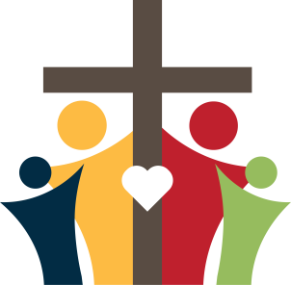

First Christian Church

Brownstown

516 W. Cumberland Rd.

P.O. Box 296

Brownstown, IL 62418

618-427-3687

Website: [www.fccbrownstown.com](http://www.fccbrownstown.com) Email: [brownstownfcc@gmail.com](mailto:brownstownfcc@gmail.com)

Nathan Brands, Preaching Minister Jamie Smith, Administrative Assistant



*Duane Willms

*Les Hipsher *Rylin Pruett

*Phyllis Pryor

**Don/Ellen Willms

*Aiden Smith

*Heather Miller *Megan Willms

**Jeremy/Shannon Claycomb

*Judy Palecek *Wilma Kruger

*Gracie Meador

*Jori Adams **Matthew/Jamie Smith

*Karen Morrison

*Mike Boggs *Lynn Boggs

**Eric/Tresnee Adams

**Kent/Teresa Durbin

*Birthday

**Anniversary