**First Word**

**First Christian Church Brownstown**

**August 2024**

**Tools for School**

Need help with getting school supplies? Go to the First United Methodist Church Family Center at 4th & Main St. in Vandalia on Wednesday, August 7th from 4-6 pm to receive a free backpack. Then bring that backpack to St James Lutheran Church at 727 W. Gallatin Street in Vandalia on Wednesday, August 7th through Saturday, August 10th to receive your free school supplies. Child must be present with an adult to receive supplies.



**Collecting for Our Troops**

Taylor Ring (Bayle Ring’s husband) is deployed for 9 months and he has mentioned that there is a need for personal care items and snacks. (There is no store where they are stationed to buy items needed. Due to the heat, they ask for things that will not melt.

What better way as the body of Christ than to help out a fellow Christian in a time of need and supporting our troops?

Items needed: (Please buy gender neutral if possible)

Razors Toothbrushes/Toothpaste Spray Deodorant Body Wash (no bars) Shampoo (no conditioner) Cooling Tools Sunscreen Snacks (nothing that will melt or get sticky) Liquid IV packets



Questions: Contact Jamie Smith

#### We Exist to:

#### * WORSHIP the Living God * WIN People to Jesus * TRAIN God’s People for Service

#### * SEND Them Out Into the World

#### 



**From the Minister**

As school starts back up soon, I am reminded of the struggles our youth are facing. One of the biggest struggles they are facing is the issue of identity. Who am I? This is a question that the youth are faced with almost every day. Ultimately, this question is one of value. The problem is that our culture seems to place value on the wrong things. Our culture values what you do (sports, clubs, academics, etc.), what gender or sexual identity is (LGBTQIA+, transgender, etc.), and/or what we believe (manifesting, evolution, etc.). While what we do is not necessarily bad, they distract us from who we truly are and where our value comes from. The other issues that our culture values negatively impact the youth of today.

When people focus on what our culture values in regards to identity, it does the opposite of the intended goal. Our culture tries to say that by focusing on these things you will find yourself and gain self-confidence. However, what it really produces is more confusion and low self-esteem. When the youth fail at what they do, don’t feel complete from their gender or sexual identity, or what they believe doesn’t happen or answer their questions, they are demoralized and/or more confused than before.

What is the solution then? How do we answer this question: Who am I? The answer is found as early as Genesis 1. There we find that we are made in the image of God. We see that when God made us, it wasn’t just good but very good. Later in Genesis, God confirms that people have value because they are made in God’s likeness. The Bible also says we are loved by God, and that we are his masterpiece. This is where our value is from. This is our identity.

Please remind the youth of this as they head back to school. Help them to remember what makes them valuable and who they are.

God bless,  
Nathan Brands



## What’s Going On?

**Breakfast Fellowship:** If you would like to provide breakfast on a Sunday morning, there will be a sign-up sheet in the kitchen. Breakfast starts at 9:00 am.

**Leadership Team (Elder’s & Deacon’s) Meeting** is Tuesday, August 13th @ 7:00 pm.

VB

## 



**Men’s Breakfast**

We will be gathering at FCCB for a time of prayer and fellowship at 7:00 am on the last Saturday of each month. This is open for all men! This month’s breakfast will be Saturday, Augsut 31st.

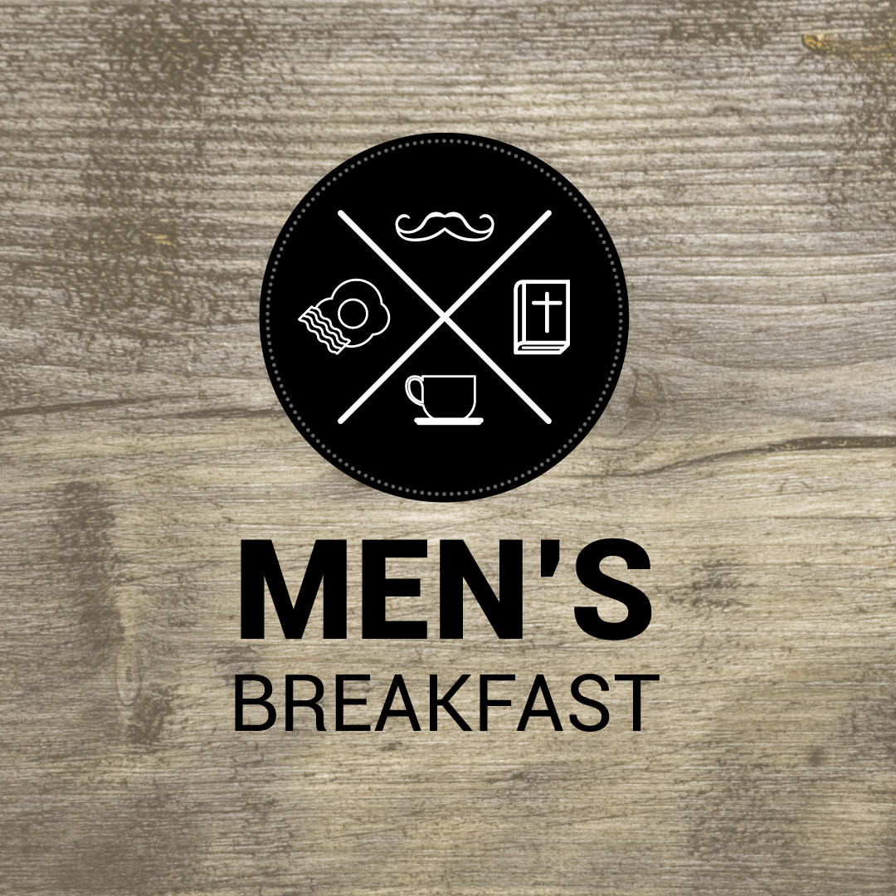

## 5th Sunday

A 5th Sunday Offering will be taken up on Sunday, September 29th. The entire amount collected will be going to the Building Loan Principle. The goal is $22,000. There will be a potluck following at noon.

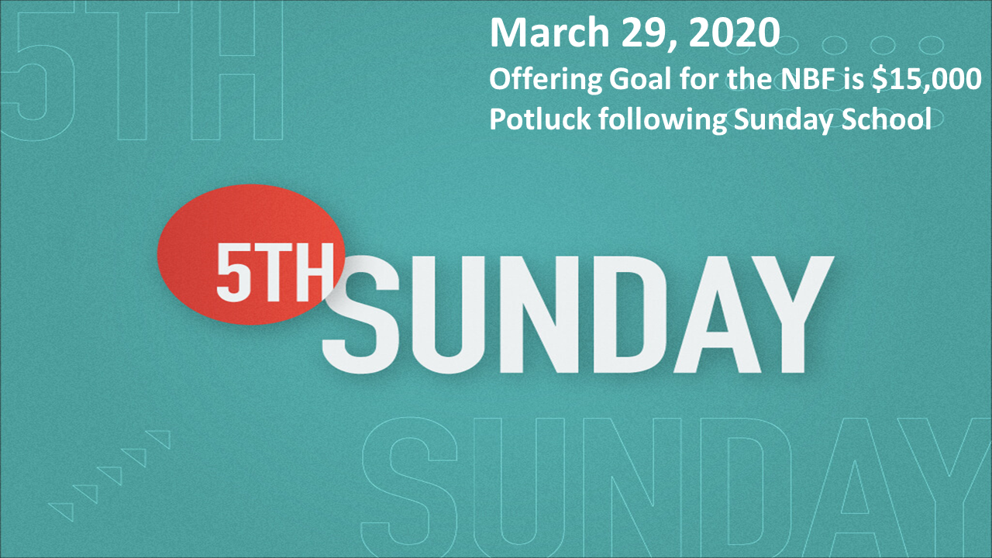

## For the Record

Date Attendance Offering Building Fund

6/23 52 $1,897.00 $0.00

6/30 65 5th Sunday $17,788.00

7/7 54 $2,183.00 $1,815.00

7/14 57 $1,085.00 $435.00

7/21 50 $2,777.00 $40.00

New Building Fund - $58,724.15



First Christian Church

Brownstown

516 W. Cumberland Rd.

P.O. Box 296

Brownstown, IL 62418

618-427-3687

Website: [www.fccbrownstown.com](http://www.fccbrownstown.com) Email: [brownstownfcc@gmail.com](mailto:brownstownfcc@gmail.com)

Nathan Brands, Preaching Minister Jamie Smith, Administrative Assistant



*Birthday

**Anniversary

*Duane Willms

*Phyllis Pryor

*Aiden Smith

**Jeremy/Shannon Claycomb

*Wilma Kruger *Judy Palecek

*Gracie Meador

*Jori Adams **Matthew/ Jamie Smith

*Karen Morrison

*Mike Boggs *Lynn Boggs

**Eric/Tresnee Adams

**Kent/Teresa Durbin