First Word

First Christian Church Brownstown
December 2023

The Polar Express
On Christmas Eve, a young boy embarks on a magical adventure to the North Pole on the Polar Express, while learning about friendship, bravery, and the spirit of Christmas.
Please join us on Sunday, December 10th at 9:30 am as our children present a special program.


Support our Youth
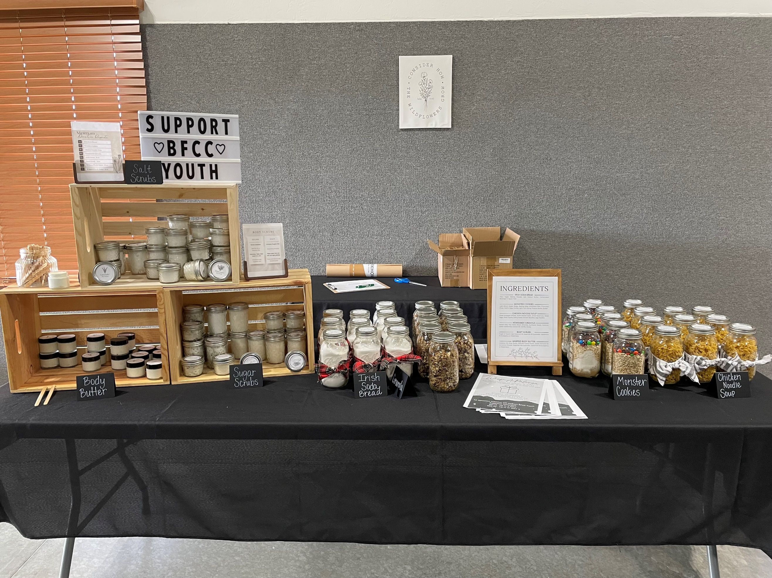

The youth are accepting donations for Body Scrubs, Body Butter, Irish Soda Bread, Monster Cookie Mix, Chicken Noodle Soup Mix, and Homemade Granola. If you would like to support them, you can contact one of the Jr/Sr. High youth kids or stop by the table at the back of the fellowship hall.
~~~~~~~~~~~~~~~~~~~~~~~~~~~~~~~~~~~~~~~~~~~~~~~~~~~~~~~~~~~~~~~~~~~~~
WRAP-A-PALOOZA – Take a break this season and let us wrap your gifts!
Sunday, December 3rd ∙ First Christian Church Brownstown Drop off begins at 4:30 pm Suggested donations: $10-$15 up to 5 gifts ∙ $20-$25 up to 10 gifts


We Exist to:

* WORSHIP the Living God * WIN People to Jesus * TRAIN God’s People for Service

* SEND Them Out Into the World

From the Minister

As we continue our look into church history, I want to go deeper within the history of the restoration movement. We have looked into the contributions of Barton Stone and the father-son duo of Thomas and Alexander Campbell. Now I wish to take a look at someone many of you probably have not heard of, Walter Scott. Walter Scott started to work with the Campbells in 1826. The next year Scott was hired to work as an evangelist.
It has been reported that Scott converted over 3,000 people within his first three years as an evangelist. How did he do this? He kept it simple. He developed the five-finger exercise. This exercise is as follows:
Hold up your hand. Point to each finger as you go through the next five things: “faith, repentance, baptism, remission of sins, gift of the Holy Spirit.”
He developed the belief in a six-phased covenantal understanding of salvation. The individual person would have faith, repent, and be baptized. God would provide the remission of sins, the gift of the Holy Spirit, and eternal life. He based both his five-finger exercise and his six-phased covenantal understanding of salvation on Acts 2:38.
I tell you about Walter Scott simply to encourage you to tell others about Jesus. Ultimately, it is the Holy Spirit doing the work in someone’s life that convicts them to be saved. We do not need to overcomplicate it.

God bless,
Nathan Brands

Caring & Sharing
Caring & Sharing will be giving out Christmas Baskets in the Brownstown community once again. With your help, we will do the best to provide deserving families with a Christmas dinner complete with all the trimmings plus gifts for the children. All collections should be completed by Sunday, December 10th. A box will be at the back of the fellowship hall for all donations.
Items you can donate:
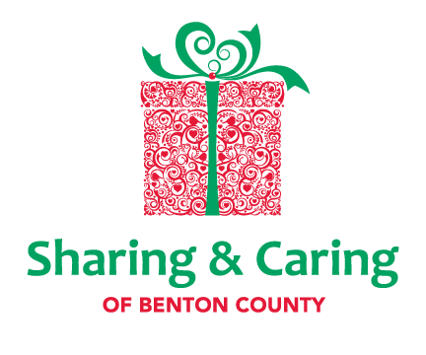
Non-perishable food items
New toys, puzzles, games
Hats, gloves, mittens, scarves, socks
Teen items
Christmas decorations and disposable dinnerware
Monetary Contributions (mark as Caring & Sharing)

What’s Going On?
Breakfast Fellowship: If you would like to provide breakfast on a Sunday morning, there will be a sign-up sheet in the kitchen. Breakfast starts at 9:00 am.
Youth Groups will be Sundays from 6:00 – 7:30 pm.
Leadership Voting for 2024 will be Sunday, December 3rd during the morning service.
Leadership Team (Elder’s & Deacon’s) Meeting is Tuesday, December 12th @ 7:00 pm.
Men’s Breakfast Prayer & Fellowship will meet on December 2nd at 7:00 am.



Upcoming Christmas Events
Sunday, December 1st – Ladies Christmas Supper/Secret Sister Reveal at 6:00 pm Sunday, December 2nd – Christmas Program Practice 4:30 – 6:00 pm Saturday, December 8th – Christmas Program Practice 11:30 am – 2:15 pm Sunday, December 9th – The Polar Express Christmas Program at 9:30 am Sunday, December 24th – Combined Christmas Service at Liberty Christian Church at 6:00 pm


5th Sunday

A 5th Sunday Offering will be taken up on Sunday, December 31st. The entire amount collected will be going to the Building Loan Principle. The goal is $22,000. There will be a potluck following at noon.
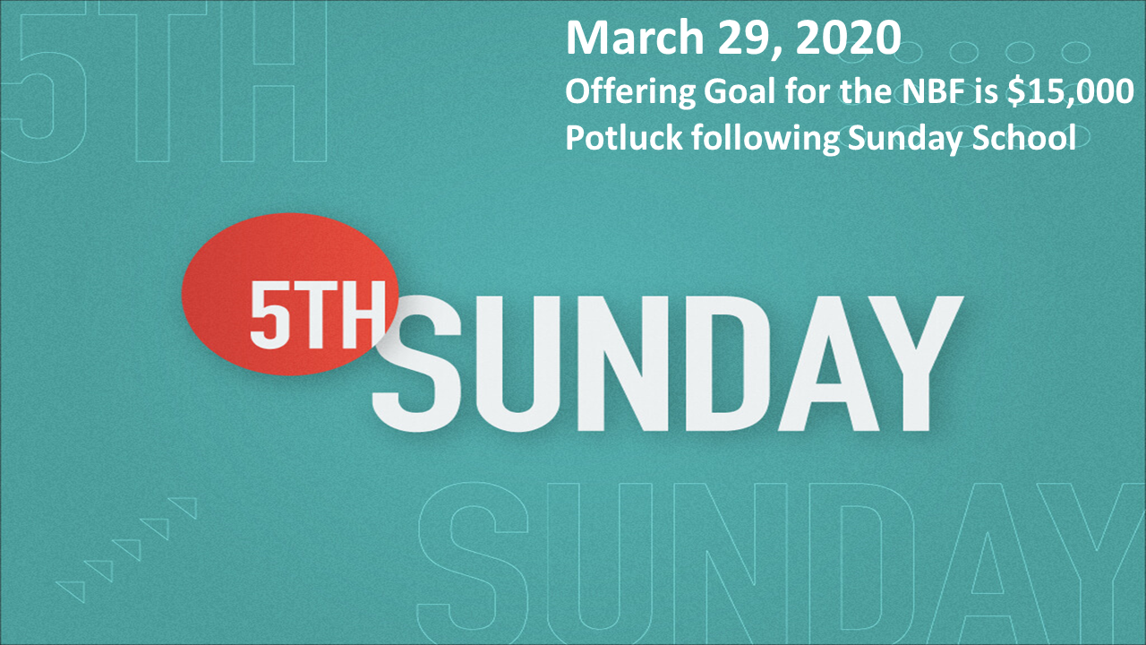

For the Record

Date Attendance Offering Building Fund
10/29 64 5th Sunday $24,756.50
11/5 65 $2,242.25 $300.00
11/12 54 $2,255.00 $340.00
11/19 50 $1,935.00 $1,106.08
Building Loan Balance - $38,215.77



First Christian Church
Brownstown
516 W. Cumberland Rd.
P.O. Box 296
Brownstown, IL 62418
618-427-3687
Website: www.fccbrownstown.com Email: brownstownfcc@gmail.com

Nathan Brands, Preaching Minister Jamie Smith, Administrative Assistant

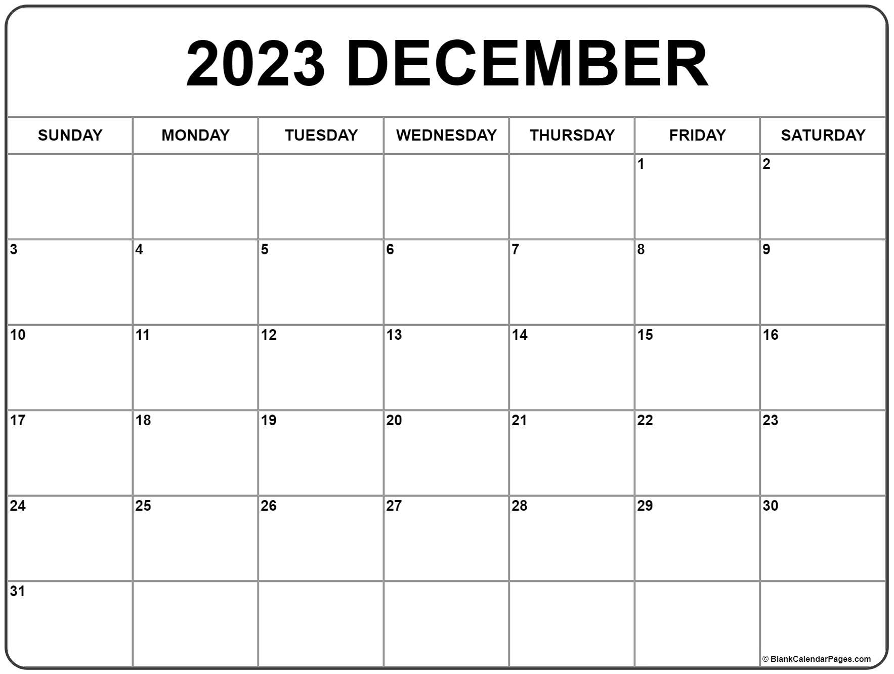
*Amanda Koehler *Avelyn Brands *Carolynn Shelton
*Andrew Shelton
*Chris Meador
*Deb Hunter
*Taylor Claycomb
*Jamie Smith
*Eric Adams
*Birthday
**Anniversary

