**First Word**

**First Christian Church Brownstown**

**February 2023**

**Valentines for Seniors Card Drive**

Senator Plummer and his staff are hoping to brighten the days of senior citizens who are living in nursing homes and assisted living facilities through his Valentines for Seniors program.

“This is a chance to let our seniors know that not only are they not forgotten, but that they are loved,” said Senator Plummer. “We need your help to get as many valentines together as we can so that we brighten the days of as many seniors as possible.”

Senator Plummer is asking students from public and private schools, church groups, scouting organizations and other groups to create homemade cards that will be delivered to assisted living centers, nursing homes, and long-term care facilities across the state.

Cards, poems, and other well-wishes will be collected through Feb. 7th at Senator Plummer’s office, located at 310 W. Gallatin St., Vandalia, Il.

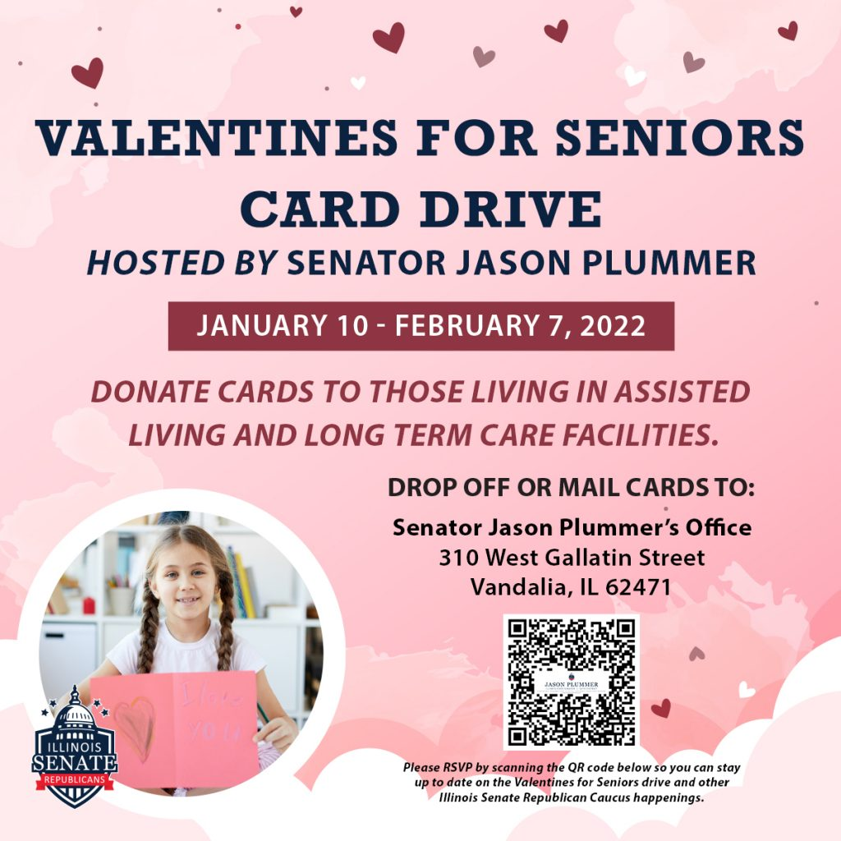

**Just for the Youth**

Sunday Night Youth Group for 5th – 12th grade will resume on February 5th with a trip to Winter Jam in St. Louis, MO. We will meet at the church at 3:30 pm and return home around midnight. Please bring money for supper, $15 for admission, and money for any souvenirs you wish to buy.



#### We Exist to:

#### * WORSHIP the Living God * WIN People to Jesus * TRAIN God’s People for Service

#### * SEND Them Out Into the World

#### 



**From the Minister**

February is known as the month of love. Typically, this is the love shared with a significant other. However, there is no reason not to shine a light on love towards others in general.

The Bible in many places talks about love. We are to love God and to love one another. When Jesus tells us to do this, he shares a story of the Good Samaritan (Luke 10). This is a story of a Samaritan loving an injured Jewish man, an enemy of the Samaritans, with all that he has. The Bible does not want us to only have this love on some occasions. 1 Corinthians 16:14 says, “Let all that you do be done in love.” We are to always show love. In fact, our love reflects relationship to God. 1 John 4 says, “God is love, and whoever abides in love abides in God, and God abides in him.”

I encourage you to love one another. Let the love you have be a reflection of your relationship to God.

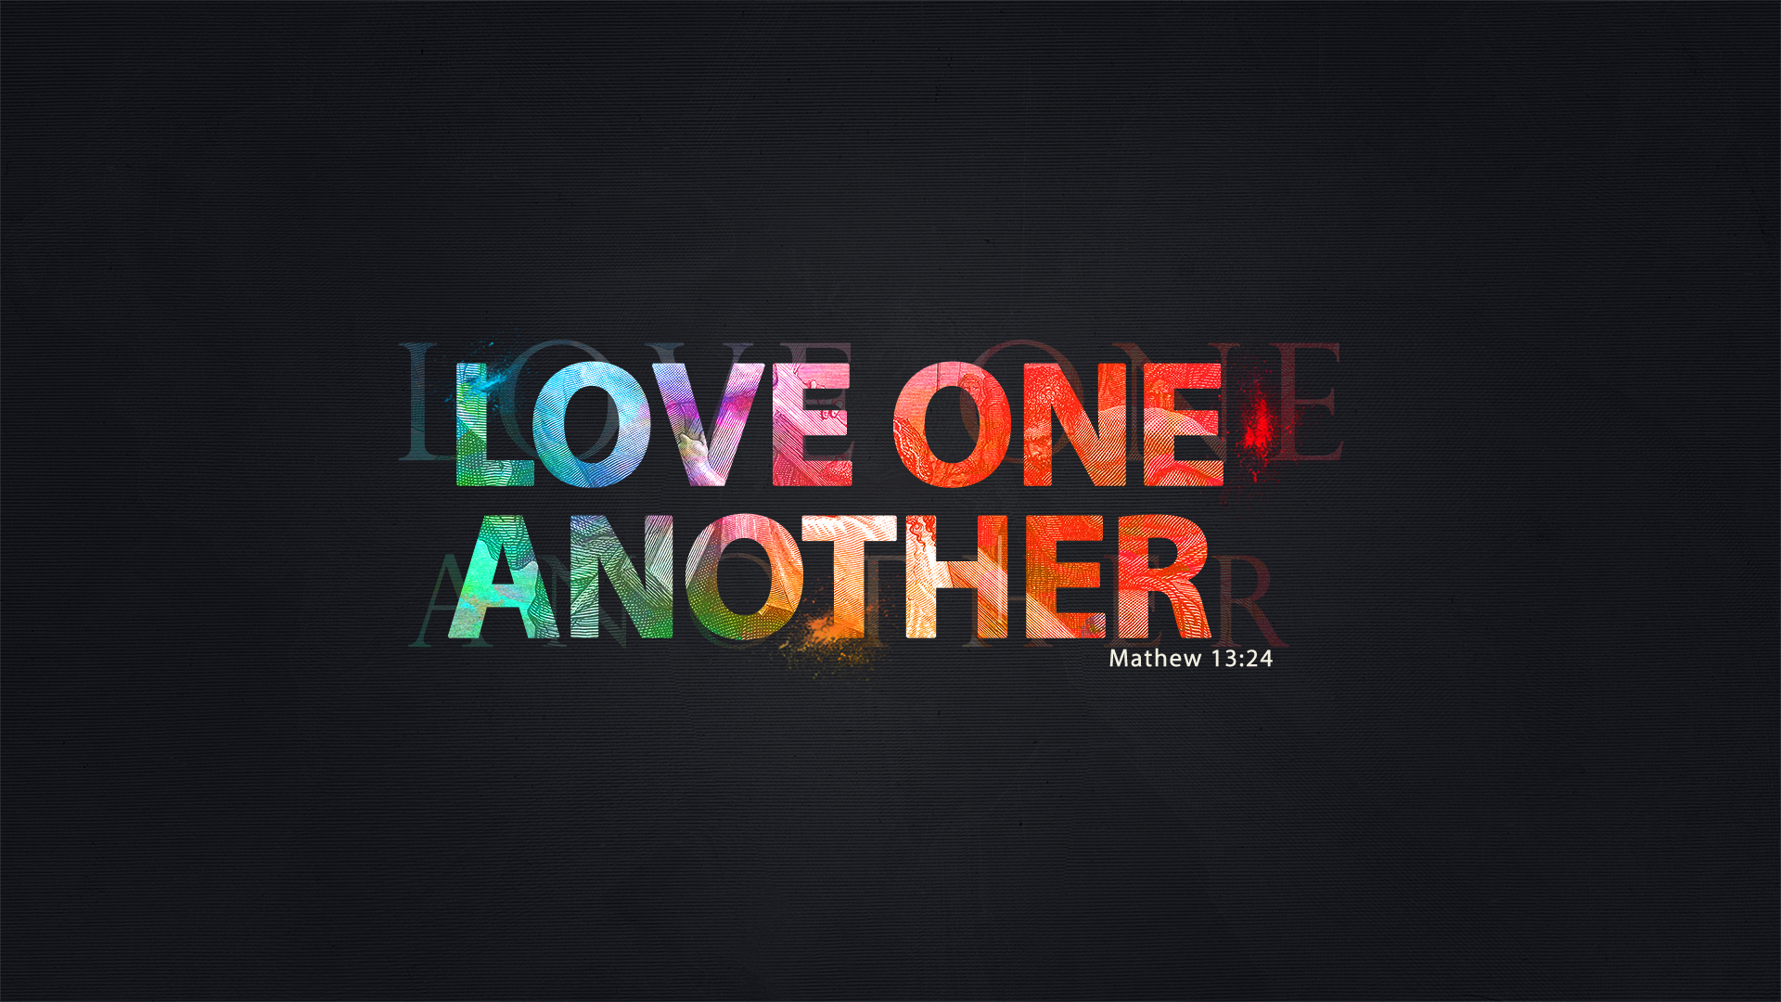

God bless,

Nathan

**FCCB Cookbook**

FCCB will be putting together another cookbook and we need your help with recipes. If you would like to submit a recipe(s), please drop them in the box at the back of the fellowship hall by Sunday, February 26th. Please limit your number of recipes submitted to 15. See Jamie Smith for any questions.



## What’s Going On?

**Leadership Team (Elder’s & Deacon’s) Meeting** is Tuesday, February 14th @ 7:00 pm.



## 5th Sunday

The next 5th Sunday Offering is Sunday, April 30th. The entire amount collected will be going to the Building Loan Principle. The goal is $22,000. There will be a potluck following at noon.

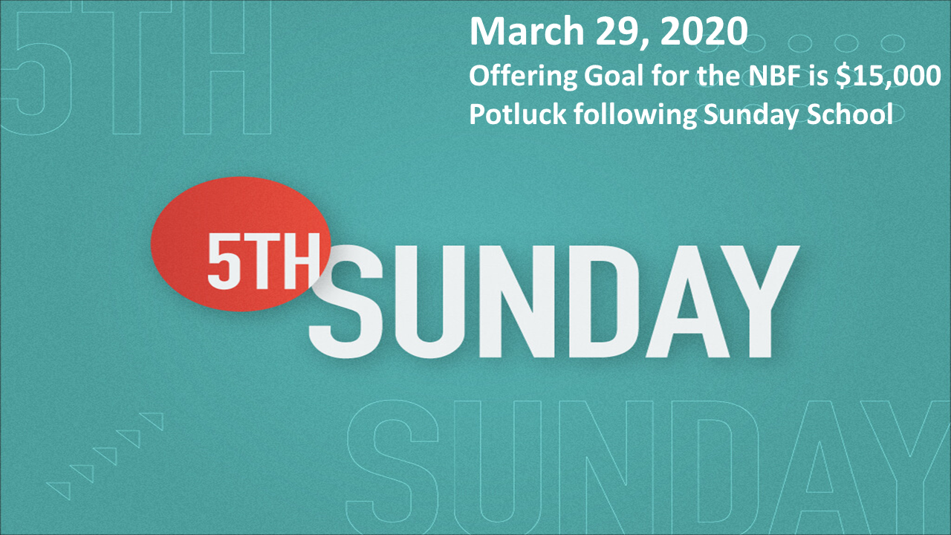

## For the Record

Date Attendance Offering Building Fund

12/25 78 $1,425.00 $4,167.05

1/1 52 $2,883.00 $1,145.00

1/8 72 $1,554.01 $50.00

1/15 70 $2,370.00 $50.00

1/22 69 $1,537.00 $40.00

1/22 LPHS Love Offering $1,088.01

Building Loan Balance - $159,736.88



First Christian Church

Brownstown

516 W. Cumberland Rd.

P.O. Box 296

Brownstown, IL 62418

618-427-3687

Website: [www.fccbrownstown.com](http://www.fccbrownstown.com) Email: [brownstownfcc@gmail.com](mailto:brownstownfcc@gmail.com)

Nathan Brands, Preaching Minister Jamie Smith, Administrative Assistant

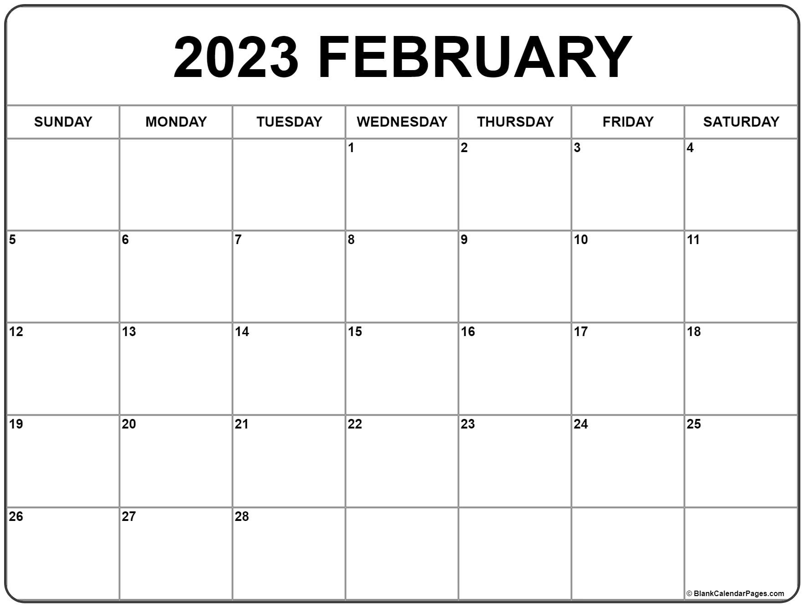

*Brody Gould *Gina Lytle

*Dawson Willms *Cade Willms *Travis Gould

*Helen Holman

*Jordan Miller

*Brynlee Willms

*Tammy Woolsey

*Don Lovett

*Brad Sidwell *Elliott Kinney

*Rae Lynn Koehler

*Birthday

**Anniversary