First Word

First Christian Church Brownstown
February 2024

Love Banquet
Sunday, February 18th
Meal: 5:00 – 6:00 pm
Entertainment: 6:30 pm


Cards for Seniors Card Drive
Senator Plummer and his staff are hoping to brighten the days of senior citizens who are living in nursing homes and assisted living facilities through his Valentines for Seniors program.
“This is a chance to let our seniors know that not only are they not forgotten, but that they are loved,” said Senator Plummer. “We need your help to get as many valentines together as we can so that we brighten the days of as many seniors as possible.”
Senator Plummer is asking students from public and private schools, church groups, scouting organizations and other groups to create homemade cards that will be delivered to assisted living centers, nursing homes, and long-term care facilities across the state.
Cards, poems, and other well-wishes will be collected through Feb. 5th at Senator Plummer’s office, located at 310 W. Gallatin St., Vandalia, Il.
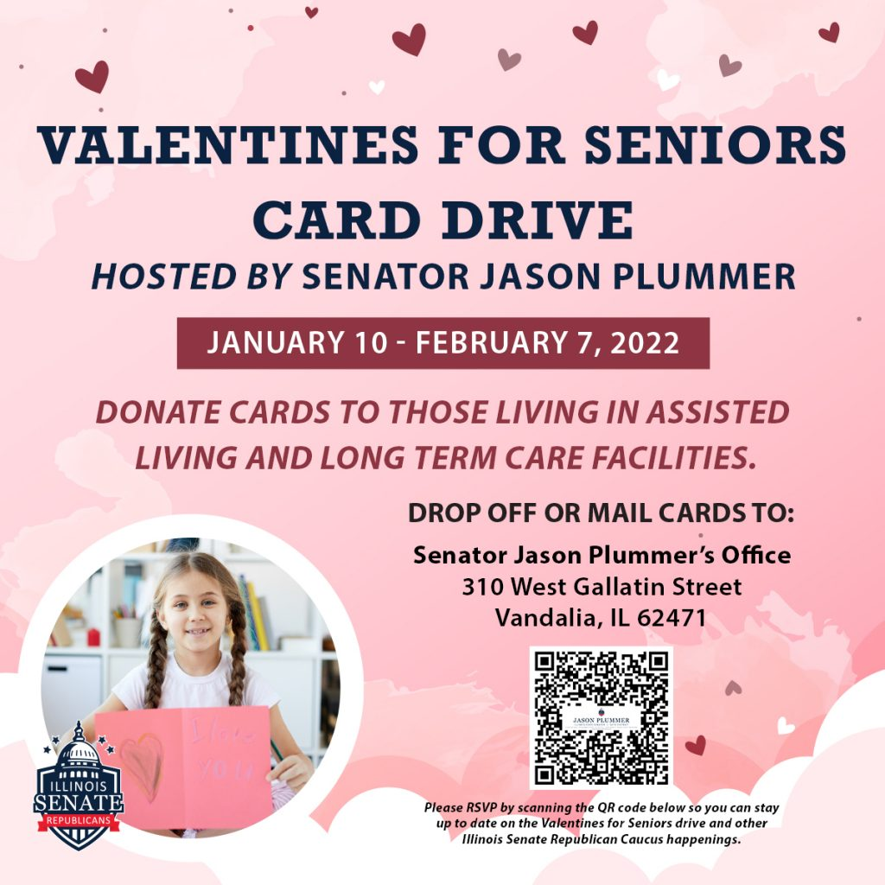

We Exist to:

* WORSHIP the Living God * WIN People to Jesus * TRAIN God’s People for Service

* SEND Them Out Into the World

From the Minister

Do we desire happiness or contentment?
I am finishing up a sermon series entitled “Joy” on the book of Philippians. This series is exactly what I needed in my personal life. This happens from time to time in my life. We all have had times in our lives where things are not going how we wish they would. In these times, we struggle with joy. We struggle because we are chasing after the wrong thing. We are pursuing happiness instead of contentment. This is something our culture, much like me, struggles with. The pursuit of happiness is engrained in us. It is written into the Declaration of Independence. We are raised to chase happiness in life. However, this pursuit doesn’t create in us joy. In fact, it often makes it hard to have lasting joy. This is because happiness is a fleeting emotion. Shortly after you obtain it, you lose it and have to start the pursuit again. This creates anxiety and stress in between moments of happiness. This is why our goal should be contentment. Joy and contentment are basically synonyms. Contentment means you are okay or good with how things in life are. Contentment means you at peace with your situation in life. Contentment means you have given control over to God. Contentment means you can finally have joy.
I needed this reminder. I needed to be reminded that contentment should be my goal not happiness. I have a feeling I am not alone in needing this reminder.
God bless,

Nathan Brands

Support our Youth
The youth are accepting donations for Body Scrubs, Body Butter, Irish Soda Bread, Monster Cookie Mix, Chicken Noodle Soup Mix, and Homemade Granola. If you would like to support them, you can contact one of the Jr/Sr. High youth kids or stop by the table at the back of the fellowship hall.
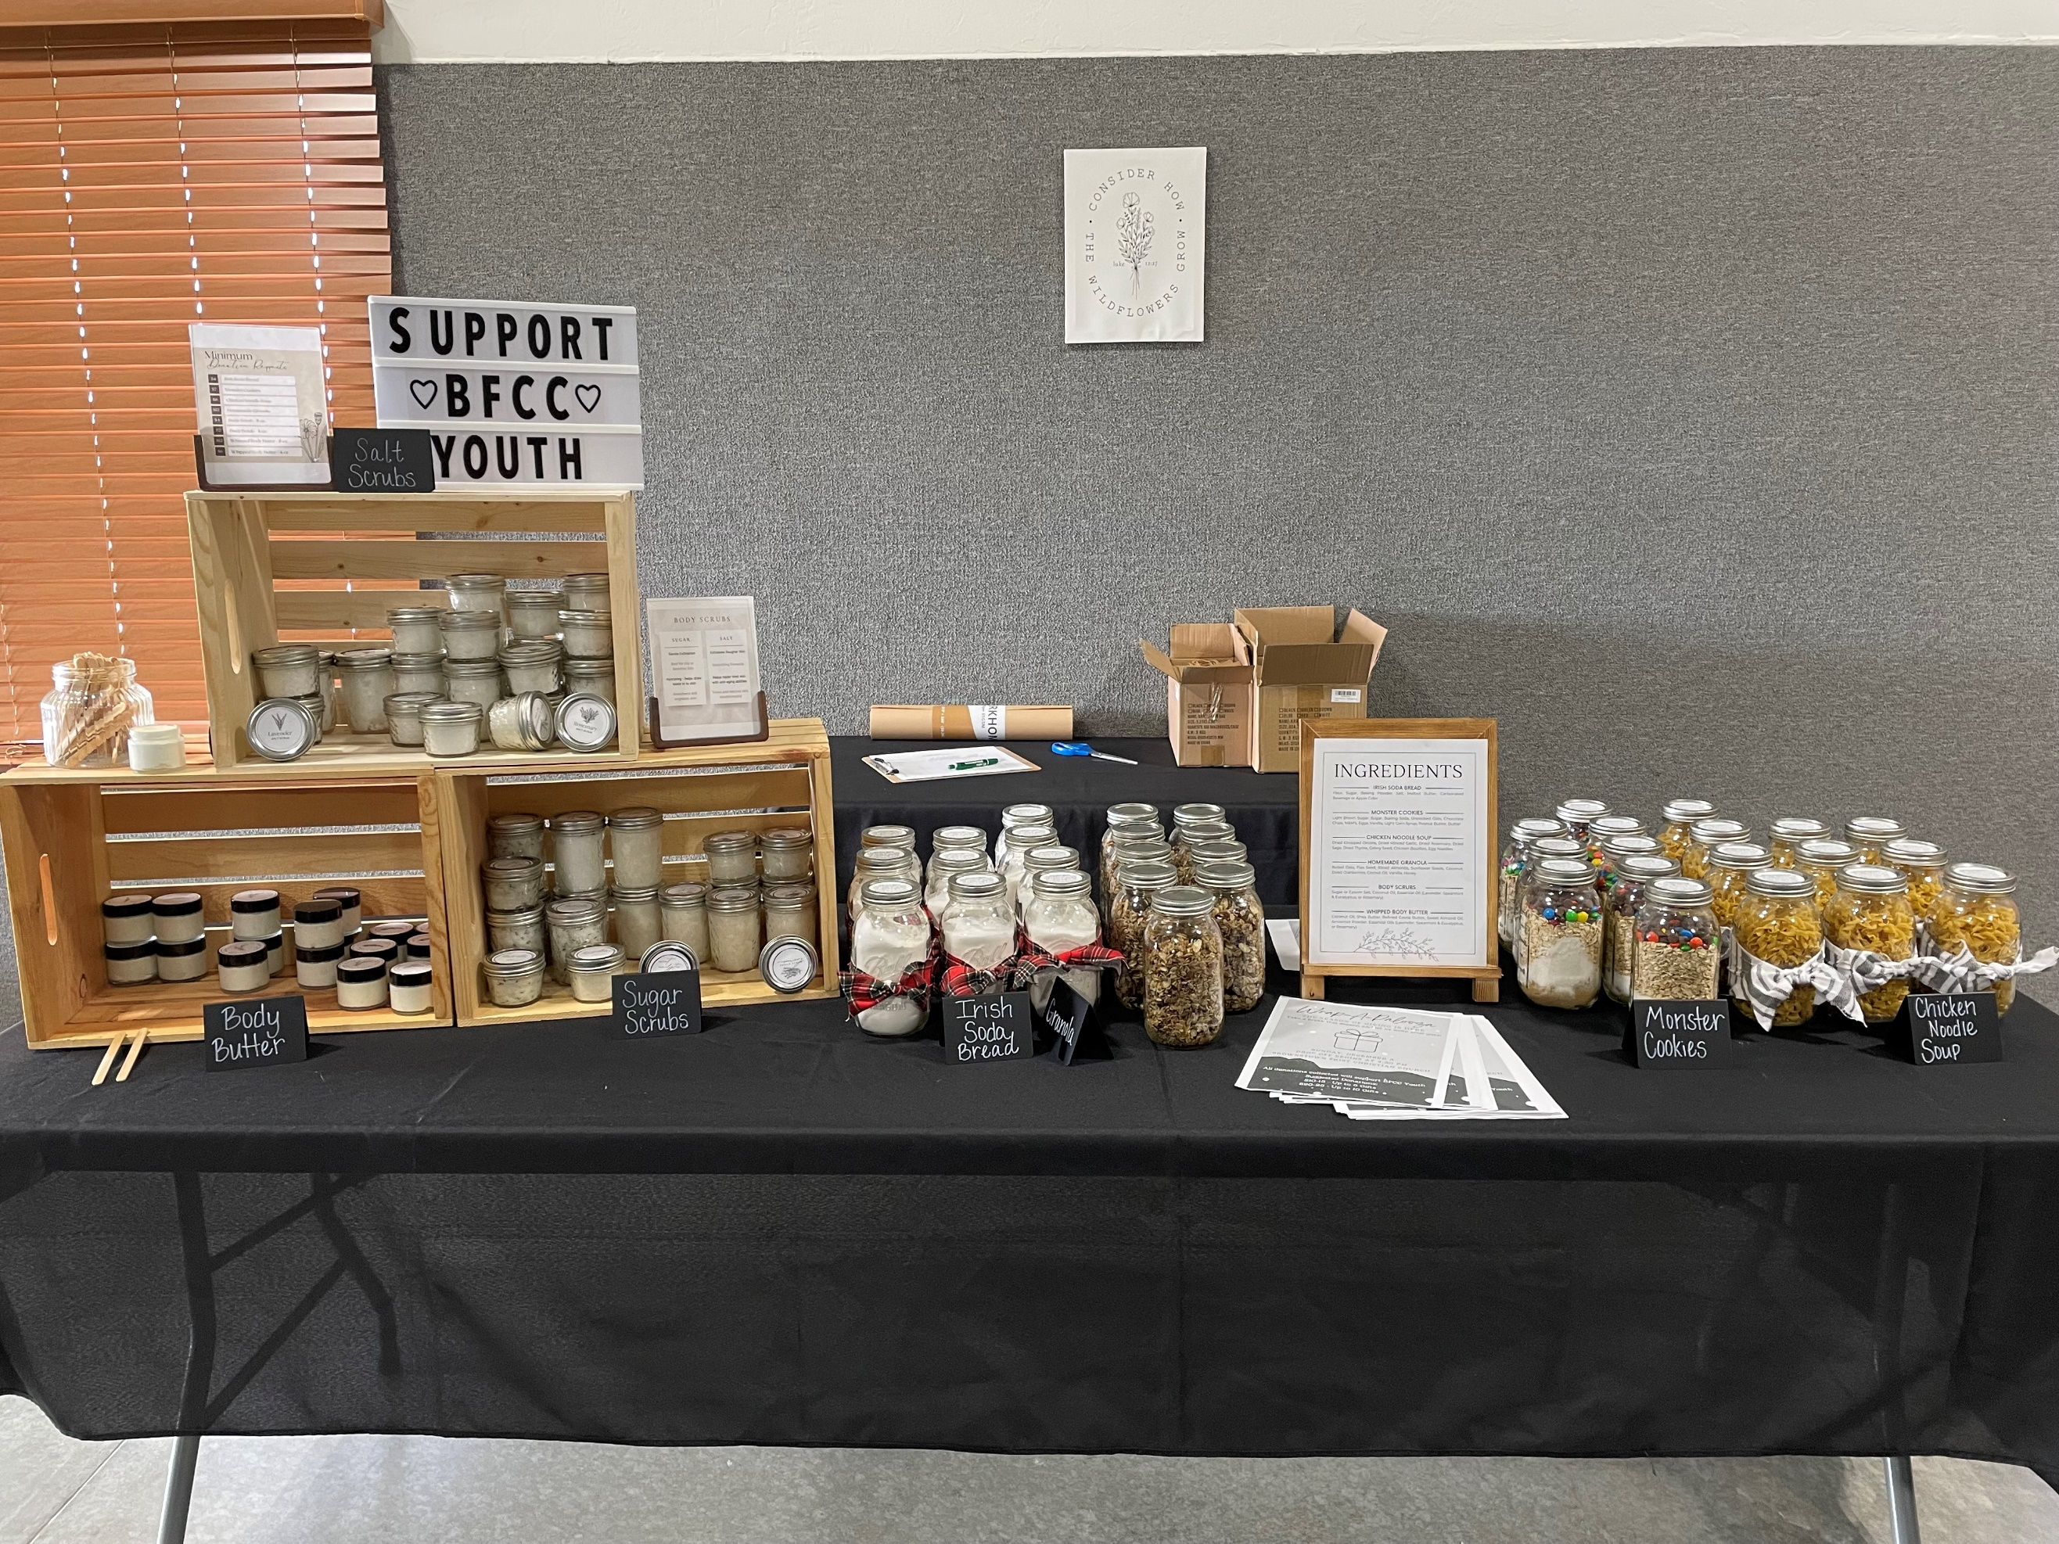

What’s Going On?
Breakfast Fellowship: If you would like to provide breakfast on a Sunday morning, there will be a sign-up sheet in the kitchen. Breakfast starts at 9:00 am.
Youth Groups will be taking a break for the holidays. Watch for a start date for the new year!
Leadership Team (Elder’s & Deacon’s) Meeting is Tuesday, February 13th @ 7:00 pm.



5th Sunday

A 5th Sunday Offering will be taken up on Sunday, March 31st. The entire amount collected will be going to the Building Loan Principle. The goal is $22,000. There will be a potluck following at noon.
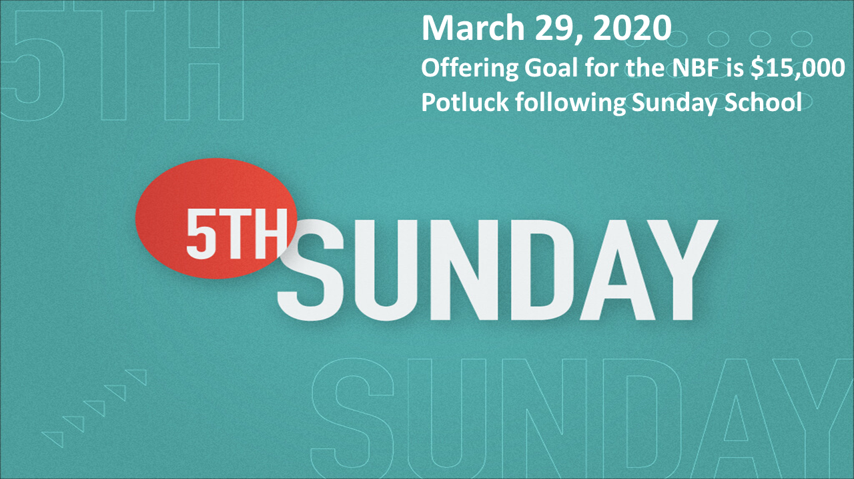

Men’s Breakfast
We will be gathering at FCCB for a time of prayer and fellowship at 7:00 am on the last Saturday of each month. This is open for all men! This months breakfast will be Saturday, February 24th.


For the Record

Date Attendance Offering Building Fund
12/31 56 5th Sunday $36,018.00
1/7 58 $2,376.20 $40.00
1/14 41 $1,525.25 $0.00
1/21 60 $2,487.00 $180.00
Building Loan Balance - $0.00



First Christian Church
Brownstown
516 W. Cumberland Rd.
P.O. Box 296
Brownstown, IL 62418
618-427-3687
Website: www.fccbrownstown.com Email: brownstownfcc@gmail.com

Nathan Brands, Preaching Minister Jamie Smith, Administrative Assistant


*Brody Gould *Gina Lytle
*Cade Willms *Dawson Willms *Travis Gould
*Helen Holman
*Jordan Miller
*Brynlee Willms
*Tammy Woolsey
*Don Lovett
*Brad Sidwell
*Rae Lynn Koehler
*Birthday
**Anniversary

