**First Word**

**First Christian Church Brownstown**

**January 2023**

**New Year’s Eve Gathering**

All Church New Year’s Eve party will be Saturday, December 31st from 6:00 pm – midnight at FCCB. Games, Food, Fun! Bring a finger food and a favorite game to play.



**Just for the Youth**

Sunday Night Youth Group for 5th – 12th grade will be taking a break for the holidays until February 2023.



#### We Exist to:

#### * WORSHIP the Living God * WIN People to Jesus * TRAIN God’s People for Service

#### * SEND Them Out Into the World

#### 



**From the Minister**

Starting in January, we will be starting a new sermon series on the Gospel of John. John is a unique gospel. In many ways it stands apart from the other gospel accounts. In fact, Matthew, Mark, and Luke are often grouped together and know as the synoptic gospels. They share many of the same stories, sayings, and general timeline. John is different though. While it does share some of the same stories as the synoptic gospels, it contains quite a bit of content about Jesus’ life that is only found in John.

John was also written later than the other gospel accounts. The synoptic gospels were all written in the middle of the 1st Century. However, John was written between A.D. 90-110. The world at the time of the writing of John was much different. Jerusalem was no longer the center of Christianity, since Jerusalem fell to the Romans in A.D. 70. This means Christianity was viewed in a more global sense. Christianity had also been around long enough that some false teaching (gnostic theology) had started to grow. Part of why John wrote his gospel account was to combat this false teaching. This is why he focuses on Jesus’ divinity, because the false teaching that had arose was denying that Jesus was fully divine.

I write all this, so as you read through John with this series, you can appreciate the special place John has amongst the four gospels. It is definitely worth digging into, so we can see the full picture of who Jesus was and is.

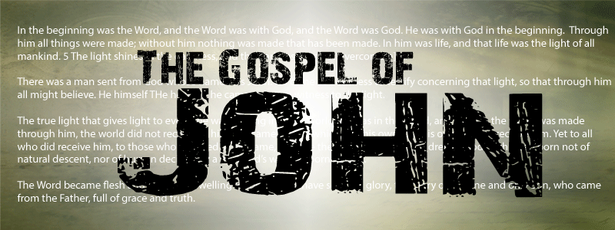

God bless,

Nathan

**Sanctity of Human Life Sunday**

Sanctity of Human Life Sunday is recognized on January 22, 2023. There will be a 5 minute video that Sunday morning along with a special offering for Lighthouse Pregnancy & Health Services.

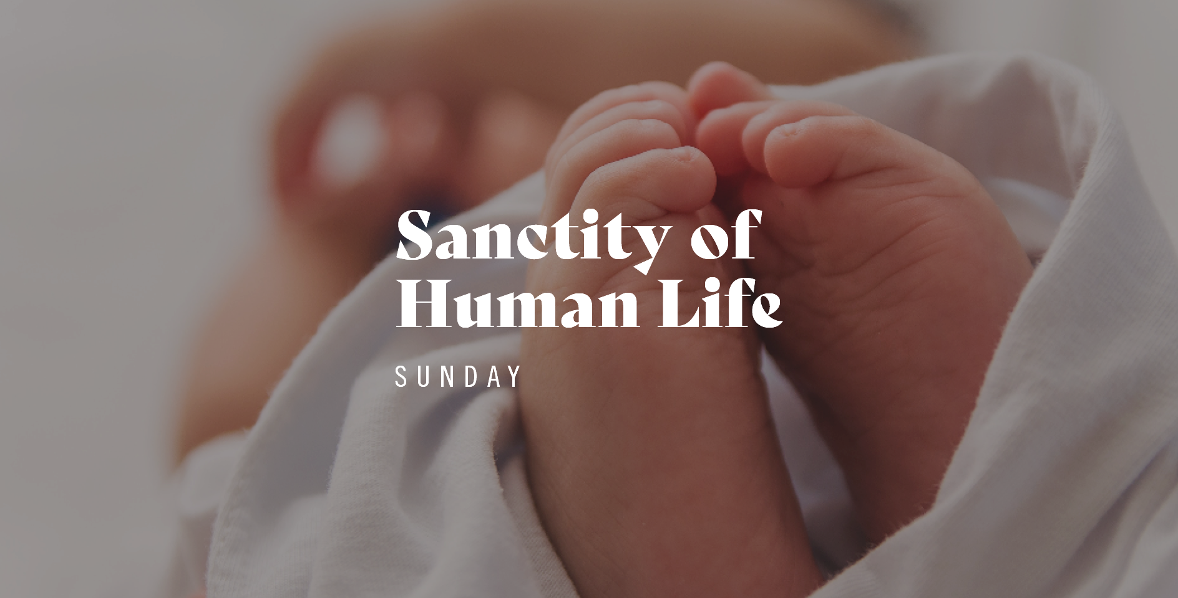

## What’s Going On?

**Leadership Team (Elder’s & Deacon’s) Meeting** is Tuesday, January 10th @ 7:00 pm.



## 5th Sunday

5th Sunday Potluck and Offering is Sunday, January 29, 2023. The entire amount collected will be going to the Building Loan Principle. The goal is $22,000. There will be a potluck following at noon.

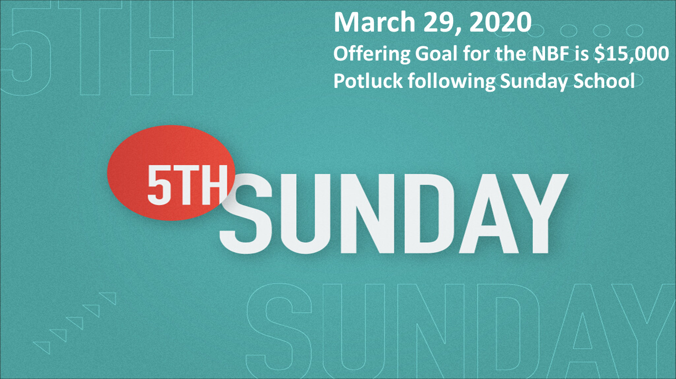

## For the Record

Date Attendance Offering Building Fund

11/27 75 $2,083.00 $1,415.00

12/4 53 $2,125.00 $1,220.00

12/11 97 $1,978.00 $35.00

12/18 57 $2,391.08 $358.00

Building Loan Balance - $164,731.10



First Christian Church

Brownstown

516 W. Cumberland Rd.

P.O. Box 296

Brownstown, IL 62418

618-427-3687

Website: [www.fccbrownstown.com](http://www.fccbrownstown.com) Email: [brownstownfcc@gmail.com](mailto:brownstownfcc@gmail.com)

Nathan Brands, Preaching Minister Jamie Smith, Administrative Assistant



*Gracyn Wise

*Jessa Adams

*Hudson Smith

*Nikki Sidwell

*Frank Rook

*Ashton Smith

*Faye Schwarm

*Walter Kinney **Bruce/ Stephanie Miller

*David Hipsher

*Patrick Satterthwaite *Tiffany Mumm

*Bruce Miller

**Allen/Deb Hunter *Gretchen Smith

*Tiffany Hipsher

*Birthday

**Anniversary