**First Word**

**First Christian Church Brownstown**

**January 2024**

**Support our Youth**

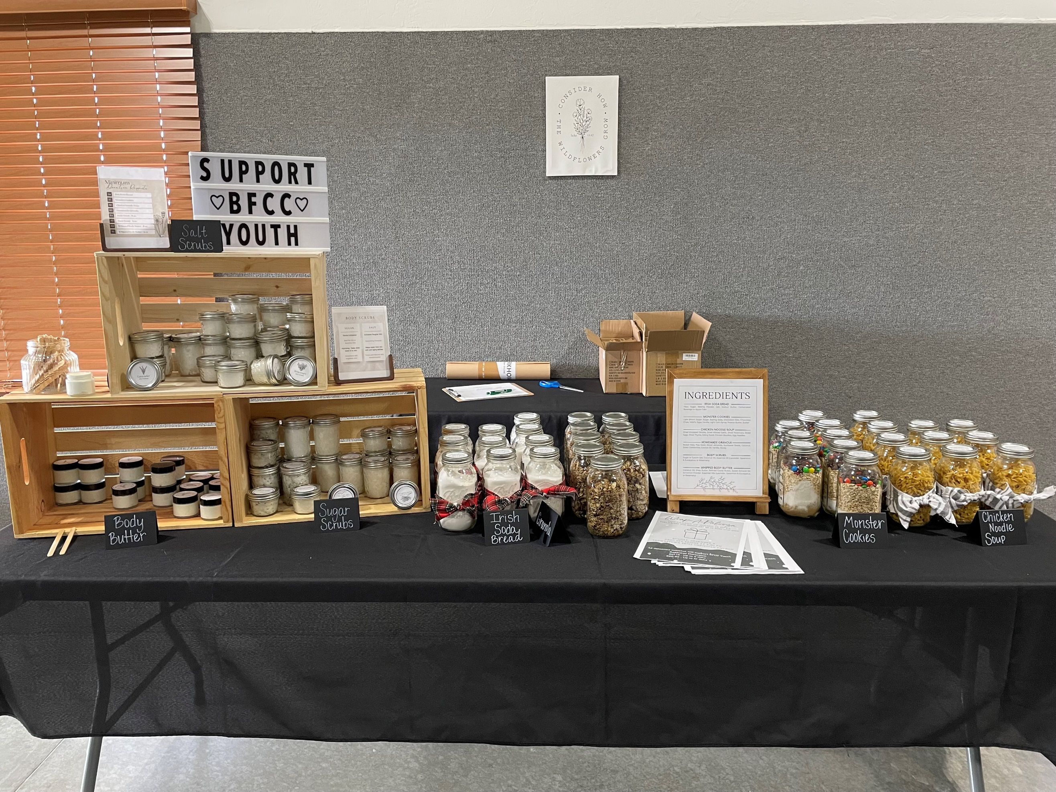

The youth are accepting donations for Body Scrubs, Body Butter, Irish Soda Bread, Monster Cookie Mix, Chicken Noodle Soup Mix, and Homemade Granola. If you would like to support them, you can contact one of the Jr/Sr. High youth kids or stop by the table at the back of the fellowship hall.

**Secret Sister Program**

The secret sister program will begin on Sunday, January 7th. If you have not turned in your papers for 2024, please see Jamie Smith asap. We would love to have more ladies participate this year. We all need extra encouragement throughout the year!



#### We Exist to:

#### * WORSHIP the Living God * WIN People to Jesus * TRAIN God’s People for Service

#### * SEND Them Out Into the World

#### 



**From the Minister**

A new year is upon us. Many people make resolutions ever year. The average person keeps their resolution for just under 4 months.

I would like to take a moment to suggest a few Biblical resolutions worth trying to keep all year.

**Mediate on Scripture.**

* Psalm 1:2; Psalm 119:15

**Go to church regularly.**

* Hebrews 10:24-25

**Be a peacemaker.**

* Matthew 5:9; Romans 12:18

**Forgive those who have hurt you.**

* Colossians 3:13

If you make a resolution, I encourage you to consider making one of these Biblical resolutions.



God bless,  
Nathan Brands

**Men’s Breakfast**

We will be gathering at FCCB for a time of prayer and fellowship at 7:00 am on the last Saturday of each month. This is open for all men! This months breakfast will be Saturday, January 27th.



## What’s Going On?

**Breakfast Fellowship:** If you would like to provide breakfast on a Sunday morning, there will be a sign-up sheet in the kitchen. Breakfast starts at 9:00 am.

**Youth Groups** will be taking a break for the holidays. Watch for a start date for the new year!

**Leadership Team (Elder’s & Deacon’s) Meeting** is Tuesday, January 9th @ 7:00 pm.



## 5th Sunday

A 5th Sunday Offering will be taken up on Sunday, March 31st. The entire amount collected will be going to the Building Loan Principle. The goal is $22,000. There will be a potluck following at noon.



## For the Record

Date Attendance Offering Building Fund

11/26 50 $1,413.75 $1,050.00

12/3 56 $2,395.00 $1,290.00

12/10 84 $2,640.00 $40.00

12/17 54 $2,436.25 $315.00

12/24 81 $2,312.25 $40.00

Building Loan Balance - $35,825.82



First Christian Church

Brownstown

516 W. Cumberland Rd.

P.O. Box 296

Brownstown, IL 62418

618-427-3687

Website: [www.fccbrownstown.com](http://www.fccbrownstown.com) Email: [brownstownfcc@gmail.com](mailto:brownstownfcc@gmail.com)

Nathan Brands, Preaching Minister Jamie Smith, Administrative Assistant



*Birthday

**Anniversary

*Frank Rook

*Jessa Adams

*Hudson Smith

*Nikki Sidwell

*Ashton Smith

*Faye Schwarm

**Bruce/ Stephanie Miller

*David Hipsher

*Patrick Satterthwaite

*Bruce Miller

*Tiffany Hipsher