**First Word**

**First Christian Church Brownstown**

**July 2023**

## Bond Christian Service Camp

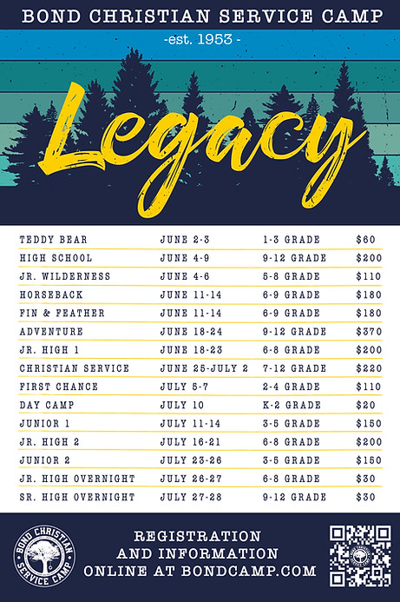

The church will pay for 1 week of camp per camper.

Our church is collecting 101 rolls of paper towels and you may place them at the back of the fellowship hall.

To register for camp, go to <http://www.bondcamp.com>.

**Tools for School**

The community is invited to help purchase school supplies and place them inside the bus on Saturday, July 1st from 10:00 am – 3:00 pm at Vandalia Walmart. The supplies will be distributed at the Tools for School Event on August 2, 3, 4, and 5 at St. James Lutheran Church in Vandalia.



#### We Exist to:

#### * WORSHIP the Living God * WIN People to Jesus * TRAIN God’s People for Service

#### * SEND Them Out Into the World

#### 



**From the Minister**

In October of 1517, Martin Luther nailed a document to Castle Church in Wittenberg, Germany. This document came to be known as the Ninety-five Theses. Many people see this as the start of the Reformation movement, out of which arose the Lutheran Church and Protestantism in general.

An important thing to remember is that Luther did not wish to start a new church movement. The Ninety-five Theses was not a document announcing his split from the Catholic Church. The Ninety-five Theses was a collection of propositions Luther hoped would lead to change within the Catholic Church. He hoped the Catholic Church would get back to following the Bible and the Bible alone as the authority for all Christians. He believed that the truth of Scripture was worth standing up for. He also believed that the Church, founded in the New Testament, should not be divided unless the truth of Scripture was at stake.

These actions, and Luther’s refusal to recant the Ninety-five Theses, led to Martin Luther’s excommunication from the Catholic Church in January of 1521. Even after his excommunication, Luther was hesitant to start his own church. The Lutheran church really began to emerge in 1525-1526, due to many people in Germany relying on the Scripture alone as the source of authority and truth.

It is important to remember what Luther was trying to accomplish. He wanted to reform the Church not split the Church. He felt both truth and unity were important, but truth should not be sacrificed for unity. The Restoration Movement, the movement we are a part of, holds this belief as well. Unity in Truth.



God bless,  
Nathan Brands

## 5th Sunday

The next 5th Sunday Offering is Sunday, July 30th. The entire amount collected will be going to the Building Loan Principle. The goal is $22,000. There will be a potluck following at noon.

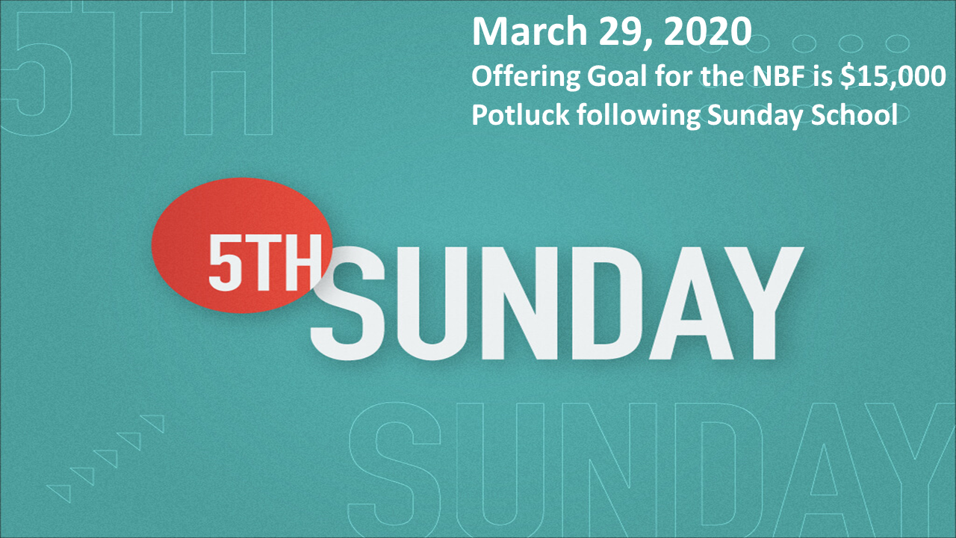

**Breakfast Fellowship**

If you would like to provide breakfast on a Sunday morning, there will be a sign-up sheet in the kitchen. Breakfast starts at 9:00 am.



## What’s Going On?

**Leadership Team (Elder’s & Deacon’s) Meeting** is Tuesday, July 11th @ 7:00 pm.



**Fayette County Hospice**

If you are interested in becoming a hospice volunteer there will be a training workshop on Tuesday, July 25th from 9:00 am – 2:00 pm at Fayette County Health Department. Hospice volunteers play a crucial role in our program. Our volunteers make visits in person, phone calls, and mailings. They also provide emotional support during end of life care to not only the patient but also the family. On average volunteers may spend approx. 1-2 hrs/week devoted to volunteering. If you or someone you know is interested, please reach out to Jenna Townsend at 618-283-7262 with any questions or to register for the training.



**Blood Drive**

There will be a blood drive here at FCCB on Monday, July 17th from 1:00 pm – 5:00 pm. Please consider giving if you can!



## For the Record

Date Attendance Offering Building Fund

6/4 59 $2,321.00 $3,390.00

6/11 70 $2,200.00 $40.00

6/18 64 $2,234.00 $240.00

Building Loan Balance - $99,499.27



First Christian Church

Brownstown

516 W. Cumberland Rd.

P.O. Box 296

Brownstown, IL 62418

618-427-3687

Website: [www.fccbrownstown.com](http://www.fccbrownstown.com) Email: [brownstownfcc@gmail.com](mailto:brownstownfcc@gmail.com)

Nathan Brands, Preaching Minister Jamie Smith, Administrative Assistant



*Jeremy Claycomb

*Brody Miller *Kristalynn Miller

*Charlie Feltner **Chris/Sherry Meador

*Tena Gould

*Shannon Claycomb

*Brooke Meador

*Macy Claycomb

*Birthday

**Anniversary

**Wayne/Sandra Lovett

*Ron Gould