**First Word**

**First Christian Church Brownstown**

**July 2024**

**Tools for School**

Need help with getting school supplies? Go to the First United Methodist Church Family Center at 4th & Main St. in Vandalia on Wednesday, August 7th from 4-6 pm to receive a free backpack. Then bring that backpack to St James Lutheran Church at 727 W. Gallatin Street in Vandalia on Wednesday, August 7th through Saturday, August 10th to receive your free school supplies. Child must be present with an adult to receive supplies.



**Bond Christian Service Camp**

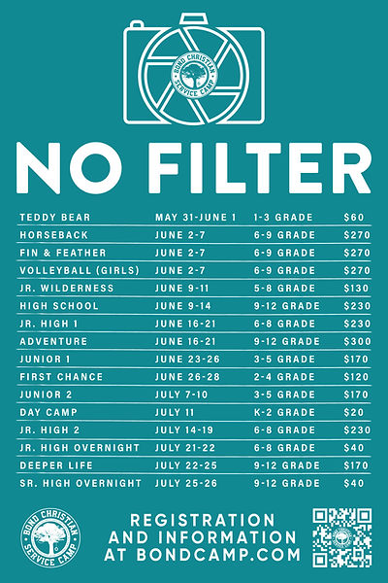

Camp is ½ way over but there is still time to attend. To register, go to bondcamp.com. The church will pay for one week of camp per camper for church members.

We are also collecting rolls of Paper Towels for BCSC. We still need 78 rolls. Please place your donations at the back of the fellowship hall.

#### We Exist to:

#### * WORSHIP the Living God * WIN People to Jesus * TRAIN God’s People for Service

#### * SEND Them Out Into the World

#### 



**From the Minister**

I just got back from Junior 1 week of Bond Christian Service Camp. Avie and Hudson came as campers and Ashton, Sam, Emalee, and I all went as faculty. It was a great week of camp. Not to make Sam feel bad, but the team Ashton and I were leading won the overall points competition. We won mainly due to our campers’ hard work in memorizing Scripture. Our team excelled at their memory work. They worked hard, and Ashton really helped by creating hand motions to go along with the verses. It was a great combination.

All this made me think about how when properly motivated we can do things that are very important to us, such as learning God’s Word. Our team wanted to win, so they were properly motivated to memorize Scripture. As adults though we often lack that motivation. We not only don’t memorize scripture, but we also don’t learn about it as much as we probably should. We tend to spend little time, compared to the other important things in our lives, focused on Scripture. I wish we could produce the same amount of motivation those campers had. I hope we can see the importance of Scripture. Maybe we aren’t going to win a point competition, but we can grow closer in our relationship with God and learn more about our faith. I can’t think of anything more important than that.



God bless,  
Nathan Brands

**Blood Drive**

There will be a blood drive here at FCCB on Monday, July 8th from 1:00 pm – 5:00 pm. Please consider giving if you can!

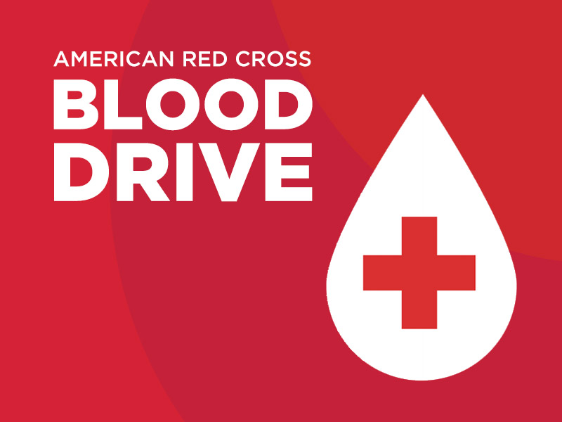

## What’s Going On?

**Breakfast Fellowship:** If you would like to provide breakfast on a Sunday morning, there will be a sign-up sheet in the kitchen. Breakfast starts at 9:00 am.

**Leadership Team (Elder’s & Deacon’s) Meeting** is Tuesday, July 9th @ 7:00 pm.

VB

## 



**Men’s Breakfast**

We will be gathering at FCCB for a time of prayer and fellowship at 7:00 am on the last Saturday of each month. This is open for all men! This month’s breakfast will be Saturday, July 27th.



## 5th Sunday

A 5th Sunday Offering will be taken up on Sunday, September 29th. The entire amount collected will be going to the Building Loan Principle. The goal is $22,000. There will be a potluck following at noon.

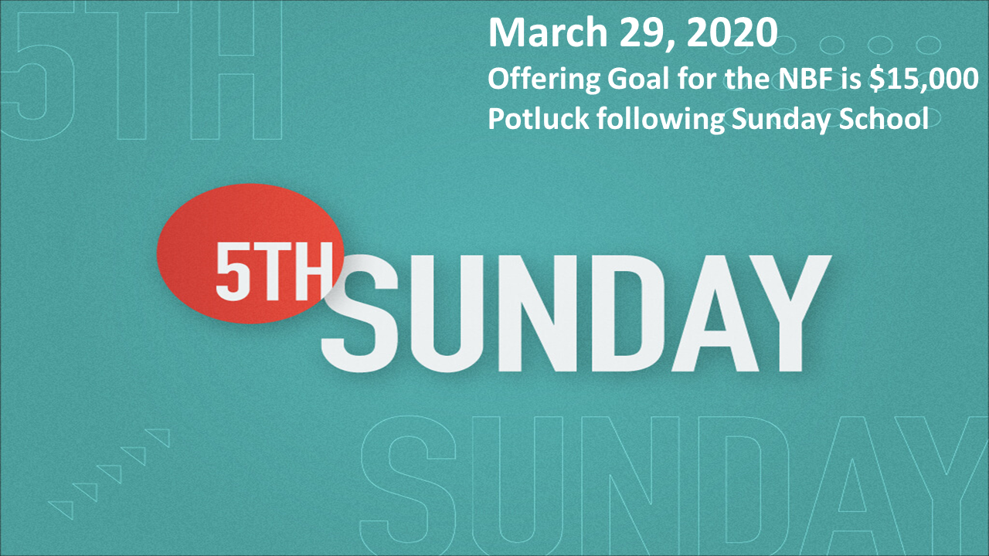

## For the Record

Date Attendance Offering Building Fund

5/26 45 $1,918.00 $140.00

6/2 64 $2,382.25 $140.00

6/9 45 $2,147.00 $40.00

6/16 52 $1,996.00 $3,140.00

New Building Fund - $34,439.15



First Christian Church

Brownstown

516 W. Cumberland Rd.

P.O. Box 296

Brownstown, IL 62418

618-427-3687

Website: [www.fccbrownstown.com](http://www.fccbrownstown.com) Email: [brownstownfcc@gmail.com](mailto:brownstownfcc@gmail.com)

Nathan Brands, Preaching Minister Jamie Smith, Administrative Assistant



*Ron Gould

*Birthday

**Anniversary

*Jeremy Claycomb

*Brody Miller *Kristalynn Miller

*Charles Feltner Sr. **Chris/Sherry Meador

*Tena Gould

*Shannon Claycomb

*Brooke Meador

*Macy Claycomb

**Wayne/ Sandra Lovett