First Word

First Christian Church Brownstown
June 2023

Vacation Bible School
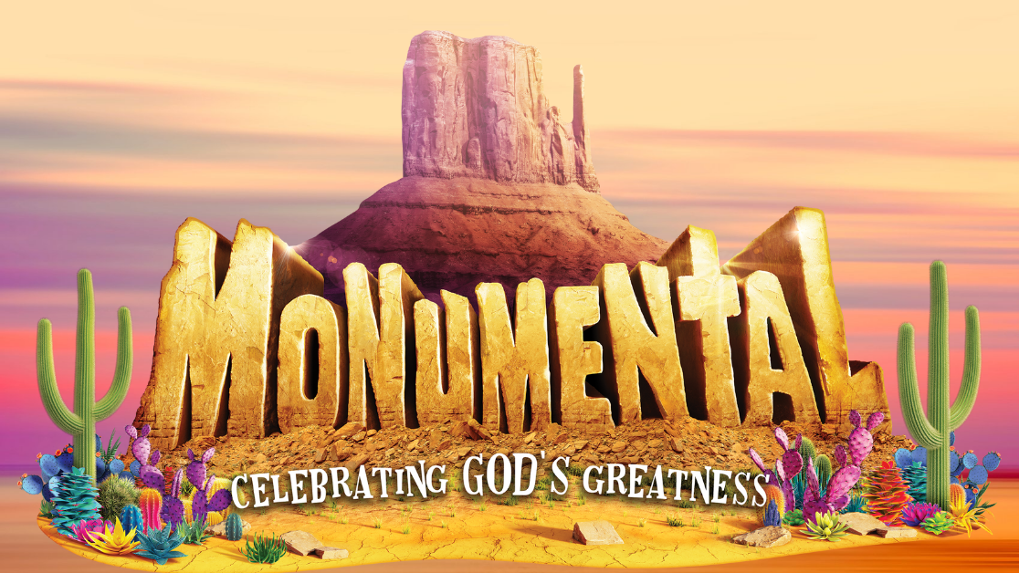
It’s Time for Fun in the Sun!
Thursday, June 8th – Sunday, June 11th
Th/Fri 6:00 pm – 8:15 pm Sat 9:00 am – 11:30 am Sun 9:30 am – 11:30 am
Ages 2 years through 6th Grade

Bond Christian Service Camp
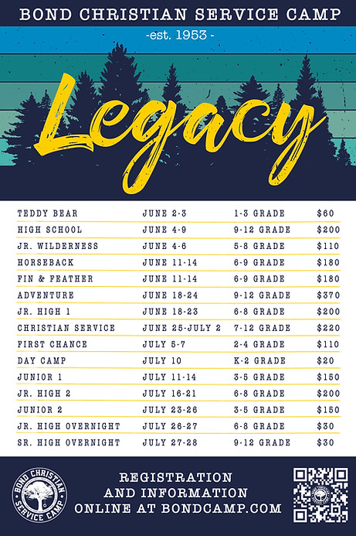

This year is going to be great at Bond Camp! To register for camp, go to http://www.bondcamp.com.
The church will pay for 1 week of camp per camper. Our church is collecting 198 rolls of paper towels and you may place them at the back of the fellowship hall.

We Exist to:

* WORSHIP the Living God * WIN People to Jesus * TRAIN God’s People for Service

* SEND Them Out Into the World

From the Minister

A good place to start learning about the history of the church, is to learn about the history of the New Testament. What I mean is how and when did the books of the New Testament become accepted as God’s Word. It is important to note that the letters of Paul were already seen on par with the rest of Scripture in 2 Peter 3:15-16. Also, the teachings of the Apostles were quoted by Jude in the same way that he quoted the Old Testament (Jude 1:17-18). This means there is already a biblical precedent to view these teachings as God’s Word. Beyond this, we see that the early church fathers, referred to the Apostles teachings as Scripture, but did not view the writings of the other church fathers on the same level.
To give some background, the early church fathers who were the leaders of the church after the Apostles, for the most part, had died. The only Apostle that seems to overlap with the time of the early church fathers is John, who died sometime around 100 AD. Some of these church fathers actually died before John, Clemet of Rome for example died in 99 AD. Ignatius and Polycarp were disciples of John and some of the first church fathers. Irenaeus another church father, who was influenced greatly by Polycarp.
It is Irenaeus that I especially want to point out. He lived from 130 – 202 AD. While some of the church fathers quoted the apostles before him, Irenaeus is the first to quote much of the New Testament. He quotes all of the books of the New Testament except 3 John, Jude, and 2 Peter. He also clearly makes a distinction between the writing of the Apostles and other Christian writings. We see here that the books of the New Testament were already considered God Word well before the Council of Nicaea in 325 AD.
We start with this, because the church gets its identity from the Word of God. This is especially true in our movement within Christianity. The Christian Church seeks to return the church to how it was in the days of the Apostles and the church fathers. The Christion Church also seeks to base their faith on the Bible alone.

God bless,
Nathan Brands

5th Sunday

The next 5th Sunday Offering is Sunday, July 30th. The entire amount collected will be going to the Building Loan Principle. The goal is $22,000. There will be a potluck following at noon.
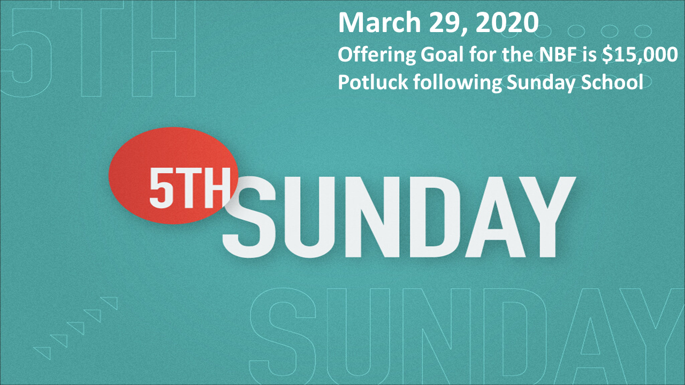

Breakfast Fellowship
If you would like to provide breakfast on a Sunday morning, there will be a sign-up sheet in the kitchen. Breakfast starts at 9:00 am.


What’s Going On?
Leadership Team (Elder’s & Deacon’s) Meeting is Tuesday, June 13th @ 7:00 pm.



Lighthouse Pregnancy & Health Services


For the Record

Date Attendance Offering Building Fund
4/30 64 $0.00 $25,027.00
5/7 72 $1,982.00 $50.00
5/14 85 $1,534.00 $50.00
5/21 86 $2,688.00 $60.00
5/28 59 $1,670.00 $1,110.00
Building Loan Balance - $103,169.27

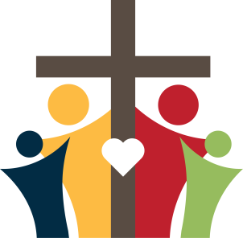

First Christian Church
Brownstown
516 W. Cumberland Rd.
P.O. Box 296
Brownstown, IL 62418
618-427-3687
Website: www.fccbrownstown.com Email: brownstownfcc@gmail.com

Nathan Brands, Preaching Minister Jamie Smith, Administrative Assistant


**Terry/Susan Smith
*Kelsey Brands
*Asa Sattherthwaite
*Samuel Miller
*Cambree Jachino
**Don/Robin Lovett
*Carter Smith
*Kyndal Adams
**Bill/Cathy Smith
*Kaci Satterthwaite
*Terry Smith
*Judy Feltner
*Alivia Claycomb *Cathy Smith
*Birthday
**Anniversary

