**First Word**

**First Christian Church Brownstown**

**June 2024**

**FCCB Kidventure**

We’re excited for our upcoming VBS. Join us Monday, June 17th – Thursday, June 20th from 6:00 – 8:15 pm. Registration is now open, so don’t wait to claim your spot in one of our classes. <http://brownstown-first-christian-church-471335.churchcenter.com/registrations/events/2291663>.

 



____________________________________________________________________________________________________



#### We Exist to:

#### * WORSHIP the Living God * WIN People to Jesus * TRAIN God’s People for Service

#### * SEND Them Out Into the World

#### 



**From the Minister**

In my sermon this last Sunday, May 19, 2024, I shared a quote by Corrie ten Boom. I mentioned how remarkable this women’s story was. During World War II, she and her sister, Betsie, opened their homes in the Netherlands to Jewish refugees & members of the resistance movement against Nazi Germany. Corrie, her sister, and their father was arrested on February 28, 1944. Their father died just ten days later, and Corrie and Betsie were transferred to a political concentration camp and finally to a women’s labor camp. This did not change who Corrie was though. At the labor camp, the sisters would lead worship services after the long & hard days of work using a Bible, they had smuggled in. These services and their example converted many of the prisoners to Christianity.

On December 16, 1944, Betsie died at the age of 59 while still at the labor camp. Twelve days later, Corrie was released. She was later told that her release was a clerical error and all the women of her age group were killed a week later in the gas chambers.

In 1946, Corrie went back to Germany and met with two Germans that were employed at the labor camp. When she met with them, she forgave them.

Corrie ten Boom was a remarkable woman. There is even more to her story, and I hope to show the same perseverance in my faith as she did in all circumstances.

Some quotes by Corrie ten Boom:

*If you look at the world, you’ll be distressed. If you look within, you’ll be depressed. If you look at God, you’ll be at rest.*

*Never be afraid to trust an unknown future to a known God.*

*Jesus did not promise to change the circumstances around us. He promised great peace and pure joy to those who would learn to believe that God actually controls all things.*

*Forgiveness is the key that unlocks the door of resentment and the handcuffs of hatred. It is a power that breaks the chains of bitterness and the shackles of selfishness.*

*Is prayer your steering wheel or your spare tire?*

*Any concern too small to be turned into a prayer is too small to be made into a burden.*

*Faith is like a radar that sees through the fog.*

**Bond Christian Service Camp**





Camp registration has begun and the weeks are starting to fill up! To register, go to bondcamp.com.

The church will pay for one week of camp per camper for church members.

We are also collecting rolls of Paper Towels for BCSC. We still need 170 rolls. Please place your donations at the back of the fellowship hall.

## What’s Going On?

**Breakfast Fellowship:** If you would like to provide breakfast on a Sunday morning, there will be a sign-up sheet in the kitchen. Breakfast starts at 9:00 am.

**Father’s Day** is Sunday, June 16th.

**Leadership Team (Elder’s & Deacon’s) Meeting** is Tuesday, June 11th @ 7:00 pm.

VB

## 



**Men’s Breakfast**

We will be gathering at FCCB for a time of prayer and fellowship at 7:00 am on the last Saturday of each month. This is open for all men! This months breakfast will be Saturday, June 29th.



## 5th Sunday

A 5th Sunday Offering will be taken up on Sunday, June 30th. The entire amount collected will be going to the Building Loan Principle. The goal is $22,000. There will be a potluck following at noon.

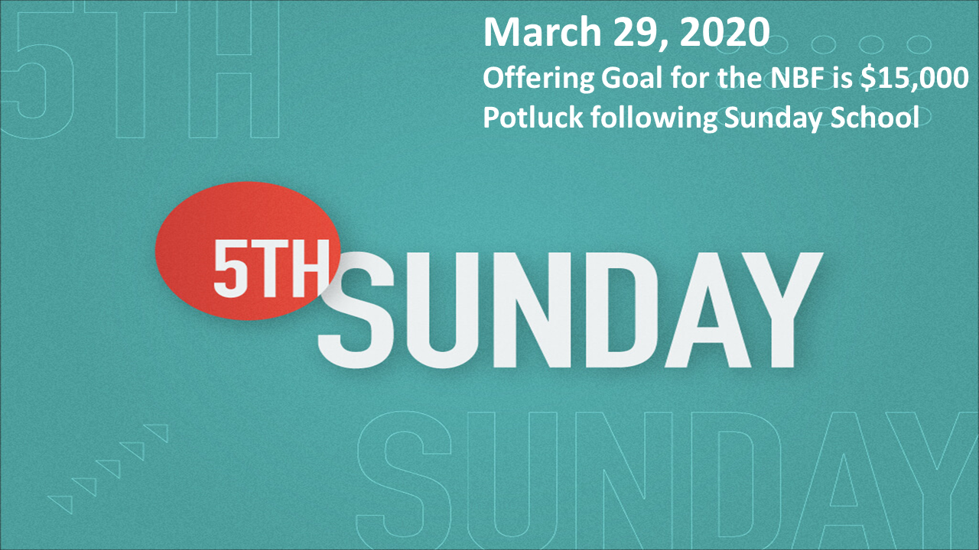

## For the Record

Date Attendance Offering Building Fund

4/28 60 $1,933.00 $190.00

5/5 60 $2,341.00 $1,235.00

5/12 70 $1,707.50 $0.00

5/19 52 $2,127.25 $190.00

New Building Fund - $34,439.15



First Christian Church

Brownstown

516 W. Cumberland Rd.

P.O. Box 296

Brownstown, IL 62418

618-427-3687

Website: [www.fccbrownstown.com](http://www.fccbrownstown.com) Email: [brownstownfcc@gmail.com](mailto:brownstownfcc@gmail.com)

Nathan Brands, Preaching Minister Jamie Smith, Administrative Assistant

*Birthday

**Anniversary



**Terry/Susan Smith

*Asa Satterthwaite

*Samuel Miller

*Cambree Jachino

*Don/Robin Lovett

*Kyndal Adams

*Carter Smith

**Bill/Cathy Smith

*Kaci Satterthwaite

*Terry Smith

*Judy Feltner

*Alivia Claycomb *Cathy Smith