**First Word**

**First Christian Church Brownstown**

**March 2023**

**Lighthouse Pregnancy & Health Services**



**Ladies Bible Study**

The ladies will begin a new Beth Moore study, ‘Jesus, The One and Only,’ on Tuesday, March 7th at 6:30 pm, here at the church. See Joann Strobel for more information.

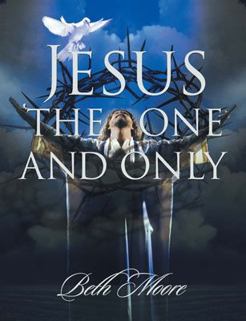

#### We Exist to:

#### * WORSHIP the Living God * WIN People to Jesus * TRAIN God’s People for Service

#### * SEND Them Out Into the World

#### 



**From the Minister**

With it being March, I thought this could be a good time to take a closer look at a historical church figure often associated with this month, Saint Patrick.

Patrick was born in England around the end of Roman rule in Britain, 5th Century. Where he was born is unknown. However, from his own writing, we know he was captured by Irish pirates at the age of 16. He was taken back to Ireland and enslaved for 6 years. During this time, surrounded by unbelievers, his faith in God actually strengthened.

After the six years of enslavement, he heard a voice telling him to go home. So, he made his way back to England, where he studied Christianity and became a priest. During this time, he had another vision. In this vision, he felt God was telling him to go back to Ireland to spread Christianity.

It is said that he baptized thousands of people in Ireland, and even planned to take the message of Christ to those that had enslaved him. Some accounts say that he was unable to tell his enslavers about Jesus, because in the time he was in England the home and land of his enslavers had been destroyed. It is said that this was a great disappointment to him.

The story of Patrick is a great story of perseverance and forgiveness. He persevered through being kidnapped and enslaved. He forgave his enslavers and even tried to tell them about Jesus.

On March 17th, Saint Patrick’s Day, I encourage you to remember the story of Saint Patrick as you wear green and think of Shamrocks and Leprechauns.



God bless,

Nathan

**FCCB Cookbook**

FCCB will be putting together another cookbook and we need your help with recipes. If you would like to submit a recipe(s), please drop them in the box at the back of the fellowship hall asap. Please limit your number of recipes submitted to 15. See Jamie Smith for any questions.



## What’s Going On?

**Sunday Night Youth Group** for 5th – 12th grade will be Sundays from 5:00 – 6:30 pm.

**Leadership Team (Elder’s & Deacon’s) Meeting** is Tuesday, March 14th @ 7:00 pm.

**Breakfast Fellowship:** If you would like to provide breakfast on a Sunday morning, there will be a sign-up sheet in the kitchen. Breakfast starts on March 5th at 9:00 am.



## Time Change

Don’t forget to set your clocks ahead one hour before bed on Saturday, March 11th.



Sunday, March 12th will be **PJ Sunday** for the youth.

## 5th Sunday

The next 5th Sunday Offering is Sunday, April 30th. The entire amount collected will be going to the Building Loan Principle. The goal is $22,000. There will be a potluck following at noon.



## For the Record

Date Attendance Offering Building Fund

1/29 66 5th Sunday $25,196.50

2/5 62 $2,138.00 $920.00

2/12 65 $1,536.20 $0.00

2/19 67 $2,483.00 $0.00

Building Loan Balance - $134,199.41



First Christian Church

Brownstown

516 W. Cumberland Rd.

P.O. Box 296

Brownstown, IL 62418

618-427-3687

Website: [www.fccbrownstown.com](http://www.fccbrownstown.com) Email: [brownstownfcc@gmail.com](mailto:brownstownfcc@gmail.com)

Nathan Brands, Preaching Minister Jamie Smith, Administrative Assistant



*Ryan Wise

*Zach Koehler

**Randy/Sandy Gelsinger

*Cameron Callaway

*Ellen Willms *Abigail Shelton

*Don Willms

**Duane/Laura Willms

*Sandra Lovett

*Genevieve Kinney

*Birthday

**Anniversary