**First Word**

**First Christian Church Brownstown**

**February 2024**

**Fundraising Banquet**

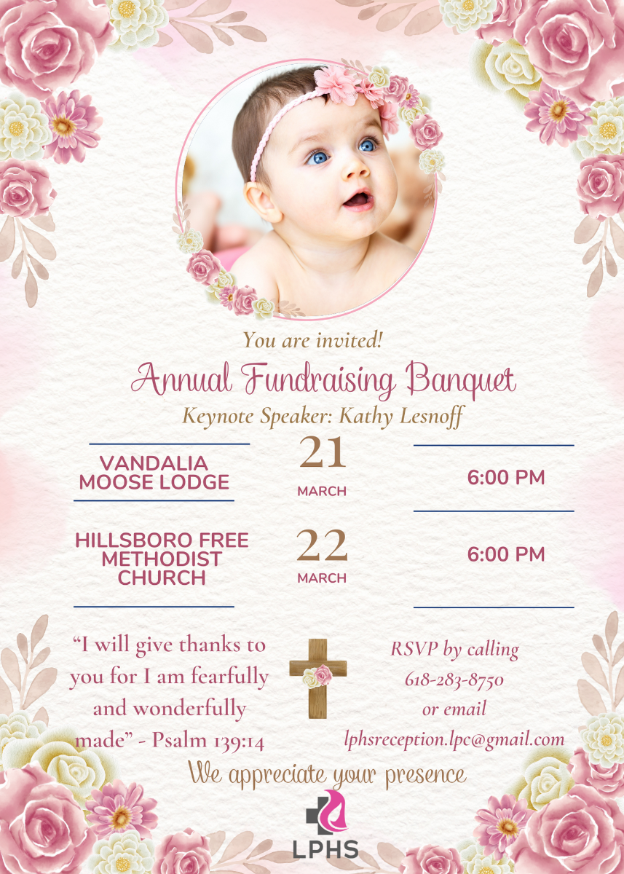



**Ladies Bible Study**

The ladies will soon be starting a new Beth Moore Bible Study, ‘The Inheritance.’ It has 9 sessions. We will study the many blessings we inherit as a child of God. The theme verse is Psalm 16:5-6, “The lines have fallen for me in pleasant places; indeed I have a beautiful inheritance.” More information coming soon. Workbooks will need to be ordered, so see Joann if you are interested.



#### We Exist to:

#### * WORSHIP the Living God * WIN People to Jesus * TRAIN God’s People for Service

#### * SEND Them Out Into the World

#### 



**From the Minister**

This last week the daily high temperatures have been higher than normal, and my kids have really enjoyed it. On one of the days, I had some errands to run in Vandalia, so after my errands I took the kids to one of the city parks. Naturally, my kids had a blast. Watching them play, I was reminded just how fortunate and blessed we are. We have this beautiful weather in the middle February and have the free time to really enjoy it. Just the week before there was snow on the ground, which was also great. My kids could not wait to go out and make snow angels, have a snow ball fight, and make a snow man that turned into more of a snow hill/mountain, since the snow was powdery. During both events, my kids were so grateful and thanked me.

I am writing about this because I think it is important to remind ourselves of how blessed we are and to be grateful for them. Often, we find ourselves always finding the problems with situations instead of seeing the blessings. God is good to us, and often we are so focused on our complaints that we cannot enjoy his blessings. I encourage you to look around and think about God’s blessings in your life. To try to be grateful for what God has done. You might find that you are truly more blessed than you realize.



God bless,

Nathan Brands

**Men’s Breakfast**

We will be gathering at FCCB for a time of prayer and fellowship at 7:00 am on the last Saturday of each month. This is open for all men! This months breakfast will be Saturday, March 30th.



## What’s Going On?

**Breakfast Fellowship:** If you would like to provide breakfast on a Sunday morning, there will be a sign-up sheet in the kitchen. Breakfast starts at 9:00 am.

**Youth Groups** will be starting back soon. Watch for a start date for the new year!

**Leadership Team (Elder’s & Deacon’s) Meeting** is Tuesday, March 12th @ 7:00 pm.



## 5th Sunday

A 5th Sunday Offering will be taken up on Sunday, March 31st. The entire amount collected will be going to the Building Loan Principle. The goal is $22,000. There will be a potluck following at noon.

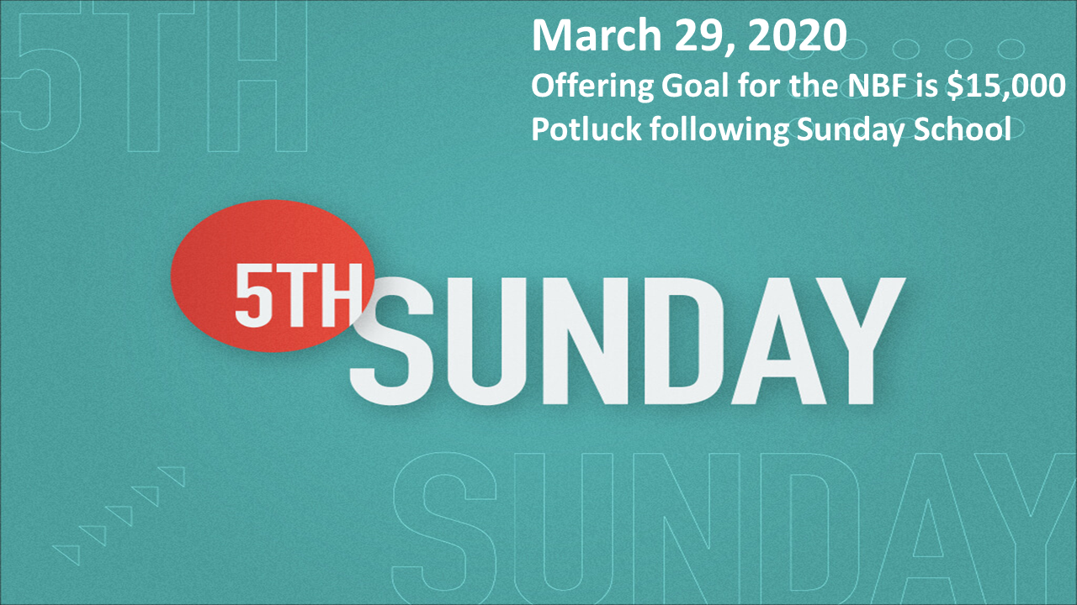

## For the Record

Date Attendance Offering Building Fund

1/28 53 $1,592.25 $130.00

2/4 55 $3,931.00 $1,240.00

2/11 48 $2,240.25 $30.00

2/18 59 $2,811.25 $50.00

2/18 Love Offering (Mike Smith Family) - $2,149.00

New Building Fund - $6,709.55



First Christian Church

Brownstown

516 W. Cumberland Rd.

P.O. Box 296

Brownstown, IL 62418

618-427-3687

Website: [www.fccbrownstown.com](http://www.fccbrownstown.com) Email: [brownstownfcc@gmail.com](mailto:brownstownfcc@gmail.com)

Nathan Brands, Preaching Minister Jamie Smith, Administrative Assistant



*Zach Koehler

**Randy & Sandy Gelsinger

*Ellen Willms

*Don Willms

**Duane & Laura Willms

*Sandra Lovett

*Birthday

**Anniversary