First Word

First Christian Church Brownstown
June 2023

Vacation Bible School

It’s Time for Fun in the Sun!
Thursday, June 8th – Sunday, June 11th
Th/Fri 6:00 pm – 8:15 pm Sat 9:00 am – 11:30 am Sun 9:30 am – 11:30 am
Ages 2 years through 6th Grade

Bond Christian Service Camp
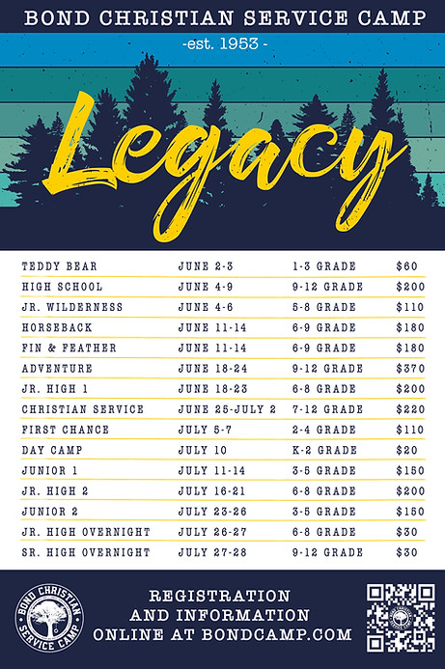

This year is going to be great at Bond Camp.To register for camp, go to www.bondcamp.com. The church will pay for 1 week of camp per camper. Our church is collecting 300 rolls of paper towels and you may place them at the back of the fellowship hall.

We Exist to:

* WORSHIP the Living God * WIN People to Jesus * TRAIN God’s People for Service

* SEND Them Out Into the World

From the Minister

When I was going to college, I struggled deciding what exactly I wanted to do. I wanted to be a youth minister, a Christian counselor, a college campus minister, a church history professor, or a small groups minister. Interesting that being a preaching minister was never really something I considered, until God stepped in.
Out of these career options, the one that probably sounds the least interesting to many of you is a church history professor. However, I love church history. My church history classes were easily some of my favorites at Bible college. I thought I would use these newsletter articles in the coming months to share some of my love for church history.
I believe in order to know yourself; it is helpful to know your history. This is true in Christianity as well. We know Jesus better, if we know the prophecies about Jesus in the Old Testament and the Gospel accounts. We know humanity better, if we know the accounts of creation and the fall. We know the Church better, if we know the book of Acts and the Epistles of the New Testament.
I also think we can know our church better, if we know how we got from the early church to the Restoration Movement (Independent Christian Church).
Hopefully over the coming months, we can get to know our church a little better through church history.

God bless,
Nathan Brands

5th Sunday

The next 5th Sunday Offering is Sunday, July 30th. The entire amount collected will be going to the Building Loan Principle. The goal is $22,000. There will be a potluck following at noon.
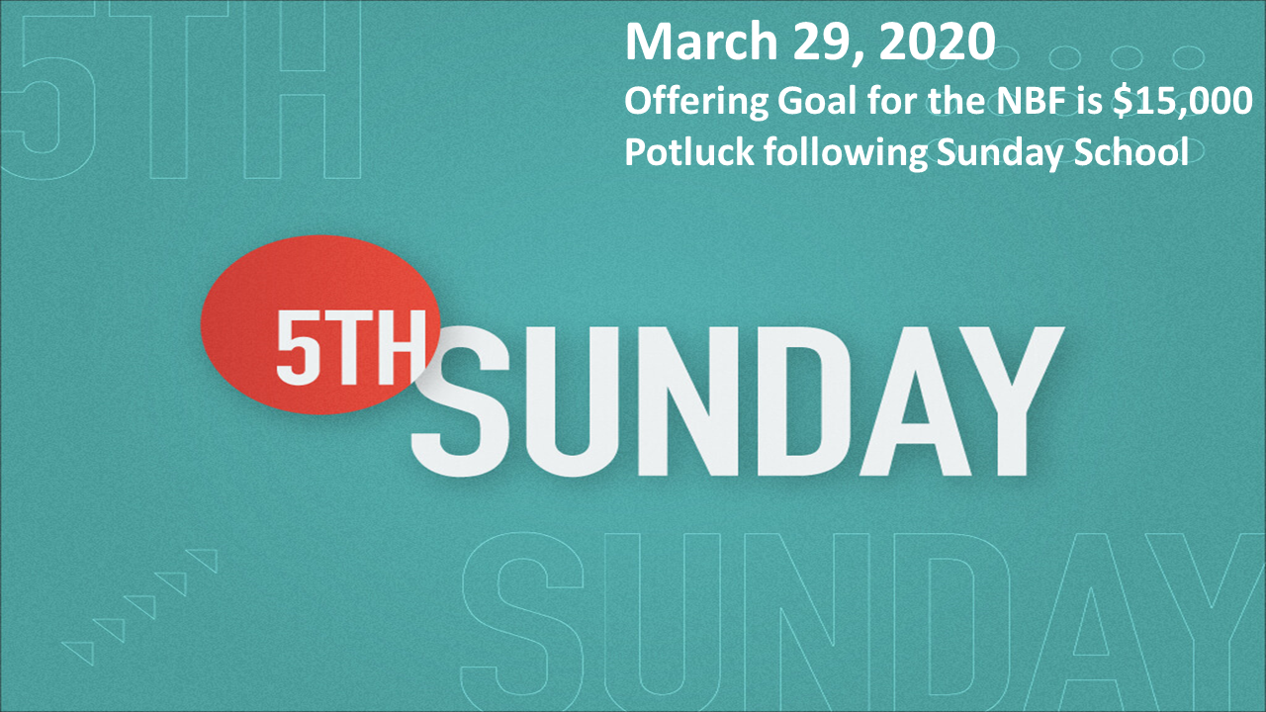

Breakfast Fellowship
If you would like to provide breakfast on a Sunday morning, there will be a sign-up sheet in the kitchen. Breakfast starts at 9:00 am.


What’s Going On?
Leadership Team (Elder’s & Deacon’s) Meeting is Tuesday, May 9th @ 7:00 pm.



Bond Camp

To register for camp, go to www.bondcamp.com. The church will pay for 1 week of camp per camper. Our church is collecting 300 rolls of paper towels and you may place them at the back of the fellowship hall.

For the Record

Date Attendance Offering Building Fund
3/26 66 $1,926.00 $1,000.00
4/2 71 $3,196.14 $1,300.00
4/9 89 $1,647.00 $0.00
4/16 61 $2,487.00 $95.00
4/23 75 $1,527.25 $0.00
Building Loan Balance - $128,626.69



First Christian Church
Brownstown
516 W. Cumberland Rd.
P.O. Box 296
Brownstown, IL 62418
618-427-3687
Website: www.fccbrownstown.com Email: brownstownfcc@gmail.com

Nathan Brands, Preaching Minister Jamie Smith, Administrative Assistant

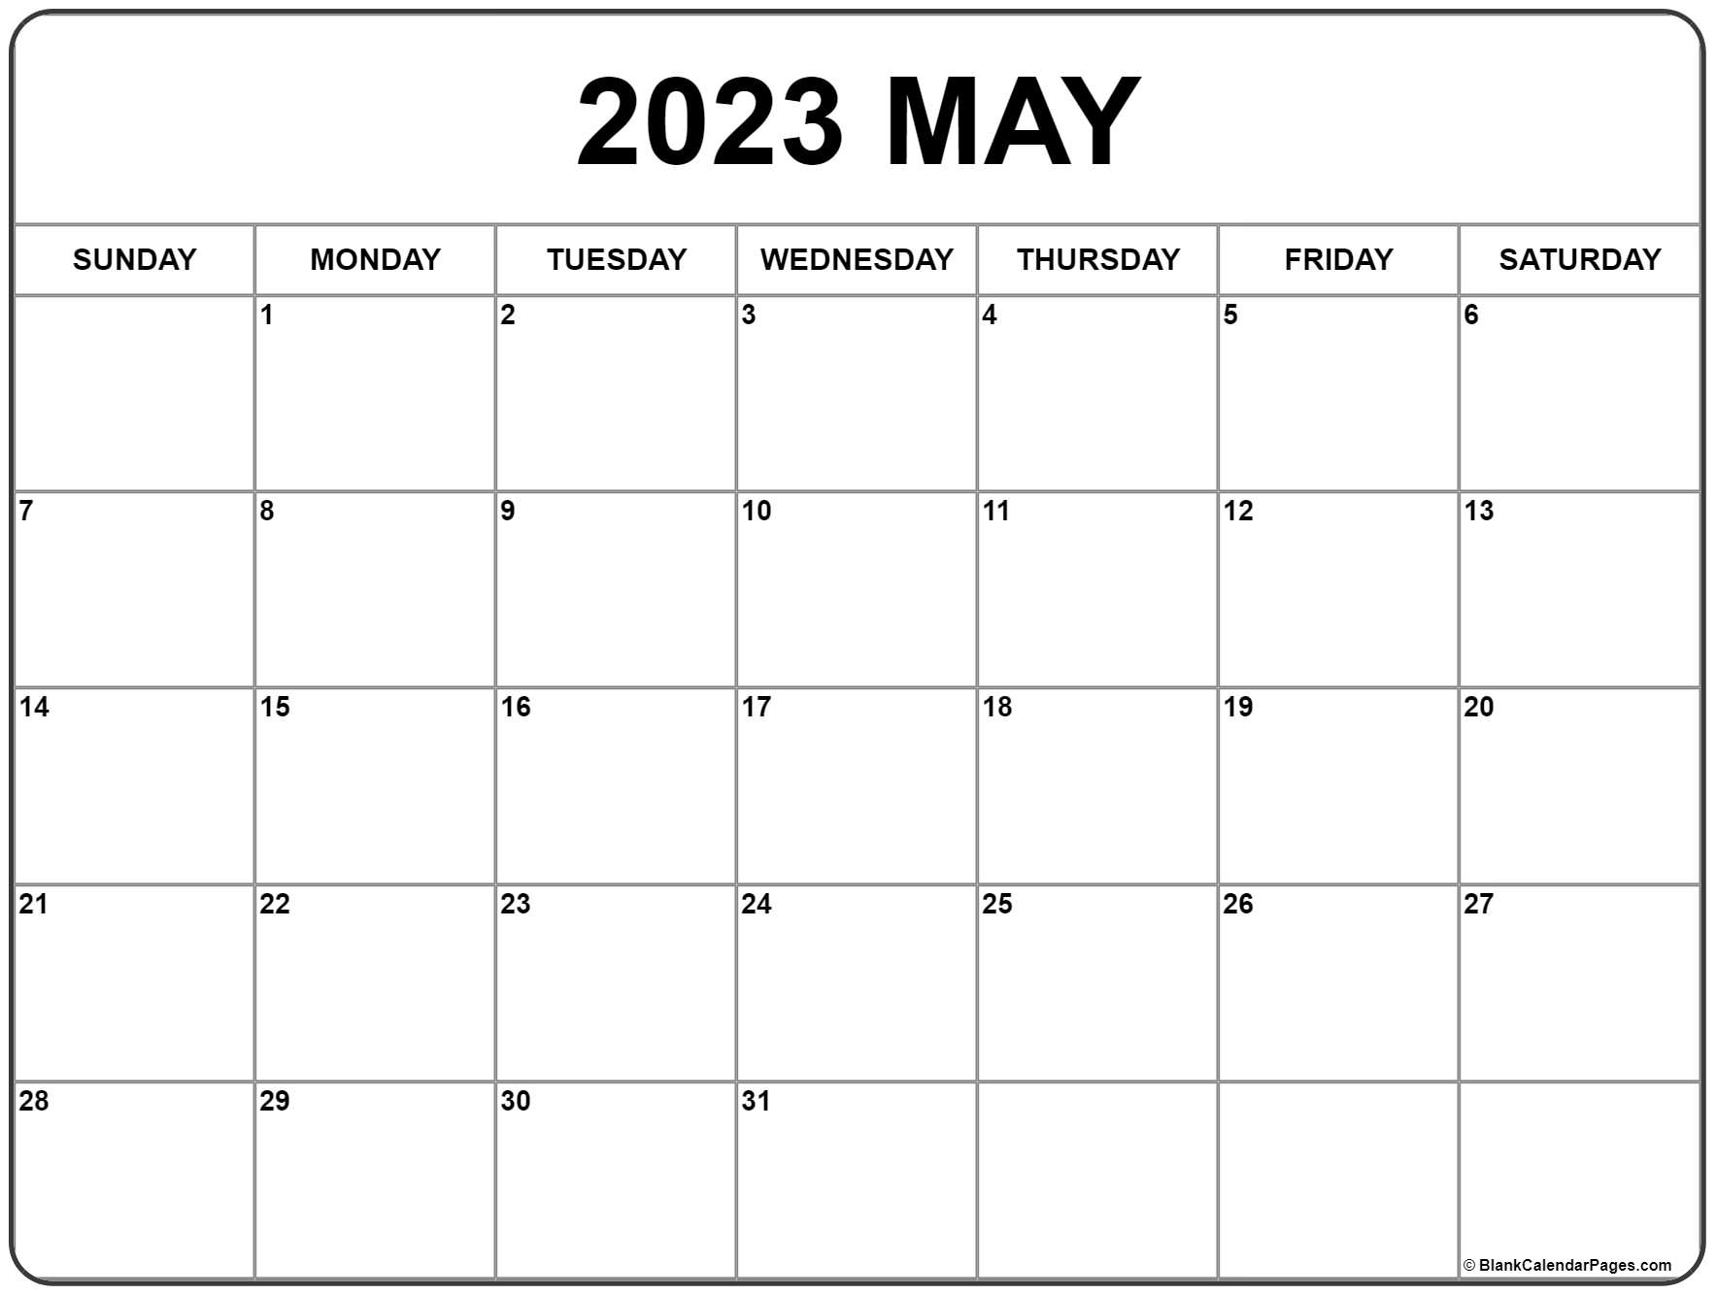
*Jameson Brands
*Vicki Hipsher
*Joann Strobel *Wayne Lovett
**Jack/Bonnie Shelton
*Callie Shelton
**Bill/Helen Holman **Josh/Heather Miller
*Karen Underwood
**David/Vicki Hipsher
*Bill Smith
*Birthday
**Anniversary

