**First Word**

**First Christian Church Brownstown**

**May 2024**

**Bond Christian Service Camp**





Camp registration has begun and the weeks are starting to fill up! To register, go to bondcamp.com.

The church will pay for one week of camp per camper for church members.

We are also collecting 250 rolls of Paper Towels for BCSC. Please place your donations at the back of the fellowship hall.

**FCCB Kidventure**

We’re excited for our upcoming VBS. Join us Monday, June 17th – Thursday, June 20th from 6:00 – 8:15 pm. Registration is now open, so don’t wait to claim your spot in one of our classes. <http://brownstown-first-christian-church-471335.churchcenter.com/registrations/events/2291663>.

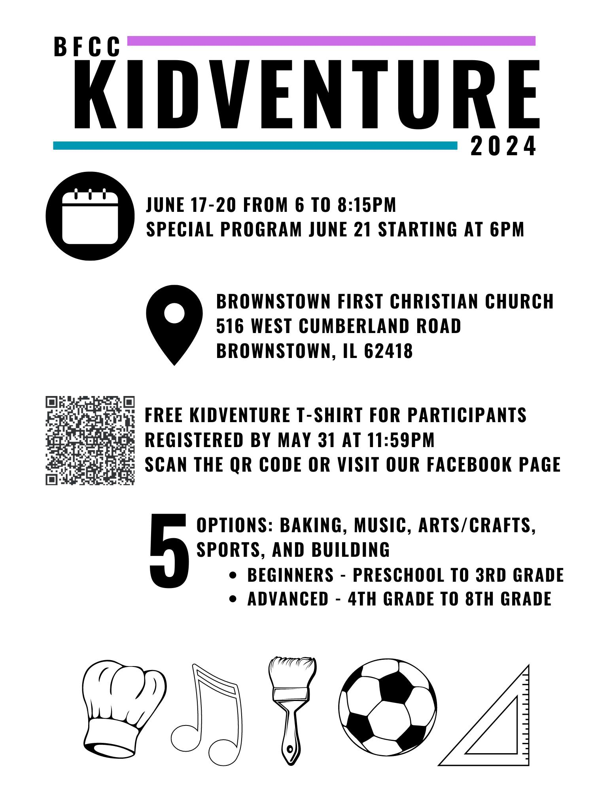 



#### We Exist to:

#### * WORSHIP the Living God * WIN People to Jesus * TRAIN God’s People for Service

#### * SEND Them Out Into the World

#### 



**From the Minister**

I have been preaching a series on 1 Timothy, the first of three letters written by Paul called the Pastoral Epistles. Two of these letters were written to Timothy and one was written to Titus. Both individuals were people that Paul discipled and even considered his children in the faith. Yet Paul fully acknowledges that he is not the originator of Timothy’s faith.

*I am reminded of your sincere faith, a faith that dwelt first in your grandmother Lois and your mother Eunice and now, I am sure, dwells in you as well.*

*2 Timothy 1:5*

Timothy was a person of sincere faith. Someone that Paul left at the church in Ephesus, a church that Paul had a special relationship with. He left him there to help the church to establish leaders and stomp out false teaching. He trusted Timothy to accomplish this task, not simply because he had trained him, but also due to the faith of his mother and grandmother.

I think this is important to draw attention to, due to Mother’s Day coming up. Faith starts in the home. Often the first teachers of that faith are moms. They do this by being an example of faith and through directly teaching God’s Word.

I want to take a moment a thank all the moms and women out there that have been influential in the faith of another person. I want to encourage all those that currently have children in their homes to raise them up with sincere faith.

God bless,  
Nathan Brands

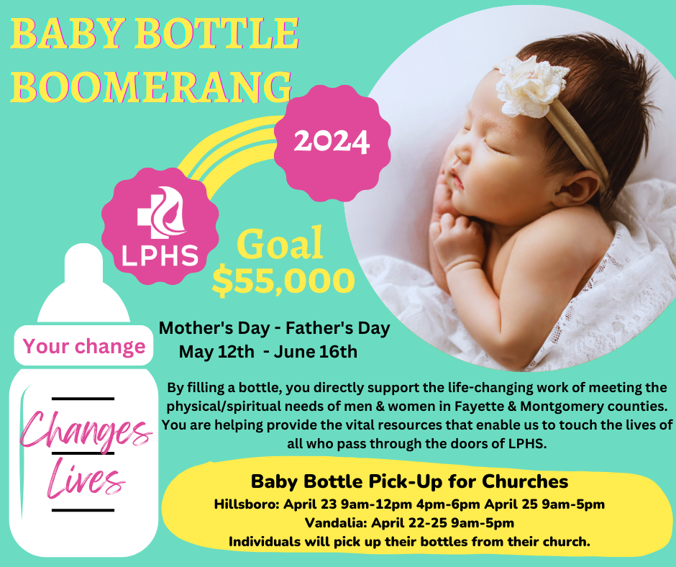

## What’s Going On?

**Breakfast Fellowship:** If you would like to provide breakfast on a Sunday morning, there will be a sign-up sheet in the kitchen. Breakfast starts at 9:00 am.

**Mother’s Day** is Sunday, May 12th.

**Graduation Sunday:** We will be celebrating our graduates in the congregation on Sunday, May 12th.

**Leadership Team (Elder’s & Deacon’s) Meeting** is Tuesday, May 14th @ 7:00 pm.

VB



**Men’s Breakfast**

We will be gathering at FCCB for a time of prayer and fellowship at 7:00 am on the last Saturday of each month. This is open for all men! This months breakfast will be Saturday, May 26th.



## 5th Sunday

A 5th Sunday Offering will be taken up on Sunday, June 30th. The entire amount collected will be going to the Building Loan Principle. The goal is $22,000. There will be a potluck following at noon.

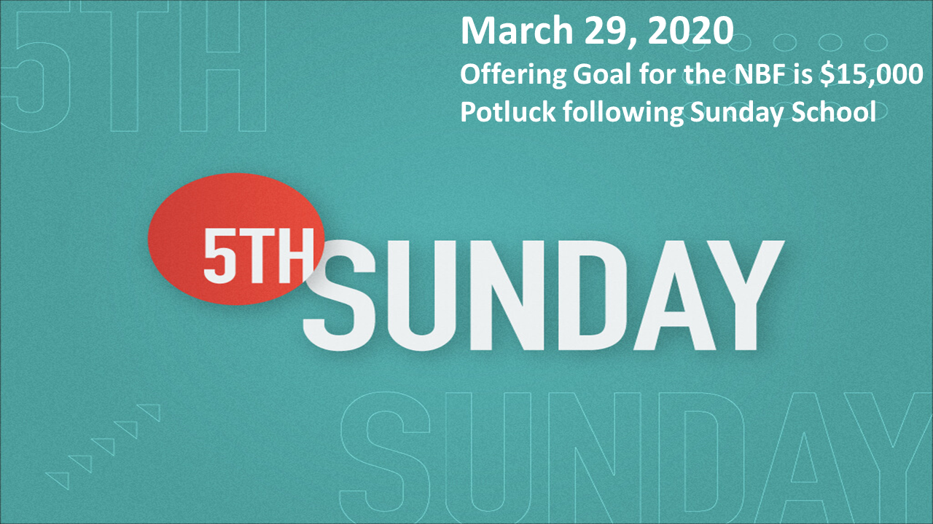

## For the Record

Date Attendance Offering Building Fund

4/7 61 $2,165.00 $130.00

4/14 57 $1,991.00 $40.00

4/21 46 $7,946.00 $0.00

New Building Fund - $32,728.15



First Christian Church

Brownstown

516 W. Cumberland Rd.

P.O. Box 296

Brownstown, IL 62418

618-427-3687

Website: [www.fccbrownstown.com](http://www.fccbrownstown.com) Email: [brownstownfcc@gmail.com](mailto:brownstownfcc@gmail.com)

Nathan Brands, Preaching Minister Jamie Smith, Administrative Assistant

*Birthday

**Anniversary



*Jameson Brands

*Vicki Hipsher

*Joann Strobel *Wayne Lovett

**Bill/Helen Holman **Josh/Heather Miller

**Jack/Bonnie Shelton

*Karen Underwood

**David/Vicki Hipsher

*Bill Smith