First Word

First Christian Church Brownstown
November 2023

Operation Christmas Child
The mission of Operation Christmas Child is to demonstrate God’s love in a tangible way to children in need around the world. Through this project, Samaritan’s Purse partners with the local church worldwide to share the Good News of Jesus Christ and make disciples of the nations.
Please consider filling a shoebox for the children of this world! Shoeboxes are available at the back of the fellowship hall and are due back by Sunday, November 12th. $10/shoebox suggested donation for shipping.
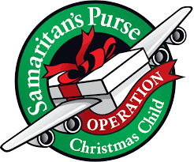

Community Thanksgiving Service
We will be hosting the community Thanksgiving Service this year on Sunday, November 19th at 6:00 pm. We will be having a dessert fellowship following the service. Please bring a dessert to share.
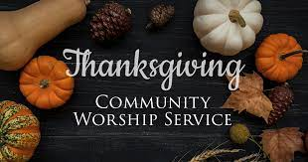

The Polar Express
On Christmas Eve, a young boy embarks on a magical adventure to the North Pole on the Polar Express, while learning about friendship, bravery, and the spirit of Christmas.
Please join us on Sunday, December 10th at 9:30 am as our children present a special program.


We Exist to:

* WORSHIP the Living God * WIN People to Jesus * TRAIN God’s People for Service

* SEND Them Out Into the World

From the Minister

In my newsletter articles, we have taken a look at two of the three founders of the Restoration Movement. I would like to now take a look at the third, Alexander Campbell. Alexander Campbell was the son of Thomas Campbell, which we looked at last week. In many ways, he has become the most known of the three founders.
He was the author of two popular journals that were published in the early days of the movement, the Christian Baptist and the Millennial Harbinger. He also founded Bethany College, the oldest Restoration Movement college. However, it is not these accomplishments of Alexander Campbell that I want to focus. I want to look at his commitment to the truth of Scripture.
In 1811, Campbell married his wife, Margaret Brown, and within a year they had a daughter, Jane. This was the first time Campbell had to personally wrestle with the concept of infant baptism. His father had already spoken out against it and Alexander agreed, but now it became very real to him. He took a year to study the issue. He acquired a large number of works on baptism and did an independent study of the New Testament in its original language, Greek, on the issue of baptism. Finally, he was satisfied with what he believed Scripture said on the issue. He determined that it was not his daughter that needed to be baptized but himself. On June 12, 1812, Alexander Campbell was baptized.
Campbell was dedicated to the truth of Scripture. While he also promoted unity, and felt this cause was very important, he would not sacrifice the truth to obtain this. Campbell originally became a Baptist minister, in fact he was baptized by a Baptist minister, Matthias Luce. He ran into conflict with them over the connection between baptism and salvation. He wanted to stay within the Baptist church, feeling unity was important. However, when they asked him to change what he preached, he refused. He would not compromise the truth.
We can learn from Alexander Campbell. The truth of Scripture should be of the utmost importance in our lives. We must be willing to change our views and lives based on this truth. We also must seek unity with fellow believers, but not at the cost of the truth.

God bless,
Nathan Brands

Leadership Selection
On Sunday, November 12th & 19th, we will taking up nominations for leadership. On Sunday, December 3rd, we will be voting on those nominations for approval.
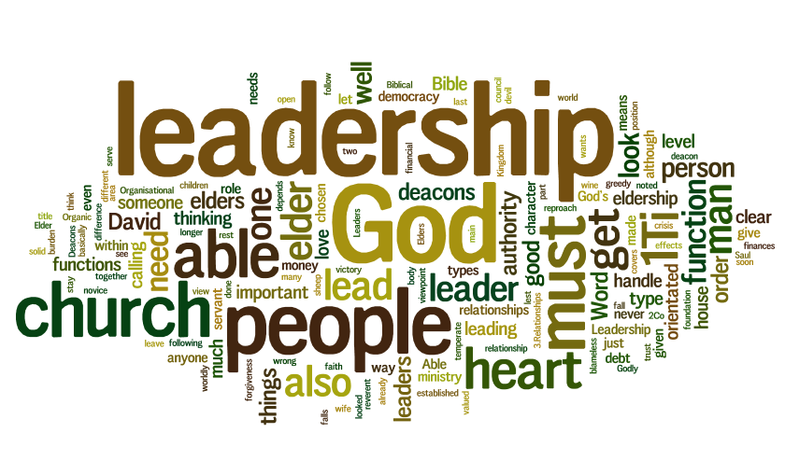

What’s Going On?
Breakfast Fellowship: If you would like to provide breakfast on a Sunday morning, there will be a sign-up sheet in the kitchen. Breakfast starts at 9:00 am.
Christmas Program Practice will be Sundays from 4:30 – 6:00 pm.
Youth Groups will be Sundays from 6:00 – 7:30 pm.
Leadership Team (Elder’s & Deacon’s) Meeting is Tuesday, November 14th @ 7:00 pm.
Ladies Christmas Supper will be Friday, December 1st at 6:00 pm. All ladies are invited to attend. We will be revealing our secret sisters for 2023 and filling out new forms for 2024.
Time Change: Don’t forget to set your clocks back one hour before bed on Saturday, November 5th.



5th Sunday

A 5th Sunday Offering will be taken up on Sunday, December 31st. The entire amount collected will be going to the Building Loan Principle. The goal is $22,000. There will be a potluck following at noon.
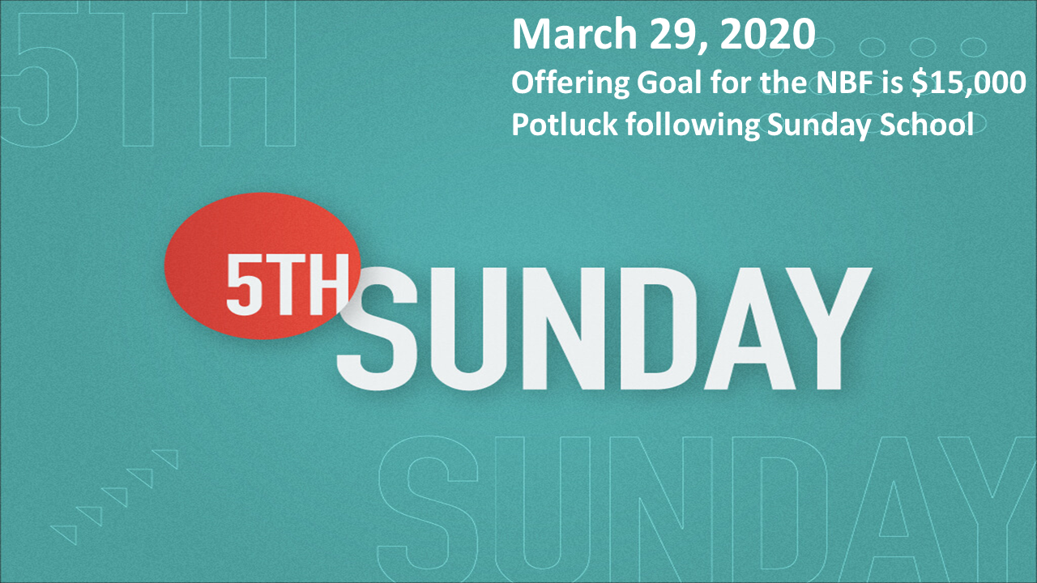

Men’s Breakfast
We will be gathering at FCCB for a time of prayer and fellowship at 7:00 am on the last Saturday of each month. This is open for all men! This month’s breakfast will be Saturday, November 18th.


For the Record

Date Attendance Offering Building Fund
9/17 55 $2,324.00 $0.00
9/24 57 $1,197.05 $1,000.00
10/1 72 $3,318.91 $1,950.00
10/8 71 $1,707.25 $0.00
10/15 66 $2,445.00 $60.00
10/22 72 $1,561.50 $50.00
Building Loan Balance - $64,718.35



First Christian Church
Brownstown
516 W. Cumberland Rd.
P.O. Box 296
Brownstown, IL 62418
618-427-3687
Website: www.fccbrownstown.com Email: brownstownfcc@gmail.com

Nathan Brands, Preaching Minister Jamie Smith, Administrative Assistant


*Joyce Garrison
*Amy Jachino
*Robin Lovett
*Matthew Smith
**Nathan/ Kelsey Brands
**Ron/Tena Gould
*Birthday
**Anniversary

