First Word

First Christian Church Brownstown
October 2023

Operation Christmas Child

“Let the children come to Me; do not hinder them, for to such belongs the kingdom of God.”
Mark 10:14, ESV
The mission of Operation Christmas Child is to demonstrate God’s love in a tangible way to children in need around the world. Through this project, Samaritan’s Purse partners with the local church worldwide to share the Good News of Jesus Christ and make disciples of the nations.
In the summer of 1993, Samaritan’s Purse President Franklin Graham received a call from a man in England asking if he’d be willing to fill shoeboxes with gifts for children in war-torn Bosnia. Franklin agreed, but figured Christmas was months away. He forgot about the promise until he received a call back around Thanksgiving asking about the gifts. Franklin asked his friend, the late Pastor Ross Rhoads of Calvary Church of Charlotte to see if he could help with the need. A Sunday shortly afterward, Pastor Rhoads demonstrated for his congregation how to fill a shoebox with simple gifts and encouraged them to include a letter to the child as well. Within weeks, the church had 11,000 shoeboxes lining their hallways. Due to their generosity and additional gifts from Canada, Samaritan’s Purse sent 28,000 shoebox gifts to children in the Balkans that Christmas. Through these gifts, we communicated to children and their families what the angel said to the shepherds about Jesus’ birth: “I bring you good news of great joy that will be for all the people”
Every year since, Samaritan’s Purse has collected shoebox gifts filled with toys, school supplies, and hygiene items for children around the world. Since 1993, more than 209 million children in more than 170 countries and territories have received an Operation Christmas Child shoebox. The project delivers not only the joy of what, for many kids, is their first gift ever, but also gives them a tangible expression of God’s love. Tens of thousands of volunteers from local churches around the world partner with us to present the Gospel of Jesus Christ at festive outreach events where children are surprised with these shoebox gifts.
Please consider filling a shoebox for the children of this world! Shoeboxes are available at the back of the fellowship hall and are due back by Sunday, November 12th. $10/shoebox suggested donation for shipping.
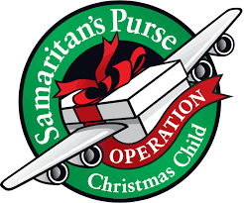

We Exist to:

* WORSHIP the Living God * WIN People to Jesus * TRAIN God’s People for Service

* SEND Them Out Into the World

From the Minister

Last month we began to look at the founders of the Restoration Movement, which is the movement that the Christian Church is a part of, by writing about Barton Stone. This month we are going to look at Thomas Campbell.
He might be the least famous of the founders, and his son, Alexander Campbell, is definitely more famous. However, his impact on the movement was certainly substantial. He published one of the most important documents of the Restoration Movement, The Declaration and Address. In this document he advocated for unity of the Church and dependence on the Bible alone as their foundation of Christian doctrine.
He felt the division within churches over human creeds was a stain upon the church. He felt that if Christians would rely on Scripture alone as the basis for their faith, there would be less to no divisions within the Church. It is this belief that he is most known for and can be seen in his most famous quote.
“Where the Bible speaks, we speak; where the Bible is silent, we are silent.”
God bless,
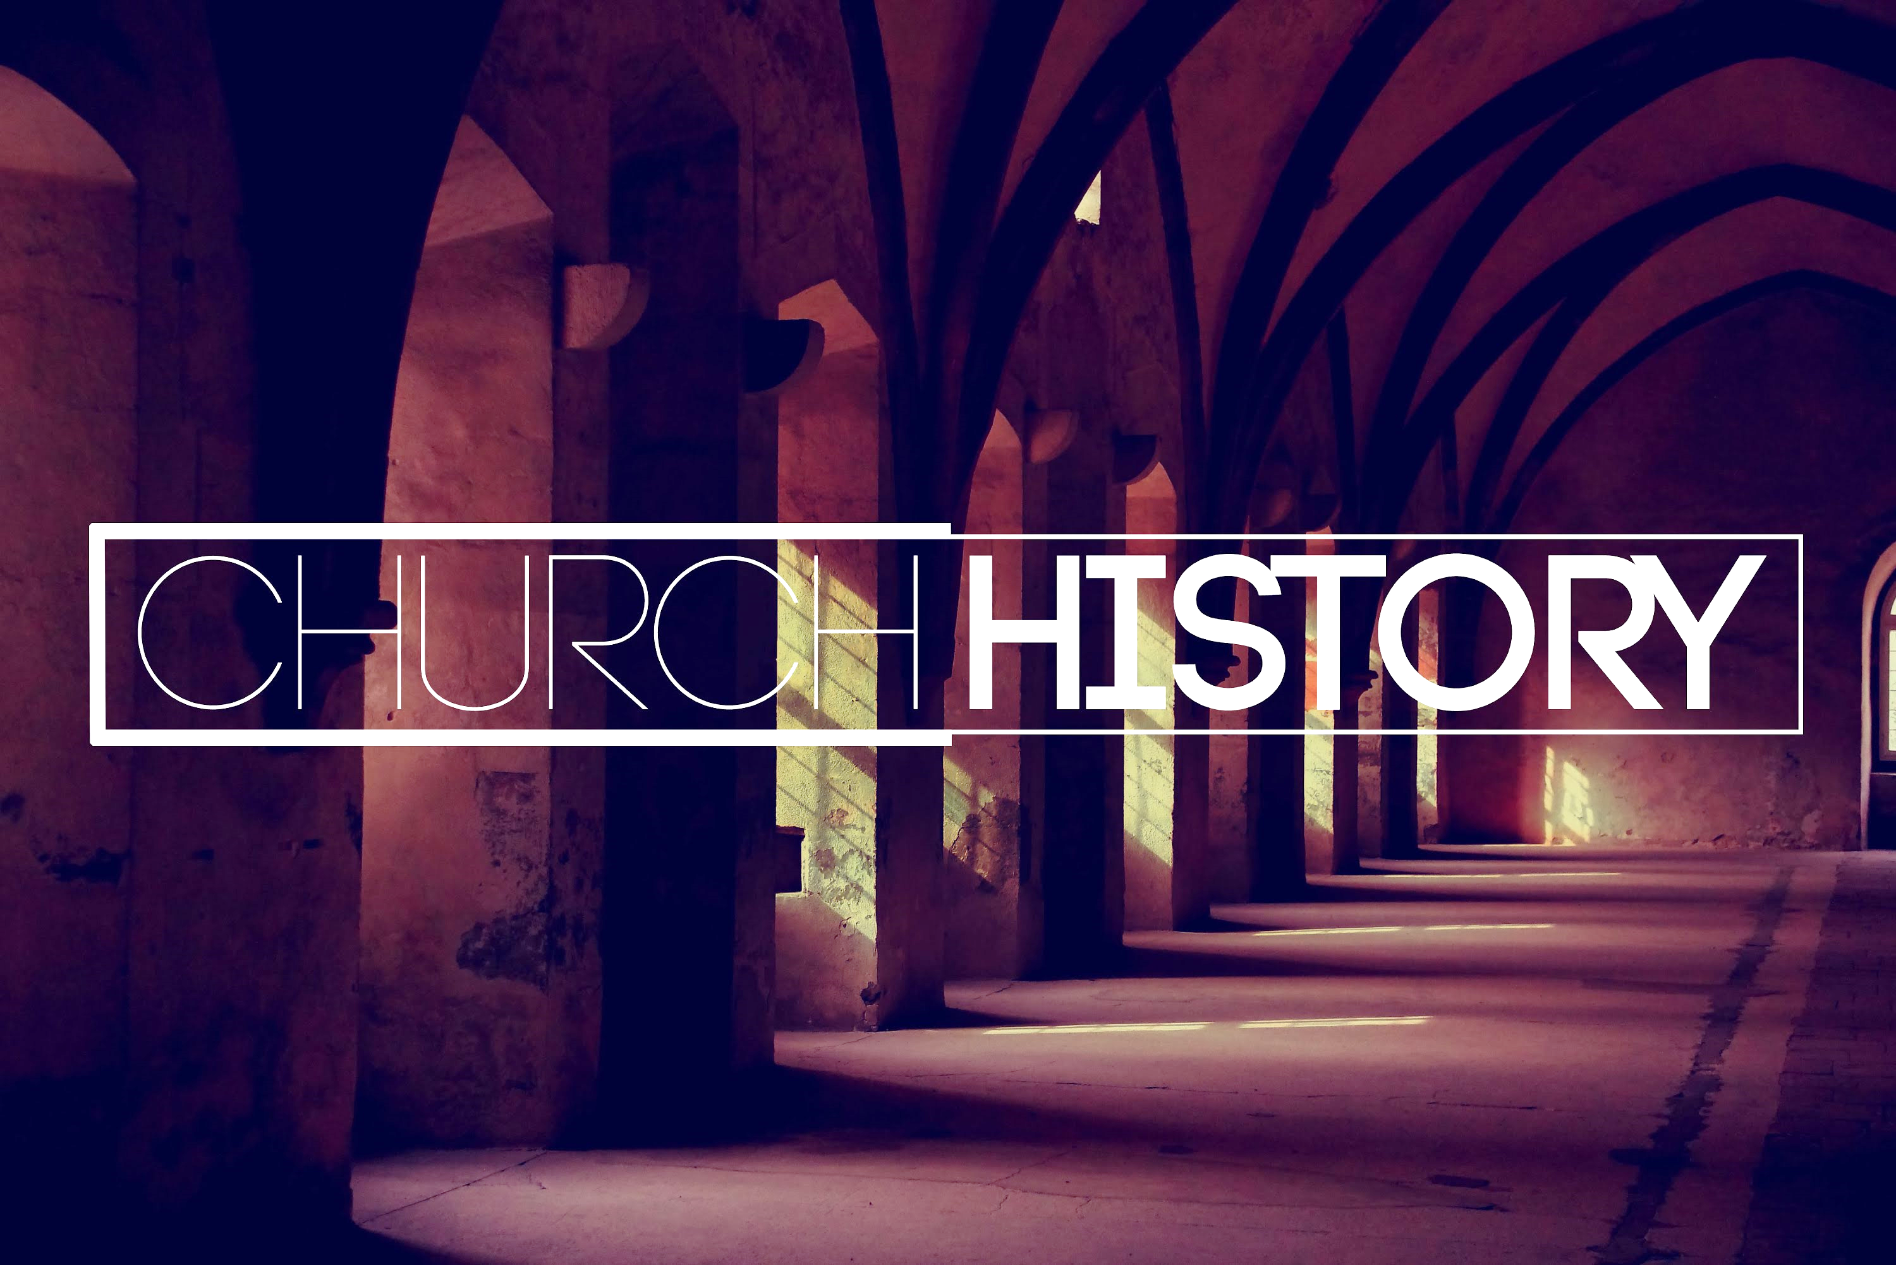
Nathan Brands

Breakfast Fellowship
If you would like to provide breakfast on a Sunday morning, there will be a sign-up sheet in the kitchen. Breakfast starts at 9:00 am.


Cookbook Pre-Order
Sign up today to pre-order your copy of Gather Around the Table. Pre-orders and payments must be completed by Sunday, October 22nd. Suggested donation - $20/book. Contact Jamie Smith at 618-322-5027 for more info and/or to order a book.
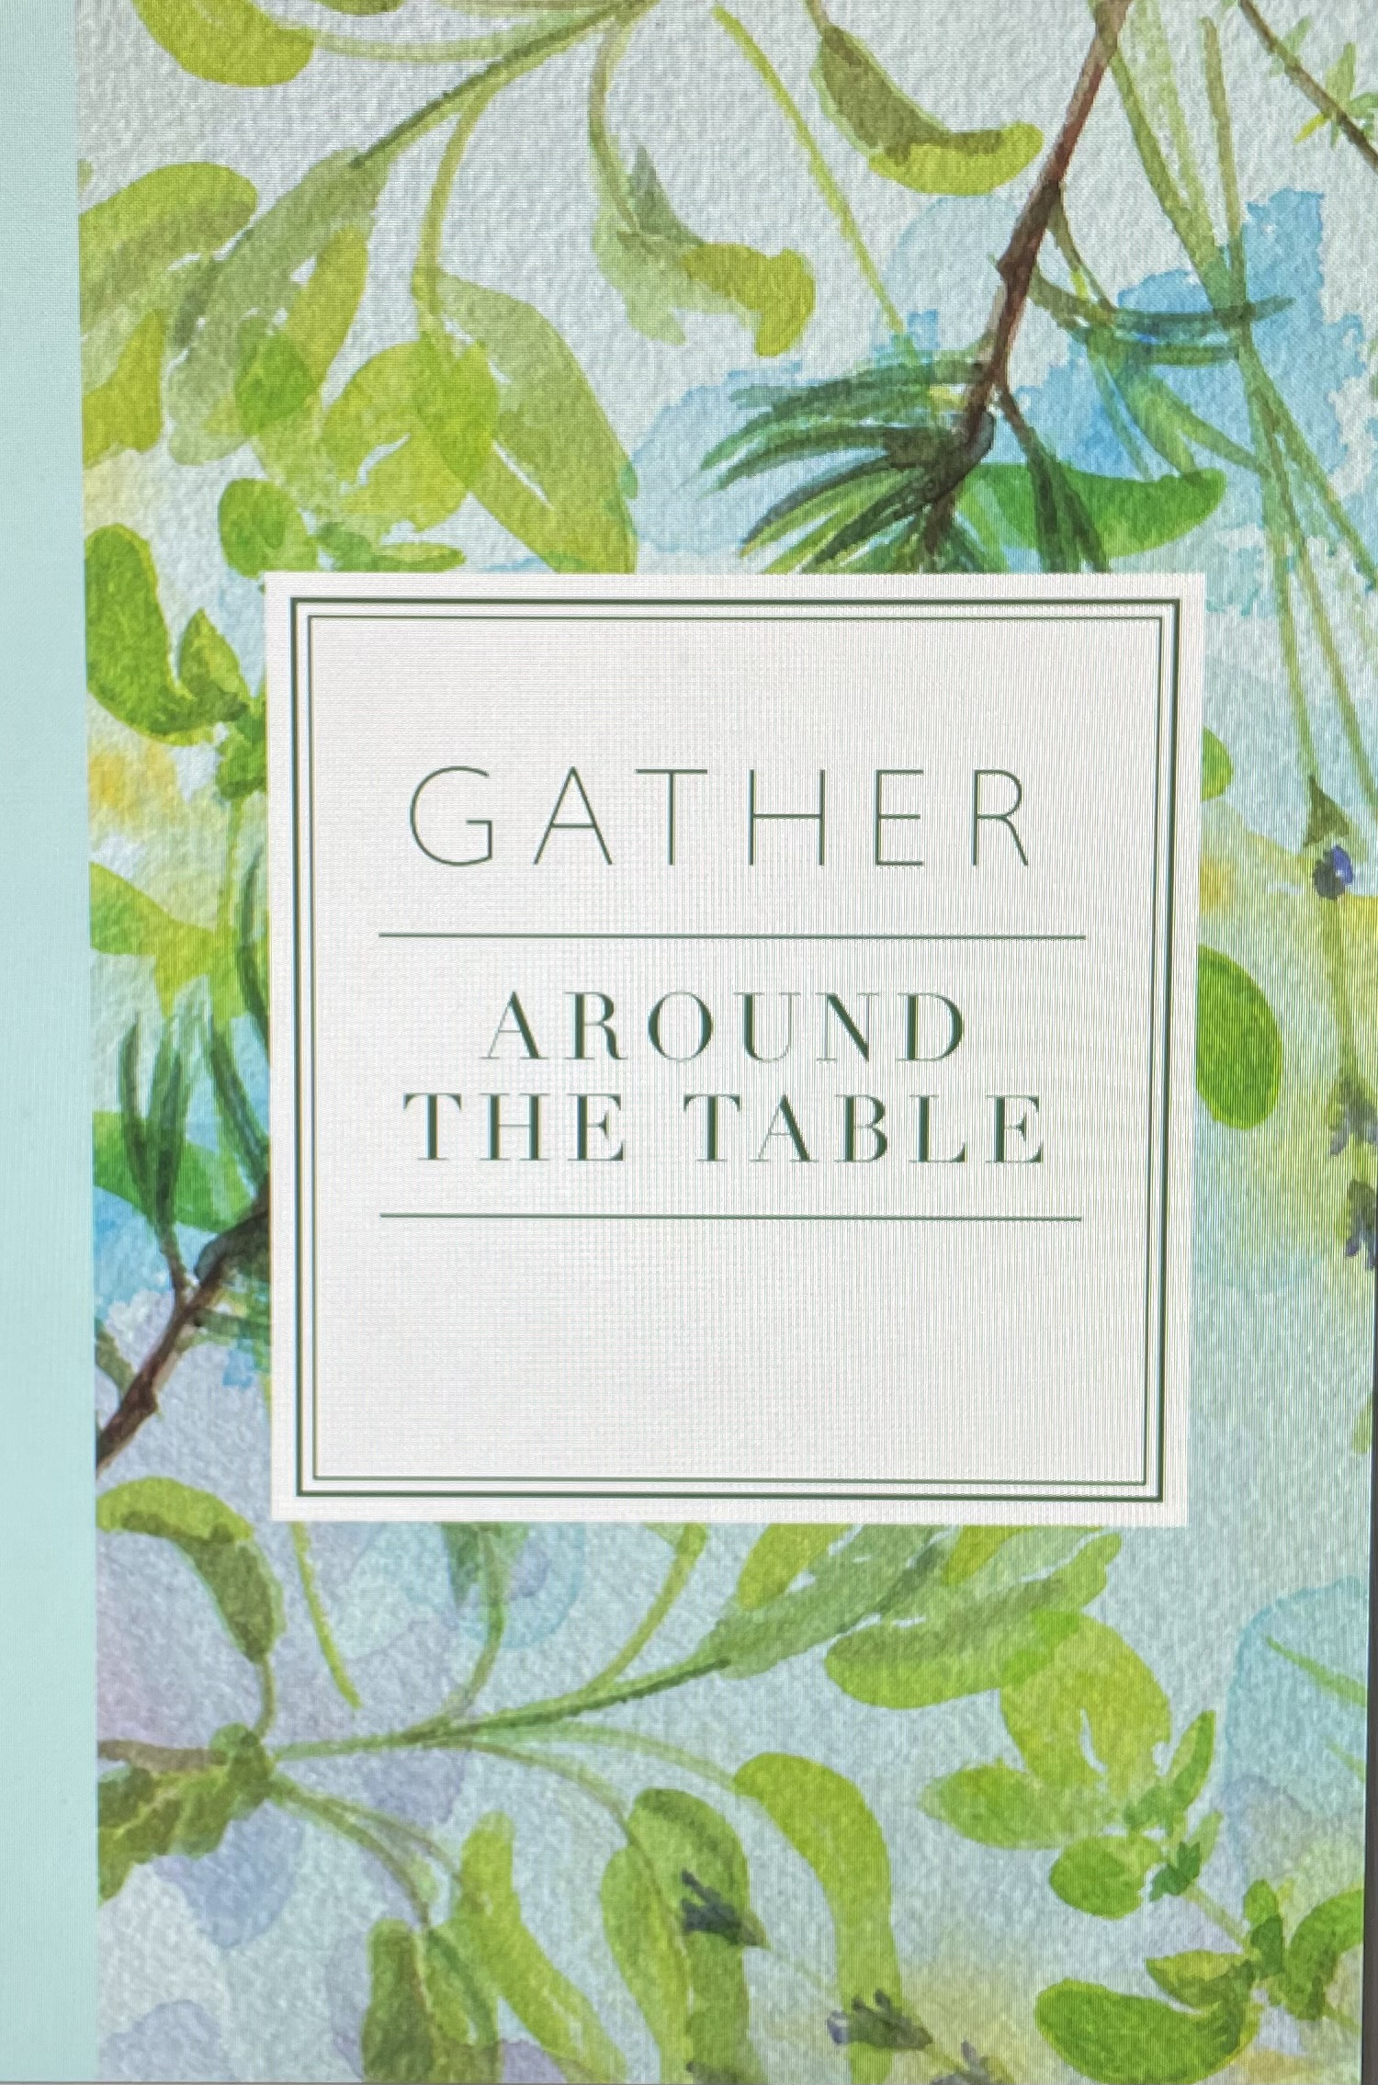

What’s Going On?
Christmas Program Practice will be Sundays from 4:30 – 6:00 pm.
Youth Groups will be Sundays from 6:00 – 7:30 pm.
Women’s Bible Study will be Wednesdays at 6:30 pm. Come join us as Beth Moore leads us in a study that examines why devoted followers of Christ can fall into the traps of Satan.
Fall Fest will be Sunday, October 8th beginning at 4:00 pm.
Leadership Team (Elder’s & Deacon’s) Meeting is Tuesday, October 10th @ 7:00 pm.



5th Sunday

A 5th Sunday Offering will be taken up on Sunday, October 29th. The entire amount collected will be going to the Building Loan Principle. The goal is $22,000. There will be a potluck following at noon.
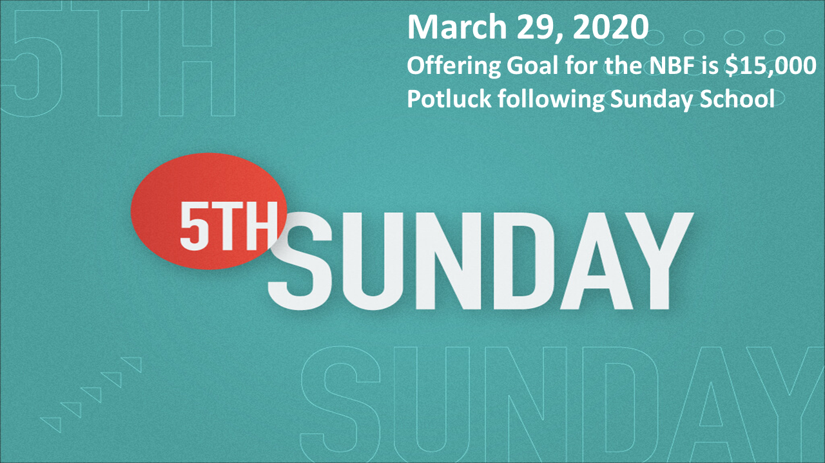

Men’s Breakfast
We will be gathering at FCCB for a time of prayer and fellowship at 7:00 am on the last Saturday of each month. This is open for all men! This months breakfast will be Saturday, October 28th.


For the Record

Date Attendance Offering Building Fund
8/27 69 $1,876.05 $1,050.00
9/3 71 $2,730.00 $1,380.00
9/10 71 $1,297.29 $0.00
Building Loan Balance - $67,562.65

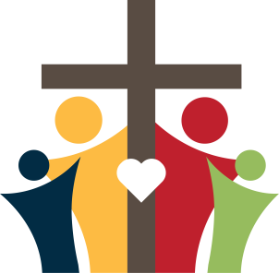

First Christian Church
Brownstown
516 W. Cumberland Rd.
P.O. Box 296
Brownstown, IL 62418
618-427-3687
Website: www.fccbrownstown.com Email: brownstownfcc@gmail.com

Nathan Brands, Preaching Minister Jamie Smith, Administrative Assistant

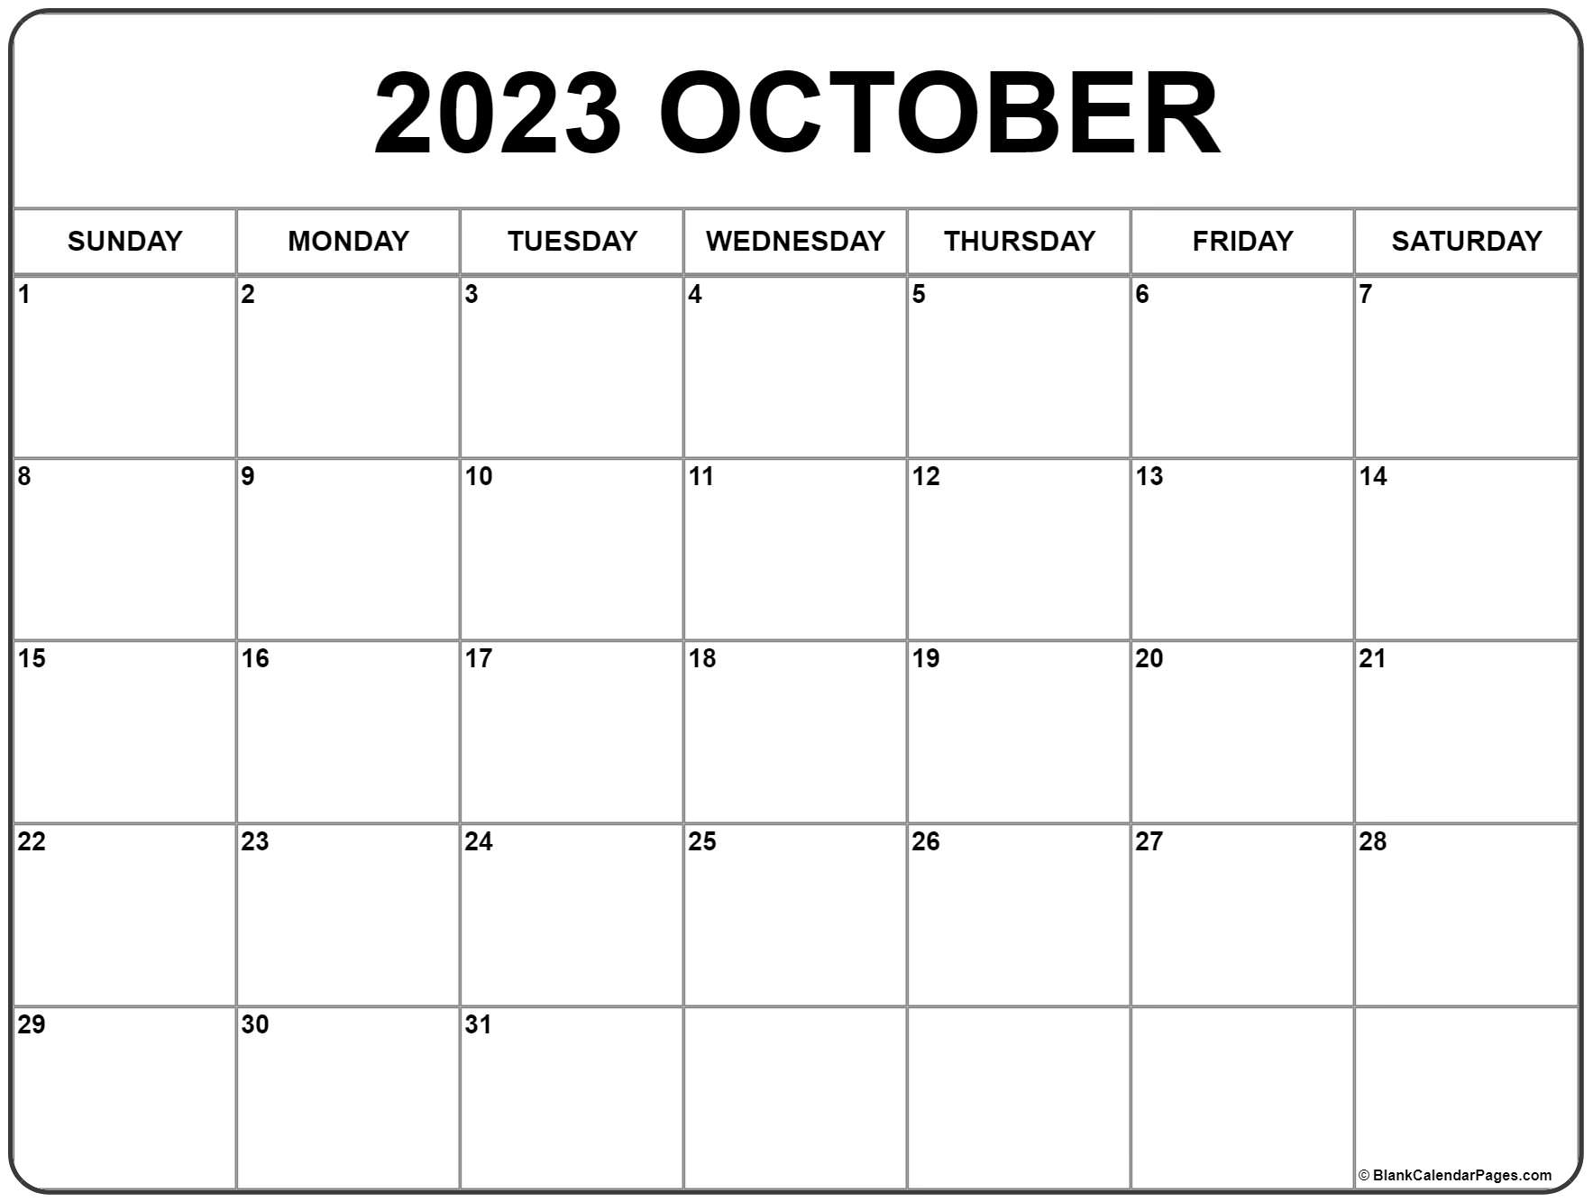
**Frank/Shelly Rook
*Lyndsey Pruett
*Hazel Jachino
*Trevor Willms
*Deanna Miller
*Emalee Smith *Joel Miller
*Cordelia Lytle
**Jody/Jamie Meador
*Madilyn Miller
**Patrick/Kaci Satterthwaite
**Travis/Lauren Gould
*Choya Morrison
*Jack Shelton
*Susan Smith
*Birthday
**Anniversary

