First Word

First Christian Church Brownstown
September 2023

Men’s Breakfast
We will be gathering at FCCB for a time of prayer and fellowship at 7:00 am on the last Saturday of the month. This is open for all men! The first breakfast will be Saturday, September 30th.


Women’s Bible Study
“When Godly People Do Ungodly Things,” a Beth Moore Study, will begin on Wednesday, September 6th at 6:30 pm at the church. This will be a 7 week study that examines why devoted followers of Christ can fall into the traps of Satan. This study is written in three parts. The first part is a warning to believers, while the second part shows women how to prepare for attacks by the Enemy. The third part is directed to those who have been snared by seduction, and compassionately points the way back to God.
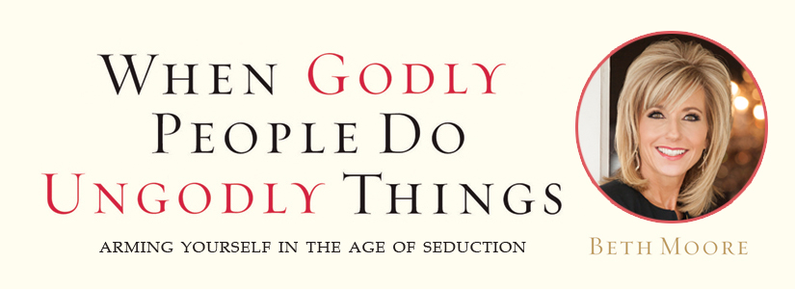

Breakfast Fellowship
If you would like to provide breakfast on a Sunday morning, there will be a sign-up sheet in the kitchen. Breakfast starts at 9:00 am.


We Exist to:

* WORSHIP the Living God * WIN People to Jesus * TRAIN God’s People for Service

* SEND Them Out Into the World

From the Minister

Previously, we have looked at Martin Luther and John Calvin. We are now going to jump a bit in time and move to the founders of the Restoration Movement, which is the movement the Christian Church is a part of. The founders of this movement were Barton Stone, Thomas Campbell, and Alexander Campbell. We will begin by taking a look at Barton Stone.
Stone was a Presbyterian minister in Kentucky. The Second Great Awakening, a protestant religious revival, was sweeping through Kentucky in the early 19th century. Stone helped lead the Cane Ridge Revival in Kentucky. This event impacted Stone. He began to take a closer look at his faith and the teachings of the Presbyterian Church. He determined that he did not believe all of the Presbyterian beliefs were Bible-based. He made this known to the Kentucky Presbyterian synod. They did not wish to reform, so Barton and four other ministers decided to form the Springfield Presbytery.
Eventually they decided that this new Presbytery could lead to similar issues the Kentucky synod had. They decided individual churches should be autonomous. They publicized this in a document entitled The Last Will and Testament of the Springfield Presbytery. It is in this document that they declared to take “no other name than Christians” to identity their group; a stance we hold to even today.
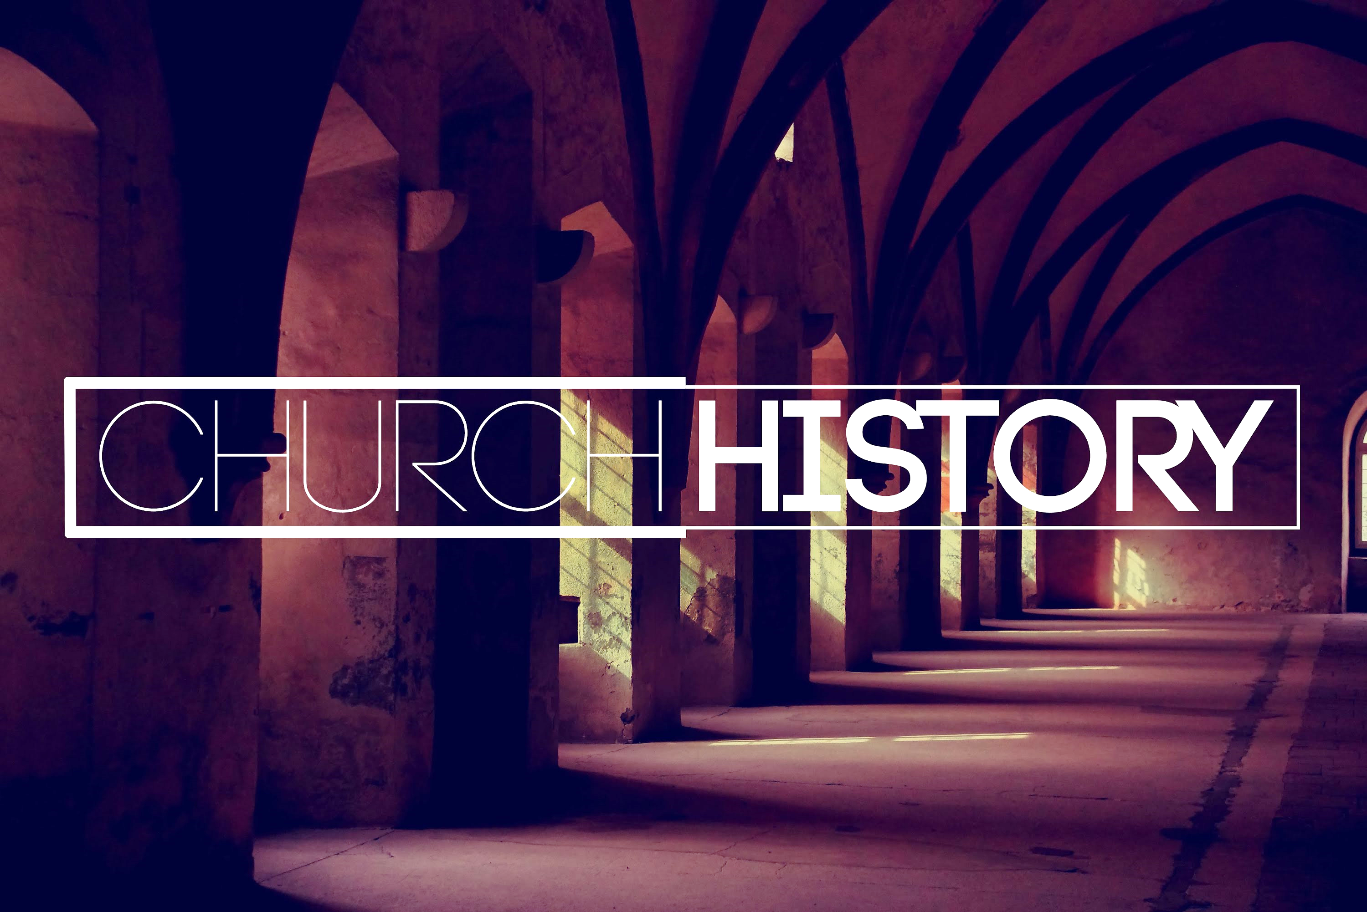
God bless,
Nathan

5th Sunday

The next 5th Sunday Offering is Sunday, October 29th. The entire amount collected will be going to the Building Loan Principle. The goal is $22,000. There will be a potluck following at noon.
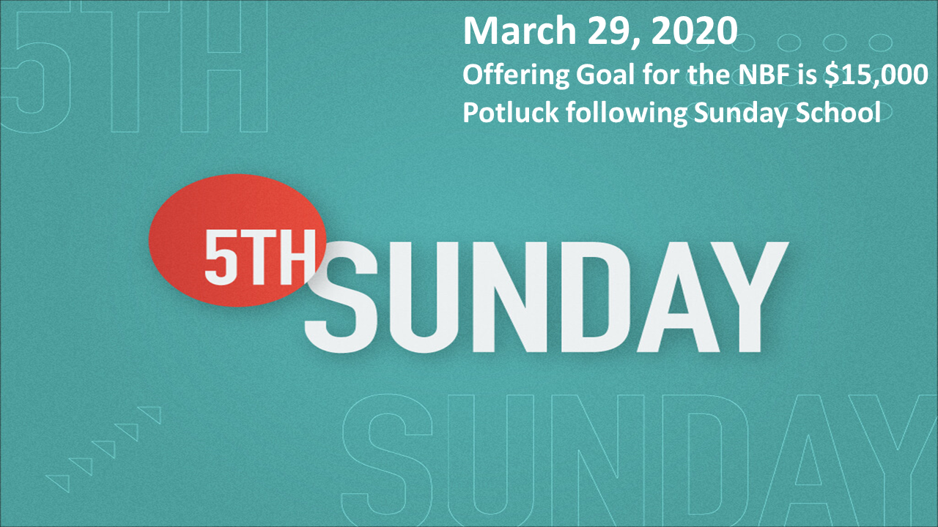

What’s Going On?
Leadership Team (Elder’s & Deacon’s) Meeting is Tuesday, September 12th @ 7:00 pm.



Upcoming Youth Events

Christmas Program Practice will start on Sunday, September 17th from 4:30 – 6:00 pm.


Youth Groups will also begin on Sunday, September 17th from 6:00 – 7:30 pm.
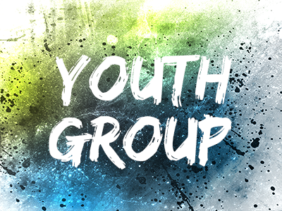

For the Record

Date Attendance Offering Building Fund
7/30 57 5th Sunday $26,468.11
8/6 70 $2,652.00 $360.00
8/13 68 $1,394.00 $200.00
8/20 79 $2,910.17 $485.00
Building Loan Balance - $69,769.13

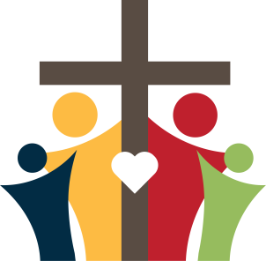

First Christian Church
Brownstown
516 W. Cumberland Rd.
P.O. Box 296
Brownstown, IL 62418
618-427-3687
Website: www.fccbrownstown.com Email: brownstownfcc@gmail.com

Nathan Brands, Preaching Minister Jamie Smith, Administrative Assistant


*Mitch Koehler
*Jamie Meador
**Kent/Tammy Woolsey
*Jody Meador
**Choya/Karen Morrison
*Bill Holman
**Trevor/Megan Willms
*Birthday
**Anniversary

