**First Word**

**First Christian Church Brownstown**

**September 2024**

**Movie on the Lawn**

 

#### We Exist to:

#### * WORSHIP the Living God * WIN People to Jesus * TRAIN God’s People for Service

#### * SEND Them Out Into the World

#### 



**From the Minister**

On September 1st, I will be starting a new sermon series out of 1 & 2 Kings and 1 & 2 Chronicles. This time in the history of Israel was not a great one. Israel is divided into two Kingdoms, Judea in the South, and Israel in the North. The majority of the kings of Judea were bad and refused follow God’s ways. All the kings of the Israel were bad and refused to follow God’s ways. The people of both kingdoms seem to follow their kings. They worshipped idols and were unrighteous in their actions. God sent prophets to try and correct this, but both kingdoms rarely listened. However, there were some good amongst the bad.

This is what we are going to look at in this series, the good amongst the bad. I think this is something we need today as well. As Christians, we are trying to live godly, righteous lives amongst a culture that promotes idols and unrighteous actions. We are trying to be the good amongst the bad.

I hope you will join us as we look at two kings, Hezekiah and Josiah, and two prophets, Elijah and Elisha, over a four-week period.

God bless,



Nathan Brands

**Collecting for Our Troops**

Taylor Ring (Bayle Ring’s husband) is deployed for 9 months and he has mentioned that there is a need for personal care items and snacks. (There is no store where they are stationed to buy items needed. Due to the heat, they ask for things that will not melt.

What better way as the body of Christ than to help out a fellow Christian in a time of need and supporting our troops? Please have your donations here by Sunday, September 29th.

Items needed: (Please buy gender neutral if possible)

Razors Toothbrushes/Toothpaste Spray Deodorant Body Wash (no bars) Shampoo (no conditioner) Cooling Tools Sunscreen Snacks (nothing that will melt or get sticky) Liquid IV packets



Questions: Contact Jamie Smith

## What’s Going On?

**Breakfast Fellowship:** If you would like to provide breakfast on a Sunday morning, there will be a sign-up sheet in the kitchen. Breakfast starts at 9:00 am.

**Leadership Team (Elder’s & Deacon’s) Meeting** is Tuesday, September 10th @ 7:00 pm.

VB



## 

## 5th Sunday

A 5th Sunday Offering will be taken up on Sunday, September 29th. The entire amount collected will be going to the Building Loan Principle. The goal is $22,000. There will be a potluck following at noon.

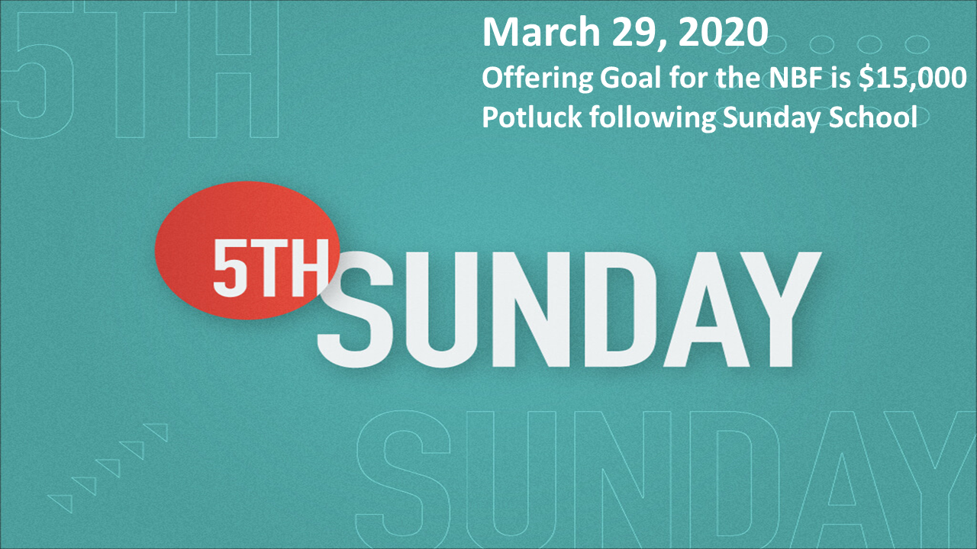

## Just for the Youth

Youth Groups for 2024-2025 year will begin on Sunday, September 8th. More information coming soon.



## For the Record

Date Attendance Offering Building Fund

7/28 47 $1,475.35 $1,380.00

8/4 59 $2,518.00 $80.00

8/11 63 $1,875.00 $3,577.00

8/18 61 $2,697.00 $975.00

New Building Fund - $61,184.15



First Christian Church

Brownstown

516 W. Cumberland Rd.

P.O. Box 296

Brownstown, IL 62418

618-427-3687

Website: [www.fccbrownstown.com](http://www.fccbrownstown.com) Email: [brownstownfcc@gmail.com](mailto:brownstownfcc@gmail.com)

Nathan Brands, Preaching Minister Jamie Smith, Administrative Assistant

*Birthday

**Anniversary



**Zayne Koehler

**Mitch Koehler

**Jamie Meador

**Kent/Tammy Woolsey

**Jody Meador

**Choya/Karen Morrison

**Bill Holman

**Trevor/Megan Willms