**First Word**

**First Christian Church Brownstown**

**August 2025**

**Worship Center Construction Project Update**

The worship center space is being cleared out so construction can begin. The projected construction date has been pushed back because of other commitments. $49,361.31 deposit (70%) has been paid to FTS Sound for audio/video equipment. There has been $119,616.85 spent on the construction project without borrowing any money. There is currently $50,731.31 in the building Fund.

God is Good!!!!

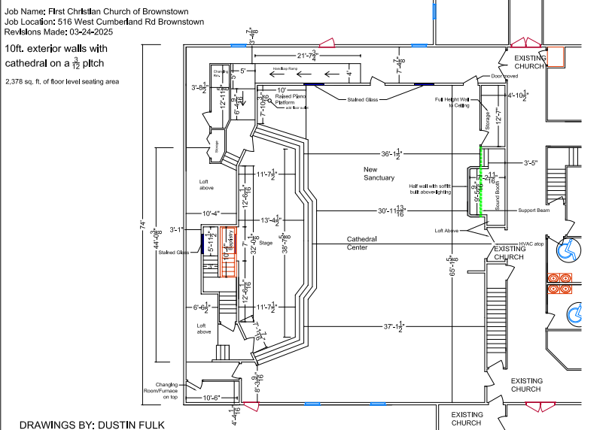

#### We Exist to:

#### * WORSHIP the Living God * WIN People to Jesus * TRAIN God’s People for Service

#### * SEND Them Out Into the World

#### 



**From the Minister**

It is near the end of July, and I am on vacation. I am visiting the Creation Museum and the Ark Encounter near Cincinnati, OH. At the Creation Museum, I watched Created Cosmos at their planetarium. In it, it showed the vast size, complexity, and majesty of the universe. Through this, we experience just how amazing God truly is. With a simple phrase, He created the entire cosmos. This show was Avie’s favorite part of the Creation Museum.

When we got back to where we were staying, I asked Avie and Jameson what God’s masterpiece of creation was. Avie quickly answered, “us.” I told her she was right and how amazing that is considering he created the entire universe.

This is a good reminder to all of us. God created some astounding things, yet all of them pale in comparison to us. We are God’s masterpiece. We are the one made in His image. We are valuable beyond all the rest of creation. We are the reason He was willing to sacrifice His Son. We are loved. Remember this the next time you feel you do not matter or that you are not important or are not valuable, because you are to God, the Creator of the universe.

God bless,  
Nathan Brands



**Day of Giving**

On Sunday, August 10th during the morning service, we are asking everyone in the congregation to trust God and give 10% of your income.



## What’s Going On?

**Breakfast Fellowship:** If you would like to provide breakfast on a Sunday morning, there will be a sign-up sheet in the kitchen. Breakfast starts at 9:00 am.

**Leadership Team (Elder’s & Deacon’s) Meeting** is Tuesday, August 12th @ 7:00 pm.

**Youth Groups** will be taking a break for the summer. They will resume in the fall.

## 



## 5th Sunday

A 5th Sunday Offering will be taken up on Sunday, August 31st. The entire amount collected will be going to the Building Loan Principle. The goal is $22,000. There will also be a potluck following Sunday School.

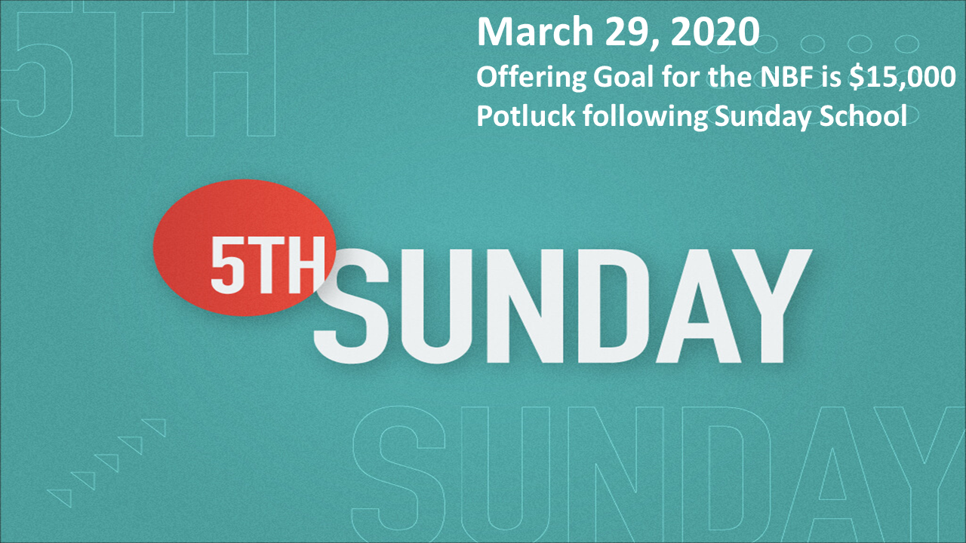

## For the Record

Date Attendance Offering Building Fund

6/29 55 5th Sunday $20,392.00

7/6 47 $3,501.00 $2,422.00

7/13 46 $1,491.00 $190.00

7/20 52 $3,163.00 $65.00



First Christian Church

Brownstown

516 W. Cumberland Rd.

P.O. Box 296

Brownstown, IL 62418

618-427-3687

Website: fcc-brownstown.com

Email: [brownstownfcc@gmail.com](mailto:brownstownfcc@gmail.com)

Nathan Brands, Preaching Minister Jamie Smith, Administrative Assistant



*Duane Willms

*Phyllis Pryor

*Aiden Smith

**Jeremy/ Shannon Claycomb

*Judy Palecek *Wilma Kruger

*Gracie Meador

*Jori Adams **Matthew/ Jamie Smith

*Karen Morrison

**Eric/Tresnee Adams

**Kent/Teresa Durbin

*Birthday

**Anniversary